1 In the accompanying diagram, is tangent to circle O at A, is a secant, , and .

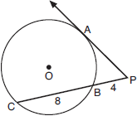

What is the length of ?
1)
2)
3)
4) | 4

2 In the diagram below, tangent and secant are drawn to circle O from external point P.

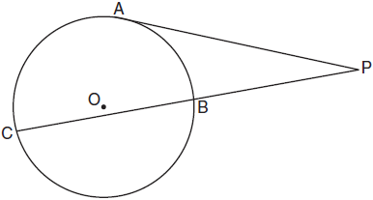

If and , what is the length of ?
1) | 20
2) | 9
3) | 8
4) | 6

3 In the diagram below, is a tangent to circle O at point S, is a secant, , , and .

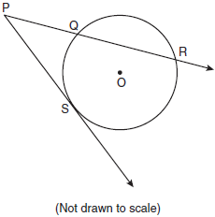

What is the length of ?
1) | 6
2) | 9
3) | 3
4) | 27

4 In the diagram shown below, is tangent to circle T at A, and secant is drawn where point B is on circle T.

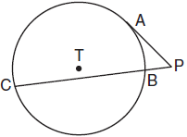

If and , what is the length of ?
1)
2)
3) | 3
4) | 9

5 Circle O is drawn below with secant . The length of tangent is 24.

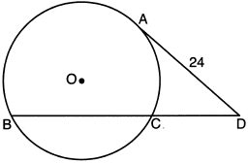

If the ratio of is , what is the length of ?
1) | 36
2) | 20
3) | 16
4) | 4

6 In the accompanying diagram, cabins B and G are located on the shore of a circular lake, and cabin L is located near the lake. Point D is a dock on the lake shore and is collinear with cabins B and L. The road between cabins G and L is 8 miles long and is tangent to the lake. The path between cabin L and dock D is 4 miles long.

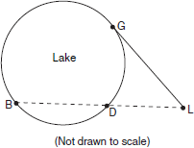

What is the length, in miles, of ?
1) | 24
2) | 12
3) | 8
4) | 4

7 In the accompanying diagram, is tangent to circle O at A, secant is drawn, , and . Find PA.
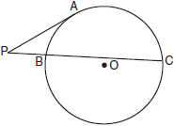

8 In the accompanying diagram, is tangent to circle O at B. If and , what is the length of ?
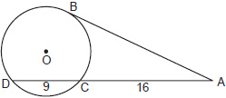

9 In the accompanying diagram of circle O, is a tangent and is a secant. If and , find PA.
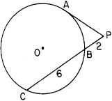

10 In the accompanying figure, is tangent to circle O at A, and is a secant. If and , find PA.

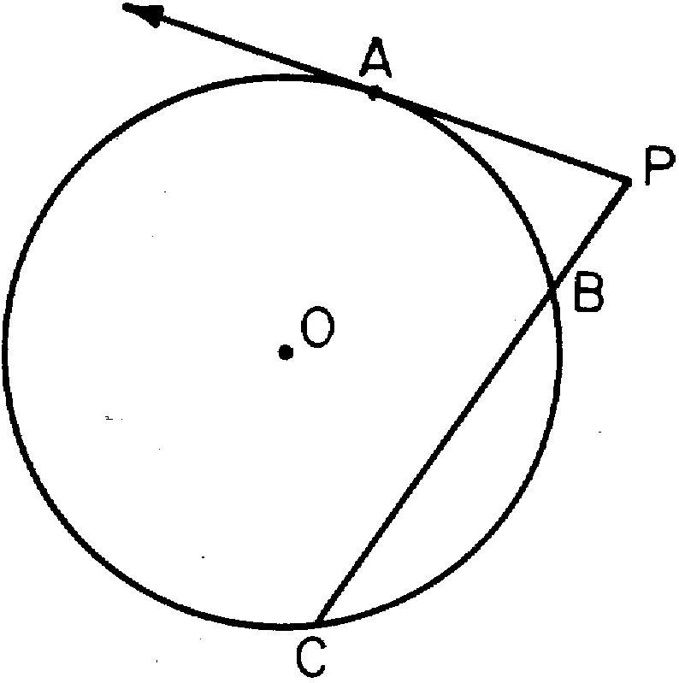

11 In the accompanying diagram, is tangent to circle at and is a secant. If and , find the length of .

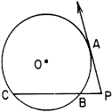

12 In circle P below, tangent and secant are drawn.

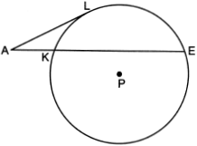

If and , determine and state the length of .

13 In the diagram below of circle O, secant and tangent are drawn.

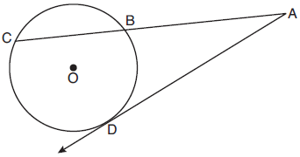

If and , determine and state the length of .

14 In the accompanying diagram, tangent and secant are drawn to circle O from point A, , and . Find AD.

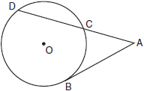

15 In the accompanying diagram, is tangent to circle O at D and is a secant. If and , find AB.

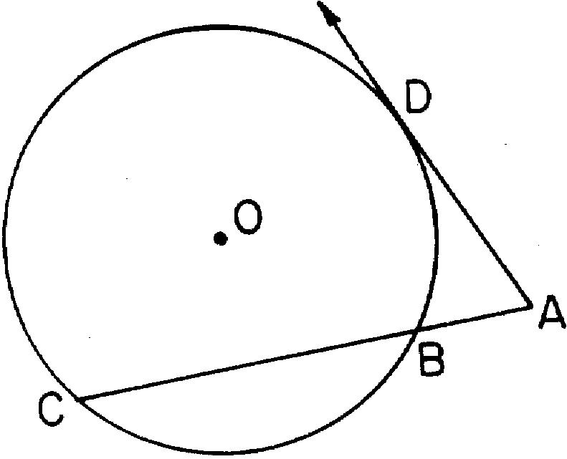

16 In the accompanying diagram, is tangent to circle O and is a secant. If and , find PB.

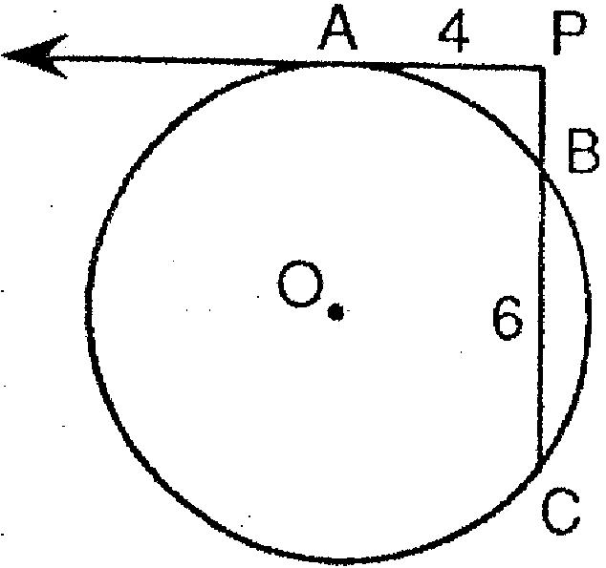

17 In the accompanying diagram, is tangent to circle O at B and is a secant. If and , find AC.

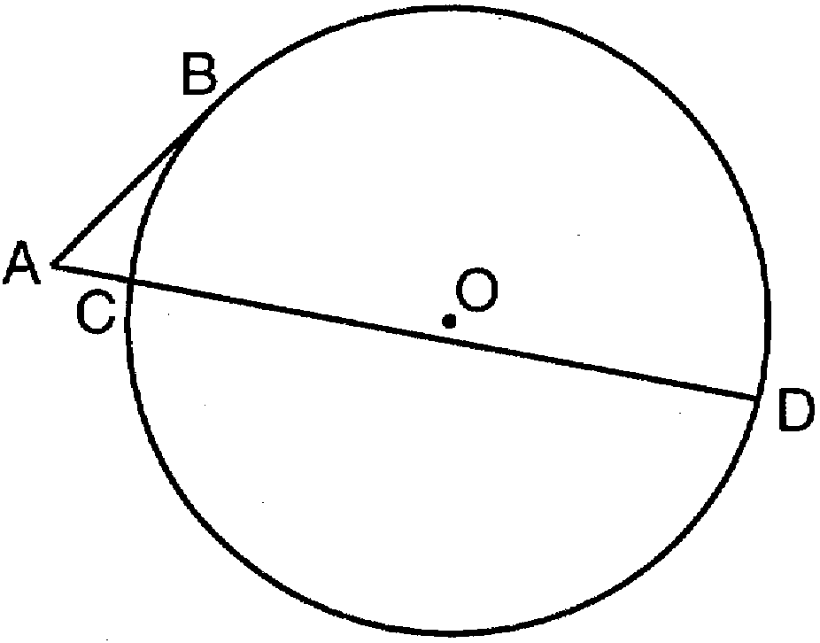

18 In the accompanying diagram, is tangent to circle O at D and is a secant. If and , find AB.

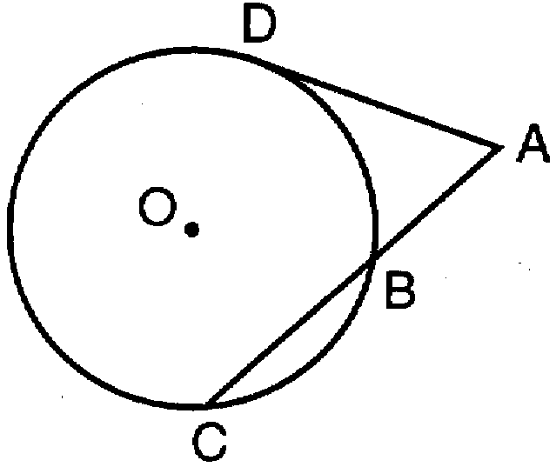

19 In the accompanying diagram, tangent and secant are drawn to circle O from external point P. If and , find the length of .

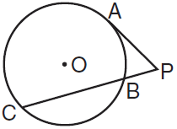

20 In the accompanying diagram, is tangent to circle O, is a secant, , and . Find AB.
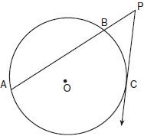

21 In circle E below, tangent and secant are drawn.
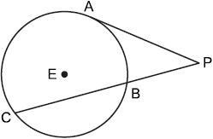
If and , determine and state the length of .

22 In the diagram below of circle O, chords and intersect at M. Secant and tangent are drawn to circle O. The length of is two more than the length of , , , and .
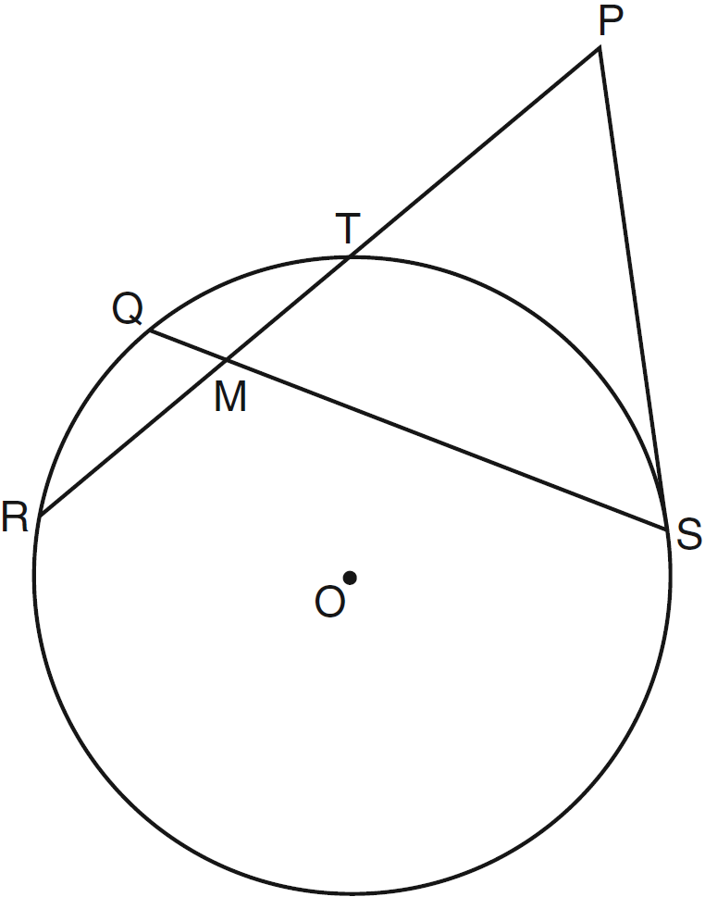

Find the length of . Find the length of .
1 ANS: 3
If a tangent and a secant intersect outside a circle, the tangent squared will equal the product of the secant and its external segment. 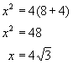.

REF: 080719b

2 ANS: 4
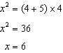

REF: 011008ge

3 ANS: 2
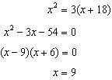

REF: fall0817ge

4 ANS: 2
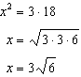

REF: 081712geo

5 ANS: 2
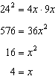

REF: 012312geo

6 ANS: 2
If a tangent and a secant intersect outside a circle, the tangent squared will equal the product of the secant and its external segment. 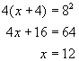. 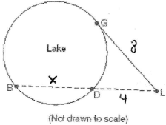

REF: 080103b

7 ANS:
8. If a tangent and a secant intersect outside a circle, the tangent squared will equal the product of the secant and its external segment. 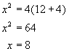. 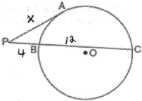

REF: 010623b

8 ANS:
20. If a tangent and a secant intersect outside a circle, the tangent squared will equal the product of the secant and its external segment. 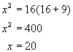.

REF: 010821b

9 ANS:
4

REF: 068805siii

10 ANS:
8

REF: 068914siii

11 ANS:
6
REF: 089011siii

12 ANS:
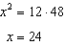
REF: 062428geo

13 ANS:
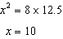
REF: 012028geo

14 ANS:
9
REF: 010416siii

15 ANS:
2
REF: 068607siii

16 ANS:
2
REF: 019408siii

17 ANS:
3
REF: 019701siii

18 ANS:
4
REF: 089715siii

19 ANS:
12
REF: 010314siii

20 ANS:
9
REF: 060314siii

21 ANS:
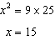
REF: 012530geo

22 ANS:
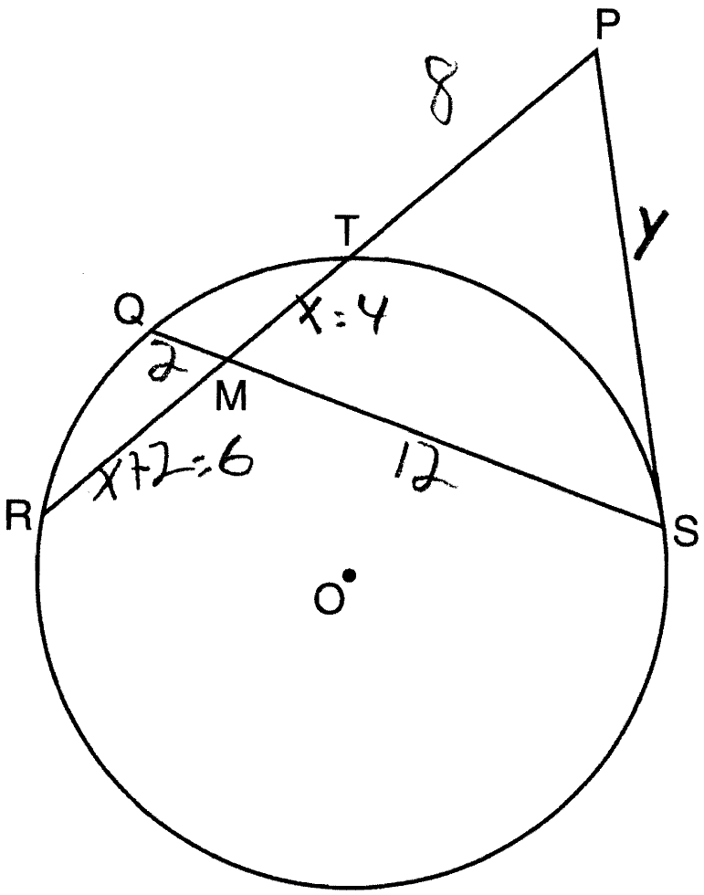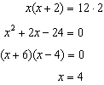. . 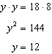
REF: 061237ge

