1 In right triangle LMN below, , , and .

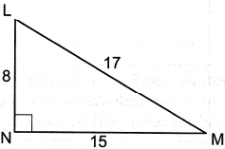

If triangle LMN is translated such that it maps onto triangle XYZ, which statement is always true?
1)
2)
3)
4)

2 In the diagram below, is reflected over line to create .

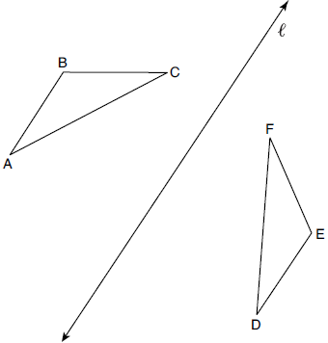

If and , what is ?
1) | 40°
2) | 45°
3) | 85°
4) | 95°

3 In the diagram below, with sides 13, 15, and 16, is mapped onto after a clockwise rotation of 90° about point P.

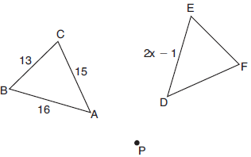

If , what is the value of x?
1) | 7
2) | 7.5
3) | 8
4) | 8.5

4 In the diagram below, is mapped onto after a sequence of rigid motions.

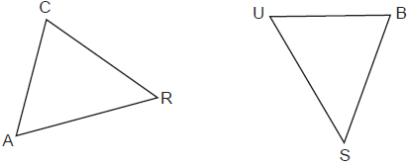

If , , , and , what is the length of ?
1) | 6
2) | 16
3) | 20
4) | 28

5 Rhombus ABCD can be mapped onto rhombus KLMN by a rotation about point P, as shown below.

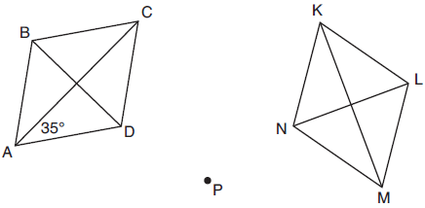

What is the measure of if the measure of ?
1) | 35°
2) | 55°
3) | 70°
4) | 110°

6 In the diagram below, a sequence of rigid motions maps ABCD onto JKLM.

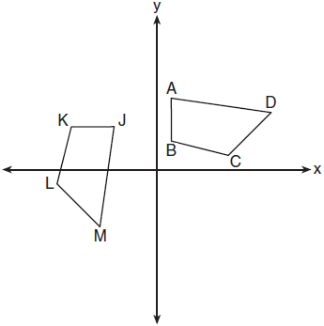

If , , and , the measure of is
1) | 53°
2) | 82°
3) | 104°
4) | 121°

7 Quadrilateral ABCD is graphed on the set of axes below.

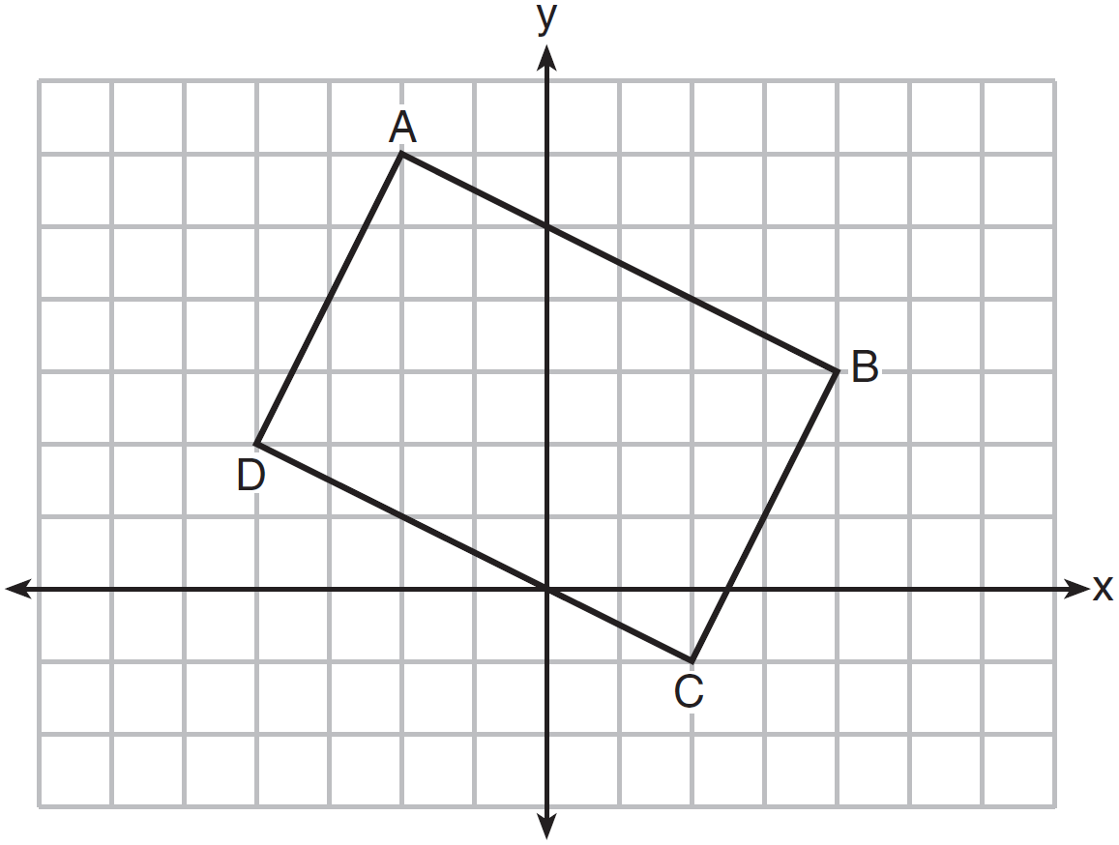

When ABCD is rotated 90° in a counterclockwise direction about the origin, its image is quadrilateral A'B'C'D'. Is distance preserved under this rotation, and which coordinates are correct for the given vertex?
1) | no and
2) | no and
3) | yes and
4) | yes and

8 The image of after a rotation of 90º clockwise about the origin is , as shown below.

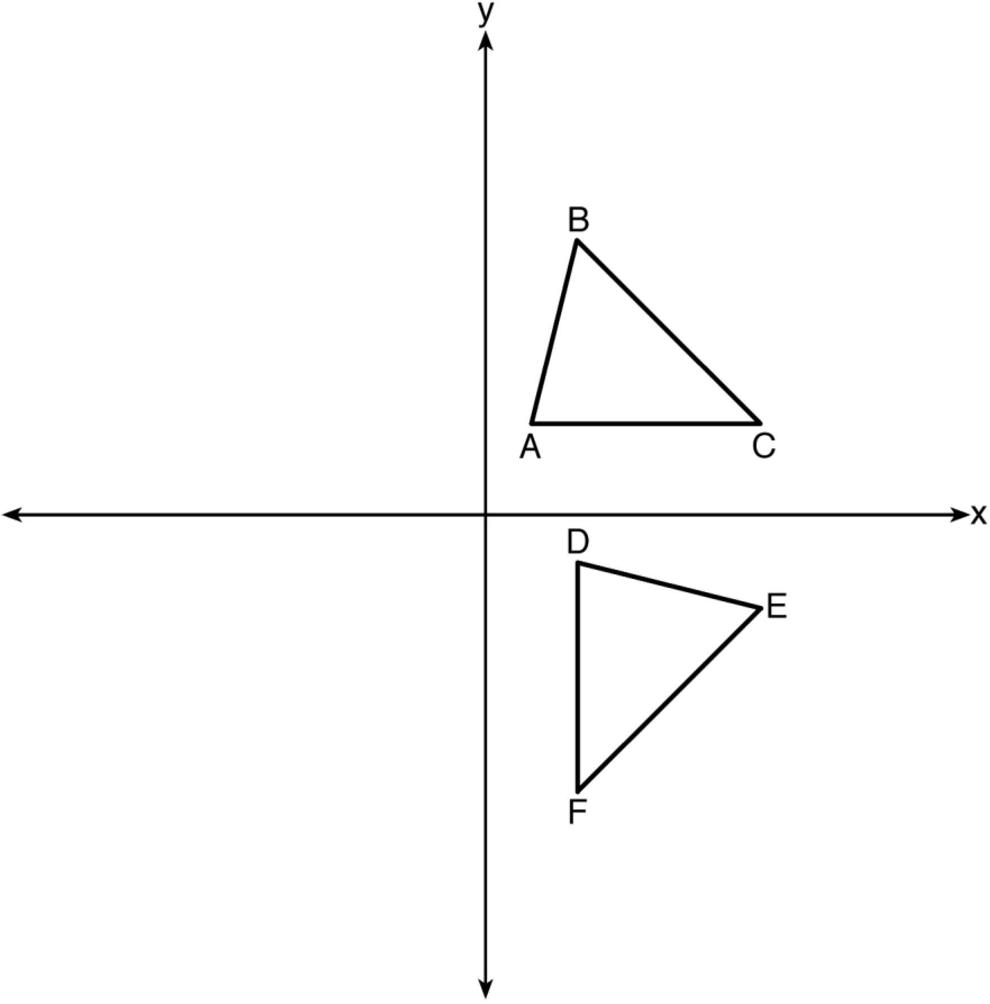

Which statement is true?
1)
2)
3)
4)

9 After a counterclockwise rotation about point X, scalene triangle ABC maps onto , as shown in the diagram below.

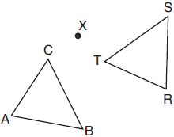

Which statement must be true?
1)
2)
3)
4)

10 In below, and .

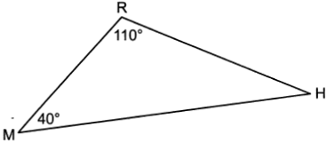

If is reflected over side to form quadrilateral RHR'M, which statement is always true?
1) | Quadrilateral RHR'M is a parallelogram.
2)
3)
4)

11 Trapezoid ABCD is drawn such that . Trapezoid A'B'C'D' is the image of trapezoid ABCD after a rotation of 110° counterclockwise about point P.

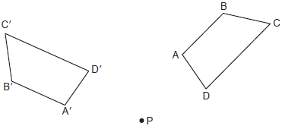

Which statement is always true?
1)
2)
3)
4)

12 In the diagram below, a line reflection followed by a rotation maps onto .

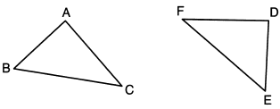

Which statement is always true?
1)
2)
3)
4)

13 In the diagram below, is the image of after a translation. Triangle CAT is the image of after a line reflection.
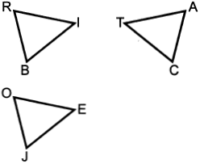

Which statement is always true?
1)
2)
3)
4)

14 Triangle MNP is the image of triangle JKL after a 120° counterclockwise rotation about point Q. If the measure of angle L is 47° and the measure of angle N is 57°, determine the measure of angle M. Explain how you arrived at your answer.

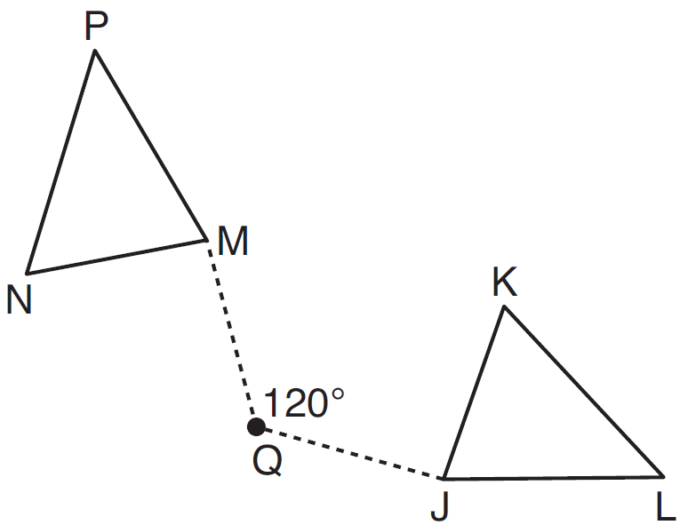

15 In the diagram below, quadrilateral BCDE maps onto quadrilateral JKLM using a sequence of rigid motions.
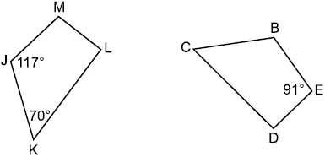

Determine and state the degree measure of angle D.

16 In the diagram below, is the image of after a reflection over .
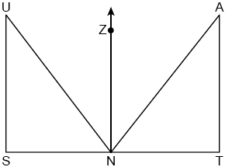
Use the properties of rigid motions to explain why .

17 In the diagram below, parallelogram EFGH is mapped onto parallelogram IJKH after a reflection over line .
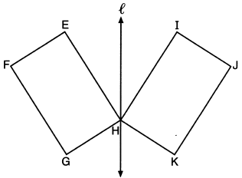
Use the properties of rigid motions to explain why parallelogram EFGH is congruent to parallelogram IJKH.

18 If is mapped onto after a line reflection and is mapped onto after a translation, the relationship between and is that they are always
1) | congruent and similar
2) | congruent but not similar
3) | similar but not congruent
4) | neither similar nor congruent

19 Quadrilateral MATH is congruent to quadrilateral WXYZ. Which statement is always true?
1)
2)
3) | Quadrilateral WXYZ can be mapped onto quadrilateral MATH using a sequence of rigid motions.
4) | Quadrilateral MATH and quadrilateral WXYZ are the same shape, but not necessarily the same size.

20 Triangle A'B'C' is the image of triangle ABC after a translation of 2 units to the right and 3 units up. Is triangle ABC congruent to triangle A'B'C'? Explain why.
1 ANS: 3
The measures of the angles of a triangle remain the same after a translation because translations are rigid motions which preserve angle measure.

REF: 082401geo

2 ANS: 2

REF: 082201geo

3 ANS: 4
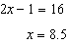

REF: 011902geo

4 ANS: 3
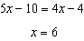

REF: 012408geo

5 ANS: 4

REF: 012015geo

6 ANS: 1

REF: 011801geo

7 ANS: 4 REF: 011611geo

8 ANS: 4
The measures of the angles of a triangle remain the same after all rotations because rotations are rigid motions which preserve angle measure.

REF: fall1402geo

9 ANS: 1 REF: 061801geo

10 ANS: 3 REF: 062407geo

11 ANS: 3 REF: 062302geo

12 ANS: 1
The lengths of the sides of a triangle remain the same after all rotations and reflections because rotations and reflections are rigid motions which preserve distance.

REF: 012301geo

13 ANS: 4 REF: 062401geo

14 ANS:
Rotations do not change angle measurements.

REF: 081629geo

15 ANS:

REF: 012525geo

16 ANS:
Reflections preserve distance, so the corresponding sides are congruent.

REF: 082430geo

17 ANS:
Reflections preserve distance and angle measure.

REF: 062228geo

18 ANS: 1
Distance and angle measure are preserved after a reflection and translation.

REF: 081802geo

19 ANS: 3 REF: 082203geo

20 ANS:
Yes, as translations do not change angle measurements.

REF: 061825geo

