1 Which numbers could represent the lengths of the sides of a triangle?
1)
2)
3)
4)

2 Which set of numbers represents the lengths of the sides of a triangle?
1)
2)
3)
4)

3 Phil is cutting a triangular piece of tile. If the triangle is scalene, which set of numbers could represent the lengths of the sides?
1)
2)
3)
4)

4 Which set can not represent the lengths of the sides of a triangle?
1)
2)
3)
4)

5 Which set could not represent the lengths of the sides of a triangle?
1)
2)
3)
4)

6 In , feet and feet. Which inequality represents all possible values for the length of , in feet?
1)
2)
3)
4)

7 The lengths of two sides of a triangle are 7 and 11. Which inequality represents all possible values for x, the length of the third side of the triangle?
1)
2)
3)
4)

8 If two sides of a triangle are 1 and 3, the third side may be
1) | 5
2) | 2
3) | 3
4) | 4

9 If two sides of a triangle have lengths of 2 and 7, the length of the third side could be
1) | 9
2) | 8
3) | 5
4) | 4

10 If two sides of a triangle have lengths of 4 and 10, the third side could be
1) | 8
2) | 2
3) | 16
4) | 4

11 If two sides of a triangle have lengths of and , which fraction can not be the length of the third side?
1)
2)
3)
4)

12 Which set of numbers could be the lengths of the sides of an isosceles triangle?
1)
2)
3)
4)

13 Which set of integers could represent the lengths of the sides of an isosceles triangle?
1)
2)
3)
4)

14 Sara is building a triangular pen for her pet rabbit. If two of the sides measure 8 feet and 15 feet, the length of the third side could be
1) | 13 ft
2) | 7 ft
3) | 3 ft
4) | 23 ft

15 The direct distance between city A and city B is 200 miles. The direct distance between city B and city C is 300 miles. Which could be the direct distance between city C and city A?
1) | 50 miles
2) | 350 miles
3) | 550 miles
4) | 650 miles

16 A box contains one 2-inch rod, one 3-inch rod, one 4-inch rod, and one 5-inch rod. What is the maximum number of different triangles that can be made using these rods as sides?
1) | 1
2) | 2
3) | 3
4) | 4

17 How many integer values of x are there so that x, 5, and 8 could be the lengths of the sides of a triangle?
1) | 6
2) | 9
3) | 3
4) | 13

18 In the diagram below of , D is a point on , , , and .

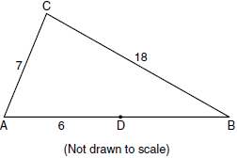

The length of could be
1) | 5
2) | 12
3) | 19
4) | 25

19 A plot of land is in the shape of rhombus ABCD as shown below.

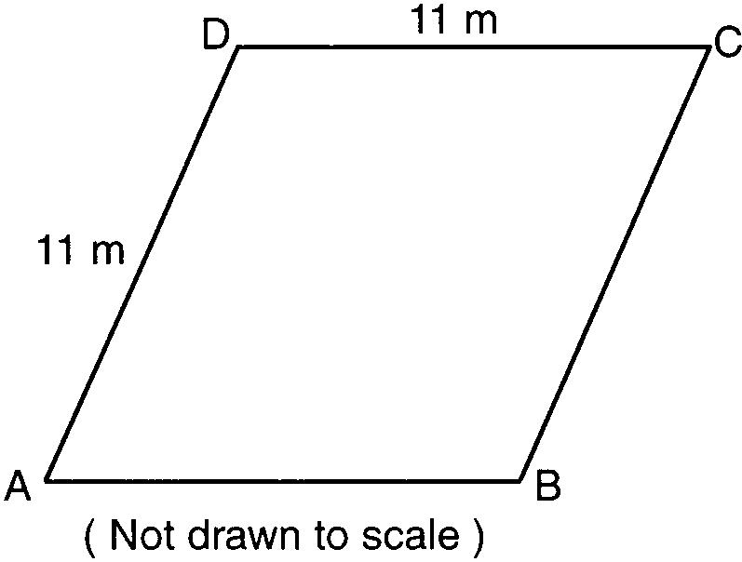

Which can not be the length of diagonal AC?
1) | 24 m
2) | 18 m
3) | 11 m
4) | 4 m

20 The plot of land illustrated in the accompanying diagram has a perimeter of 34 yards. Find the length, in yards, of each side of the figure. Could these measures actually represent the measures of the sides of a triangle? Explain your answer.

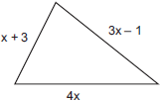

21 José wants to build a triangular pen for his pet rabbit. He has three lengths of boards already cut that measure 7 feet, 8 feet, and 16 feet. Explain why José cannot construct a pen in the shape of a triangle with sides of 7 feet, 8 feet, and 16 feet.
1 ANS: 4

REF: 061416ge

2 ANS: 2

REF: 080916ge

3 ANS: 2
(1) and (2) are not possible. (4) is not scalene.

REF: 080830a

4 ANS: 2
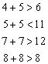

REF: 080425a

5 ANS: 2
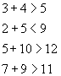

REF: 060515a

6 ANS: 2

REF: 011228ge

7 ANS: 4

REF: 061525ge

8 ANS: 3
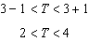

REF: 080018a

9 ANS: 2
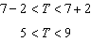

REF: 012522geo

10 ANS: 1
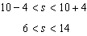

REF: 011519ge

11 ANS: 4
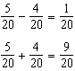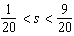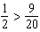
REF: 011625ge

12 ANS: 2 REF: 081527ge

13 ANS: 4
REF: 062421geo

14 ANS: 1
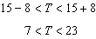
REF: 080520a

15 ANS: 2
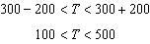
REF: 069905a

16 ANS: 3
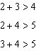
REF: 080120b

17 ANS: 2
and . There are 9 integers between 3 and 13.
REF: spring9809a

18 ANS: 2
REF: fall0819ge

19 ANS: 1
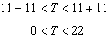
REF: 010010a

20 ANS:
7, 11, 16 and yes because . 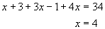
REF: 060227a

21 ANS:
The sum of any two sides of a triangle must be greater than the third side.
REF: 010534a

