1 In with shown in the diagram below, and are drawn.

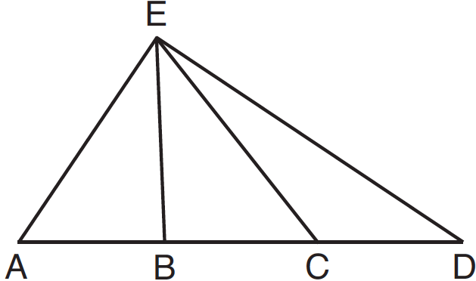

If , which statement could always be proven?
1)
2)
3)
4)

2 Line segment EA is the perpendicular bisector of , and and are drawn.

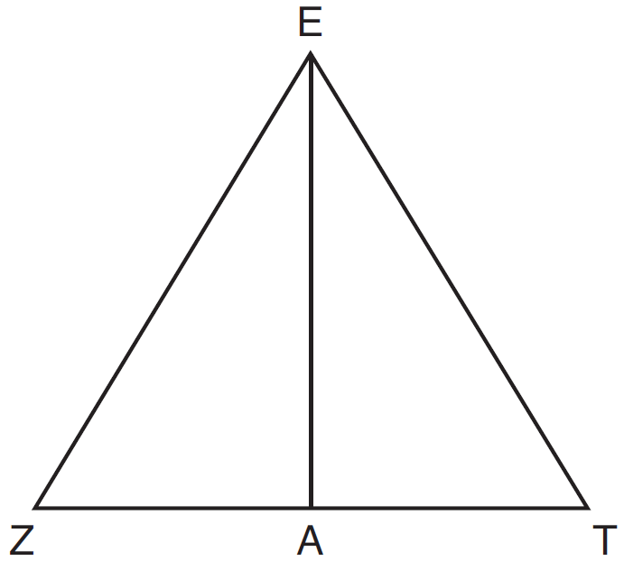

Which conclusion can not be proven?
1) | bisects angle ZET.
2) | Triangle EZT is equilateral.
3) | is a median of triangle EZT.
4) | Angle Z is congruent to angle T.

3 Given: , , and bisects
Prove that is a right angle.

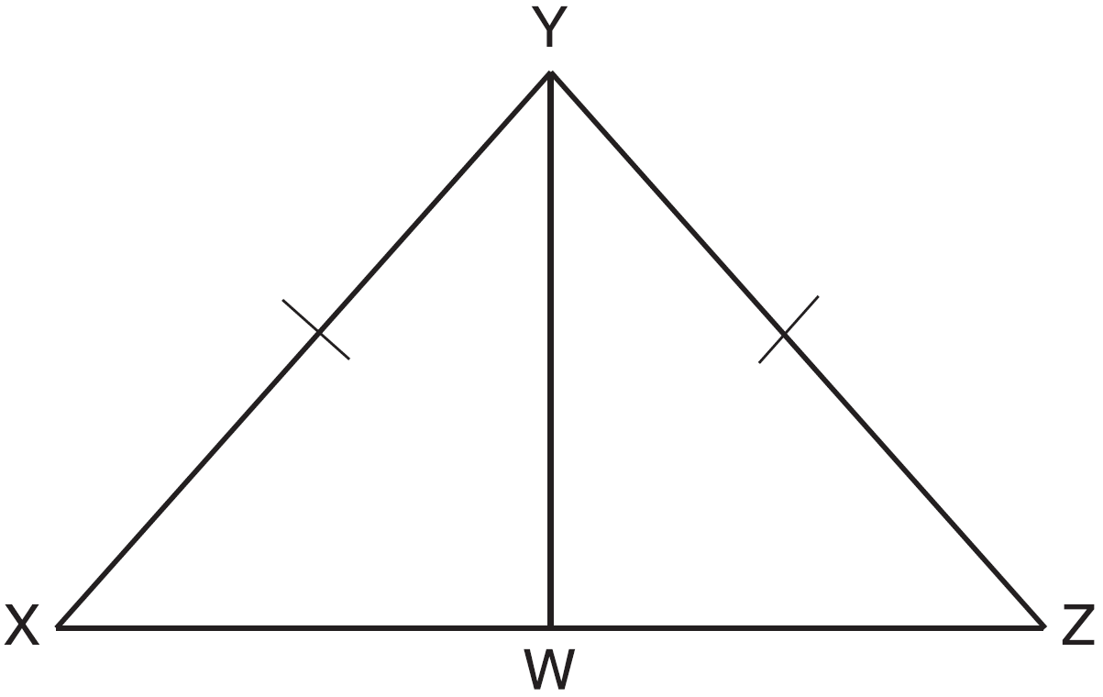

4 Prove the sum of the exterior angles of a triangle is 360°.

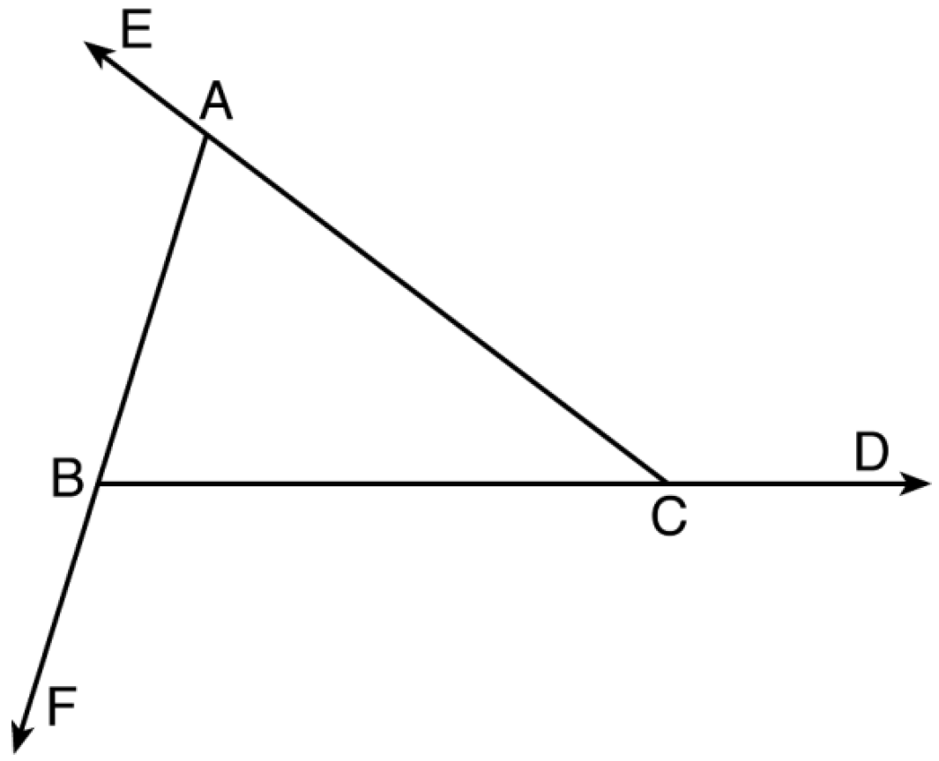

5 Given the theorem, “The sum of the measures of the interior angles of a triangle is 180°,” complete the proof for this theorem.

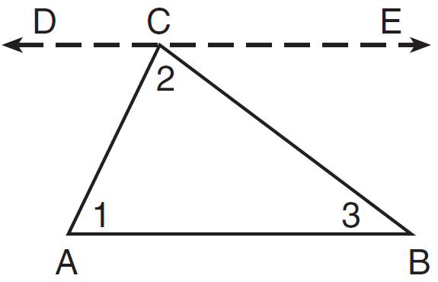

Given:
Prove:
Fill in the missing reasons below.

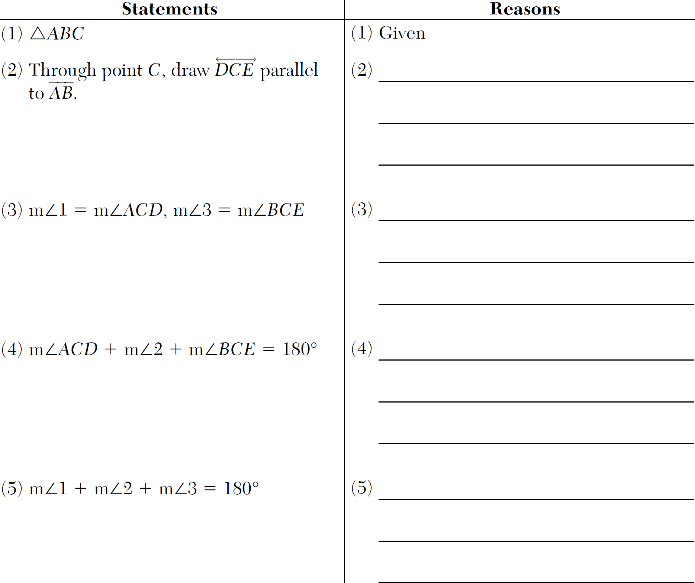
1 ANS: 1
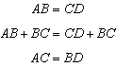

REF: 081207ge

2 ANS: 2
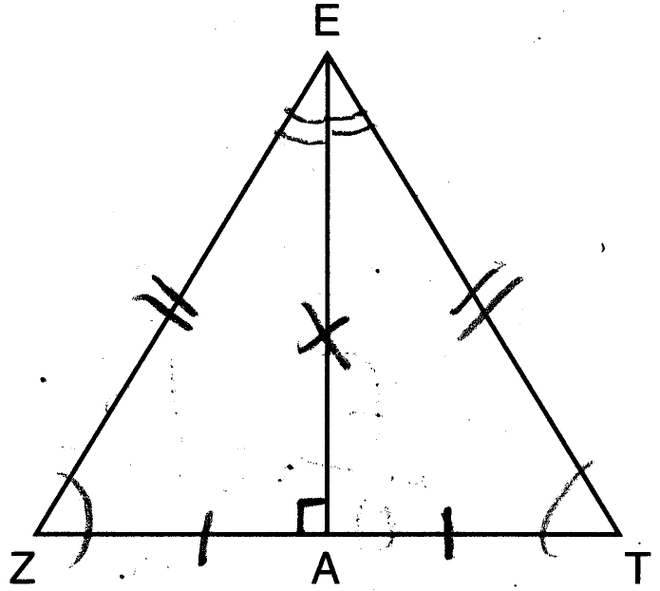

REF: 061619geo

3 ANS:
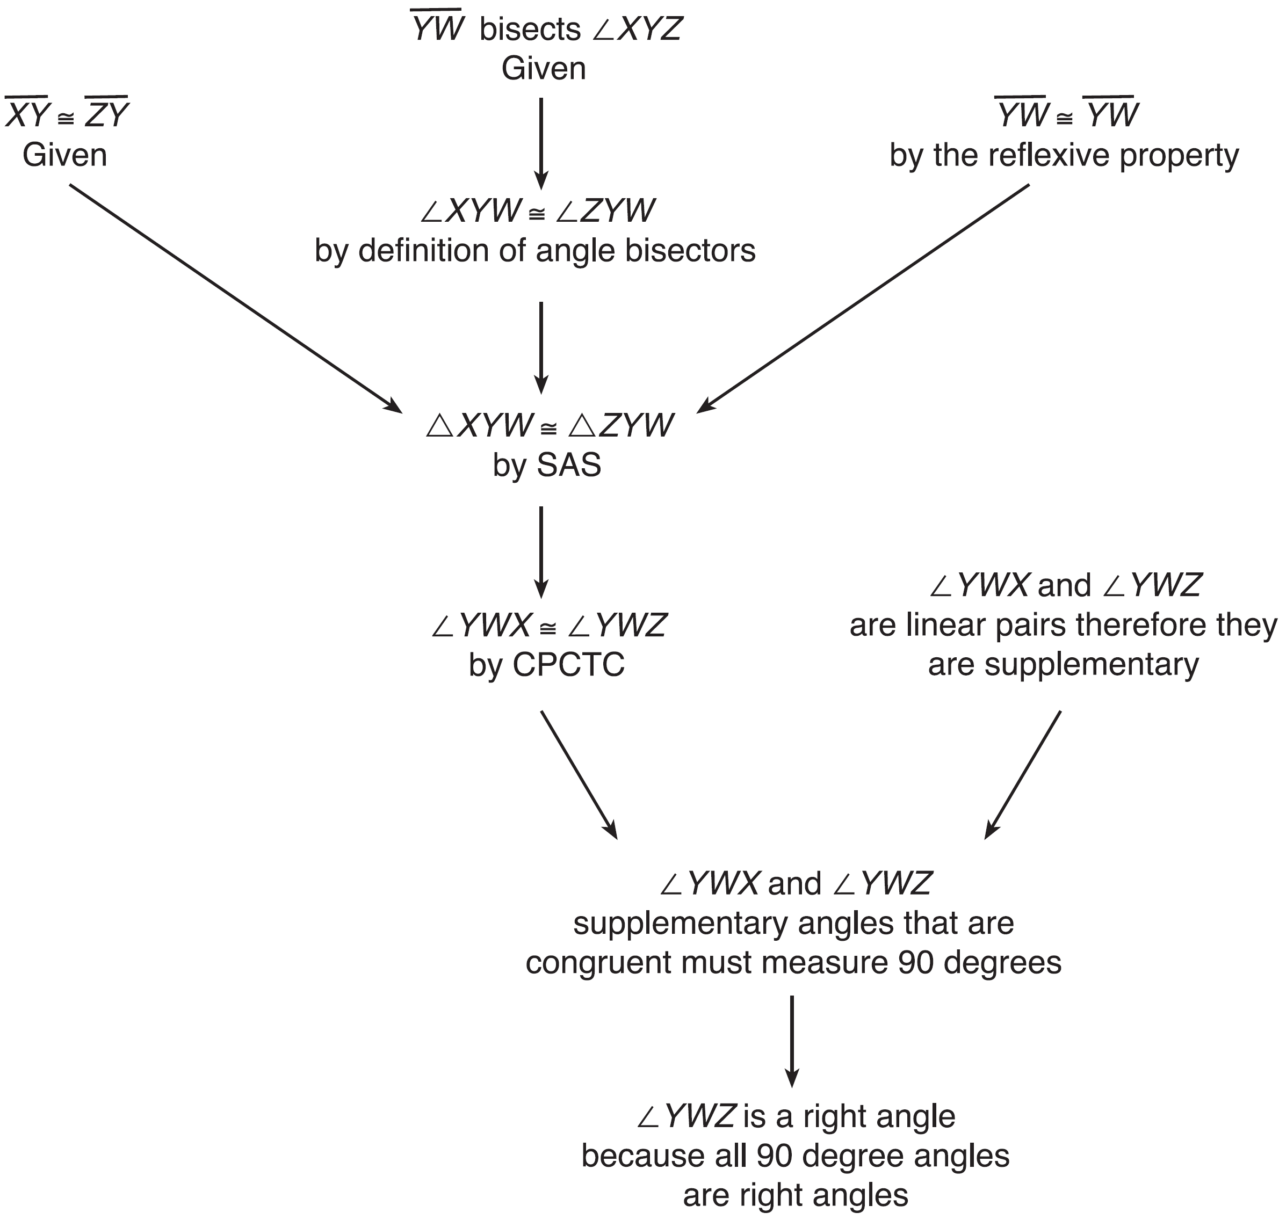 , , and bisects (Given). is isosceles (Definition of isosceles triangle). is an altitude of (The angle bisector of the vertex of an isosceles triangle is also the altitude of that triangle). (Definition of altitude). is a right angle (Definition of perpendicular lines).

REF: spr1411geo

4 ANS:
As the sum of the measures of the angles of a triangle is 180°, . Each interior angle of the triangle and its exterior angle form a linear pair. Linear pairs are supplementary, so , , and . By addition, the sum of these linear pairs is 540°. When the angle measures of the triangle are subtracted from this sum, the result is 360°, the sum of the exterior angles of the triangle.

REF: fall1410geo

5 ANS:
(2) Euclid’s Parallel Postulate; (3) Alternate interior angles formed by parallel lines and a transversal are congruent; (4) Angles forming a line are supplementary; (5) Substitution

REF: 011633geo

