1 In the diagram below of square CASH, diagonals and intersect at Z.

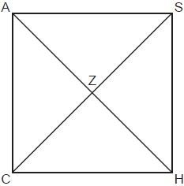

Which statement is true?
1)
2)
3)
4)

2 Which information is not sufficient to prove that a parallelogram is a square?
1) | The diagonals are both congruent and perpendicular.
2) | The diagonals are congruent and one pair of adjacent sides are congruent.
3) | The diagonals are perpendicular and one pair of adjacent sides are congruent.
4) | The diagonals are perpendicular and one pair of adjacent sides are perpendicular.

3 Parallelogram BETH, with diagonals and , is drawn below.

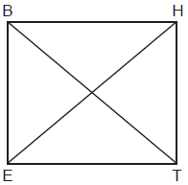

What additional information is sufficient to prove that BETH is a rectangle?
1)
2)
3)
4)

4 If ABCD is a parallelogram, which additional information is sufficient to prove that ABCD is a rectangle?
1)
2)
3)
4)

5 In parallelogram ABCD, diagonals and intersect at E. Which statement proves ABCD is a rectangle?
1)
2)
3)
4) | bisects

6 A parallelogram must be a rectangle when its
1) | diagonals are perpendicular
2) | diagonals are congruent
3) | opposite sides are parallel
4) | opposite sides are congruent

7 A parallelogram is always a rectangle if
1) | the diagonals are congruent
2) | the diagonals bisect each other
3) | the diagonals intersect at right angles
4) | the opposite angles are congruent

8 The diagram below shows parallelogram ABCD with diagonals and intersecting at E.

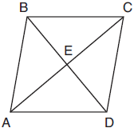

What additional information is sufficient to prove that parallelogram ABCD is also a rhombus?
1) | bisects .
2) | is parallel to .
3) | is congruent to .
4) | is perpendicular to .

9 Parallelogram EATK has diagonals and . Which information is always sufficient to prove EATK is a rhombus?
1)
2)
3)
4)

10 Which congruence statement is sufficient to prove parallelogram MARK is a rhombus?
1)
2)
3)
4)

11 In parallelogram ABCD, diagonals and intersect at E. Which statement does not prove parallelogram ABCD is a rhombus?
1)
2)
3)
4) | bisects

12 If ABCD is a parallelogram, which statement would prove that ABCD is a rhombus?
1)
2)
3)
4)

13 A parallelogram must be a rhombus if its diagonals
1) | are congruent
2) | bisect each other
3) | do not bisect its angles
4) | are perpendicular to each other

14 In quadrilateral TOWN, and . Which additional information is sufficient to prove quadrilateral TOWN is a rhombus?
1)
2)
3)
4) | and bisect each other.

15 Which set of statements would describe a parallelogram that can always be classified as a rhombus?
I. Diagonals are perpendicular bisectors of each other.
II. Diagonals bisect the angles from which they are drawn.
III. Diagonals form four congruent isosceles right triangles.
1) | I and II
2) | I and III
3) | II and III
4) | I, II, and III

16 In rhombus , diagonals and intersect at R. The perimeter of TIGE is 68, and .

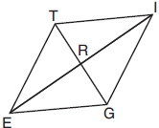

What is the length of diagonal ?
1) | 15
2) | 30
3) | 34
4) | 52

17 In rhombus VENU, diagonals and intersect at S. If and , what is the perimeter of the rhombus?
1) | 80
2) | 40
3) | 20
4) | 10

18 In the diagram of rhombus PQRS below, the diagonals and intersect at point T, , and . Determine and state the perimeter of PQRS.

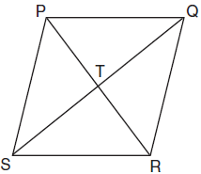

19 In the diagram below, if and is drawn, then it could be proven that quadrilateral ABCD is a

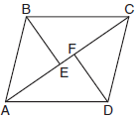
1) | square
2) | rhombus
3) | rectangle
4) | parallelogram

20 A quadrilateral has diagonals that are perpendicular but not congruent. This quadrilateral could be
1) | a square
2) | a rhombus
3) | a rectangle
4) | an isosceles trapezoid

21 Which polygon does not always have congruent diagonals?
1) | square
2) | rectangle
3) | rhombus
4) | isosceles trapezoid

22 Which quadrilateral has diagonals that are always perpendicular?
1) | rectangle
2) | rhombus
3) | trapezoid
4) | parallelogram

1 ANS: 3 REF: 012413geo

2 ANS: 3 REF: 061924geo

3 ANS: 3 REF: 062310geo

4 ANS: 3 REF: 062417geo

5 ANS: 1 REF: 012004geo

6 ANS: 2 REF: 081501geo

7 ANS: 1 REF: 011716geo

8 ANS: 4 REF: 061813geo

9 ANS: 2 REF: 012420geo

10 ANS: 1 REF: 062423geo

11 ANS: 1
1) opposite sides; 2) adjacent sides; 3) perpendicular diagonals; 4) diagonal bisects angle

REF: 061609geo

12 ANS: 3
In (1) and (2), ABCD could be a rectangle with non-congruent sides. (4) is not possible

REF: 081714geo

13 ANS: 4 REF: 011819geo

14 ANS: 1 REF: 012524geo

15 ANS: 4 REF: 061711geo

16 ANS: 2

REF: 061917geo

17 ANS: 2
for one side

REF: 011907geo

18 ANS:
The four small triangles are 8-15-17 triangles.

REF: 081726geo

19 ANS: 4 REF: 011705geo

20 ANS: 2 REF: 082204geo

21 ANS: 3 REF: 012309geo

22 ANS: 2 REF: 082305geo

