1 Steve drew line segments ABCD, EFG, BF, and CF as shown in the diagram below. Scalene is formed.

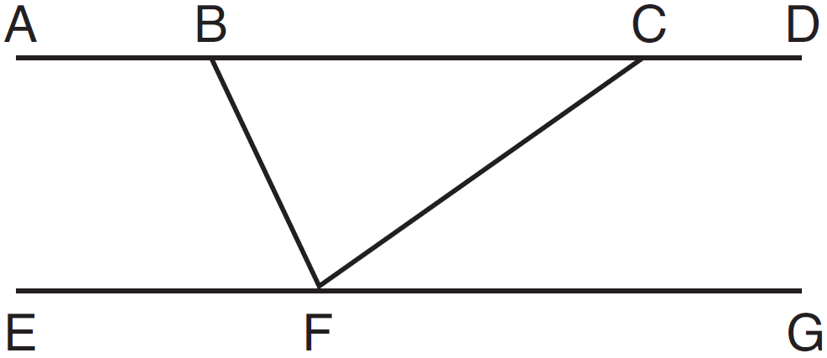

Which statement will allow Steve to prove ?
1)
2)
3)
4)

2 In the diagram below, bisects at B, and bisects at C.

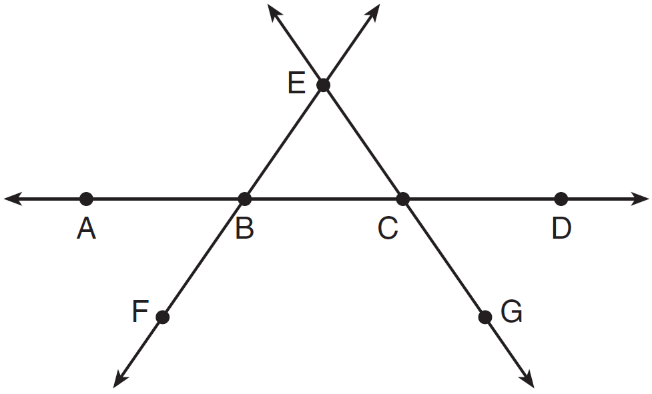

Which statement is always true?
1)
2)
3) | bisects at C.
4) | bisects at B.

3 In the diagram below, lines , m, n, and p intersect line r.

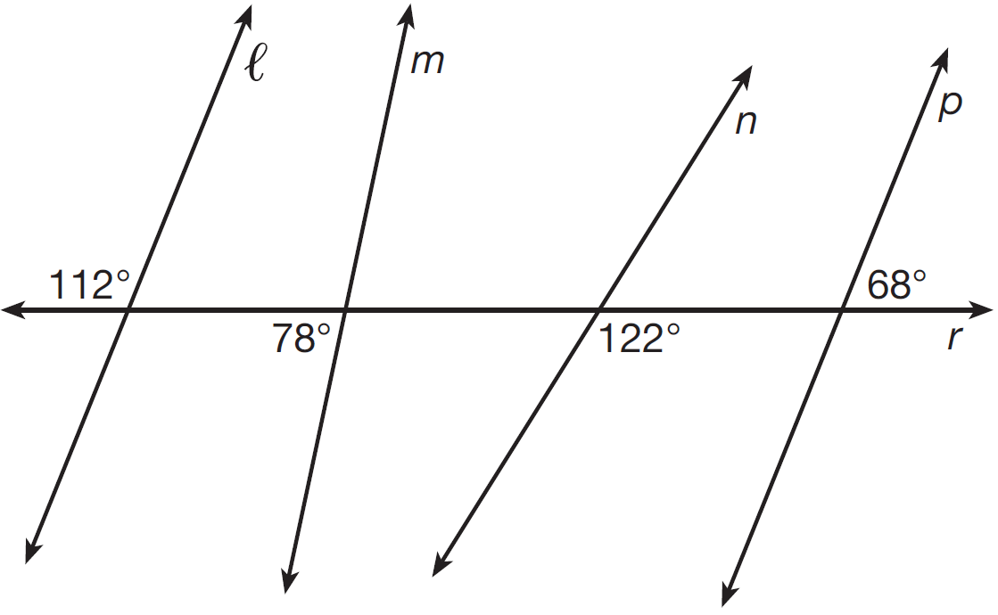

Which statement is true?
1)
2)
3)
4)

4 Segment CD is the perpendicular bisector of at E. Which pair of segments does not have to be congruent?
1)
2)
3)
4)

5 In the diagram below, , and intersect at C, , and .

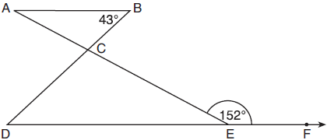

Which statement is true?
1)
2)
3)
4)

6 In the diagram below, and intersect at point C, and and are drawn.

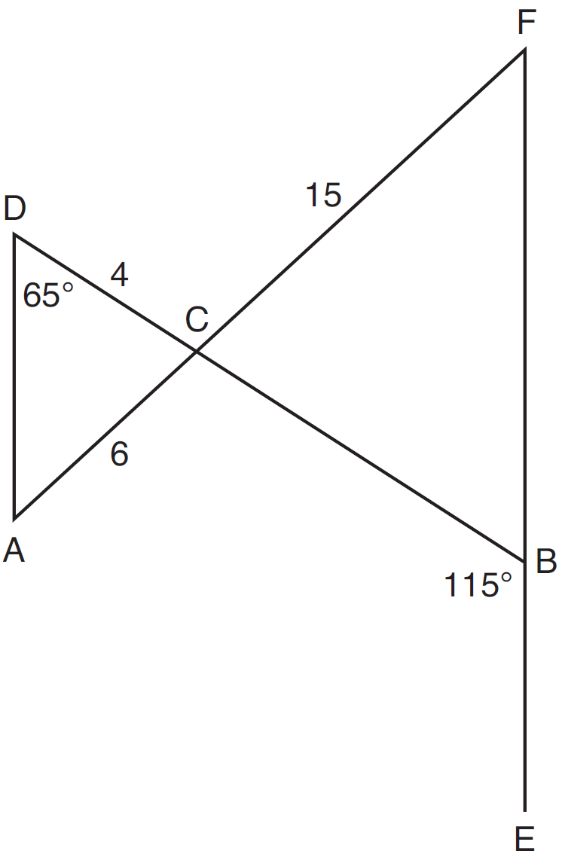

If , , , , and , what is the length of ?
1) | 10
2) | 12
3) | 17
4) | 22.5

7 In the diagram below, , and and are drawn such that .

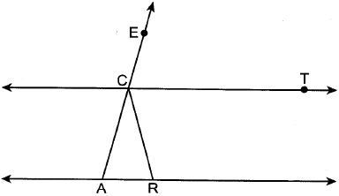

If , what is ?
1) | 30º
2) | 60º
3) | 75º
4) | 105º

8 As shown in the diagram below, and .

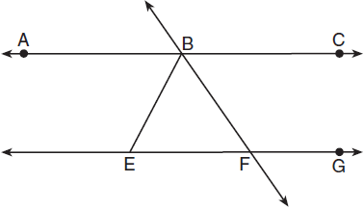

If , then is
1) | 42.5°
2) | 68.75°
3) | 95°
4) | 137.5°

9 In the diagram below, , and and are drawn.

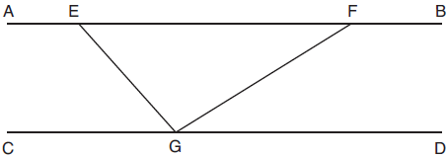

If and , what is ?
1) | 11º
2) | 43º
3) | 75º
4) | 105º

10 In the diagram below, , and and are drawn such that .

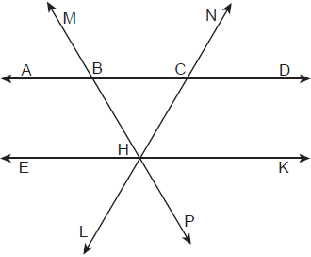

If , what is ?
1) | 118º
2) | 68º
3) | 62º
4) | 56º

11 In the diagram below, , and and are drawn.

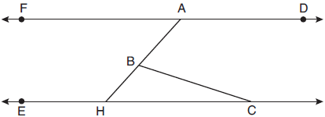

If and , what is ?
1) | 18º
2) | 48º
3) | 66º
4) | 114º

12 As shown in the diagram below, , , and .

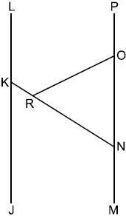

If , what is ?
1) | 58º
2) | 116º
3) | 122º
4) | 128º

13 In the diagram below, , , , and bisects .

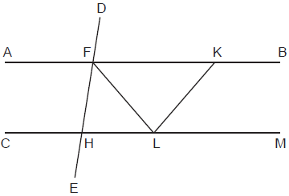

Which statement is always true?
1)
2)
3)
4)

14 In the diagram below, intersects and at G and H, respectively, and is drawn such that .

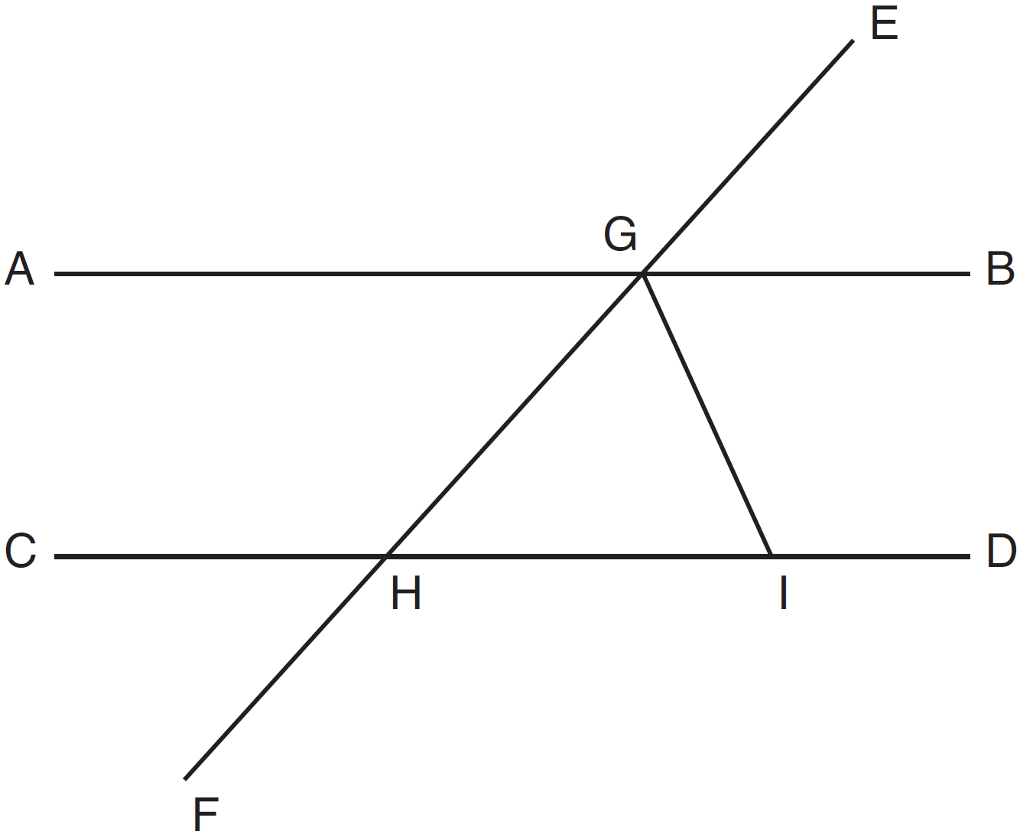

If and , explain why .
1 ANS: 1
Alternate interior angles

REF: 061517geo

2 ANS: 1 REF: 011606geo

3 ANS: 2 REF: 081601geo

4 ANS: 4 REF: 081611geo

5 ANS: 3 REF: 061802geo

6 ANS: 1
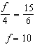

REF: 061617geo

7 ANS: 1

REF: 082407geo

8 ANS: 2
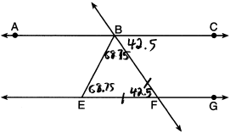

REF: 011818geo

9 ANS: 4 REF: 081801geo

10 ANS: 4
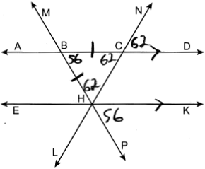

REF: 012421geo

11 ANS: 3

REF: 012001geo

12 ANS: 3
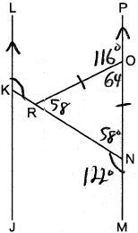

REF: 012513geo

13 ANS: 4 REF: 062318geo

14 ANS:
Since linear angles are supplementary, . Since , . Since , the corresponding angles formed by the transversal and lines are congruent and .

REF: 061532geo

