1 One step in a construction uses the endpoints of to create arcs with the same radii. The arcs intersect above and below the segment. What is the relationship of and the line connecting the points of intersection of these arcs?
1) | collinear
2) | congruent
3) | parallel
4) | perpendicular

2 Line segment AB is shown in the diagram below.
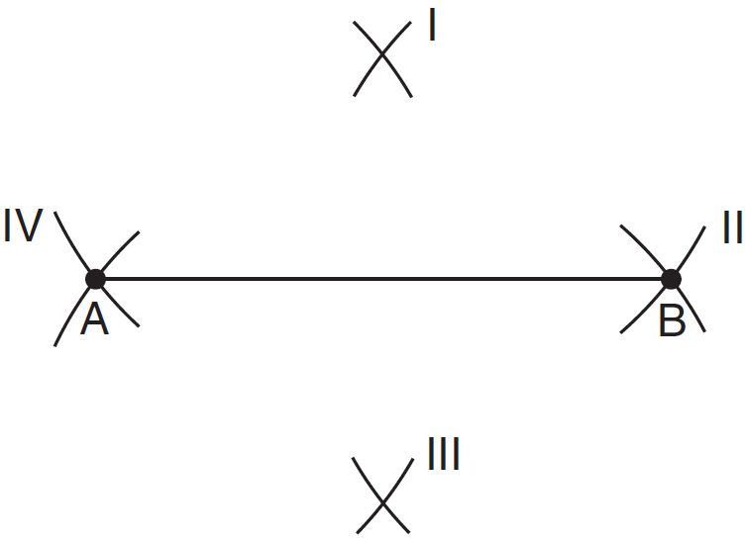
Which two sets of construction marks, labeled I, II, III, and IV, are part of the construction of the perpendicular bisector of line segment AB?
1) | I and II
2) | I and III
3) | II and III
4) | II and IV

3 In the construction shown below, is drawn.
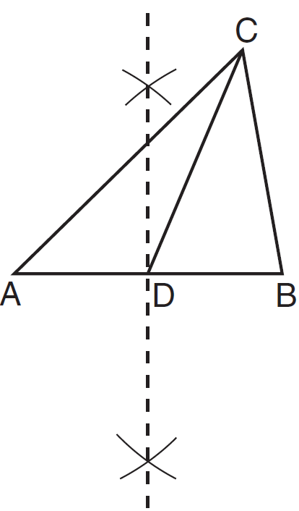
In , is the
1) | perpendicular bisector of side
2) | median to side
3) | altitude to side
4) | bisector of

4 The diagram below shows the construction of the perpendicular bisector of

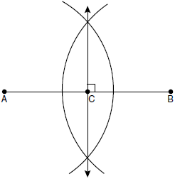

Which statement is not true?
1)
2) | 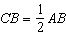
3)
4)

5 Based on the construction below, which conclusion is not always true?

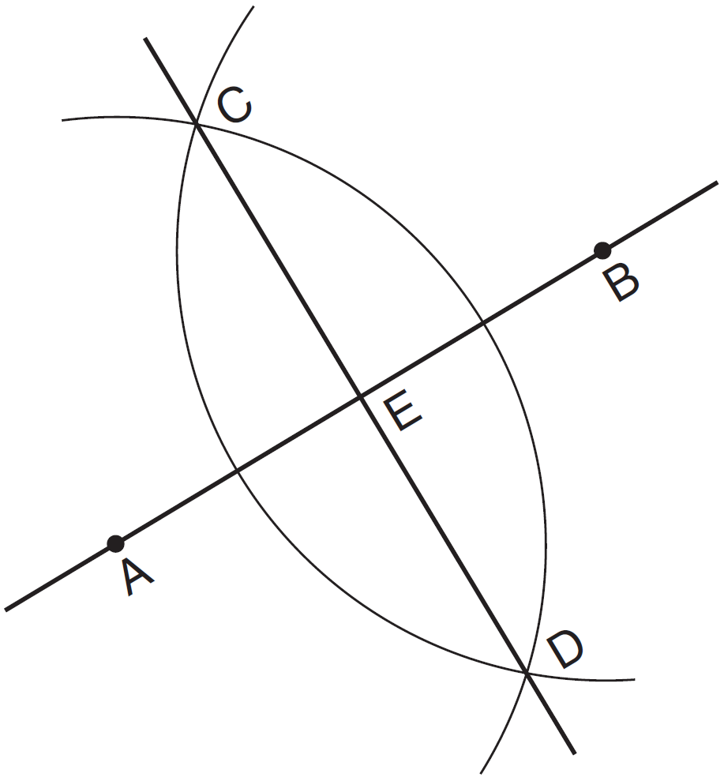
1)
2)
3)
4)

6 Which diagram shows the construction of the perpendicular bisector of ?
1) | 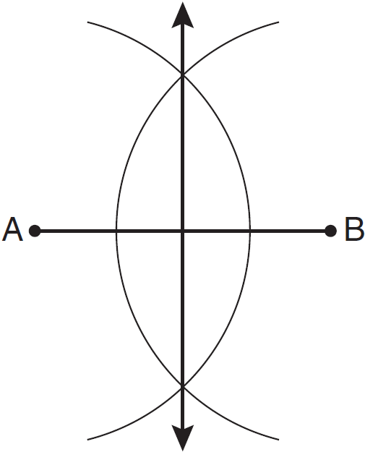
2) | 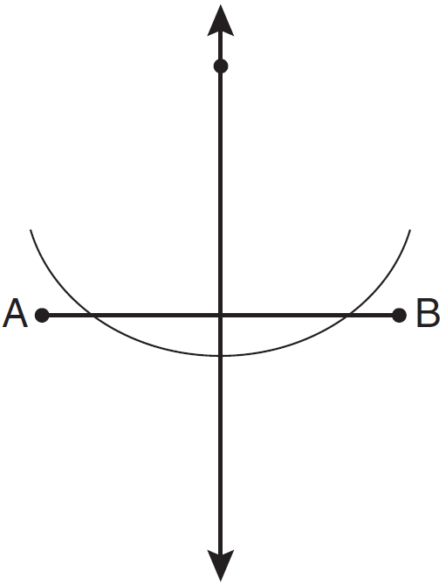
3) | 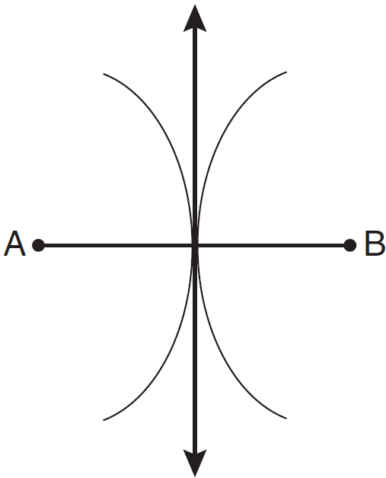
4) | 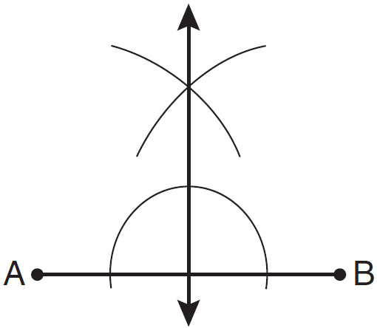

7 Using a compass and straightedge, locate the midpoint of by construction. [Leave all construction marks.]

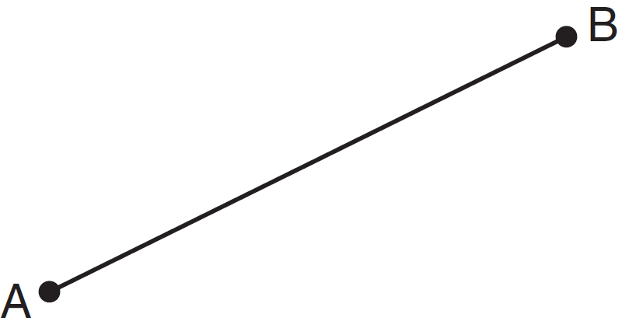

8 Given below, use a compass and a straightedge to construct a segment that is . [Leave all construction marks.]

9 Use a compass and straightedge to divide line segment AB below into four congruent parts. [Leave all construction marks.]

10 Using a compass and straightedge, construct the perpendicular bisector of . [Leave all construction marks.]

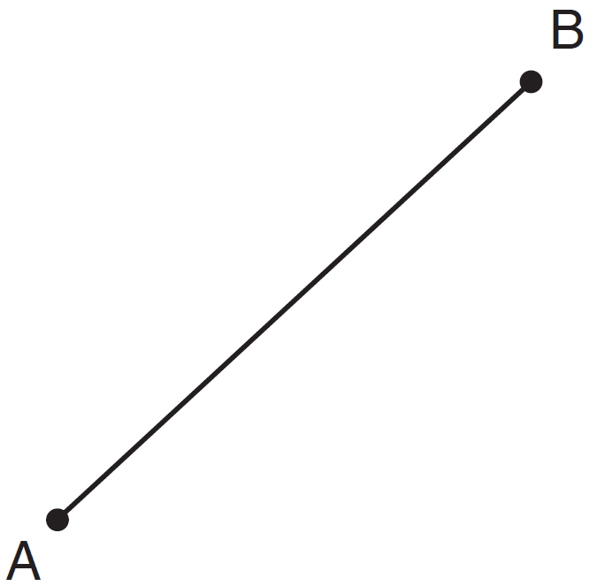

11 Using only a compass and a straightedge, construct the perpendicular bisector of and label it c. [Leave all construction marks.]

12 Using a compass and straightedge, construct the perpendicular bisector of shown below. Show all construction marks.

13 On the diagram of shown below, use a compass and straightedge to construct the perpendicular bisector of . [Leave all construction marks.]

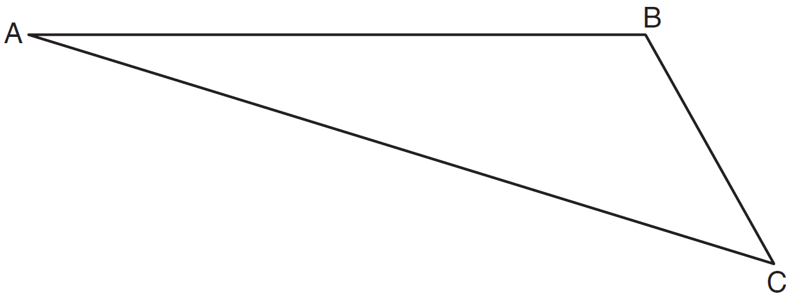

14 Using a compass and straightedge, construct the perpendicular bisector of side in shown below. [Leave all construction marks.]

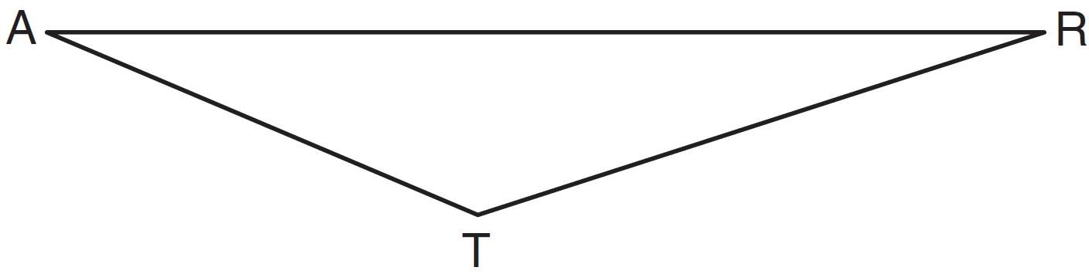

15 Triangle XYZ is shown below. Using a compass and straightedge, construct the circumcenter of .
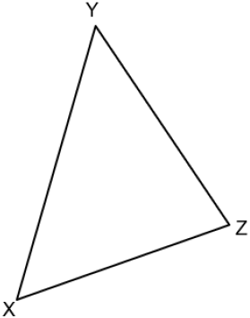

16 In the diagram of shown below, use a compass and straightedge to construct the median to . [Leave all construction marks.]

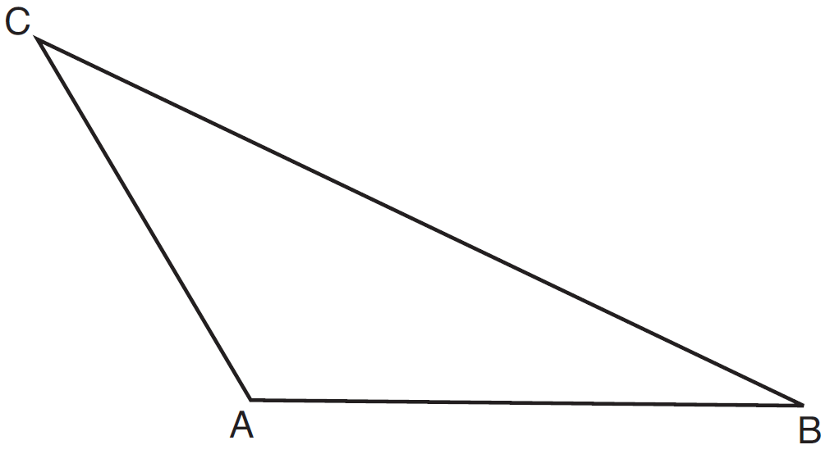

17 On the accompanying diagram of , use a compass and a straightedge to construct a median from A to .

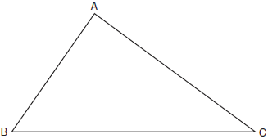

18 Using a compass and straightedge, construct the median to side in below. [Leave all construction marks.]

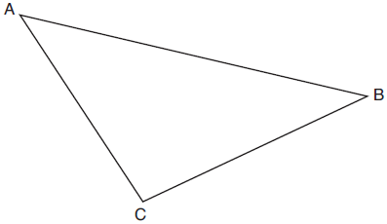

19 Using a compass and straightedge, construct a midsegment of below. [Leave all construction marks.]

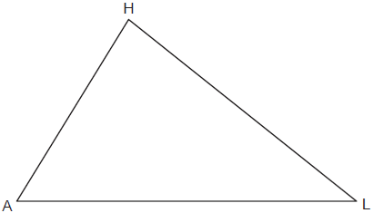

20 Using a compass and straightedge, construct the line of reflection over which triangle RST reflects onto triangle R’S’T’. [Leave all construction marks.]
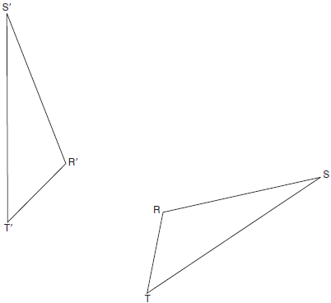

21 Using a compass and straightedge, construct the line of reflection that maps onto its image, . [Leave all construction marks.]

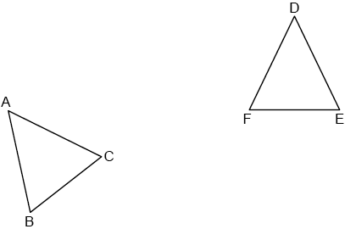
1 ANS: 4 REF: 081005ge

2 ANS: 2 REF: 061101ge

3 ANS: 2 REF: 011628ge

4 ANS: 3 REF: fall0804ge

5 ANS: 2 REF: 061305ge

6 ANS: 1 REF: 011120ge

7 ANS:
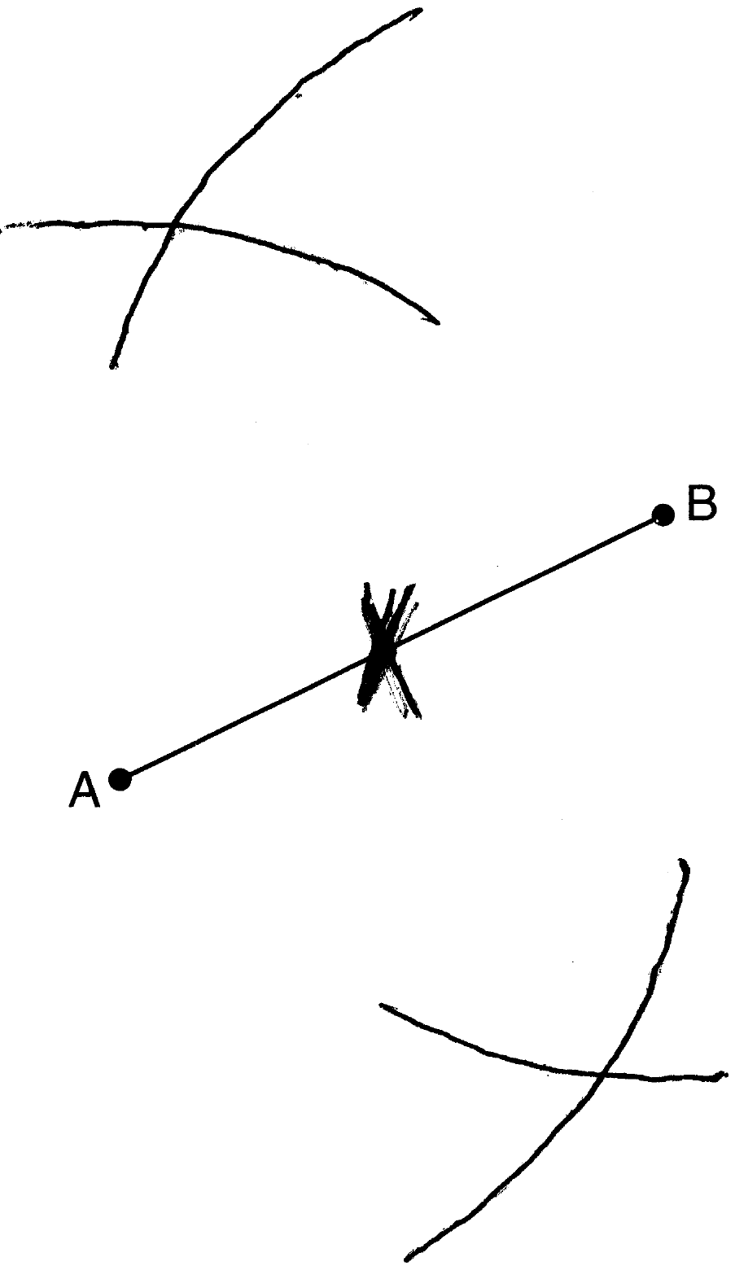

REF: 061532ge

8 ANS:
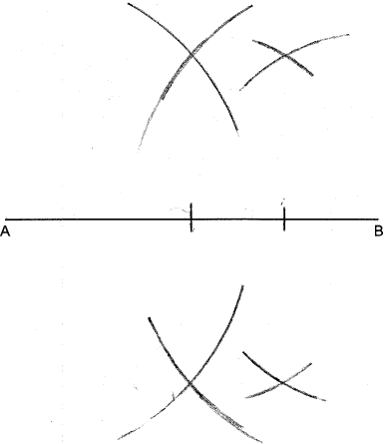

REF: 012526geo

9 ANS:
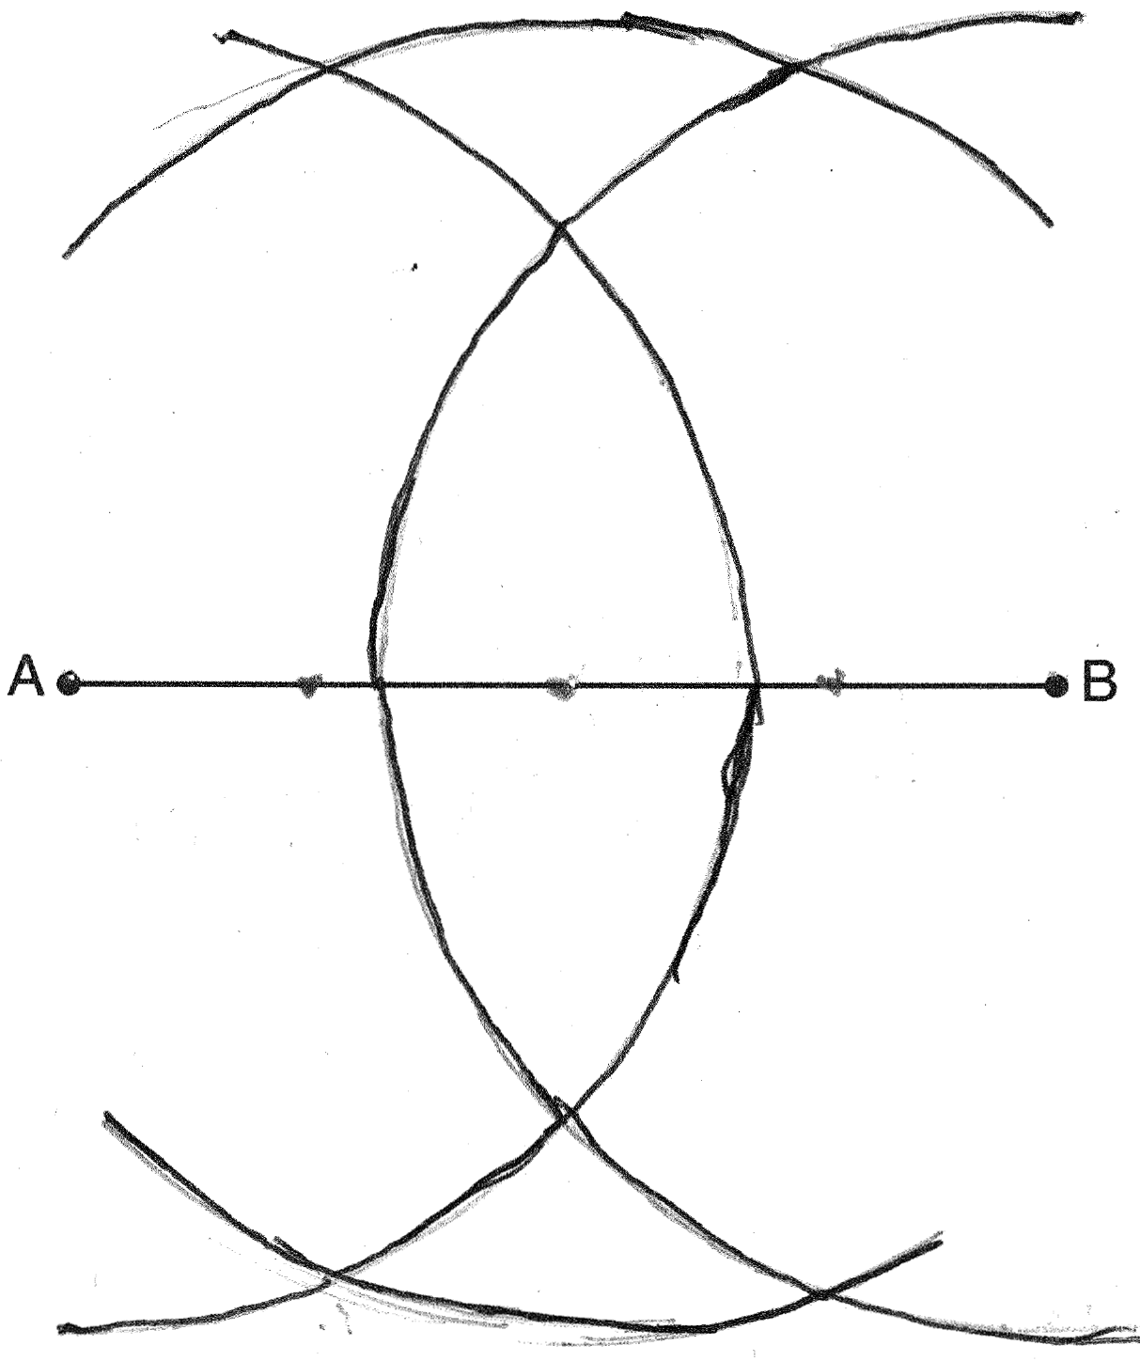

REF: 081437ge

10 ANS:
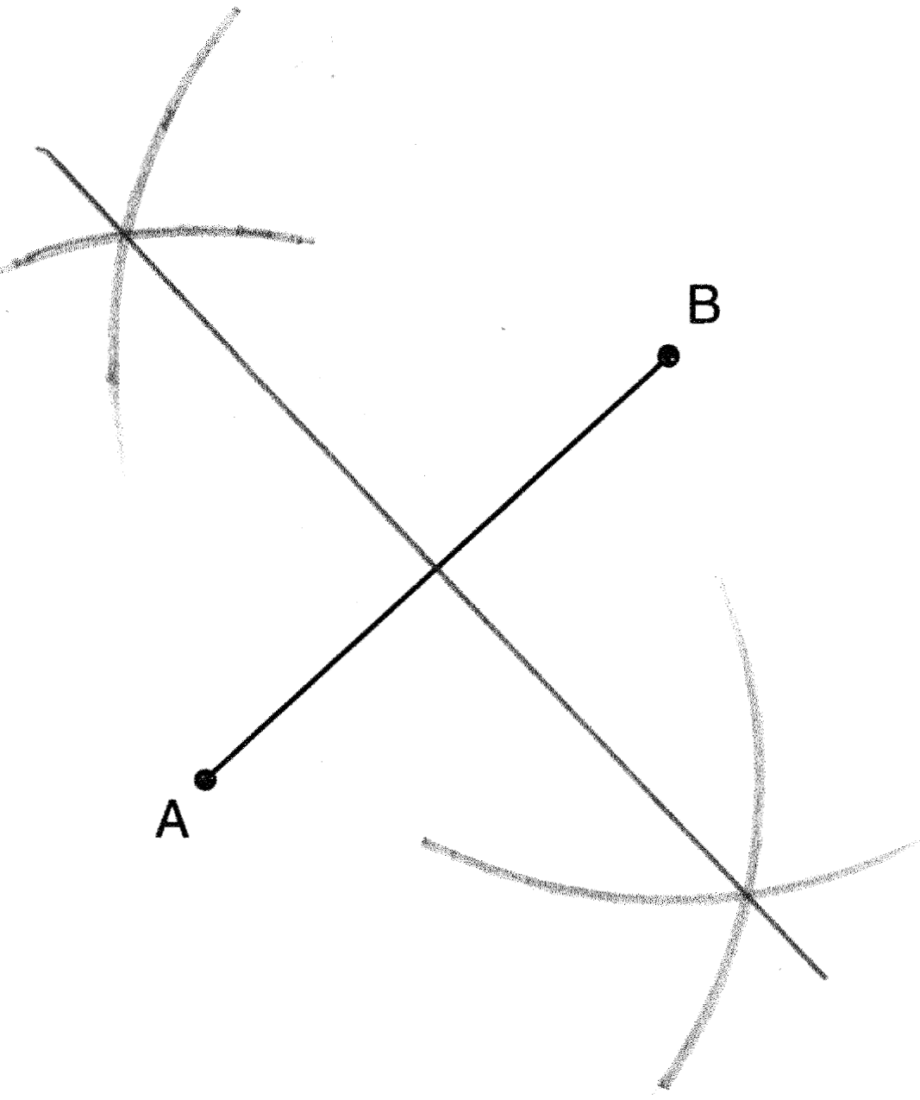

REF: 011430ge

11 ANS:
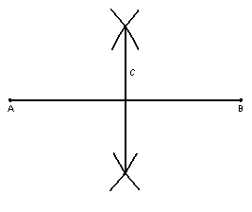

REF: 060435a

12 ANS:
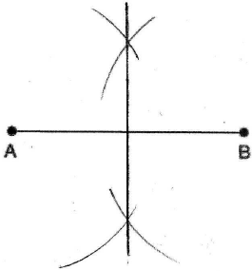

REF: 060734a

13 ANS:
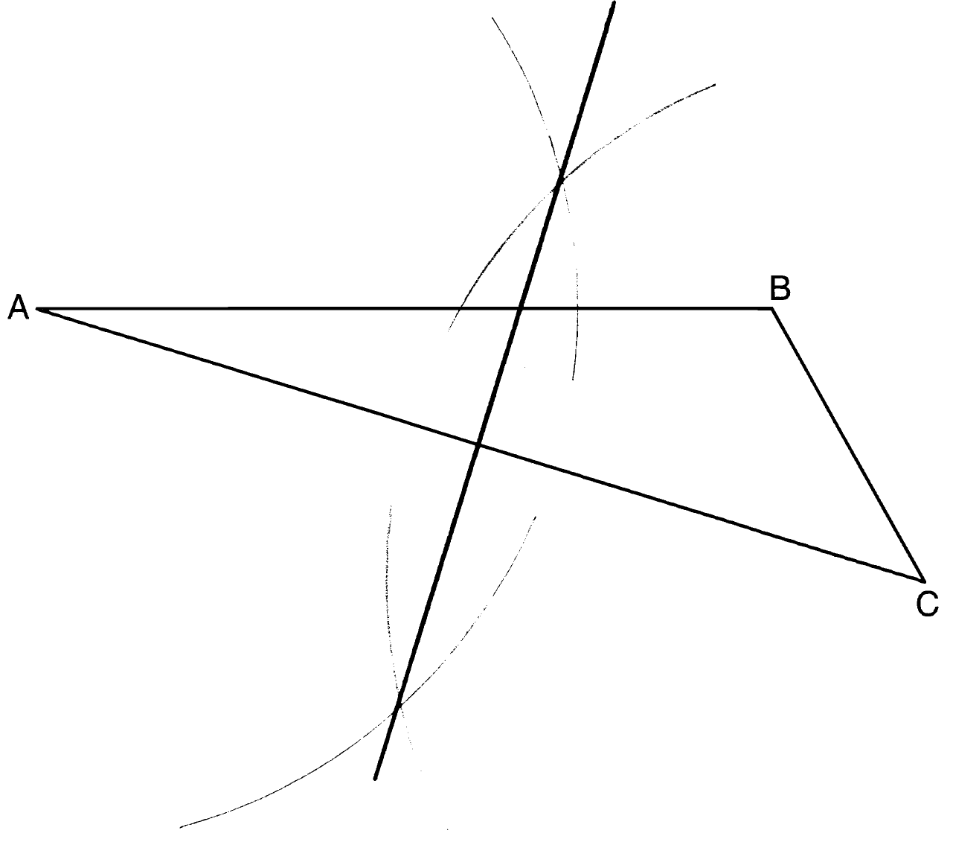

REF: 081130ge

14 ANS:
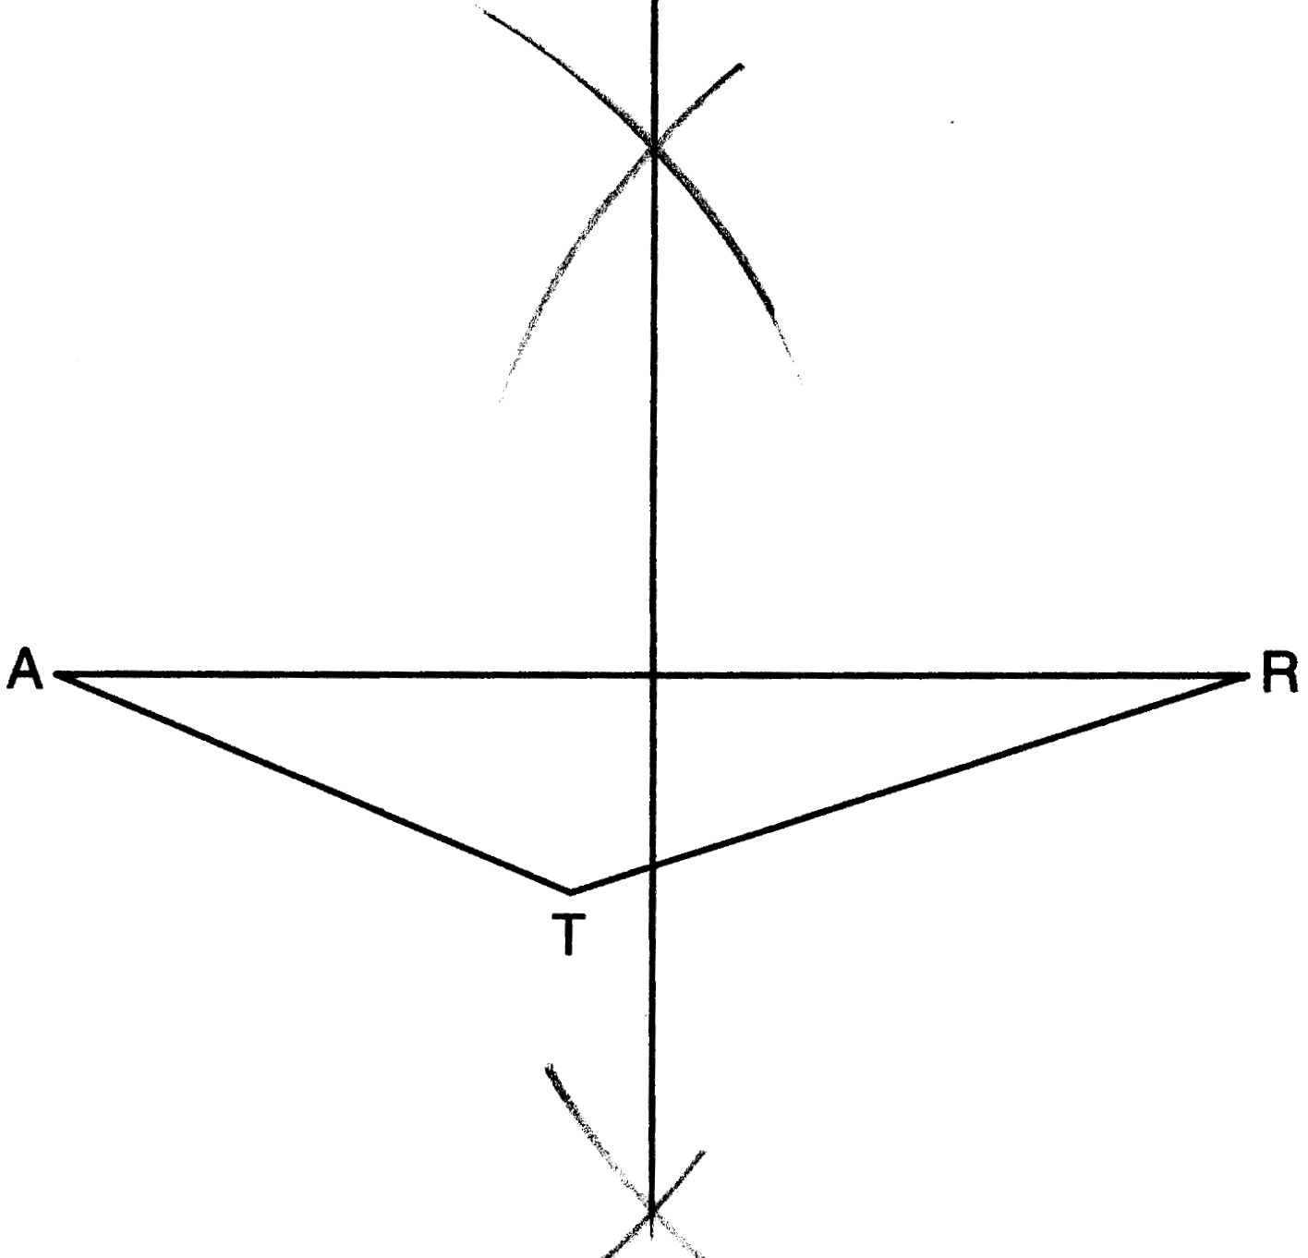

REF: 011530ge

15 ANS:
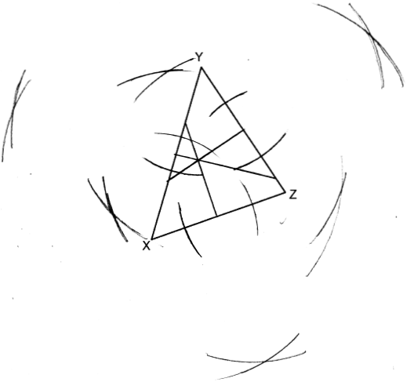

REF: spr2406geo

16 ANS:
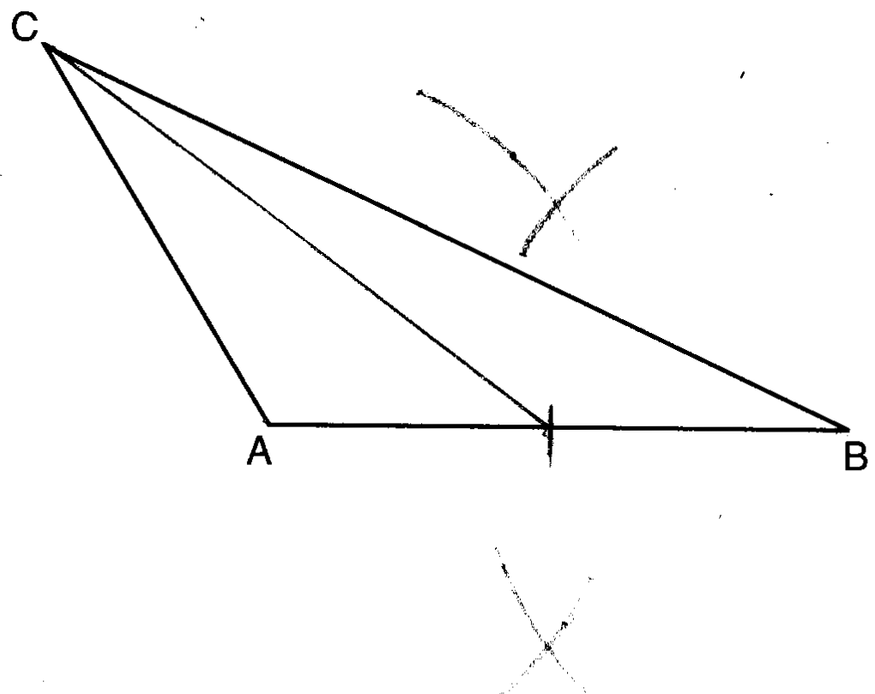

REF: 081628geo

17 ANS:
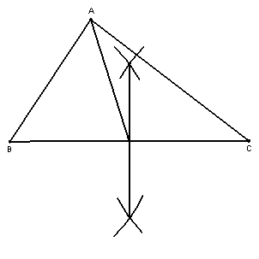

REF: 060325a

18 ANS:
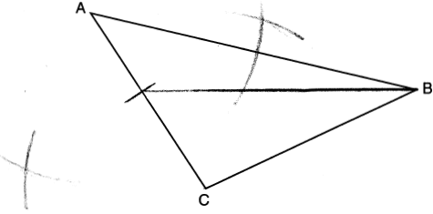

REF: 061829geo

19 ANS:
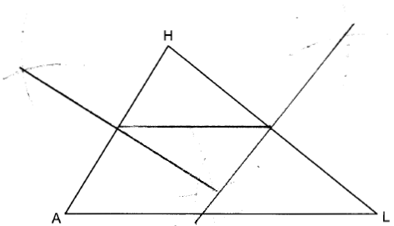

REF: 082329geo

20 ANS:
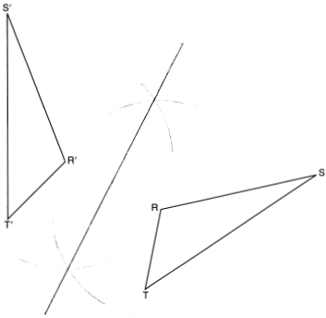

REF: 011725geo

21 ANS:
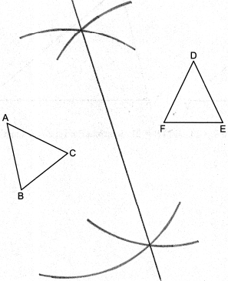

REF: 082426geo

