1 As shown in the diagram below, a regular pyramid has a square base whose side measures 6 inches.

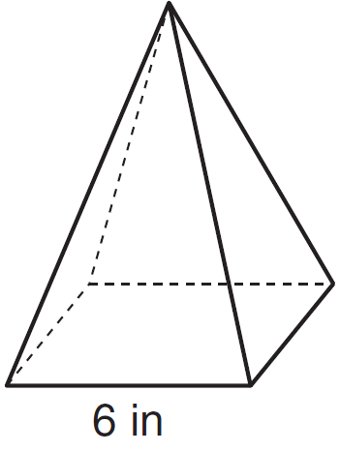

If the altitude of the pyramid measures 12 inches, its volume, in cubic inches, is
1) | 72
2) | 144
3) | 288
4) | 432

2 A regular pyramid has a square base. The perimeter of the base is 36 inches and the height of the pyramid is 15 inches. What is the volume of the pyramid in cubic inches?
1) | 180
2) | 405
3) | 540
4) | 1215

3 A tent is in the shape of a right pyramid with a square floor. The square floor has side lengths of 8 feet. If the height of the tent at its center is 6 feet, what is the volume of the tent, in cubic feet?
1) | 48
2) | 128
3) | 192
4) | 384

4 A child's tent can be modeled as a pyramid with a square base whose sides measure 60 inches and whose height measures 84 inches. What is the volume of the tent, to the nearest cubic foot?
1) | 35
2) | 58
3) | 82
4) | 175

5 The Pyramid of Memphis, in Tennessee, stands 107 yards tall and has a square base whose side is 197 yards long.

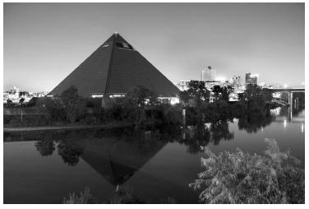

What is the volume of the Pyramid of Memphis, to the nearest cubic yard?
1) | 751,818
2) | 1,384,188
3) | 2,076,212
4) | 4,152,563

6 The pyramid shown below has a square base, a height of 7, and a volume of 84.

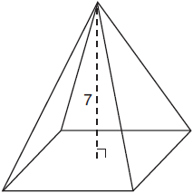

What is the length of the side of the base?
1) | 6
2) | 12
3) | 18
4) | 36

7 The square pyramid drawn below has a volume of 175.

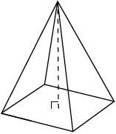

If the height of the pyramid is 21, what is the perimeter of the base?
1) | 5
2) | 10
3) | 20
4) | 25

8 A regular pyramid has a height of 12 centimeters and a square base. If the volume of the pyramid is 256 cubic centimeters, how many centimeters are in the length of one side of its base?
1) | 8
2) | 16
3) | 32
4) | 64

9 The Great Pyramid of Giza was constructed as a regular pyramid with a square base. It was built with an approximate volume of 2,592,276 cubic meters and a height of 146.5 meters. What was the length of one side of its base, to the nearest meter?
1) | 73
2) | 77
3) | 133
4) | 230

10 The base of a pyramid is a rectangle with a width of 4.6 cm and a length of 9 cm. What is the height, in centimeters, of the pyramid if its volume is 82.8 cm³?
1) | 6
2) | 2
3) | 9
4) | 18

11 What is the volume, in cubic centimeters, of a right square pyramid with base edges that are 64 cm long and a slant height of 40 cm?
1) | 8192.0
2)
3) | 32,768.0
4)

12 A regular pyramid with a square base is shown in the diagram below.

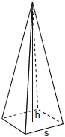

A side, s, of the base of the pyramid is 12 meters, and the height, h, is 42 meters. What is the volume of the pyramid in cubic meters?

13 The base of a pyramid is a rectangle with a width of 6 cm and a length of 8 cm. Find, in centimeters, the height of the pyramid if the volume is .
1 ANS: 2
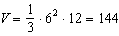

REF: 011607geo

2 ANS: 2
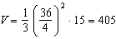

REF: 011822geo

3 ANS: 2
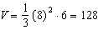

REF: 061906geo

4 ANS: 2
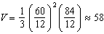

REF: 081819geo

5 ANS: 2
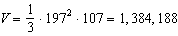

REF: 082208geo

6 ANS: 1
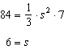

REF: 061716geo

7 ANS: 3
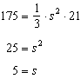

REF: 012516geo

8 ANS: 1
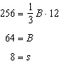

REF: 081428ge

9 ANS: 4
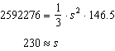

REF: 081521geo

10 ANS: 1
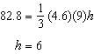

REF: 061810geo

11 ANS: 3
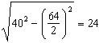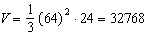

REF: 081921geo

12 ANS:
2016. 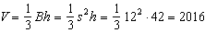

REF: 080930ge

13 ANS:
18. 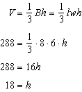

REF: 061034ge

