1 Kevin’s work for deriving the equation of a circle is shown below.
STEP 1
STEP 2
STEP 3
STEP 4
In which step did he make an error in his work?
1) | Step 1
2) | Step 2
3) | Step 3
4) | Step 4

2 The equation is equivalent to
1)
2)
3)
4)

3 The equation is equivalent to
1)
2)
3)
4)

4 What are the coordinates of the center of a circle whose equation is ?
1)
2)
3)
4)

5 The equation of a circle is . What are the coordinates of the center and the length of the radius of the circle?
1) | center and radius 4
2) | center and radius 4
3) | center and radius 16
4) | center and radius 16

6 What are the center and radius of the circle whose equation is ?
1) | and 1
2) | and 1
3) | and 3
4) | and 3

7 The equation of a circle is . What are the coordinates of the center and the length of the radius of the circle?
1) | center and radius 4
2) | center and radius 4
3) | center and radius 16
4) | center and radius 16

8 The equation of a circle is . What are the coordinates of the center and the length of the radius of the circle?
1) | center and radius 3
2) | center and radius 9
3) | center and radius 3
4) | center and radius 9

9 What are the coordinates of the center and the length of the radius of the circle whose equation is ?
1) | center and radius 7.5
2) | center and radius 7.5
3) | center and radius 4.5
4) | center and radius 4.5

10 The equation of a circle is . What are the coordinates of the center and the length of the radius of this circle?
1) | center and radius
2) | center and radius
3) | center and radius
4) | center and radius

11 The equation of a circle is . What are the coordinates of the center and the length of the radius of the circle?
1) | center and radius 12
2) | center and radius 12
3) | center and radius 14
4) | center and radius 14

12 What are the coordinates of the center and length of the radius of the circle whose equation is ?
1) | and 36
2) | and 6
3) | and 36
4) | and 6

13 What are the coordinates of the center and the length of the radius of the circle represented by the equation ?
1) | center and radius 3
2) | center and radius 3
3) | center and radius 9
4) | center and radius 9

14 An equation of circle M is . What are the coordinates of the center and the length of the radius of circle M?
1) | center and radius 9
2) | center and radius 3
3) | center and radius 9
4) | center and radius 3

15 The equation of a circle is . What are the coordinates of the center and the length of the radius of the circle?
1) | center and radius 4
2) | center and radius 4
3) | center and radius 16
4) | center and radius 16

16 What are the coordinates of the center and length of the radius of the circle whose equation is ?
1) | center and radius 4
2) | center and radius 4
3) | center and radius 16
4) | center and radius 16

17 What are the coordinates of the center and the length of the radius of the circle whose equation is ?
1) | center and radius 64
2) | center and radius 64
3) | center and radius 8
4) | center and radius 8

18 The equation of a circle is . What are the coordinates of the center and the length of the radius?
1) | center and radius 5
2) | center and radius 5
3) | center and radius 25
4) | center and radius 25

19 If is the equation of a circle, the length of the radius is
1) | 25
2) | 16
3) | 5
4) | 4

20 What is the length of the radius of the circle whose equation is ?
1)
2)
3) | 5
4) | 10

21 An equation of circle O is . The statement that best describes circle O is the
1) | center is and is tangent to the x-axis
2) | center is and is tangent to the y-axis
3) | center is and is tangent to the x-axis
4) | center is and is tangent to the y-axis

22 Determine and state the coordinates of the center and the length of the radius of the circle represented by the equation .

23 The equation of a circle is . Determine and state the coordinates of the center and the length of the radius of the circle.

24 Determine and state the coordinates of the center and the length of the radius of a circle whose equation is .

25 Determine and state the coordinates of the center and the length of the radius of the circle whose equation is .
1 ANS: 2 REF: 061603geo

2 ANS: 2
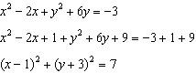

REF: 061016a2

3 ANS: 4
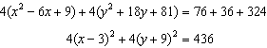

REF: 061619aii

4 ANS: 3
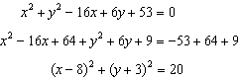

REF: 011415a2

5 ANS: 2
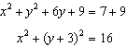

REF: 061514geo

6 ANS: 4
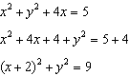

REF: 081626a2

7 ANS: 1
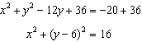

REF: 061712geo

8 ANS: 3
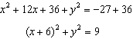

REF: 082313geo

9 ANS: 1
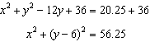

REF: 082219geo

10 ANS: 1
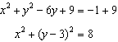

REF: 011718geo

11 ANS: 4
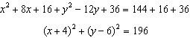

REF: 061920geo

12 ANS: 4
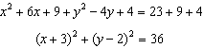

REF: 011617geo

13 ANS: 1
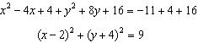

REF: 081616geo

14 ANS: 4
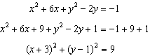

REF: 062309geo

15 ANS: 2
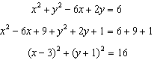

REF: 011812geo

16 ANS: 2
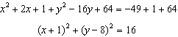

REF: 012314geo

17 ANS: 4
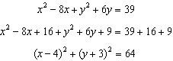

REF: 081906geo

18 ANS: 1
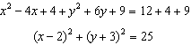

REF: 012506geo

19 ANS: 3
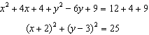

REF: 081509geo

20 ANS: 2
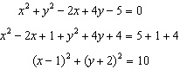

REF: 082416geo

21 ANS: 4
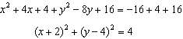

REF: 081821geo

22 ANS:
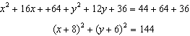

REF: 012430geo

23 ANS:
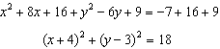

REF: 062429geo

24 ANS:
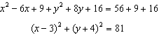

REF: 081731geo

25 ANS:
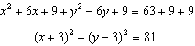

REF: 062230geo

