1 Which equation represents the set of points equidistant from line and point R shown on the graph below?
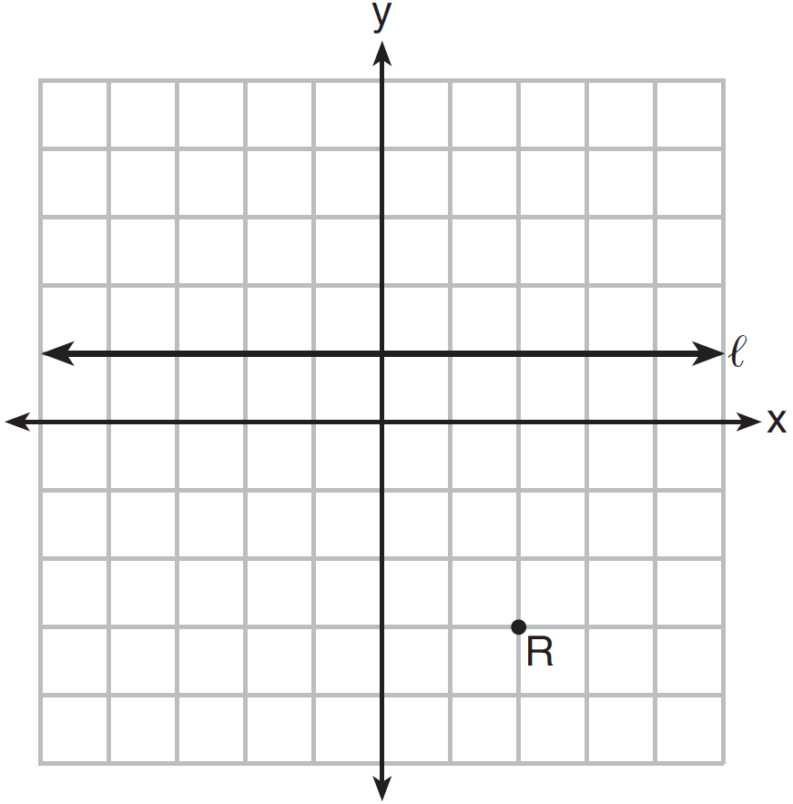
1) | 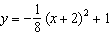
2) | 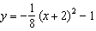
3) | 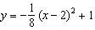
4) | 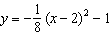

2 Which equation represents a parabola with the focus at and the directrix of ?
1)
2)
3)
4)

3 If the focus of a parabola is and the directrix is , what is an equation for the parabola?
1)
2)
3)
4)

4 Which equation represents a parabola with a focus of and a directrix of ?
1)
2)
3) | 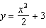
4) | 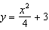

5 A parabola has its focus at and its directrix is . The equation of this parabola could be
1)
2) | 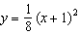
3)
4) | 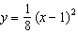

6 The equation of the parabola that has its focus at the point and directrix at is
1) | 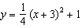
2) | 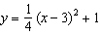
3) | 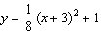
4) | 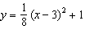

7 Which equation represents the equation of the parabola with focus and directrix ?
1) | 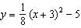
2) | 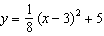
3) | 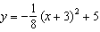
4) | 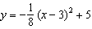

8 Which equation represents a parabola with a focus of and directrix of ?
1)
2)
3)
4)

9 A parabola that has a vertex at and a focus of has an equation of
1) | 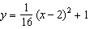
2) | 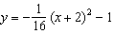
3) | 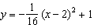
4) | 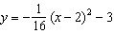

10 Which equation represents a parabola with a focus of and a directrix of ?
1)
2)
3)
4)

11 What is the equation of the directrix for the parabola ?
1)
2)
3)
4)

12 What is the focus of the parabola ?
1)
2)
3)
4)

13 A parabola has a directrix of and a vertex at . Which ordered pair is the focus of the parabola?
1)
2)
3)
4)

14 The parabola described by the equation 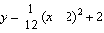 has the directrix at . The focus of the parabola is
1)
2)
3)
4)

15 The parabola with equation has
1) | a vertex at
2) | a focus at
3) | a directrix
4) | four units between the focus and vertex

16 The directrix of the parabola has the equation . Find the coordinates of the focus of the parabola.

17 Consider the parabola given by 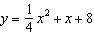 with vertex and focus . Use this information to explain how to determine the equation of the directrix.

18 The parabola 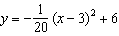 has its focus at . Determine and state the equation of the directrix. (The use of the grid below is optional.)

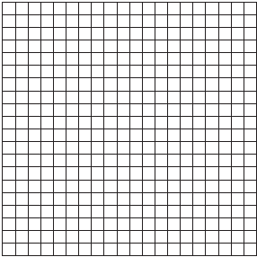

19 Determine an equation for the parabola with focus and directrix . (Use of the grid below is optional.)

20 Determine an equation for the parabola with focus and directrix . (The use of the grid below is optional.)

1 ANS: 4
The vertex is and . 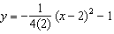

REF: 081619aii

2 ANS: 2
The vertex of the parabola is . The distance, p, between the vertex and the focus or the vertex and the directrix is 1. 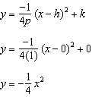

REF: 081706aii

3 ANS: 2
Since the distance from the focus to the directrix is 2, and the vertex of the parabola is . 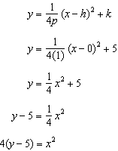

REF: 062323aii

4 ANS: 4
A parabola with a focus of and a directrix of is sketched as follows: 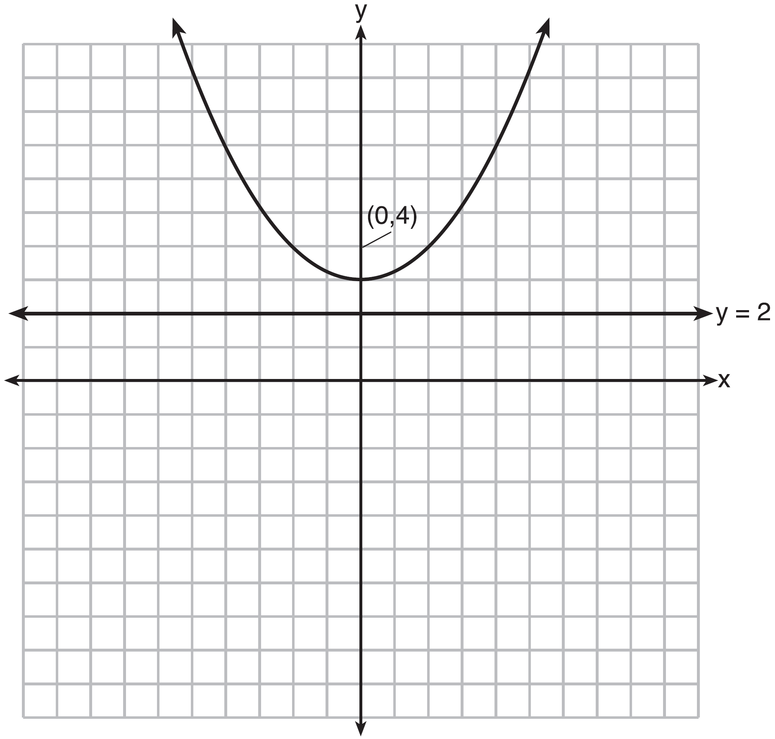By inspection, it is determined that the vertex of the parabola is . It is also evident that the distance, p, between the vertex and the focus is 1. It is possible to use the formula to derive the equation of the parabola as follows: 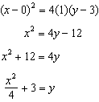
or A point on the parabola must be the same distance from the focus as it is from the directrix. For any such point , the distance to the focus is and the distance to the directrix is . Setting this equal leads to: 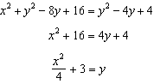

REF: spr1502aii

5 ANS: 4
The vertex is and . 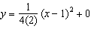

REF: 061717aii

6 ANS: 1
Distance from the focus to the directrix is 2, so . Vertex is . 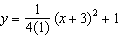

REF: 012409aii

7 ANS: 3
The vertex is and . 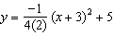

REF: 011914aii

8 ANS: 4
The distance between the focus and directrix is . p is half this distance, or 2. The vertex of the parabola is . Since the directrix is above the focus, the parabola faces downward. 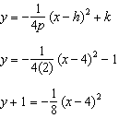

REF: 012322aii

9 ANS: 3
The distance from the vertex to the focus, p, is 4. Since the focus is below the vertex, p is negative. 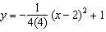

REF: 082212aii

10 ANS: 4
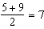, vertex: ; , 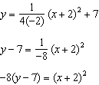

REF: 061821aii

11 ANS: 1
In vertex form, the parabola is 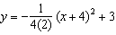. The vertex is and .

REF: 011816aii

12 ANS: 1
In vertex form, the parabola is 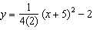. The vertex is and .

REF: 082416aii

13 ANS: 1
The vertical distance from the directrix to the vertex, p, is 2. The vertical distance from the vertex to the focus must also be 2.

REF: 062213aii

14 ANS: 4
The vertex is and .

REF: 081823aii

15 ANS: 3
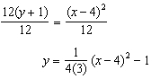 The vertex is and , so the focus is .

REF: 062423aii

16 ANS:
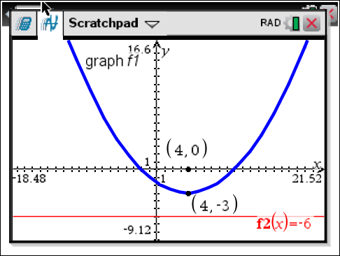 The vertex of the parabola is . The x-coordinate of the focus and the vertex is the same. Since the distance from the vertex to the directrix is 3, the distance from the vertex to the focus is 3, so the y-coordinate of the focus is 0. The coordinates of the focus are .

REF: 061630aii

17 ANS:
p is the distance from the focus to the vertex: . p is the distance from the directrix to the vertex: 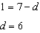.

REF: 082330aii

18 ANS:
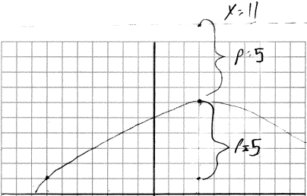 vertex , focus , , directrix

REF: 012028aii

19 ANS:
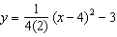 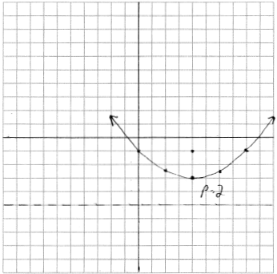 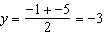. The vertex is and .

REF: 061935aii

20 ANS:
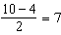, so the vertex is and . 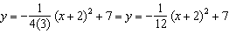 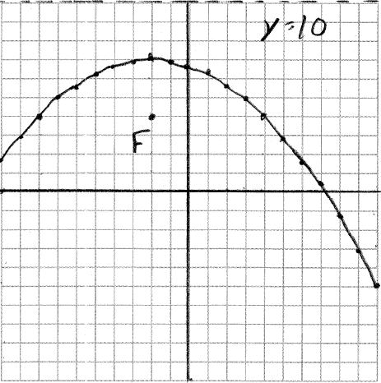

REF: 012535aii

