1 In the diagram below of , Q is a point on , S is a point on , is drawn, and .
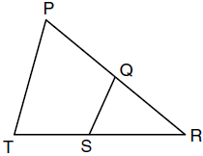
Which reason justifies the conclusion that ?
1) | AA
2) | ASA
3) | SAS
4) | SSS

2 In the diagram of and below, and intersect at C, and .
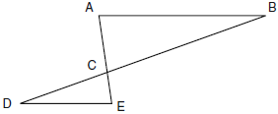
Which method can be used to show that must be similar to ?
1) | SAS
2) | AA
3) | SSS
4) | HL

3 In the diagram below, and intersect at T, is drawn, and .
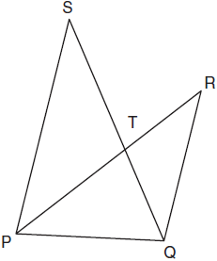
What technique can be used to prove that ?
1) | SAS
2) | SSS
3) | ASA
4) | AA

4 In triangles ABC and DEF, , , , , and . Which method could be used to prove ?
1) | AA
2) | SAS
3) | SSS
4) | ASA

5 In the diagram below of , D and E are the midpoints of and , respectively, and is drawn.

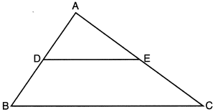

I. AA similarity
II. SSS similarity
III. SAS similarity
Which methods could be used to prove ?
1) | I and II, only
2) | II and III, only
3) | I and III, only
4) | I, II, and III

6 In the diagram below, , , and and are drawn.

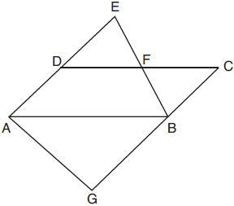

Which statement is always true?
1)
2)
3)
4)

7 In the diagram below, , , , , and .

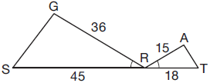

Which triangle similarity statement is correct?
1) | by AA.
2) | by SAS.
3) | by SSS.
4) | is not similar to .

8 In and , 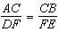. Which additional information would prove ?
1)
2)
3)
4)

9 For which diagram is the statement not always true??
1) | 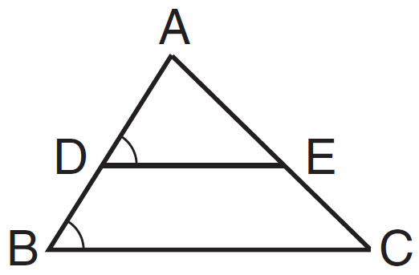
2) | 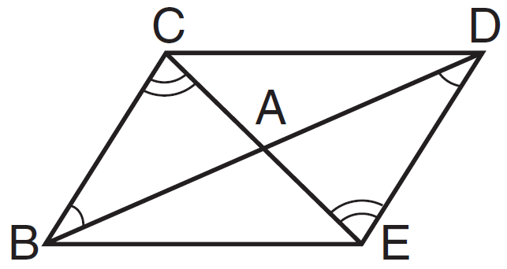
3) | 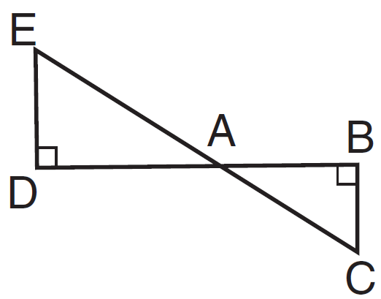
4) | 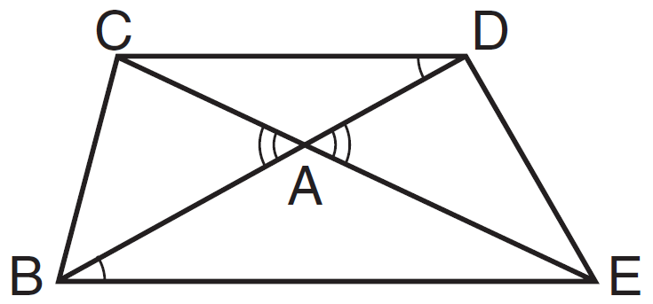

10 In the diagram below, is the image of after a transformation.

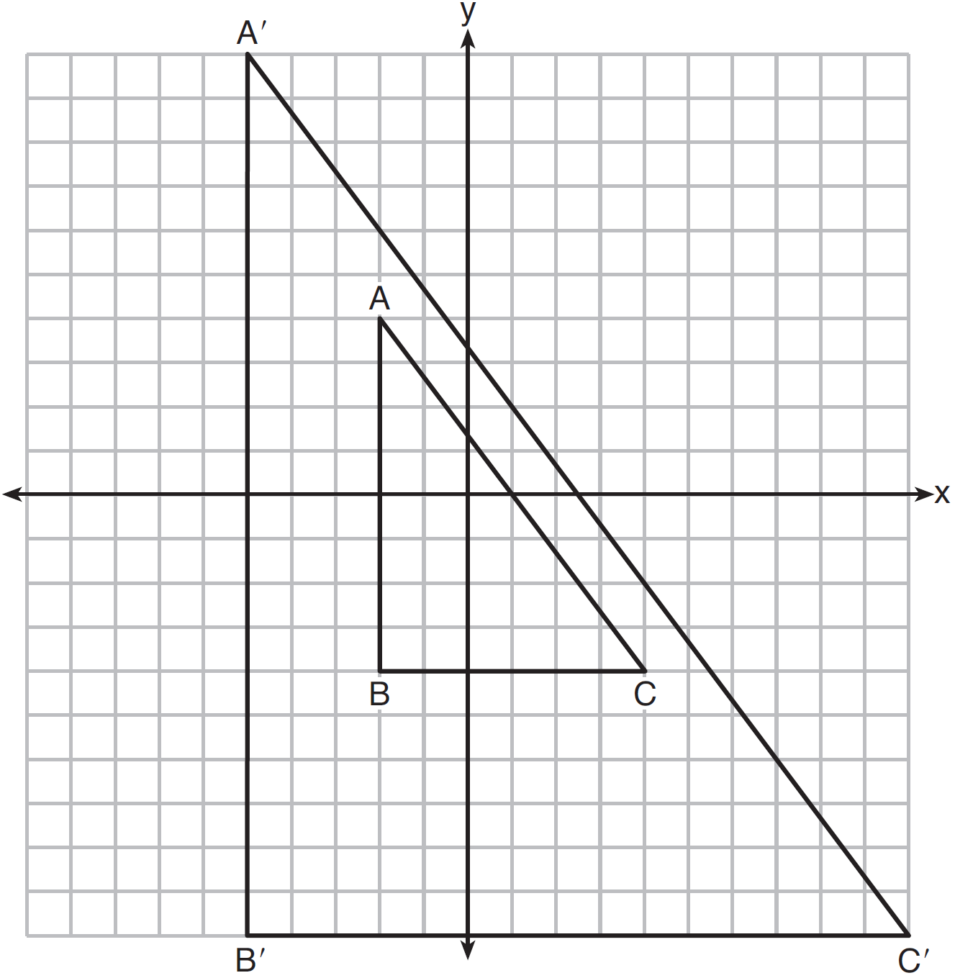

Describe the transformation that was performed. Explain why .

11 In the diagram below, , , , and . Prove that .

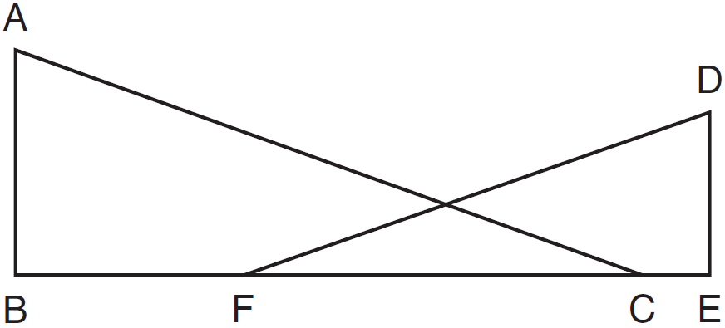

12 The diagram below shows , with , , and . Prove that is similar to .

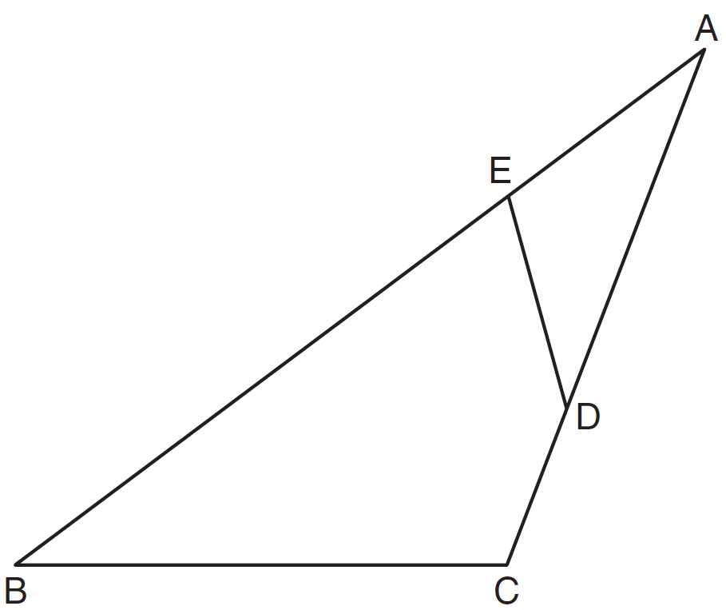

13 In the diagram below, is parallel to , and intersects at A.

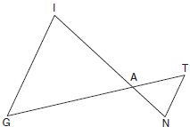

Prove:

14 Given: Parallelogram ABCD, , and diagonal

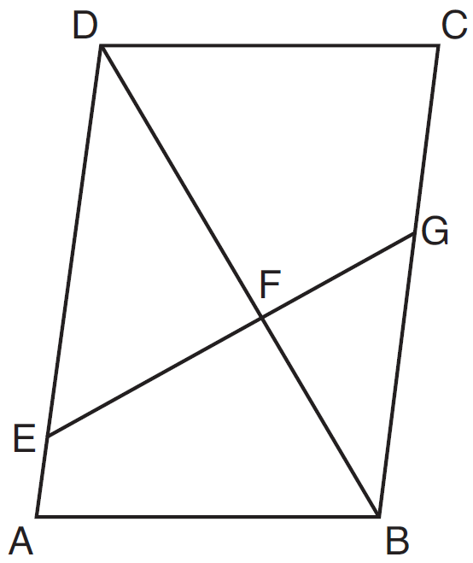

Prove:

15 Given: with , , and

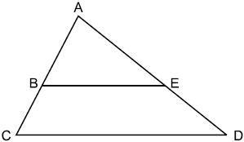

Prove:

16 In the accompanying diagram, and and intersect at point T. Prove that .

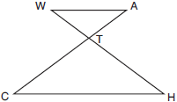

17 In the diagram below of quadrilateral FACT, intersects diagonal at E, , and .

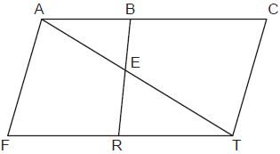

Prove:

1 ANS: 1
and share and it is given that .

REF: fall0821ge

2 ANS: 2
and are congruent vertical angles and . 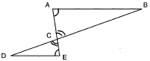

REF: 060917ge

3 ANS: 4 REF: 011019ge

4 ANS: 2 REF: 061324ge

5 ANS: 4
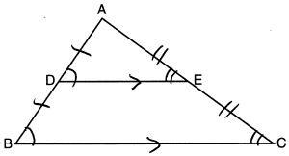 AA from diagram; SSS as the three corresponding sides are proportional; SAS as two corresponding sides are proportional and an angle is equal.

REF: 012324geo

6 ANS: 4
AA

REF: 061809geo

7 ANS: 4
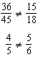

REF: 081709geo

8 ANS: 3 REF: 011209ge

9 ANS: 4 REF: 011528ge

10 ANS:
A dilation of about the origin. Dilations preserve angle measure, so the triangles are similar by AA.

REF: 061634geo

11 ANS:
and are right angles because of the definition of perpendicular lines. because all right angles are congruent. and are supplementary and and are supplementary because of the definition of supplementary angles. because angles supplementary to congruent angles are congruent. because of AA.

REF: 011136ge

12 ANS:
is given. because of the reflexive property. Therefore because of AA.

REF: 081133ge

13 ANS:
is parallel to , and intersects at A (given); , (paralleling lines cut by a transversal form congruent alternate interior angles); (AA).

REF: 011729geo

14 ANS:
Parallelogram ABCD, , and diagonal (given); (vertical angles); (opposite sides of a parallelogram are parallel); (alternate interior angles are congruent); (AA).

REF: 061633geo

15 ANS:
1) with , , and (Given); 2) and (A transversal crossing parallel lines creates congruent corresponding angles; 3) (AA); 4) 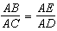 (Corresponding sides of similar triangles are proportional); 5) (Product of the means equals the product of the extremes)
REF: 012534geo

16 ANS:
and are congruent vertical angles. Since , and are alternate interior angles and congruent and and are alternate interior angles and congruent. Therefore by AA. Because corresponding sides of similar triangles are in proportion, 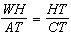. Cross-multiplying, . 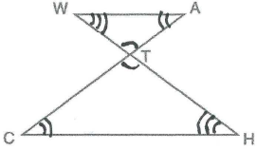
REF: 010833b

17 ANS:
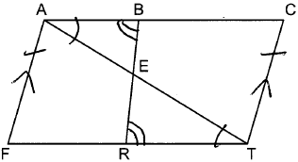 Quadrilateral FACT, intersects diagonal at E, , and (Given); FACT is a parallelogram (A quadrilateral with one pair of opposite sides parallel and congruent is a parallelogram); (Opposite sides of a parallelogram are parallel); (Parallel lines cut by a transversal form alternate interior angles that are congruent); (AA); 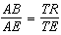 (Corresponding sides of similar triangles are proportional); (Product of the means equals the product of the extremes).
REF: 082335geo

