1 In the diagram shown below, altitude is drawn to the hypotenuse of right triangle ABC.

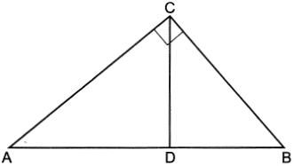

Which equation can always be used to find the length of ?
1) | 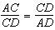
2) | 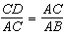
3) | 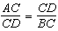
4) | 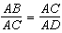

2 In right triangle RST below, altitude is drawn to hypotenuse .

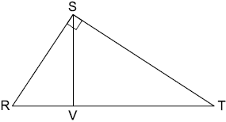

Which statement is always true?
1) | 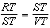
2) | 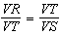
3) | 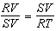
4) | 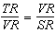

3 In right triangle SNO below, altitude is drawn to hypotenuse .

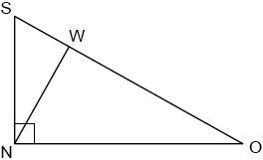

Which statement is not always true?
1) | 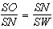
2) | 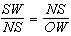
3) | 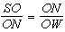
4) | 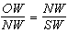

4 In the diagram of below, and altitude is drawn from vertex A.

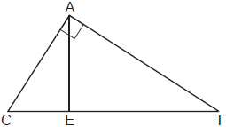

Which statement is always true?
1) | 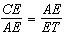
2) | 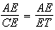
3) | 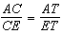
4) | 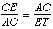

5 In the diagram below of right triangle ABC, altitude intersects hypotenuse at D.

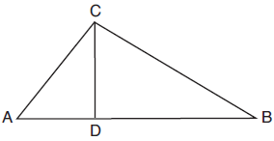

Which equation is always true?
1) | 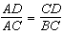
2) | 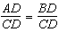
3) | 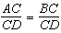
4) | 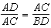

6 In the accompanying diagram of right triangle ABC, altitude is drawn to hypotenuse .

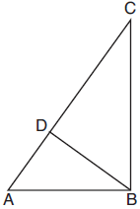

Which statement must always be true?
1) | 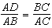
2) | 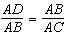
3) | 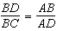
4) | 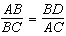

7 In the diagram below of right triangle KMI, altitude is drawn to hypotenuse .
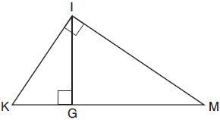
If and , the length of is
1) | 15
2) | 16
3) | 20
4) | 25

8 In the diagram below of right triangle ABC, altitude is drawn to hypotenuse .
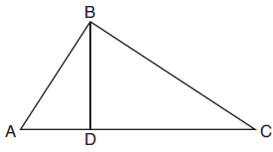
If , , and , what is the length of ?
1) | 5
2) | 2
3) | 8
4) | 11

9 In the diagram below of right triangle MET, altitude is drawn to hypotenuse .

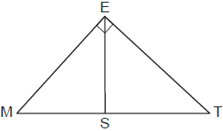

If and , what is MT?
1) | 9
2) | 8
3) | 5
4) | 4

10 In the diagram below of right triangle EFG, altitude intersects hypotenuse at H.
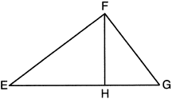
If and , what is EG?
1) | 6.75
2) | 12
3) | 18.75
4) | 25

11 In right triangle RST below, altitude is drawn to hypotenuse .
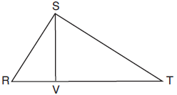
If and , what is the length of , to the nearest tenth?
1) | 6.5
2) | 7.7
3) | 11.0
4) | 12.1

12 In the diagram below of , is a right angle, , , and altitude is drawn.
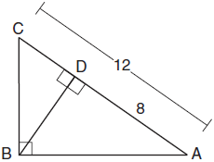
What is the length of ?
1)
2)
3)
4)

13 In the diagram below of right triangle MDL, altitude is drawn to hypotenuse .

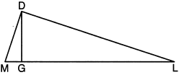

If and , what is the length of ?
1) | 8
2) | 9
3)
4)

14 In right triangle ABC, altitude is drawn to hypotenuse . If and , the length of is
1)
2)
3) | 12
4) | 16

15 Line segment CD is the altitude drawn to hypotenuse in right triangle ECF. If and , then, to the nearest tenth, ED is
1) | 4.2
2) | 5.4
3) | 15.5
4) | 21.8

16 In right triangle RST, altitude is drawn to hypotenuse . If and , what is the length of ?
1)
2) | 15
3)
4) | 27

17 Kirstie is testing values that would make triangle KLM a right triangle when is an altitude, and , as shown below.
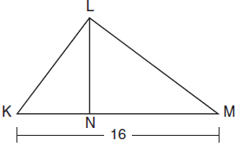
Which lengths would make triangle KLM a right triangle?
1) | and
2) | and
3) | and
4) | and

18 In the diagram below, is the altitude drawn to the hypotenuse of right triangle ABC.

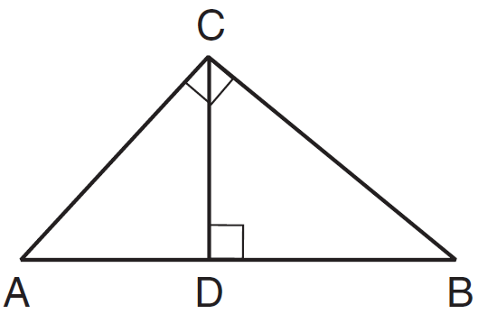

Which lengths would not produce an altitude that measures ?
1) | and
2) | and
3) | and
4) | and

19 In shown below, altitude is drawn to at U.
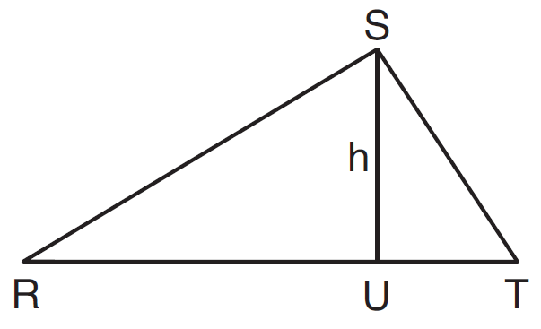
If , , and , which value of h will make a right triangle with as a right angle?
1)
2)
3)
4)

20 In the diagram of right triangle ABC, intersects hypotenuse at D.

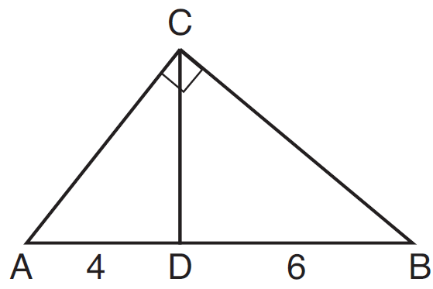

If and , which length of makes ?
1)
2)
3)
4)

21 In the diagram below of right triangle ACB, altitude is drawn to hypotenuse , and .

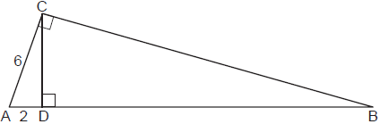

Determine and state the length of .

22 In the diagram below of right triangle BAL, altitude is drawn to hypotenuse . The length of is 6.

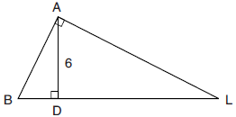

If the length of is four times the length of , determine and state the length of .

23 Right triangle STR is shown below, with . Altitude is drawn to , and .

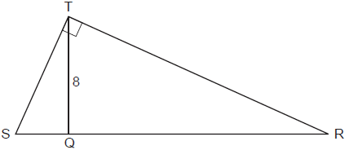

If the ratio is , determine and state the length of .

24 In right triangle PRT, , altitude is drawn to hypotenuse , , and .

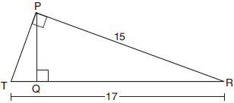

Determine and state, to the nearest tenth, the length of .

25 In right triangle ABC shown below, altitude is drawn to hypotenuse . Explain why .

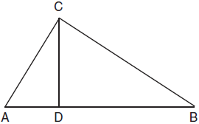

26 In the diagram below, the line of sight from the park ranger station, P, to the lifeguard chair, L, on the beach of a lake is perpendicular to the path joining the campground, C, and the first aid station, F. The campground is 0.25 mile from the lifeguard chair. The straight paths from both the campground and first aid station to the park ranger station are perpendicular.

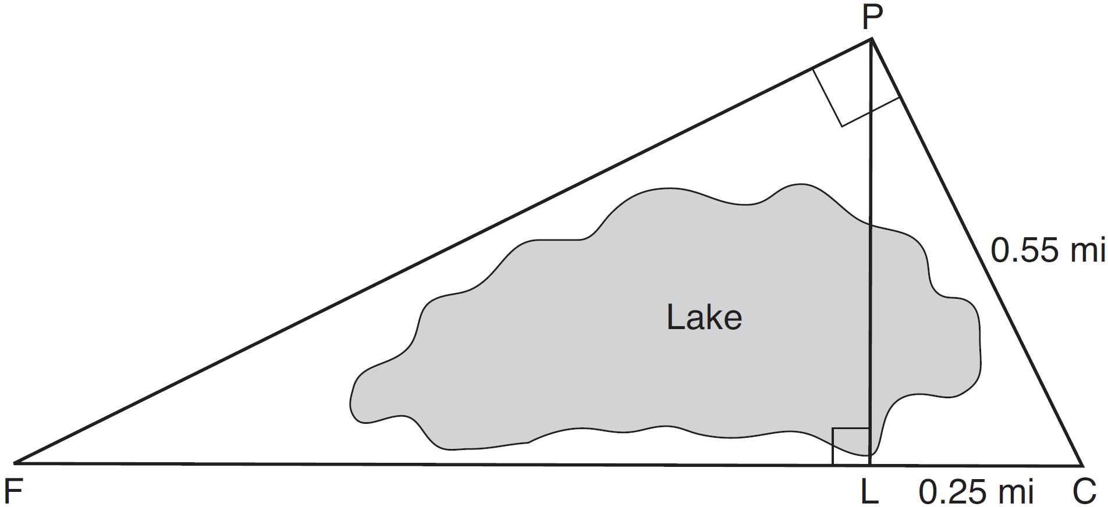

If the path from the park ranger station to the campground is 0.55 mile, determine and state, to the nearest hundredth of a mile, the distance between the park ranger station and the lifeguard chair. Gerald believes the distance from the first aid station to the campground is at least 1.5 miles. Is Gerald correct? Justify your answer.

1 ANS: 4 REF: 062422geo

2 ANS: 1 REF: 012519geo

3 ANS: 2 REF: 082419geo

4 ANS: 1 REF: 012418geo

5 ANS: 1 REF: 081916geo

6 ANS: 2
since is a 6-8-10 triangle. 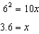
REF: 081820geo

7 ANS: 3
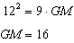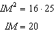
REF: 011910geo

8 ANS: 3
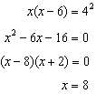
REF: 081807geo

9 ANS: 1
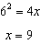
REF: 012412geo

10 ANS: 3
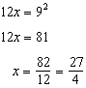
REF: 062213geo

11 ANS: 4
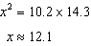
REF: 012016geo

12 ANS: 2
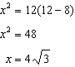
REF: 011823geo

13 ANS: 4
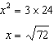
REF: 012315geo

14 ANS: 4
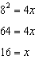
REF: 062416geo

15 ANS: 1
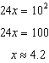
REF: 061823geo

16 ANS: 2
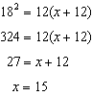
REF: 081920geo

17 ANS: 2
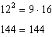
REF: 081718geo

18 ANS: 2
REF: 011622geo

19 ANS: 2
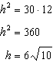
REF: 061613geo

20 ANS: 2
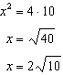
REF: 081610geo

21 ANS:
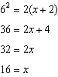;
REF: 062330geo

22 ANS:
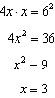
REF: 082229geo

23 ANS:
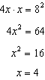
REF: 082330geo

24 ANS:
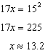
REF: 061930geo

25 ANS:
If an altitude is drawn to the hypotenuse of a triangle, it divides the triangle into two right triangles similar to each other and the original triangle.
REF: 061729geo

26 ANS:
No, 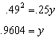
REF: 061534geo

