1 Which is not a property of all similar triangles?
1) | The corresponding angles are congruent.
2) | The corresponding sides are congruent.
3) | The perimeters are in the same ratio as the corresponding sides.
4) | The altitudes are in the same ratio as the corresponding sides.

2 Two triangles are similar, and the ratio of each pair of corresponding sides is . Which statement regarding the two triangles is not true?
1) | Their areas have a ratio of .
2) | Their altitudes have a ratio of .
3) | Their perimeters have a ratio of .
4) | Their corresponding angles have a ratio of .

3 Given such that 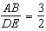. Which statement is not true?
1) | 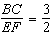
2) | 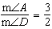
3) | 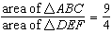
4) | 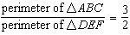

4 If , which statement is not always true?
1)
2)
3) | 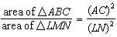
4) | 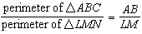

5 is similar to . The ratio of the length of to the length of is . Which ratio is also equal to ?
1) | 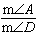
2) | 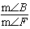
3) | 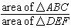
4) | 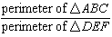

6 In the diagram below, .

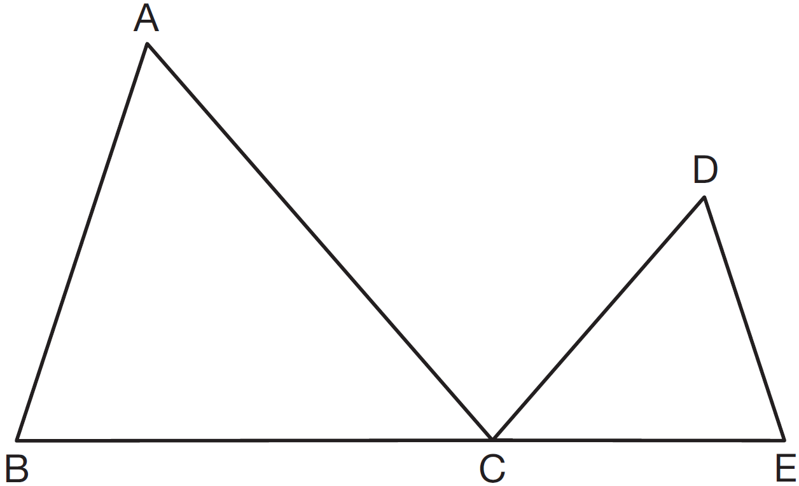

If , , , and the perimeter of is 30, what is the perimeter of ?
1) | 12.5
2) | 14.0
3) | 14.8
4) | 17.5

7 Two triangles are similar. The lengths of the sides of the smaller triangle are 3, 5, and 6, and the length of the longest side of the larger triangle is 18. What is the perimeter of the larger triangle?
1) | 14
2) | 18
3) | 24
4) | 42

8 Delroy’s sailboat has two sails that are similar triangles. The larger sail has sides of 10 feet, 24 feet, and 26 feet. If the shortest side of the smaller sail measures 6 feet, what is the perimeter of the smaller sail?
1) | 15 ft
2) | 36 ft
3) | 60 ft
4) | 100 ft

9 The base of an isosceles triangle is 5 and its perimeter is 11. The base of a similar isosceles triangle is 10. What is the perimeter of the larger triangle?
1) | 15
2) | 21
3) | 22
4) | 110

10 The corresponding medians of two similar triangles are 8 and 20. If the perimeter of the larger triangle is 45, what is the perimeter of the smaller triangle?
1) | 14
2) | 18
3) | 33
4) | 37

11 The sides of a triangle are 8, 12, and 15. The longest side of a similar triangle is 18. What is the ratio of the perimeter of the smaller triangle to the perimeter of the larger triangle?
1)
2)
3)
4)

12 The ratio of similarity of square ABCD to square WXYZ is . If and , then the perimeter of ABCD is
1) | 8
2) | 20
3) | 32
4) | 80

13 Triangle ABC is similar to triangle DEF. The lengths of the sides of are 5, 8, and 11. What is the length of the shortest side of if its perimeter is 60?
1) | 10
2) | 12.5
3) | 20
4) | 27.5

14 On a scale drawing of a new school playground, a triangular area has sides with lengths of 8 centimeters, 15 centimeters, and 17 centimeters. If the triangular area located on the playground has a perimeter of 120 meters, what is the length of its longest side?
1) | 24 m
2) | 40 m
3) | 45 m
4) | 51 m

15 The ratio of the corresponding sides of two similar squares is 1 to 3. What is the ratio of the area of the smaller square to the area of the larger square?
1)
2)
3)
4)

16 In right triangles ABC and RST, hypotenuse and hypotenuse . If , then 1:16 is the ratio of the corresponding
1) | legs
2) | areas
3) | volumes
4) | perimeters

17 Triangle RST is similar to with inches and inches. If the area of is 27 square inches, determine and state the area of , in square inches.

18 The lengths of the sides of two similar rectangular billboards are in the ratio . If 250 square feet of material is needed to cover the larger billboard, how much material, in square feet, is needed to cover the smaller billboard?

1 ANS: 2 REF: 080729a

2 ANS: 4
Corresponding angles of similar triangles are congruent.

REF: fall0826ge

3 ANS: 2
Because the triangles are similar, 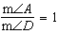

REF: 011022ge

4 ANS: 1 REF: 061517ge

5 ANS: 4 REF: 081023ge

6 ANS: 4
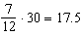

REF: 061521geo

7 ANS: 4
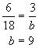. 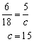.

REF: 060208a

8 ANS: 2
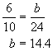. 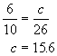.

REF: 060411a

9 ANS: 3
If the base of the isosceles triangle is 5, the other sides are each 3. 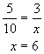.

REF: 010704a

10 ANS: 2
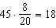

REF: 081511ge

11 ANS: 3
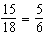

REF: 081317ge

12 ANS: 3
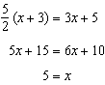

REF: 012514geo

13 ANS: 2
Perimeter of is . 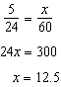

REF: 011307ge

14 ANS: 4
The perimeter of the drawing is 40 cm, for a scale of 300:1. If the longest side of the scale drawing is 17 cm, the longest side of the playground is 51 m.

REF: 060524a

15 ANS: 4

REF: 089918a

16 ANS: 2
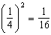

REF: 082216geo

17 ANS:
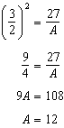

REF: 061434ge

18 ANS:
160. Both the length and width of the smaller rectangle are that of the larger. 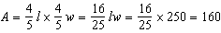.

REF: 060322a

