1 In scalene triangle ABC shown in the diagram below, .

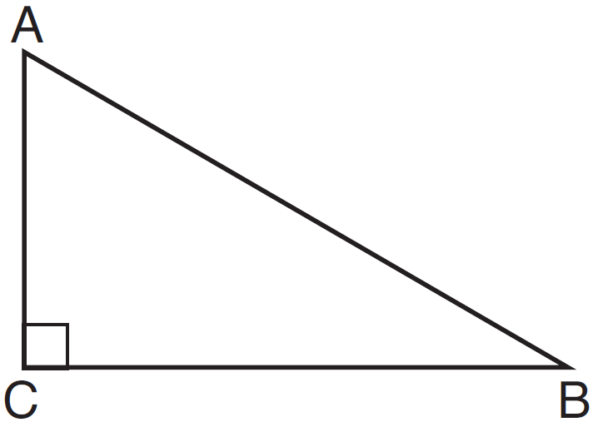

Which equation is always true?
1)
2)
3)
4)

2 In below, angle C is a right angle.

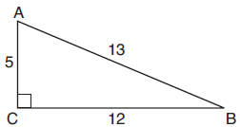

Which statement must be true?
1)
2)
3)
4)

3 Right triangle ABC is shown below.

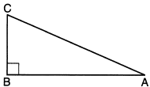

Which trigonometric equation is always true for triangle ABC?
1)
2)
3)
4)

4 In the diagram below, , where and are right angles.
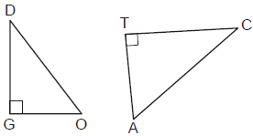

Which expression is always equivalent to ?
1)
2)
3)
4)

5 In right triangle DAN, . Which statement must always be true?
1)
2)
3)
4)

6 Right triangle TMR is a scalene triangle with the right angle at M. Which equation is true?
1)
2)
3)
4)

7 In , the complement of is . Which statement is always true?
1)
2)
3)
4)

8 If scalene triangle XYZ is similar to triangle QRS and , which equation is always true?
1)
2)
3)
4)

9 In right triangle ABC, and . Which trigonometric ratio is equivalent to ?
1)
2)
3)
4)

10 Right triangle ACT has . Which expression is always equivalent to ?
1)
2)
3)
4)

11 In right triangle ABC, . If 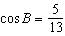, which function also equals ?
1)
2)
3)
4)

12 In , where is a right angle, 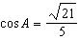. What is ?
1) | 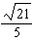
2) | 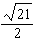
3)
4) | 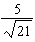

13 Which expression is always equivalent to when ?
1)
2)
3)
4)

14 Which expression is equal to ?
1)
2)
3)
4)

15 The expression is equal to
1)
2)
3)
4)

16 In a right triangle, the acute angles have the relationship . What is the value of x?
1) | 20
2) | 21
3) | 24
4) | 25

17 For the acute angles in a right triangle, . What is the number of degrees in the measure of the smaller angle?
1) | 11°
2) | 13°
3) | 44°
4) | 52°

18 In a right triangle, . What is the value of x?
1) | 10
2) | 15
3) | 20
4) | 25

19 If , what is the value of x?
1) | 7
2) | 15
3) | 21
4) | 30

20 If , what is the value of x?
1) | 8
2) | 11
3) | 33
4) | 42

21 In a right triangle, . Determine and state the value of x.

22 Find the value of R that will make the equation true when . Explain your answer.

23 In right triangle ABC with the right angle at C, and . Determine and state the value of x. Explain your answer.

24 Explain why for x such that .

25 Given: Right triangle ABC with right angle at C. If increases, does increase or decrease? Explain why.

26 When instructed to find the length of in right triangle HJG, Alex wrote the equation 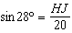 while Marlene wrote 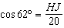. Are both students’ equations correct? Explain why.

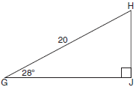
1 ANS: 4 REF: 061512geo

2 ANS: 1 REF: 081919geo

3 ANS: 1 REF: 012304geo

4 ANS: 1 REF: 062312geo

5 ANS: 2
Sine and cosine are cofunctions.

REF: 082403geo

6 ANS: 3
Sine and cosine are cofunctions.

REF: 062206geo

7 ANS: 4 REF: 011609geo

8 ANS: 4 REF: 082210geo

9 ANS: 1 REF: 011922geo

10 ANS: 2 REF: 082311geo

11 ANS: 3 REF: 061703geo

12 ANS: 1 REF: 081606geo

13 ANS: 1 REF: 081504geo

14 ANS: 3

REF: 012401geo

15 ANS: 2

REF: 061909geo

16 ANS: 1
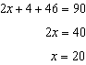

REF: 061808geo

17 ANS: 3
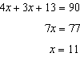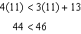

REF: 012021geo

18 ANS: 4
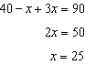

REF: 081721geo

19 ANS: 2
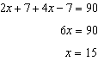

REF: 081824geo

20 ANS: 2
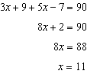

REF: 062420geo

21 ANS:
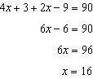

REF: 012531geo

22 ANS:
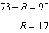 Equal cofunctions are complementary.

REF: 061628geo

23 ANS:
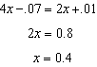 is the ratio of the opposite side and the hypotenuse while is the ratio of the adjacent side and the hypotenuse. The side opposite angle A is the same side as the side adjacent to angle B. Therefore, .

REF: fall1407geo

24 ANS:
The acute angles in a right triangle are always complementary. The sine of any acute angle is equal to the cosine of its complement.

REF: spr1407geo

25 ANS:
increases because and are complementary and .
REF: 011827geo

26 ANS:
Yes, because 28º and 62º angles are complementary. The sine of an angle equals the cosine of its complement.
REF: 011727geo

