1 In right triangle ABC below, , , and .

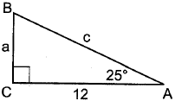

Which equation is correct for ?
1) | 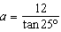
2)
3) | 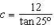
4)

2 Given the right triangle in the diagram below, what is the value of x, to the nearest foot?

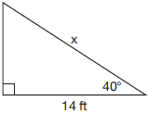
1) | 11
2) | 17
3) | 18
4) | 22

3 A vertical mine shaft is modeled in the diagram below. At a point on the ground 50 feet from the top of the mine, a ventilation tunnel is dug at an angle of 47°.

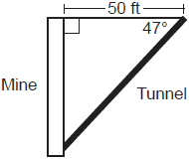

What is the length of the tunnel, to the nearest foot?
1) | 47
2) | 54
3) | 68
4) | 73

4 As shown in the diagram below, the angle of elevation from a point on the ground to the top of the tree is 34°.

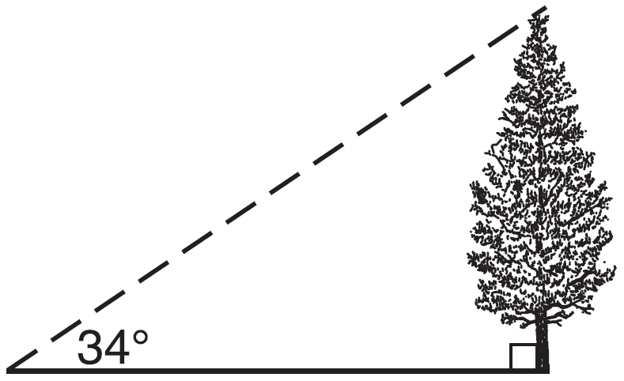

If the point is 20 feet from the base of the tree, what is the height of the tree, to the nearest tenth of a foot?
1) | 29.7
2) | 16.6
3) | 13.5
4) | 11.2

5 A tipping platform is a ramp used to unload trucks, as shown in the diagram below.

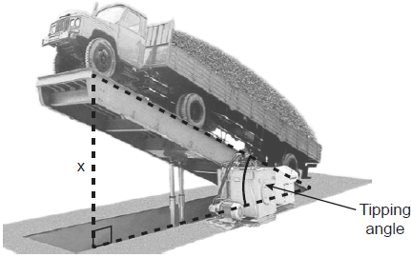

The truck is on a 75-foot-long ramp. The ramp is tipped at an angle of 30°. What is the height of the upper end of the ramp, x, to the nearest tenth of a foot?
1) | 68.7
2) | 65.0
3) | 43.3
4) | 37.5

6 A man was parasailing above a lake at an angle of elevation of 32° from a boat, as modeled in the diagram below.
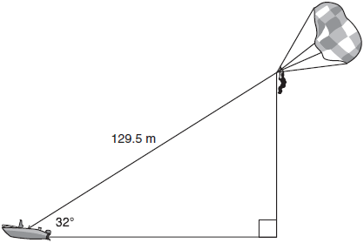
If 129.5 meters of cable connected the boat to the parasail, approximately how many meters above the lake was the man?
1) | 68.6
2) | 80.9
3) | 109.8
4) | 244.4

7 Yolanda is making a springboard to use for gymnastics. She has 8-inch-tall springs and wants to form a 16.5° angle with the base, as modeled in the diagram below.
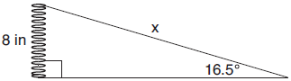

To the nearest tenth of an inch, what will be the length of the springboard, x?
1) | 2.3
2) | 8.3
3) | 27.0
4) | 28.2

8 The diagram below shows a tree growing vertically on a hillside. The angle formed by the tree trunk and the hillside is 100°. The distance from the base of the tree to the bottom of the hill is 140 feet.
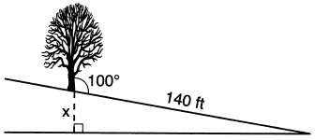

What is the vertical drop, x, to the base of the hill, to the nearest foot?
1) | 24
2) | 25
3) | 70
4) | 138

9 The diagram below shows two similar triangles.

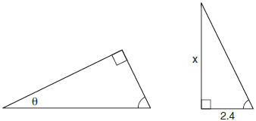

If 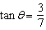, what is the value of x, to the nearest tenth?
1) | 1.2
2) | 5.6
3) | 7.6
4) | 8.8

10 Triangle ABC has a right angle at C. If and , what is AB, to the nearest tenth?
1) | 18.9
2) | 17.3
3) | 8.4
4) | 3.1

11 In right triangle ABC, , , and . To the nearest tenth, the length of is
1) | 2.5
2) | 8.4
3) | 24.6
4) | 25.9

12 In right triangle ABC, , , and . What is the length of , to the nearest tenth of a centimeter?
1) | 3.3
2) | 3.9
3) | 5.3
4) | 11.7

13 A 20-foot support post leans against a wall, making a 70° angle with the ground. To the nearest tenth of a foot, how far up the wall will the support post reach?
1) | 6.8
2) | 6.9
3) | 18.7
4) | 18.8

14 A ladder 20 feet long leans against a building, forming an angle of 71° with the level ground. To the nearest foot, how high up the wall of the building does the ladder touch the building?
1) | 15
2) | 16
3) | 18
4) | 19

15 A 15-foot ladder leans against a wall and makes an angle of 65° with the ground. What is the horizontal distance from the wall to the base of the ladder, to the nearest tenth of a foot?
1) | 6.3
2) | 7.0
3) | 12.9
4) | 13.6

16 Chelsea is sitting 8 feet from the foot of a tree. From where she is sitting, the angle of elevation of her line of sight to the top of the tree is 36°. If her line of sight starts 1.5 feet above ground, how tall is the tree, to the nearest foot?
1) | 8
2) | 7
3) | 6
4) | 4

17 From a point on the ground one-half mile from the base of a historic monument, the angle of elevation to its top is 11.87°. To the nearest foot, what is the height of the monument?
1) | 543
2) | 555
3) | 1086
4) | 1110

18 In rectangle ABCD, diagonal is drawn. The measure of is 37° and the length of is 7.6 cm. What is the length of , to the nearest tenth of a centimeter?
1) | 4.6
2) | 9.5
3) | 10.1
4) | 12.6

1 ANS: 2
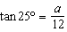

REF: 082409geo

2 ANS: 3
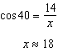

REF: 011712geo

3 ANS: 4
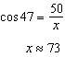

REF: 012406geo

4 ANS: 3
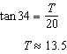

REF: 061505geo

5 ANS: 4
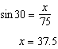

REF: 012411geo

6 ANS: 1
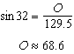

REF: 011804geo

7 ANS: 4
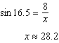

REF: 081806ai

8 ANS: 1
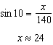

REF: 062217geo

9 ANS: 2
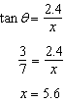

REF: 011707geo

10 ANS: 1
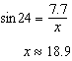

REF: 012504geo

11 ANS: 4
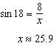

REF: 062316geo

12 ANS: 1
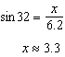

REF: 081719geo

13 ANS: 4
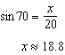

REF: 061611geo

14 ANS: 4
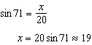

REF: 061721geo

15 ANS: 1
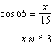

REF: 081924geo

16 ANS: 2
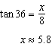

REF: 081915geo

17 ANS: 2
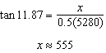

REF: 011913geo

18 ANS: 4
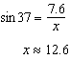

REF: 062412geo

