1 The following conversion was done correctly:
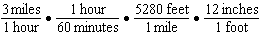
What were the final units for this conversion?
1) | minutes per foot | 3) | feet per minute
2) | minutes per inch | 4) | inches per minute

2 Morgan read that a snail moves about 72 feet per day. He performs the calculation 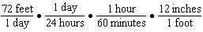 to convert this rate to different units. What are the units for the converted rate?
1) | hours/inch | 3) | inches/hour
2) | minutes/inch | 4) | inches/minute

3 Peyton is a sprinter who can run the 40-yard dash in 4.5 seconds. He converts his speed into miles per hour, as shown below.
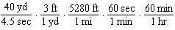
Which ratio is incorrectly written to convert his speed?
1) |  | 3) | 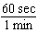
2) | 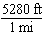 | 4) | 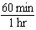

4 Olivia entered a baking contest. As part of the contest, she needs to demonstrate how to measure a gallon of milk if she only has a teaspoon measure. She converts the measurement using the ratios below:
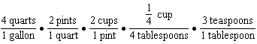
Which ratio is incorrectly written in Olivia's conversion?
1) | 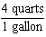 | 3) | 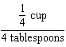
2) | 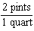 | 4) | 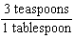

5 It takes Tim 4.5 hours to run 50 kilometers. Which expression will allow him to change this rate to minutes per mile?
1) | 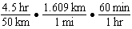 | 3) | 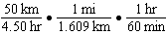
2) | 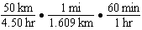 | 4) | 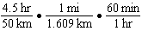

6 Elena’s fastest time for the 50-meter dash is 7 seconds. She wants to know how fast this is in inches per minute. Which expression can Elena use for a correct conversion?
1) | 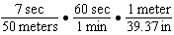 | 3) | 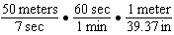
2) | 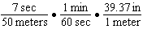 | 4) | 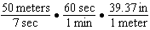

7 Wayde van Niekerk, a runner from South Africa, ran 400 meters in 43.03 seconds to set a world record. Which calculation would determine his average speed, in miles per hour?
1) | 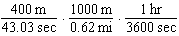 | 3) | 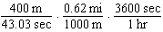
2) | 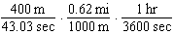 | 4) | 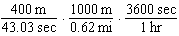

8 Joe is ordering water for his swimming pool. He determines the volume of his pool to be about 3240 cubic feet. There are approximately 7.5 gallons of water in 1 cubic foot. A truck load holds 6000 gallons of water. Which expression would allow Joe to correctly calculate the number of truck loads of water he needs to fill his pool?
1) | 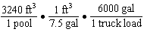 | 3) | 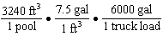
2) | 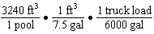 | 4) | 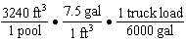

9 Joe compared gas prices in England and New York State one day. In England, gas sold for 1.35 euros per liter, and one dollar equaled 0.622 euros. A correct way to figure out this cost, in dollars per gallon, is
1) | 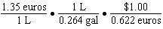 | 3) | 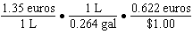
2) | 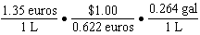 | 4) | 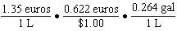

10 A swimmer set a world record in the women's 1500-meter freestyle, finishing the race in 15.42 minutes. If 1 meter is approximately 3.281 feet, which set of calculations could be used to convert her speed to miles per hour?
1) | 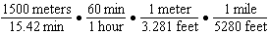
2) | 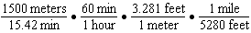
3) | 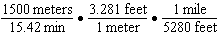
4) | 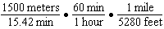

11 A construction worker needs to move 120 ft³ of dirt by using a wheelbarrow. One wheelbarrow load holds 8 ft³ of dirt and each load takes him 10 minutes to complete. One correct way to figure out the number of hours he would need to complete this job is
1) | 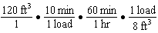 | 3) | 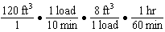
2) | 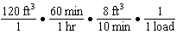 | 4) | 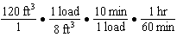

12 A company ships an average of 30,000 items each week. The approximate number of items shipped each minute is calculated using the conversion
1) | 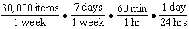 | 3) | 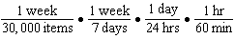
2) | 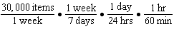 | 4) | 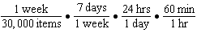

13 When the temperature is 59°F, the speed of sound at sea level is 1225 kilometers per hour. Which process could be used to convert this speed into feet per second?
1) | 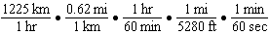
2) | 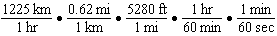
3) | 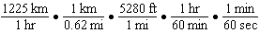
4) | 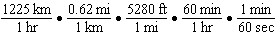

14 Bamboo plants can grow 91 centimeters per day. What is the approximate growth of the plant, in inches per hour?
1) | 1.49 | 3) | 9.63
2) | 3.79 | 4) | 35.83

15 Dan took 12.5 seconds to run the 100-meter dash. He calculated the time to be approximately
1) | 0.2083 minute | 3) | 0.2083 hour
2) | 750 minutes | 4) | 0.52083 hour

16 Sarah travels on her bicycle at a speed of 22.7 miles per hour. What is Sarah's approximate speed, in kilometers per minute?
1) | 0.2 | 3) | 36.5
2) | 0.6 | 4) | 36.6

17 The Utica Boilermaker is a 15-kilometer road race. Sara is signed up to run this race and has done the following training runs:
I. 10 miles
II. 44,880 feet
III. 15,560 yards
Which run(s) are at least 15 kilometers?
1) | I, only | 3) | I and III
2) | II, only | 4) | II and III

18 Faith wants to use the formula  to convert degrees Fahrenheit, f, to degrees Celsius, . If Faith calculated , what would her result be?
1) | 20° Celsius | 3) | 154° Celsius
2) | 20° Fahrenheit | 4) | 154° Fahrenheit

19 A news report suggested that an adult should drink a minimum of 4 pints of water per day. Based on this report, determine the minimum amount of water an adult should drink, in fluid ounces, per week.

20 A typical marathon is 26.2 miles. Allan averages 12 kilometers per hour when running in marathons. Determine how long it would take Allan to complete a marathon, to the nearest tenth of an hour. Justify your answer.

21 A two-inch-long grasshopper can jump a horizontal distance of 40 inches. An athlete, who is five feet nine, wants to cover a distance of one mile by jumping. If this person could jump at the same ratio of body-length to jump-length as the grasshopper, determine, to the nearest jump, how many jumps it would take this athlete to jump one mile.
1 ANS: 4 REF: 011924ai

2 ANS: 4 REF: 012323ai

3 ANS: 2 REF: 011502ai

4 ANS: 3 REF: 081812ai

5 ANS: 1 REF: 062222ai

6 ANS: 4 REF: 012519ai

7 ANS: 3 REF: 062423ai

8 ANS: 4 REF: 082424ai

9 ANS: 1 REF: 082324ai

10 ANS: 2 REF: 082221ai

11 ANS: 4 REF: 061720ai

12 ANS: 2 REF: 062309ai

13 ANS: 2 REF: 012422ai

14 ANS: 1
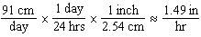
REF: 061924ai

15 ANS: 1
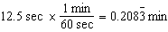
REF: 061608ai

16 ANS: 2
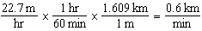
REF: 062123ai

17 ANS: 1
I. 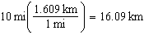; II. 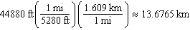; III. 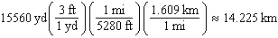
REF: 061815ai

18 ANS: 1

REF: 011710ai

19 ANS:
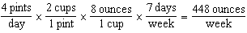
REF: 012027ai

20 ANS:
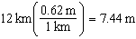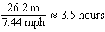
REF: 011726ai

21 ANS:
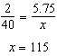
REF: 081730ai

