1 The expression 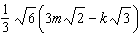 is equivalent to
1) 2) 3) 4)

2 The product of and is
1) 2) 3) 14 4) 4

3 The expression 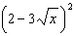 is equivalent to
1) 2) 3) 4)

4 The legs of a right triangle are represented by and . The length of the hypotenuse of the right triangle is represented by
1) 2) 3) 4)

5 The expression is equivalent to
1) 2) 3) 4)

6 The expression is equivalent to
1) 2) 3) 4)

7 The product of and expressed in simplest radical form is
1) 2) 3) 4)

8 The expression 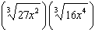 is equivalent to
1) 2) 3) 4)

9 What is the product of and ?
1) 2) 3) 4)

10 The expression is equivalent to
1) 2) 3) 4)

11 The sum of and , expressed in simplest radical form, is
1) 2) 3) 4)

12 What is the value of 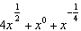 when ?
1) 2) 3) 4)

13 The expression 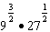 is equivalent to
1) 2) 3) 4) 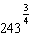

14 The expression is equivalent to
1) 2) 3) 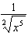 4) 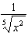

15 Which expression is equivalent to 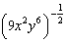?
1) 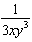 2) 3) 4)

16 The expression 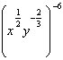 is equivalent to
1) 2) 3) 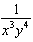 4)

17 When simplified, the expression 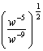 is equivalent to
1) 2) 3) 4)

18 The expression 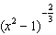 is equivalent to
1) 2) 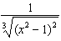 3) 4) 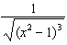

19 The expression is equivalent to
1) 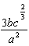 2) 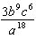 3) 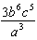 4) 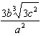

20 The expression is equivalent to
1) 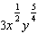 2) 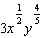 3) 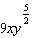 4) 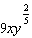

21 The expression is equivalent to
1) 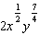 2) 3) 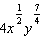 4)

22 Determine the exact value of 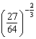 as a fraction in simplest form.

23 Express 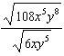 in simplest radical form.

24 Express in simplest form: 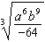

25 Express in simplest radical form.
1 ANS: 1
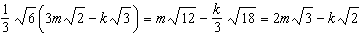

REF: 011710a2

2 ANS: 4

REF: 081001a2

3 ANS: 3 REF: 061407a2

4 ANS: 1

REF: 011626a2

5 ANS: 3

REF: 061204a2

6 ANS: 1

REF: 061504a2

7 ANS: 4

REF: 081627a2

8 ANS: 4
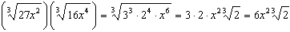

REF: 011421a2

9 ANS: 1

REF: 011516a2

10 ANS: 4

REF: fall0918a2

11 ANS: 3
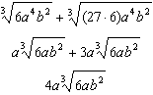

REF: 011319a2

12 ANS: 4
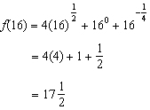

REF: 081503a2

13 ANS: 2
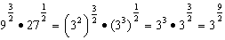

REF: 011707a2

14 ANS: 4
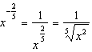

REF: 011118a2

15 ANS: 1 REF: 011306a2

16 ANS: 1
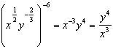

REF: 081611a2

17 ANS: 2
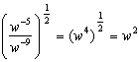

REF: 081011a2

18 ANS: 2 REF: 061011a2

19 ANS: 1
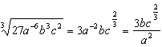

REF: 011606a2

20 ANS: 1
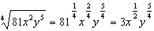

REF: 081504a2

21 ANS: 1
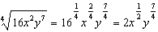

REF: 061107a2

22 ANS:
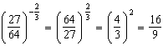

REF: 011729a2

23 ANS:
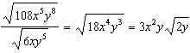

REF: 011133a2

24 ANS:
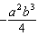

REF: 011231a2

25 ANS:

REF: 061032a2

