1 The expression simplifies to
1) | 22.9
2) | 48
3) | 864
4) | 3,456

2 Which number is the largest?
1) | 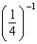
2) | 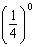
3) | 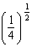
4) | 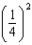

3 If 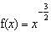, then 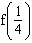 is equal to
1) | 8
2)
3)
4)

4 The expression 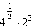 is equal to
1)
2)
3) | 16
4) | 4

5 The expression is equivalent to
1) | 1
2)
3) | 3
4)

6 The value of 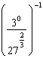 is
1)
2) | 9
3)
4)

7 Find the value of 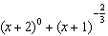 when .

8 Evaluate the expression 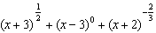 when .

9 Classical mathematics uses the term "Golden Ratio" for the ratio 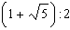. The Golden Ratio was used by many famous artists to determine the dimensions of their paintings. If the ratio of the length to the width of a painting is , find the length, in feet, of a painting that has a width of 14 feet. Express your answer in simplest radical form.

10 If , then equals
1)
2)
3)
4)

11 If , the expression 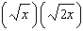 is equivalent to
1)
2)
3)
4)

12 If x is a positive integer, is equivalent to
1)
2)
3)
4)

13 The expression 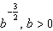, is equivalent to
1) | 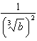
2) | 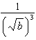
3) | 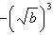
4) | 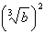

14 If , the expression 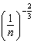 is equal to
1)
2)
3)
4)

15 The expression is equivalent to
1)
2) | 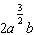
3)
4) | 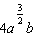

16 The volume of a soap bubble is represented by the equation , where A represents the surface area of the bubble. Which expression is also equivalent to V?
1) | 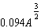
2) | 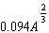
3)
4) | 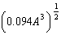

17 When simplified, the expression 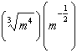 is equivalent to
1)
2)
3)
4)

18 Which expression is equivalent to 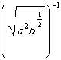?
1) | 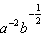
2) | 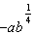
3)
4)

19 Which expression is equivalent to b in the equation 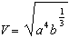?
1)
2)
3)
4)

20 Simplify:

21 Simplify the expression 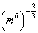 and write your answer using a positive exponent.
1 ANS: 2

REF: 060218a

2 ANS: 1 REF: 061002b

3 ANS: 1
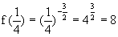

REF: 060602b

4 ANS: 3

REF: 080601b

5 ANS: 3
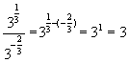

REF: 080218b

6 ANS: 2
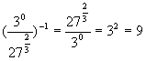

REF: 010217b

7 ANS:
1.25. 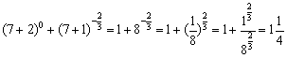

REF: 080322b

8 ANS:
4.25. 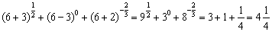

REF: 080921b

9 ANS:
. 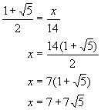

REF: 080724b

10 ANS: 3

REF: 010422a

11 ANS: 4

REF: 010103a

12 ANS: 3 REF: 060208b

13 ANS: 2
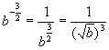

REF: 010413b

14 ANS: 3
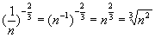

REF: 080807b

15 ANS: 2
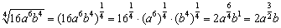

REF: 060419b

16 ANS: 1
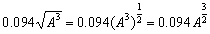

REF: 060708b

17 ANS: 4
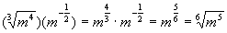

REF: 010617b

18 ANS: 4
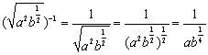

REF: 060912b

19 ANS: 1 REF: 011015b

20 ANS:
.

REF: 080125a

21 ANS:

REF: 010824b

