1 Consider the data in the table below.

 | Right Handed | Left Handed
Male | 87 | 13
Female | 89 | 11

What is the probability that a randomly selected person is male given the person is left handed?
1) |  | 3)
2) |  | 4)

2 The table below shows the food preferences of sports fans whose favorite sport is football or baseball.

Favorite Food to Eat While Watching Sports
 | Wings | Pizza | Hot Dogs
Football | 14 | 20 | 6
Baseball | 6 | 12 | 42

The probability that a fan prefers pizza given that the fan prefers football is
1) |  | 3)
2) |  | 4)

3 The set of data in the table below shows the results of a survey on the number of messages that people of different ages text on their cell phones each month.

Text Messages per Month
Age Group | 0-10 | 11-50 | Over 50
15-18 | 4 | 37 | 68
19-22 | 6 | 25 | 87
23-60 | 25 | 47 | 157

If a person from this survey is selected at random, what is the probability that the person texts over 50 messages per month given that the person is between the ages of 23 and 60?
1) |  | 3)
2) |  | 4)

4 A random sample of 152 students was surveyed on a particular day about how they got to school. The survey results are summarized in the table below.
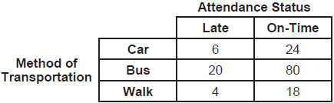

Which statement is best supported by the data?
1) | The probability of being late given that a student walked is greater than the probability that a student walked given that the student was late. | 3) | The probability of being late given that a student walked is equal to the probability that a student walked given that the student was late.
2) | The probability of being late given that a student walked is less than the probability that a student walked given that the student was late. | 4) | The probability of being late given that a student walked cannot be determined.

5 A survey about television-viewing preferences was given to randomly selected freshmen and seniors at Fairport High School. The results are shown in the table below.

Favorite Type of Program
 | Sports | Reality Show | Comedy Series
Senior | 83 | 110 | 67
Freshmen | 119 | 103 | 54

A student response is selected at random from the results. State the exact probability the student response is from a freshman, given the student prefers to watch reality shows on television.

6 Data collected about jogging from students with two older siblings are shown in the table below.

 | Neither Sibling Jogs | One Sibling Jogs | Both Siblings Jog
Student Does Not Jog | 1168 | 1823 | 1380
Student Jogs | 188 | 416 | 400

Using these data, determine whether a student with two older siblings is more likely to jog if one sibling jogs or if both siblings jog. Justify your answer.

7 The number of employees who work nights and weekends at a department store is summarized in the table below.

 | Works Nights | Doesn’t Work Nights
Works Weekends | 8 | 40
Doesn’t Work Weekends | 12 | 60

Let N represent the event "works nights" and let W represent the event "works weekends." Based on the table, are N and W independent events?
1) | Yes, because . | 3) | No, because .
2) | Yes, because . | 4) | No, because .

8 The results of a survey of the student body at Central High School about television viewing preferences are shown below.

 | Comedy Series | Drama Series | Reality Series | Total
Males | 95 | 65 | 70 | 230
Females | 80 | 70 | 110 | 260
Total | 175 | 135 | 180 | 490

Are the events “student is a male” and “student prefers reality series” independent of each other? Justify your answer.

9 Juan and Filipe practice at the driving range before playing golf. The number of wins and corresponding practice times for each player are shown in the table below.

 | Juan Wins | Felipe Wins
Short Practice Time | 8 | 10
Long Practice Time | 15 | 12

Given that the practice time was long, determine the exact probability that Filipe wins the next match. Determine whether or not the two events “Filipe wins” and “long practice time” are independent. Justify your answer.

10 The relative frequency table shows the proportion of a population who have a given eye color and the proportion of the same population who wear glasses.

 | Wear Glasses | Don’t Wear Glasses
Blue Eyes | 0.14 | 0.26
Brown Eyes | 0.11 | 0.24
Green Eyes | 0.10 | 0.15

Given the data, are the events of having blue eyes and wearing glasses independent? Justify your answer.

11 The transportation methods used by the upperclassmen at Calhoun High School are summarized in the table below.

Upperclassmen Transportation Methods
 | Drive | Take the Bus | Walk
Junior | 58 | 75 | 12
Senior | 81 | 39 | 12

Are the events "being a junior" and "driving to school" independent? Using statistical evidence, justify your answer.

12 The table below shows the results of gender and music preference. Based on these data, determine if the events "the person is female" and "the person prefers classic rock" are independent of each other. Justify your answer.

 | Rap | Techno | Classic Rock | Classical
Male | 39 | 17 | 42 | 12
Female | 17 | 37 | 36 | 15

13 The results of a poll of 200 students are shown in the table below:

 | Preferred Music Style
 | Techno | Rap | Country
Female | 54 | 25 | 27
Male | 36 | 40 | 18

For this group of students, do these data suggest that gender and preferred music styles are independent of each other? Justify your answer.

14 A public radio station held a fund-raiser. The table below summarizes the donor category and method of donation.

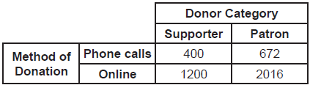

To the nearest thousandth, find the probability that a randomly selected donor was categorized as a supporter, given that the donation was made online. Do these data indicate that being a supporter is independent of donating online? Justify your answer.

15 A researcher wants to determine if nut allergies and milk allergies are related to each other. The researcher surveyed 1500 people and asked them if they are allergic to nuts or milk. The survey results are summarized in the table below.

 | Allergic to Nuts | Not Allergic to Nuts
Allergic to Milk | 3 | 42
Not Allergic to Milk | 12 | 1443

Determine the probability that a randomly selected survey respondent is allergic to milk. Determine the probability that a randomly selected survey respondent is allergic to milk, given that the person is allergic to nuts. Based on the survey data, determine whether nut allergies and milk allergies are independent events. Justify your answer.
1 ANS: 4
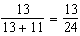

REF: 012011aii

2 ANS: 1
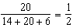

REF: 082303aii

3 ANS: 1
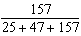

REF: 081607aii

4 ANS: 1
The probability of being late given that a student walked is . The probability that student walked given that the student was late is .

REF: 012518aii

5 ANS:
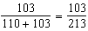

REF: 061825aii

6 ANS:
A student is more likely to jog if both siblings jog. 1 jogs: 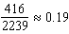. both jog: 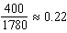

REF: 061732aii

7 ANS: 1
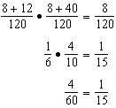

REF: 082422aii

8 ANS:
No, because 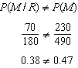

REF: 011731aii

9 ANS:
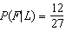 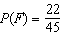 Since , the events are not independent.

REF: 061936aii

10 ANS:
Yes. 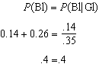

REF: 062229aii

11 ANS:
Based on these data, the two events do not appear to be independent. 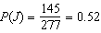, while 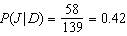. The probability of being a junior is not the same as the conditional probability of being a junior, given the junior drives to school.

REF: 062431aii

12 ANS:
No, because 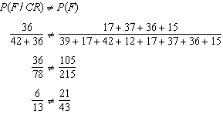

REF: 082231aii

13 ANS:
Based on these data, the two events do not appear to be independent. 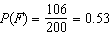, while 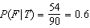, 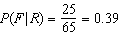, and 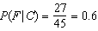. The probability of being female are not the same as the conditional probabilities. This suggests that the events are not independent.
REF: fall1508aii

14 ANS:
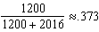. Yes, because 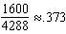 also.
REF: 062334aii

15 ANS:
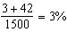 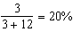 No, because a person is more likely to be allergic milk if he is also allergic to nuts.
REF: 012433aii

