1 A ball was launched into the air, and its height above the ground was recorded each second, as shown in the table below.

Time (sec) | 0 | 1 | 2 | 3 | 4
Height (ft) | 11 | 59 | 75 | 59 | 11

Based on these data, which statement is a valid conclusion?
1) | The ball lands on the ground at 4 seconds. | 3) | The ball was launched from a height of 0 feet.
2) | The ball reaches a maximum height of 11 feet. | 4) | The ball reaches its maximum height at 2 seconds.

2 A tour bus can seat, at most, 48 passengers. An adult ticket costs $18 and a child ticket costs $12. The bus company must collect at least $650 to make a profit. If a represents the number of adult tickets sold and c represents the number of child tickets sold, which system of inequalities models this situation if they make a profit?
1) | 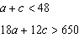 | 3) | 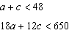
2) | 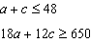 | 4) | 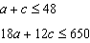

3 Which equation is always true?
1) |  | 3)
2) |  | 4)

4 The expression is equivalent to
1) |  | 3)
2) |  | 4)

5 Which sum is irrational?
1) |  | 3) | 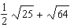
2) | 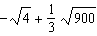 | 4)

6 The solution to 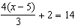 is
1) | 15 | 3) | 6
2) | 14 | 4) | 4

7 On an island, a rare breed of rabbit doubled its population each month for two years. Which type of function best models the increase in population at the end of two years?
1) | linear growth | 3) | exponential growth
2) | linear decay | 4) | exponential decay

8 What is the degree of the polynomial ?
1) | 1 | 3) | 3
2) | 2 | 4) | 4

9 The zeros of the function are
1) | 0,, and 2 | 3) | and 2, only
2) | 0, 5, and | 4) | 5 and , only

10 What is the y-intercept of the line that passes through the points and ?
1) |  | 3) | 3
2) |  | 4) | 5

11 Nancy has just been hired for her first job. Her company gives her four choices for how she can collect her annual salary over the first eight years of employment. Each function below represents the four choices she has for her annual salary in thousands of dollars, where t represents the number of years after she is hired.
Which pay plan should Nancy choose in order to have the highest salary in her eighth year?
1) |  | 3)
2) |  | 4)

12 The third term in a sequence is 25 and the fifth term is 625. Which number could be the common ratio of the sequence?
1) |  | 3)
2) | 5 | 4) | 25

13 The box plot below summarizes the data for the amount of snowfall, in inches, during the winter of 2021 for 12 locations in western New York.

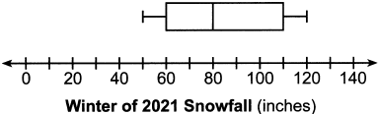

What is the interquartile range?
1) | 30 | 3) | 80
2) | 50 | 4) | 110

14 Four quadratic functions are represented below.

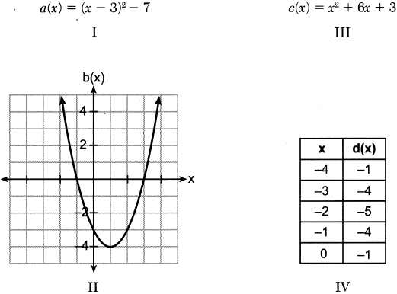

Which function has the smallest minimum value?
1) | I | 3) | III
2) | II | 4) | IV

15 The equation that represents the sequence is
1) |  | 3)
2) |  | 4)

16 The dot plot below shows the number of goals Jessica scored in each lacrosse game last season.

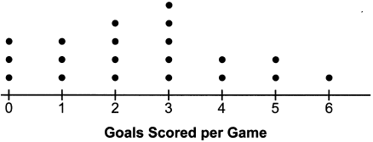

Which statement about the dot plot is correct?
1) | mean > mode | 3) | mode = median
2) | mean = median | 4) | median > mean

17 The students in Mrs. Smith's algebra class were asked to describe the graph of compared to the graph of . Which student response is correct?
1) | Ashley said that the graph of is wider and shifted left 3 units. | 3) | Carl said that the graph of is wider and shifted right 3 units.
2) | Beth said that the graph of is narrower and shifted left 3 units. | 4) | Don said that the graph of is narrower and shifted right 3 units.

18 One Saturday, Dave took a long bike ride. The graph below models his trip.

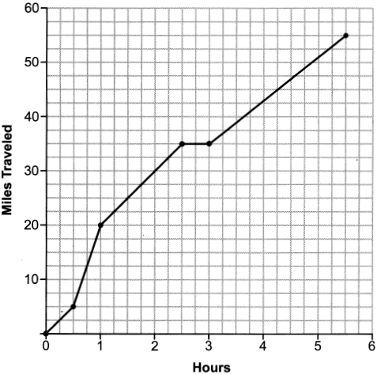

What was Dave's average rate of change, in miles per hour, on this trip?
1) | 10 | 3) | 11.6
2) | 11 | 4) | 14.5

19 Which expression is equivalent to ?
1) |  | 3)
2) |  | 4)

20 The functions and are graphed on the set of axes below.

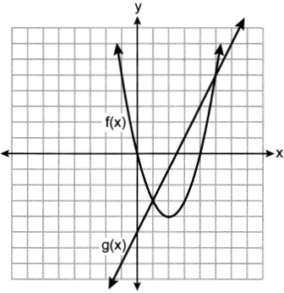

What is the solution to the equation ?
1) | 1 and 5 | 3) | and 5
2) | and 0 | 4) | 0 and 4

21 When babysitting, Nicole charges an hourly rate and an additional charge for gas. She uses the function to determine how much to charge for babysitting. The constant term of this function represents
1) | the additional charge for gas | 3) | the number of hours Nicole babysits
2) | the hourly rate Nicole charges | 4) | the total Nicole earns from babysitting

22 When solved for x in terms of a, the solution to the equation is
1) |  | 3)
2) | 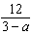 | 4) | 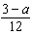

23 Wayde van Niekerk, a runner from South Africa, ran 400 meters in 43.03 seconds to set a world record. Which calculation would determine his average speed, in miles per hour?
1) | 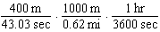 | 3) | 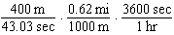
2) | 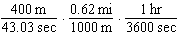 | 4) | 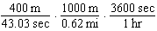

24 Which function has a domain of all real numbers and a range greater than or equal to three?
1) |  | 3)
2) |  | 4)

25 Solve algebraically.

26 Given , evaluate .

27 Given the relation . State a value for x that will make this relation a function. Explain why your answer makes this a function.

28 A survey of 150 students was taken. It was determined that of the students play video games. Of the students that play video games, 85 also use social media. Of the students that do not play video games, 20% do not use social media. Complete the two-way frequency table.

 | Play Video Games | Do Not Play Video Games | Total
Social Media
No Social Media
Total

29 Use the method of completing the square to determine the exact values of x for the equation .

30 Factor completely.

31 Graph the following system of equations on the set of axes below.
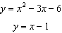

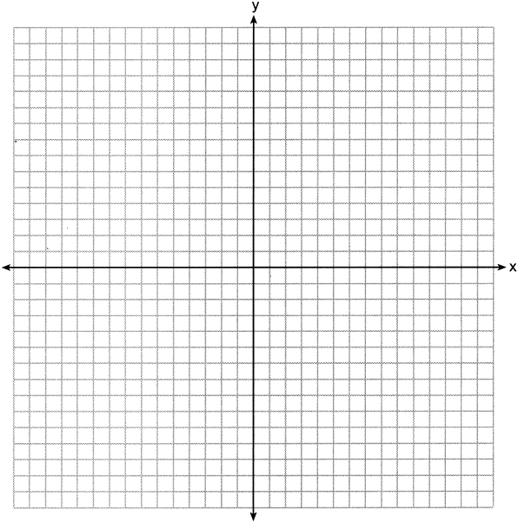

State the coordinates of all solutions.

32 The table below shows the amount of money a popular movie earned, in millions of dollars, during its first six weeks in theaters.

Week (x) | 1 | 2 | 3 | 4 | 5 | 6
Dollars Earned, in Millions (y) | 185 | 150 | 90 | 50 | 25 | 5

Write the linear regression equation for this data set, rounding all values to the nearest hundredth. State the correlation coefficient to the nearest hundredth. State what this correlation coefficient indicates about the linear fit of the data.

33 Use the quadratic formula to solve the equation . Express the answer in simplest radical form.

34 Graph the system of inequalities on the set of axes below.
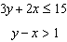

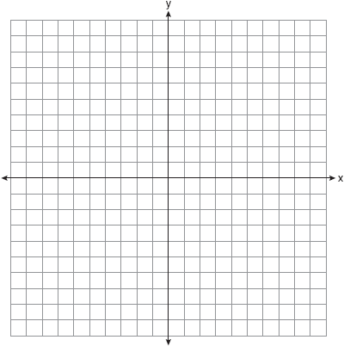

State the coordinates of a point in the solution to this system. Justify your answer.

35 Courtney went to a coffee shop to purchase lattes and donuts for her friends. One day she spent a total of $15.50 on four lattes and two donuts. The next day she spent a total of $18.10 on three lattes and five donuts. All prices included tax. If x represents the cost of one latte and y represents the cost of one donut, write a system of equations that can be used to model this situation. Courtney thinks that one latte costs $2.75 and one donut costs $2.25. Is Courtney correct? Justify your answer. Use your equations to determine algebraically the exact cost of one latte and the exact cost of one donut.
1 ANS: 4 PTS: 2 REF: 062401ai NAT: F.IF.B.4
TOP: Graphing Quadratic Functions KEY: key features

2 ANS: 2 PTS: 2 REF: 062402ai NAT: A.CED.A.3
TOP: Modeling Systems of Linear Inequalities

3 ANS: 1 PTS: 2 REF: 062403ai NAT: A.APR.A.1
TOP: Multiplication of Powers

4 ANS: 4

PTS: 2 REF: 062404ai NAT: A.APR.A.1 TOP: Operations with Polynomials
KEY: addition

5 ANS: 1 PTS: 2 REF: 062405ai NAT: N.RN.B.3
TOP: Operations with Radicals KEY: classify

6 ANS: 2
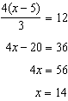

PTS: 2 REF: 062406ai NAT: A.REI.B.3 TOP: Solving Linear Equations

7 ANS: 3 PTS: 2 REF: 062407ai NAT: F.LE.A.1
TOP: Families of Functions

8 ANS: 3 PTS: 2 REF: 062408ai NAT: A.SSE.A.1
TOP: Modeling Expressions

9 ANS: 2 PTS: 2 REF: 062409ai NAT: A.APR.B.3
TOP: Zeros of Polynomials

10 ANS: 3
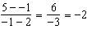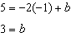

PTS: 2 REF: 062410ai NAT: F.IF.B.4 TOP: Graphing Linear Functions

11 ANS: 1

PTS: 2 REF: 062411ai NAT: F.LE.A.3 TOP: Families of Functions

12 ANS: 2
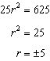

PTS: 2 REF: 062412ai NAT: F.IF.A.3 TOP: Sequences
KEY: difference or ratio

13 ANS: 2

PTS: 2 REF: 062413ai NAT: S.ID.A.1 TOP: Box Plots
KEY: interpret

14 ANS: 1
1) ; 2) ; 3) 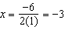, ; 4)

PTS: 2 REF: 062414ai NAT: F.IF.C.9 TOP: Comparing Quadratic Functions

15 ANS: 2 PTS: 2 REF: 062415ai NAT: F.BF.A.1
TOP: Sequences KEY: explicit

16 ANS: 2
mean: 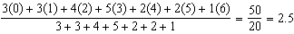, mode: 3, median: 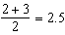

PTS: 2 REF: 062416ai NAT: S.ID.A.1 TOP: Dot Plots

17 ANS: 4 PTS: 2 REF: 062417ai NAT: F.BF.B.3
TOP: Transformations with Functions

18 ANS: 1
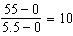

PTS: 2 REF: 062418ai NAT: F.IF.B.6 TOP: Rate of Change

19 ANS: 4

PTS: 2 REF: 062419ai NAT: A.APR.A.1 TOP: Operations with Polynomials
KEY: multiplication

20 ANS: 1 PTS: 2 REF: 062420ai NAT: A.REI.D.11
TOP: Quadratic-Linear Systems

21 ANS: 1 PTS: 2 REF: 062421ai NAT: F.LE.B.5
TOP: Modeling Linear Functions

22 ANS: 2
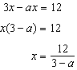

PTS: 2 REF: 062422ai NAT: A.REI.B.3 TOP: Solving Linear Equations
KEY: coefficients represented by letters

23 ANS: 3 PTS: 2 REF: 062423ai NAT: N.Q.A.1
TOP: Conversions

24 ANS: 2
All four functions have a real domain. f has a real range. h has a positive real range. m has a nonnegative real range.

PTS: 2 REF: 062424ai NAT: F.IF.A.2 TOP: Domain and Range

25 ANS:
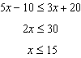

PTS: 2 REF: 062425ai NAT: A.REI.B.3 TOP: Solving Linear Inequalities

26 ANS:

PTS: 2 REF: 062426ai NAT: F.IF.A.2 TOP: Functional Notation

27 ANS:
x may be any value other than , so that for any value of x, there is a unique y.

PTS: 2 REF: 062427ai NAT: F.IF.A.1 TOP: Defining Functions

28 ANS:

 | Play Video Games | Do Not Play Video Games | Total
Social Media | 85 | 40 | 125
No Social Media | 15 | 10 | 25
Total | 100 | 50 | 150

PTS: 2 REF: 062428ai NAT: S.ID.B.5 TOP: Frequency Tables
KEY: two-way

29 ANS:
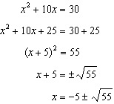

PTS: 2 REF: 062429ai NAT: A.REI.B.4 TOP: Solving Quadratics
KEY: completing the square

30 ANS:

PTS: 2 REF: 062430ai NAT: A.SSE.A.2
TOP: Factoring the Difference of Perfect Squares

31 ANS:
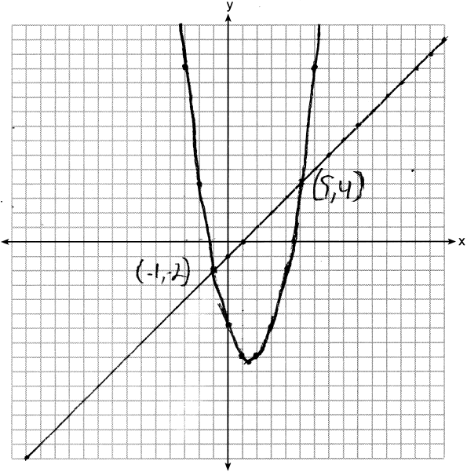

PTS: 4 REF: 062431ai NAT: A.REI.C.7 TOP: Quadratic-Linear Systems

32 ANS:
, , strong

PTS: 4 REF: 062432ai NAT: S.ID.B.6 TOP: Regression
KEY: linear with correlation coefficient

33 ANS:
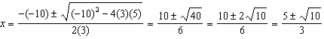

PTS: 4 REF: 062433ai NAT: A.REI.B.4 TOP: Solving Quadratics
KEY: quadratic formula

34 ANS:
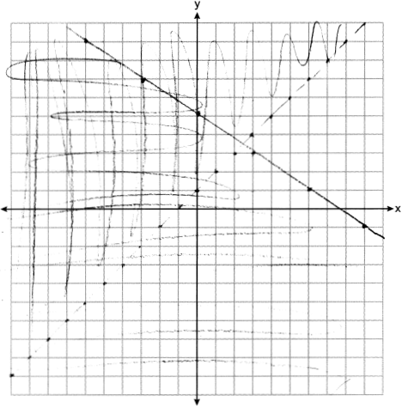 is a solution as it is in the overlap area.

PTS: 4 REF: 062434ai NAT: A.REI.D.12 TOP: Graphing Systems of Linear Inequalities

35 ANS:
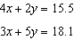 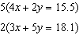 Courtney is incorrect because of the following calculations: 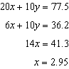 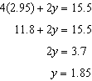
PTS: 6 REF: 062435ai NAT: A.CED.A.3 TOP: Modeling Linear Systems

