1 What is the sum of and ?
1) |  | 3)
2) |  | 4)

2 What is an equation of the line that passes through the points and ?
1) | 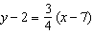 | 3) | 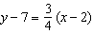
2) | 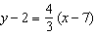 | 4) | 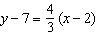

3 Rationalize: 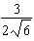

4 Use the method of completing the square to determine the exact values of x for the equation . Express your answer in simplest radical form.

5 Solve the following systems of equations algebraically for all values of x and y:
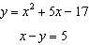
1 ANS: 1 PTS: 2 REF: fall2301ai NAT: N.RN.B.3
TOP: Operations with Radicals KEY: addition

2 ANS: 4
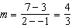

PTS: 2 REF: fall2302ai NAT: A.REI.D.10 TOP: Writing Linear Equations
KEY: other forms

3 ANS:
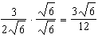

PTS: 2 REF: fall2303ai NAT: N.RN.B.3 TOP: Operations with Radicals
KEY: division

4 ANS:
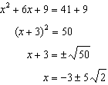

PTS: 4 REF: fall2304ai NAT: A.REI.B.4 TOP: Solving Quadratics
KEY: completing the square

5 ANS:
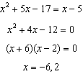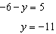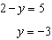

PTS: 4 REF: fall2305ai NAT: A.REI.C.7 TOP: Quadratic-Linear Systems

