1 Given , the expression 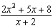 is equivalent to
1) | 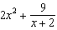 | 3) | 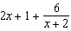
2) | 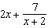 | 4) | 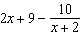

2 Given and , the quotient of is
1) |  | 3) | 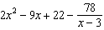
2) |  | 4)

3 The expression 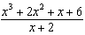 is equivalent to
1) |  | 3)
2) | 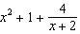 | 4) | 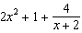

4 Given , which expression is equivalent to 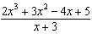?
1) |  | 3)
2) | 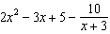 | 4) | 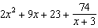

5 Given , the expression 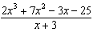 is equivalent to
1) | 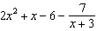 | 3)
2) | 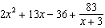 | 4) | 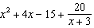

6 Which expression is equivalent to 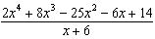?
1) | 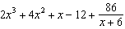 | 3) | 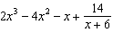
2) |  | 4)

7 Which expression is equivalent to 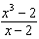?
1) |  | 3)
2) | 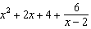 | 4) | 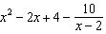

8 The expression 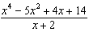 is equivalent to
1) | 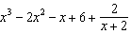 | 3) | 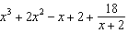
2) | 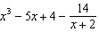 | 4) | 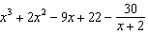

9 The rational expression 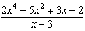 is equivalent to
1) | 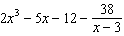 | 3) | 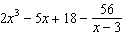
2) | 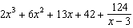 | 4) | 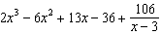

10 Which expression is equivalent to 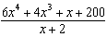?
1) | 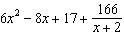 | 3) | 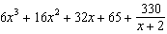
2) | 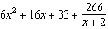 | 4) | 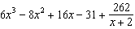

11 What is the quotient when is divided by ?
1) |  | 3)
2) |  | 4)

12 The expression 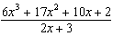 equals
1) | 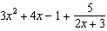 | 3) | 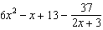
2) | 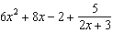 | 4) | 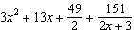

13 The expression 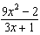 is equivalent to
1) | 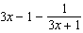 | 3) | 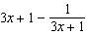
2) | 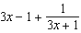 | 4) | 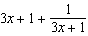

14 Which expression is equivalent to 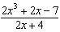?
1) | 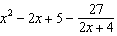 | 3) | 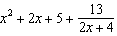
2) | 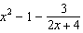 | 4) | 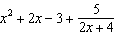

15 Which expression is equivalent to 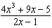, where 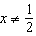?
1) |  | 3)
2) | 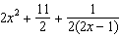 | 4) | 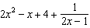

16 The expression 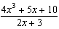 is equivalent to
1) | 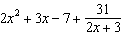 | 3) | 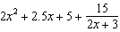
2) | 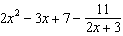 | 4) | 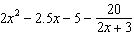

17 Given and , state the quotient and remainder of , in the form 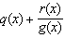.

18 Determine the quotient and remainder when is divided by . Express your answer in the form 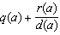.

19 Given and , state the quotient and remainder of , in the form . Is a root of ? Explain your answer.

20 Given and , determine in the form 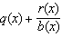. Is a factor of ? Explain.

21 When the function is divided by the quotient is 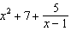. State in standard form.
1 ANS: 3
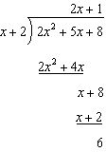

REF: 012007aii

2 ANS: 1
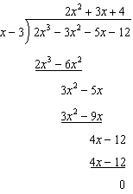

REF: 012505aii

3 ANS: 2
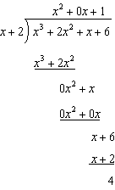

REF: 081611aii

4 ANS: 2
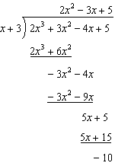

REF: 082302aii

5 ANS: 1
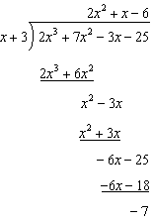

REF: 062203aii

6 ANS: 3
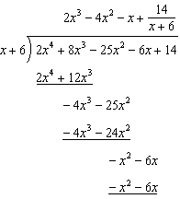

REF: 081805aii

7 ANS: 2
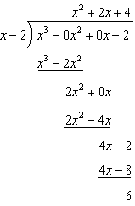

REF: 082217aii

8 ANS: 1
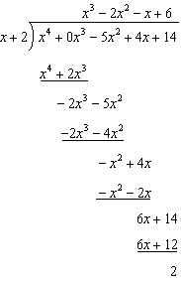

REF: 012305aii

9 ANS: 2
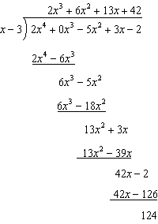

REF: 012408aii

10 ANS: 4
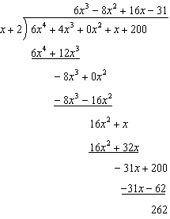

REF: 082407aii

11 ANS: 4
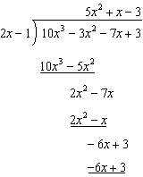

REF: 011809aii

12 ANS: 1
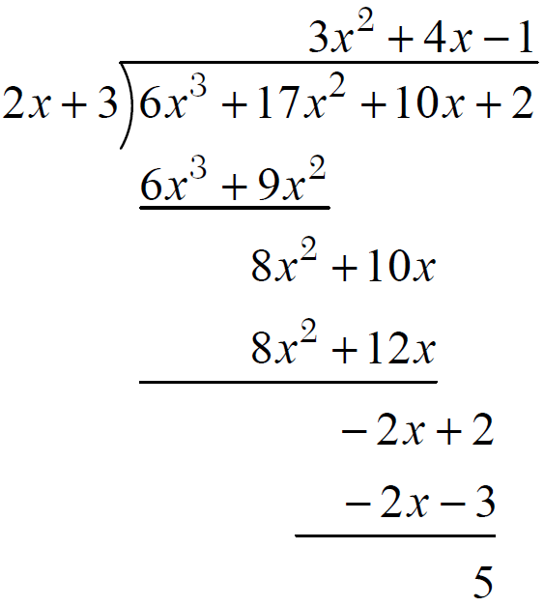

REF: fall1503aii

13 ANS: 1
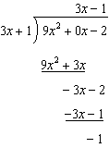

REF: 081910aii

14 ANS: 1
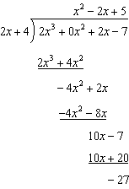

REF: 062313aii

15 ANS: 1
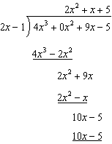

REF: 081713aii

16 ANS: 2
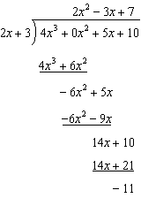

REF: 061614aii

17 ANS:
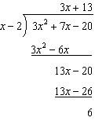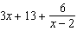

REF: 011732aii

18 ANS:
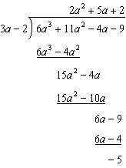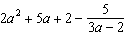

REF: 061829aii

19 ANS:
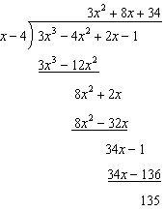 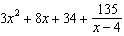 is not a root of because has a remainder.

REF: 082235aii

20 ANS:
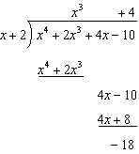 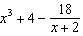. No, because there is a remainder.
REF: 011934aii

21 ANS:
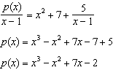
REF: 061930aii

