1 What is 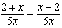 expressed in simplest form?
1) 0 2) 3) 4) 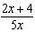

2 What is the sum of 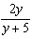 and 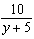 expressed in simplest form?
1) 1 2) 2 3) 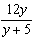 4) 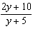

3 The sum of 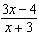 and 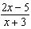 is
1) 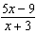 2) 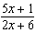 3) 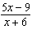 4) 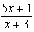

4 What is the sum of 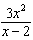 and 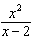?
1) 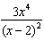 2) 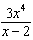 3) 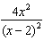 4) 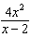

5 What is the sum of 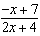 and 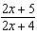?
1) 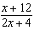 2) 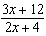 3) 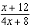 4) 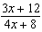

6 The expression 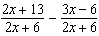 is equivalent to
1) 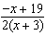 2) 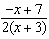 3) 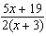 4) 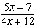

7 The sum of and is
1) 2) 3) 4)

8 What is the sum of and expressed in simplest form?
1) 2) 3) 4)

9 What is the sum of and ?
1) 2) 3) 4)

10 The expression 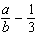 is equivalent to
1) 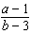 2) 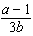 3) 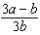 4) 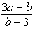

11 What is 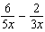 in simplest form?
1) 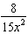 2) 3) 4)

12 What is 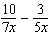 expressed in simplest form?
1) 2) 3) 4)

13 What is 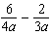 expressed in simplest form?
1) 2) 3) 4)

14 Which fraction is equivalent to 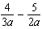?
1) 2) 3) 4) 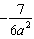

15 What is 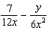 expressed in simplest form?
1) 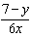 2) 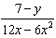 3) 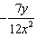 4) 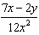

16 The expression 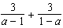 is equivalent to
1) 0 2) 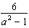 3) 6 4) 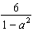

17 Expressed in simplest form, 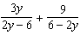 is equivalent to
1) 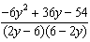 2) 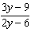 3) 4)

18 What is 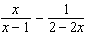 expressed as a single fraction?
1) 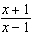 2) 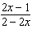 3) 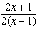 4) 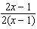
1 ANS: 3
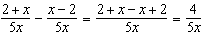

REF: 081027ia

2 ANS: 2
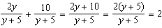

REF: 011230ia

3 ANS: 1 REF: 081409ia

4 ANS: 4 REF: 011025ia

5 ANS: 1 REF: 061024ia

6 ANS: 1 REF: 061220ia

7 ANS: 3
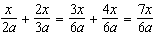

REF: 061630ia

8 ANS: 2
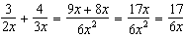

REF: 080917ia

9 ANS: 2
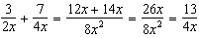

REF: 011120ia

10 ANS: 3 REF: 061424ia

11 ANS: 2
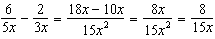

REF: 010921ia

12 ANS: 3
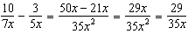

REF: 011511ia

13 ANS: 2
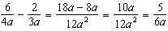

REF: 060929ia

14 ANS: 3
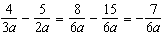

REF: 081328ia

15 ANS: 4
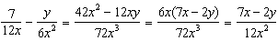

REF: 061129ia

16 ANS: 1
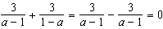

REF: 011716a2

17 ANS: 3
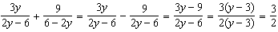

REF: 011325a2

18 ANS: 3
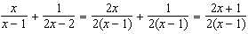

REF: 011608a2

