1 A teacher asked the class to solve the equation . Robert wrote as his first step. Which property did he use?
1) | associative property | 3) | distributive property
2) | commutative property | 4) | zero property of addition

2 While solving the equation , Becca wrote . Which property did she use?
1) | distributive | 3) | commutative
2) | associative | 4) | identity

3 When solving the equation , Laura wrote as her first step. Which property justifies Laura's first step?
1) | distributive property of multiplication over addition | 3) | commutative property of addition
2) | multiplication property of equality | 4) | addition property of equality

4 When solving , Kate wrote . The property she used is
1) | the associative property | 3) | the distributive property
2) | the commutative property | 4) | the addition property of equality

5 When solving the equation , Emily wrote as her first step. Which property justifies Emily's first step?
1) | addition property of equality | 3) | multiplication property of equality
2) | commutative property of addition | 4) | distributive property of multiplication over addition

6 A part of Jennifer's work to solve the equation is shown below.
Given:
Step 1:
Which property justifies her first step?
1) | identity property of multiplication | 3) | commutative property of multiplication
2) | multiplication property of equality | 4) | distributive property of multiplication over subtraction

7 Stephanie is solving the equation . Her first step is shown below.
Given:
Step 1:
Which property justifies her first step?
1) | associative property | 3) | distributive property
2) | commutative property | 4) | addition property of equality

8 When solving the equation , Evan wrote as his first step. Which property justifies this step?
1) | subtraction property of equality | 3) | associative property of multiplication
2) | multiplication property of equality | 4) | distributive property of multiplication over subtraction

9 When solving for the value of x in the equation , Aaron wrote the following lines on the board.
[line 1]
[line 2]
[line 3]
[line 4]
[line 5]
Which property was used incorrectly when going from line 2 to line 3?
1) | distributive | 3) | associative
2) | commutative | 4) | multiplicative inverse

10 Britney is solving a quadratic equation. Her first step is shown below.
Problem:
Step 1:
Which two properties did Britney use to get to step 1?
I. addition property of equality
II. commutative property of addition
III. multiplication property of equality
IV. distributive property of multiplication over addition
1) | I and III | 3) | II and III
2) | I and IV | 4) | II and IV

11 In the process of solving the equation , George wrote , followed by . Which properties justify George's process?
A. addition property of equality
B. division property of equality
C. commutative property of addition
D. distributive property
1) | A and C | 3) | D and C
2) | A and B | 4) | D and B

12 A method for solving is shown below. Identify the property used to obtain each of the two indicated steps.

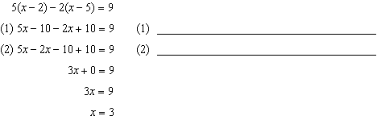

13 John was given the equation to solve. Some of the steps and their reasons have already been completed. State a property of numbers for each missing reason.

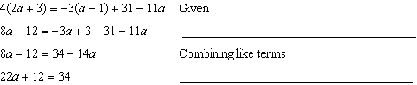

14 A student is in the process of solving an equation. The original equation and the first step are shown below.
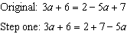
Which property did the student use for the first step? Explain why this property is correct.
1 ANS: 3 REF: 081419ia

2 ANS: 1 REF: 080601a

3 ANS: 4 REF: 082406ai

4 ANS: 4 REF: 061909ai

5 ANS: 1 REF: 061401ai

6 ANS: 4 REF: 081701ai

7 ANS: 4 REF: 012514ai

8 ANS: 4 REF: 011801aii

9 ANS: 1 REF: 061405ia

10 ANS: 4 REF: 011908ai

11 ANS: 4 REF: 082219ai

12 ANS:
(1) Distributive; (2) Commutative

REF: 061132ia

13 ANS:
Distributive and Addition Property of Equality

REF: 012029ai

14 ANS:
Commutative, This property is correct because .

REF: 081926ai

