1 Mallory wants to buy a new window air conditioning unit. The cost for the unit is $329.99. If she plans to run the unit three months out of the year for an annual operating cost of $108.78, which function models the cost per year over the lifetime of the unit, , in terms of the number of years, n, that she owns the air conditioner.
1) |  | 3) | 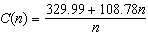
2) |  | 4) | 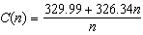

2 A manufacturing plant produces two different-sized containers of peanuts. One container weighs x ounces and the other weighs y pounds. If a gift set can hold one of each size container, which expression represents the number of gift sets needed to hold 124 ounces?
1) | 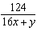 | 3) | 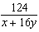
2) | 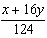 | 4) | 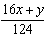

3 Julie averaged 85 on the first three tests of the semester in her mathematics class. If she scores 93 on each of the remaining tests, her average will be 90. Which equation could be used to determine how many tests, T, are left in the semester?
1) | 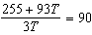 | 3) | 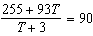
2) | 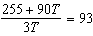 | 4) | 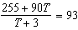

4 A rush-hour commuter train has arrived on time 64 of its first 80 days. As arrivals continue, which equation can be used to find x, the number of consecutive days that the train must arrive on schedule to raise its on-time performance rate to 90%?
1) | 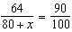 | 3) | 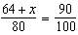
2) | 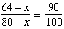 | 4) | 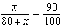

5 The number of minutes students took to complete a quiz is summarized in the table below.

Minutes | 14 | 15 | 16 | 17 | 18 | 19 | 20
Number of Students | 5 | 3 | x | 5 | 2 | 10 | 1

If the mean number of minutes was 17, which equation could be used to calculate the value of x?
1) | 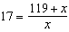 | 3) | 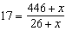
2) | 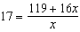 | 4) | 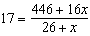

6 The table below displays the results of a survey regarding the number of pets each student in a class has. The average number of pets per student in this class is 2.

Number of Pets | 0 | 1 | 2 | 3 | 4 | 5
Number of Students | 4 | 6 | 10 | 0 | k | 2

What is the value of k for this table?
1) | 9 | 3) | 8
2) | 2 | 4) | 4

7 If the sum of a number n and ten times its reciprocal is 7, then a value of n may be
1) |  | 3) | 3
2) | 2 | 4) | 4

8 A number, minus twenty times its reciprocal, equals eight. The number is
1) | 10 or | 3) | or
2) | 10 or 2 | 4) | or 2

9 When 5 is divided by a number, the result is 3 more than 7 divided by twice the number. What is the number?
1) | 1 | 3)
2) | 2 | 4) | 5

10 Find the number that is less than its reciprocal.

11 Find the number that must be added to each term of the fraction , that the resulting fraction shall equal .

12 An excursion party had $2.00 to pay, but before the bill was paid 10 of the party went away, and those that remained had each to pay 10 cents more. Find how many were in the party at first.

13 A certain company agreed to build a vessel for $6,300. But, two of their number having died, the rest had each to advance $200 more than they otherwise would have done. Of how many persons did the company consist at first?
1 ANS: 3 REF: 061722aii

2 ANS: 3 REF: 061824aii

3 ANS: 3 REF: 061602aii

4 ANS: 2 REF: 082222aii

5 ANS: 4 REF: 061124a2

6 ANS: 4
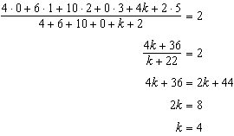
REF: 061221a2

7 ANS: 2 REF: 018428siii

8 ANS: 1
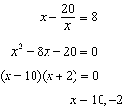
REF: 061916aii

9 ANS: 3
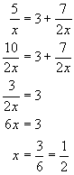
REF: 010927a

10 ANS:
REF: 060506al

11 ANS:
7
REF: 030503al

12 ANS:
20
REF: 019015al

13 ANS:
9
REF: 039016al

