1 If , then x is equal to
1) | 0.5
2) | 2
3) | 5
4) | 50

2 What is the value of w in the equation ?
1) | 0.045
2) | 0.45
3) | 4.5
4) | 45

3 The value of y in the equation is
1) | 500
2)
3) | 5,000
4)

4 What is the value of n in the equation ?
1) | 8
2) | 2
3) | 20
4) | 44

5 What is the value of n in the equation ?
1)
2) | 5
3)
4) | 4

6 Solve for x:

7 Solve for m:

8 Solve for x:

9 Solve for x:

10 A candy store sells 8-pound bags of mixed hazelnuts and cashews. If c pounds of cashews are in a bag, the price p of the bag can be found using the formula . If one bag is priced at $18.11, how many pounds of cashews does it contain?

11 What is the solution of 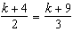?
1) | 1
2) | 5
3) | 6
4) | 14

12 Which value of x is the solution of 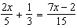?
1)
2)
3) | 3
4) | 7

13 Which value of x is the solution of the equation 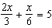?
1) | 6
2) | 10
3) | 15
4) | 30

14 Solve for x: 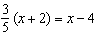
1) | 8
2) | 13
3) | 15
4) | 23

15 Which value of x is the solution of 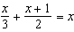?
1) | 1
2)
3) | 3
4)

16 Which value of x is the solution of the equation 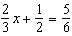?
1)
2) | 2
3)
4)

17 Which value of x is the solution of the equation 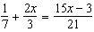?
1) | 6
2) | 0
3)
4)

18 What is the value of x in the equation 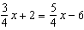?
1)
2) | 16
3)
4) | 4

19 What is the solution set of the equation 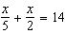?
1)
2)
3)
4)

20 What is the value of w in the equation 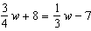?
1) | 2.4
2)
3)
4)

21 What is the value of x in the equation 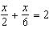?
1) | 12
2) | 8
3) | 3
4)

22 What is the value of w in the equation 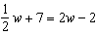?
1) | 6
2) | 2
3)
4) | 3.6

23 In the equation 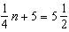, n is equal to
1) | 8
2) | 2
3)
4)

24 The number of people on the school board is represented by x. Two subcommittees with an equal number of members are formed, one with 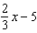 members and the other with members. How many people are on the school board?
1) | 20
2) | 12
3) | 8
4) | 4

25 Solve for x: 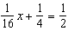

26 Solve for m: 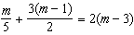 1
1 ANS: 3
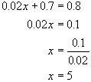

REF: 010906a

2 ANS: 4
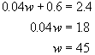

REF: 060804a

3 ANS: 3
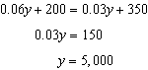

REF: 081203ia

4 ANS: 3
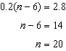

REF: 011502ia

5 ANS: 3
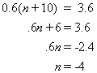

REF: 080406a

6 ANS:
1.6. 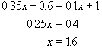

REF: 080831a

7 ANS:
2. 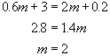

REF: 060323a

8 ANS:
2.4. 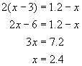

REF: 089921a

9 ANS:
2.1. 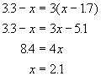

REF: 060634a

10 ANS:
5. 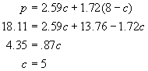

REF: 010635a

11 ANS: 3
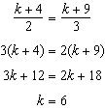

REF: 010906ia

12 ANS: 4
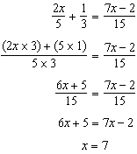

REF: 080820ia

13 ANS: 1
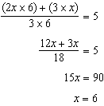

REF: 060907ia

14 ANS: 2
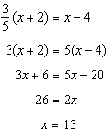

REF: 080909ia

15 ANS: 3
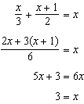

REF: 061019ia

16 ANS: 1
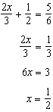

REF: 011112ia

17 ANS: 1
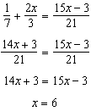

REF: 011328ia

18 ANS: 2
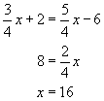

REF: 010204a

19 ANS: 3
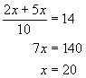

REF: 010507a

20 ANS: 4
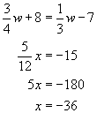

REF: 080620a

21 ANS: 3
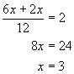

REF: 010719a

22 ANS: 1
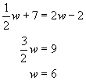

REF: 060704a

23 ANS: 2
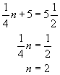

REF: 080708a

24 ANS: 2
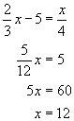

REF: 060418a

25 ANS:
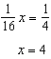

REF: 010636a

26 ANS:
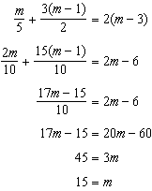

REF: 081139ia

