1 What is the solution set of the equation ?
1)
2)
3)
4)

2 Express, in terms of i, the roots of the equation 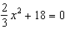.

3 Max solves a quadratic equation by completing the square. He shows a correct step:
What are the solutions to his equation?
1)
2)
3)
4)

4 The roots of the equation are
1)
2)
3)
4)

5 Solve for x in simplest form:

6 In physics class, Taras discovers that the behavior of electrical power, x, in a particular circuit can be represented by the function . If , solve the equation and express your answer in simplest form.

7 Solve the equation and express the roots in simplest form.

8 Express, in simplest form, the roots of the equation .

9 Find the roots of the equation and express your answer in simplest form.

10 Solve the equation and express the roots in the form .

11 Express the roots of the equation in form.

12 Solve the equation and express your answers in the form .

13 Solve the equation and express the roots in terms of i.

14 Solve the equation and express the roots in simplest form.

15 Solve for x and express the roots in simplest form:

16 Solve for x and express your answer in simplest form:

17 Solve for x and express your answer in simplest form:

18 Solve the equation , and express the roots in the form .

19 Express the roots of the equation in form.

20 Express the roots of the equation in form.

21 Express the roots of the equation in simplest form.

22 Solve for x and express in simplest form:

23 Solve for x and express your answer in simplest form: 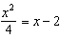
1 ANS: 2 REF: 080234siii

2 ANS:

REF: 069041siii

3 ANS: 2
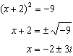

REF: 011408a2

4 ANS: 1 REF: 088422siii

5 ANS:
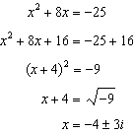

REF: 010222b

6 ANS:
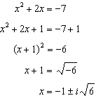

REF: 010627b

7 ANS:
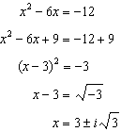. .

REF: fall9928b

8 ANS:
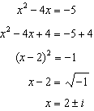

REF: 080328b

9 ANS:
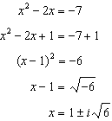

REF: 010931b

10 ANS:

REF: 068038siii

11 ANS:

REF: 088537siii

12 ANS:

REF: 088637siii

13 ANS:

REF: 088738siii

14 ANS:

REF: 088937siii

15 ANS:

REF: 019736siii

16 ANS:

REF: 010339siii

17 ANS:

REF: 060042siii

18 ANS:

REF: 018737siii

19 ANS:

REF: 019638siii

20 ANS:

REF: 018942siii

21 ANS:
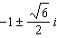

REF: 089939siii

22 ANS:
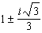

REF: 019440siii

23 ANS:

REF: 010242siii

