1 Express the equation in the form .

2 Solve for x by completing the square.

3 Solve the following equation by completing the square:

4 Solve the equation by completing the square.

5 Determine the exact values of x for by completing the square.

6 Use the method of completing the square to determine the exact values of x for the equation .

7 Find the exact roots of by completing the square.

8 Use the method of completing the square to determine the exact values of x for the equation .

9 Use the method of completing the square to determine the exact values of x for the equation . Express your answer in simplest radical form.

10 Solve by completing the square, expressing the result in simplest radical form.

11 A student was given the equation to solve by completing the square. The first step that was written is shown below.
The next step in the student’s process was . State the value of c that creates a perfect square trinomial. Explain how the value of c is determined.
1 ANS:
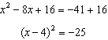

REF: 012431ai

2 ANS:
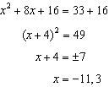

REF: 012528ai

3 ANS:
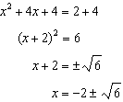

REF: 081830ai

4 ANS:
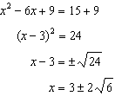

REF: 081732ai

5 ANS:
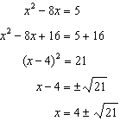

REF: 062232ai

6 ANS:
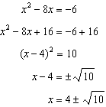

REF: 012031ai

7 ANS:
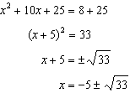

REF: 011636a2

8 ANS:
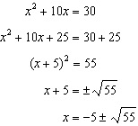

REF: 062429ai

9 ANS:
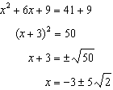

REF: fall2304ai

10 ANS:
. 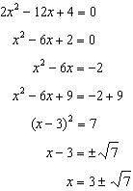

REF: fall0936a2

11 ANS:
Since , p is half the coefficient of x, and the constant term is equal to . 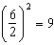

REF: 081432ai

