1 Rowan has $50 in a savings jar and is putting in $5 every week. Jonah has $10 in his own jar and is putting in $15 every week. Each of them plots his progress on a graph with time on the horizontal axis and amount in the jar on the vertical axis. Which statement about their graphs is true?
1) | Rowan’s graph has a steeper slope than Jonah’s.
2) | Rowan’s graph always lies above Jonah’s.
3) | Jonah’s graph has a steeper slope than Rowan’s.
4) | Jonah’s graph always lies above Rowan’s.

2 What is the solution of the system of equations shown in the graph below?
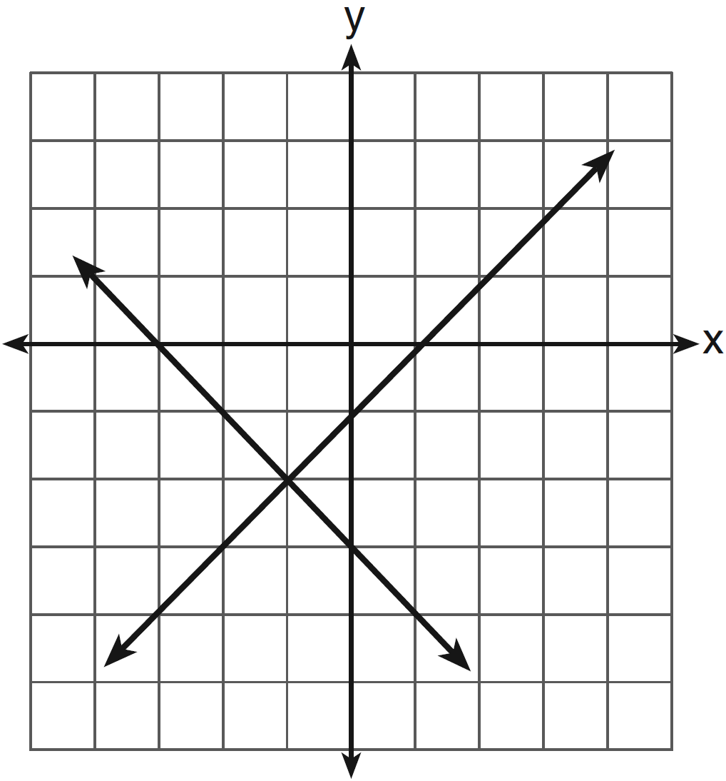
1) | and
2) | and
3)
4)

3 A system of equations is graphed on the set of axes below.
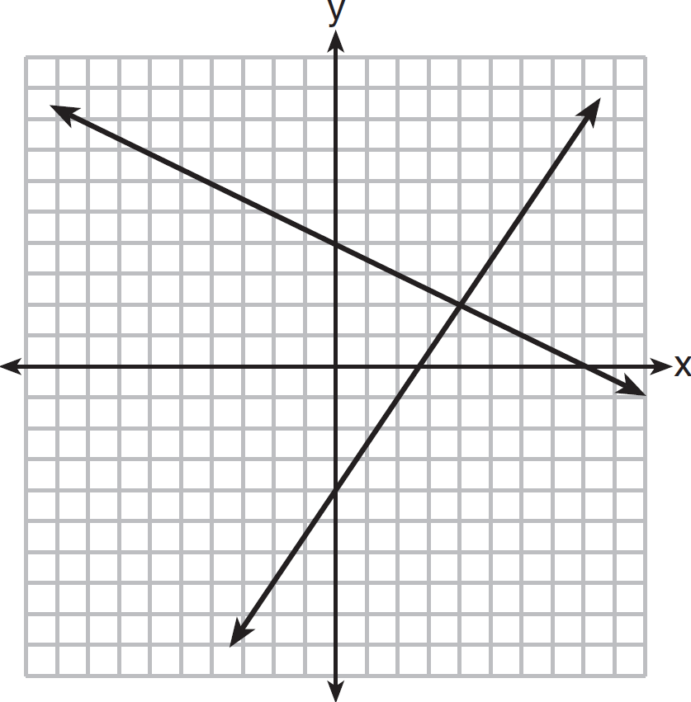
The solution of this system is
1)
2)
3)
4)

4 Two health clubs offer different membership plans. The graph below represents the total cost of belonging to Club A and Club B for one year.

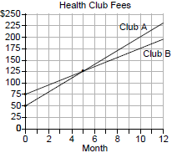

If the yearly cost includes a membership fee plus a monthly charge, what is the membership fee for Club A? What is the number of the month when the total cost is the same for both clubs? What is the total cost for Club A when both plans are the same? What is the monthly charge for Club B?

5 The graph below models the cost of renting video games with a membership in Plan A and Plan B.

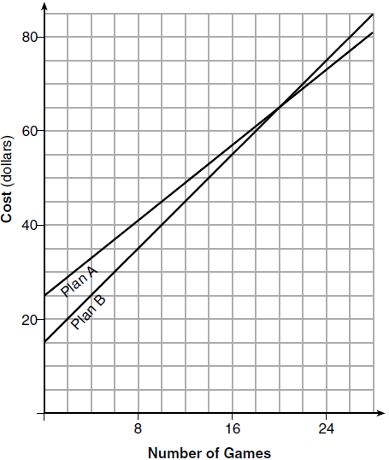

Explain why Plan B is the better choice for Dylan if he only has $50 to spend on video games, including a membership fee. Bobby wants to spend $65 on video games, including a membership fee. Which plan should he choose? Explain your answer.

6 Two video rental clubs offer two different rental fee plans: Club A charges $12 for membership and $2 for each rented video. Club B has a $4 membership fee and charges $4 for each rented video. The graph below represents the total cost of renting videos from Club A.
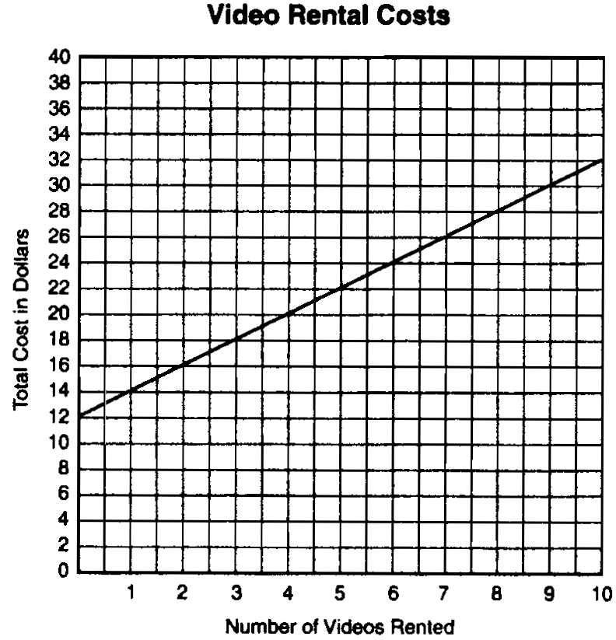

(a) On the same set of xy-axes, draw a line to represent the total cost of renting videos from Club B.
(b) For what number of video rentals is it less expensive to belong to Club A? Explain how you arrived at your answer.

7 A recreation center ordered a total of 15 tricycles and bicycles from a sporting goods store. The number of wheels for all the tricycles and bicycles totaled 38. Write a linear system of equations that models this scenario, where t represents the number of tricycles and b represents the number of bicycles ordered. On the set of axes below, graph this system of equations.
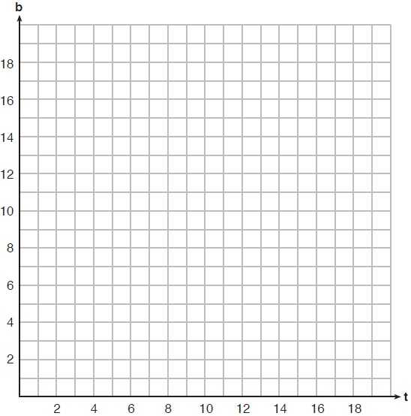

Based on your graph of this scenario, could the recreation center have ordered 10 tricycles? Explain your reasoning.

8 Two families went to Rollercoaster World. The Brown family paid $170 for 3 children and 2 adults. The Peckham family paid $360 for 4 children and 6 adults. If x is the price of a child's ticket in dollars and y is the price of an adult's ticket in dollars, write a system of equations that models this situation. Graph your system of equations on the set of axes below.
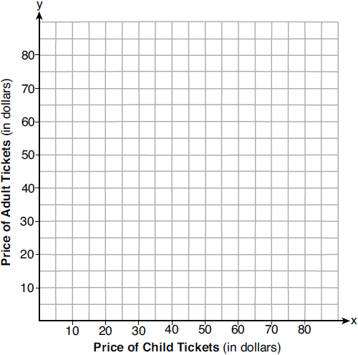
State the coordinates of the point of intersection. Explain what each coordinate of the point of intersection means in the context of the problem.

9 Anna plans to spend $30 on balloons and party hats for her daughter’s birthday party. Including tax, balloons cost $2 each and party hats cost $1.50 each. The number of party hats Anna needs is twice as many as the number of balloons. If x represents the number of balloons and y represents the number of party hats, write a system of equations that can be used to represent this situation. Graph your system of equations on the set of axes below.
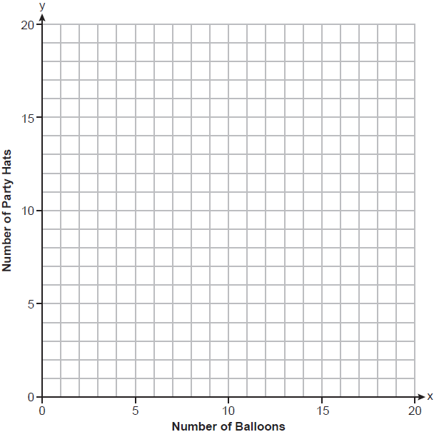
State the coordinates of the point of intersection of your lines. Explain what each coordinate means in the context of the problem.

10 At Ron’s Rental, a person can rent a big-screen television for $10 a month plus a one-time “wear-and-tear” fee of $100. At Josie’s Rental, the charge is $20 a month and an additional charge of $20 for delivery with no “wear-and-tear” fee.
a If c equals the cost, write one equation representing the cost of the rental for m months at Ron’s Rental and one equation representing the cost of the rental for m months at Josie’s Rental.
b On the accompanying grid, graph and label each equation.
c From your graph, determine in which month Josie’s cost will equal Ron’s cost.

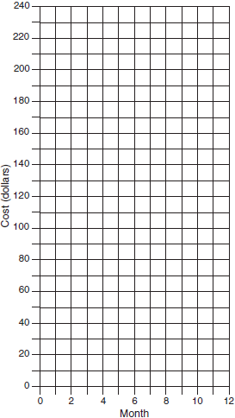

11 Lydia wants to take art classes. She compares the cost at two art centers. Center A charges $25 per hour and a registration fee of $25. Center B charges $15 per hour and a registration fee of $75. Lydia plans to take x hours of classes. Write an equation that models this situation, where A represents the total cost of Center A. Write an equation that models this situation, where B represents the total cost of Center B. If Lydia wants to take 10 hours of classes, use your equations to determine which center will cost less. Graph your equations for Center A and Center B on the set of axes below.

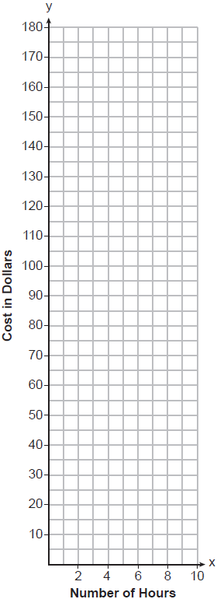

State the number of hours of classes when the centers will cost the same.

12 On the set of axes below, solve the following system of equations graphically. State the coordinates of the solution.
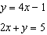

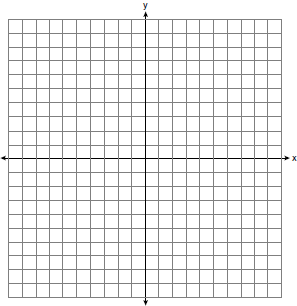

13 On the grid below, solve the system of equations graphically for x and y.
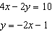



14 Next weekend Marnie wants to attend either carnival A or carnival B. Carnival A charges $6 for admission and an additional $1.50 per ride. Carnival B charges $2.50 for admission and an additional $2 per ride.
a) In function notation, write to represent the total cost of attending carnival A and going on x rides. In function notation, write to represent the total cost of attending carnival B and going on x rides.
b) Determine the number of rides Marnie can go on such that the total cost of attending each carnival is the same. [Use of the set of axes below is optional.]
c) Marnie wants to go on five rides. Determine which carnival would have the lower total cost. Justify your answer.

15 A local business was looking to hire a landscaper to work on their property. They narrowed their choices to two companies. Flourish Landscaping Company charges a flat rate of $120 per hour. Green Thumb Landscapers charges $70 per hour plus a $1600 equipment fee. Write a system of equations representing how much each company charges. Determine and state the number of hours that must be worked for the cost of each company to be the same. [The use of the grid below is optional.] If it is estimated to take at least 35 hours to complete the job, which company will be less expensive? Justify your answer.



16 Currently, Tyrone has $60 and his sister has $135. Both get an allowance of $5 each week. Tyrone decides to save his entire allowance, but his sister spends all of hers each week plus an additional $10 each week. After how many weeks will they each have the same amount of money? [The use of the grid is optional.]



17 Island Rent-a-Car charges a car rental fee of $40 plus $5 per hour or fraction of an hour. Wayne’s Wheels charges a car rental fee of $25 plus $7.50 per hour or fraction of an hour. Under what conditions does it cost less to rent from Island Rent-a-Car? [The use of the accompanying grid is optional.]

18 Franco and Caryl went to a bakery to buy desserts. Franco bought 3 packages of cupcakes and 2 packages of brownies for $19. Caryl bought 2 packages of cupcakes and 4 packages of brownies for $24. Let x equal the price of one package of cupcakes and y equal the price of one package of brownies. Write a system of equations that describes the given situation. On the set of axes below, graph the system of equations.

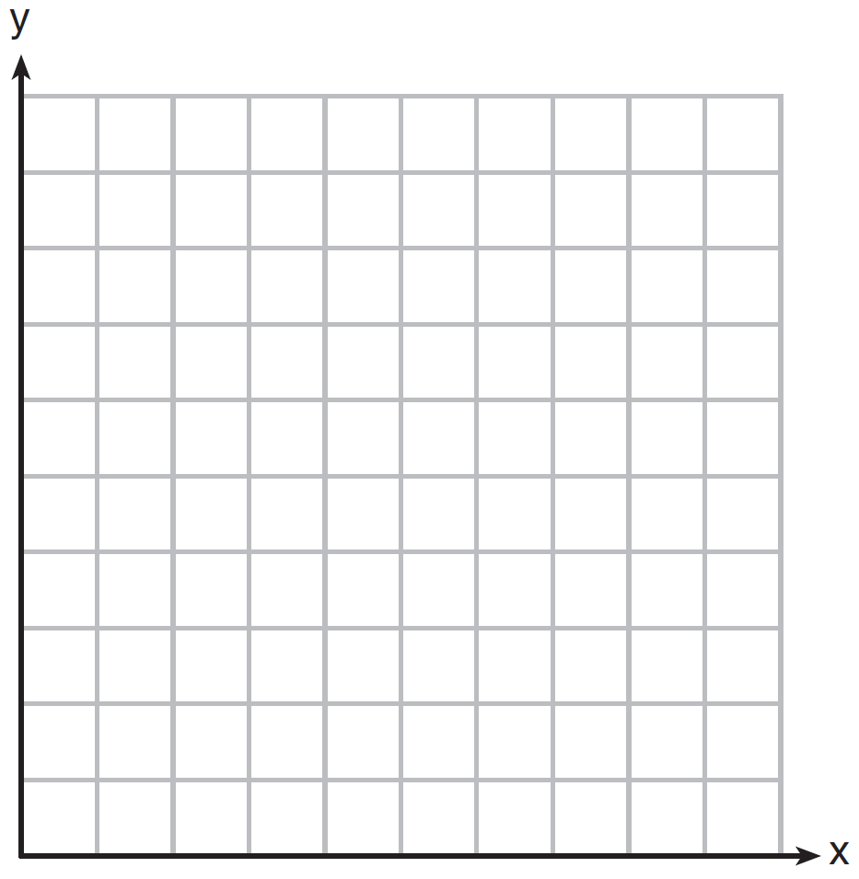

Determine the exact cost of one package of cupcakes and the exact cost of one package of brownies in dollars and cents. Justify your solution.

19 Central High School had five members on their swim team in 2010. Over the next several years, the team increased by an average of 10 members per year. The same school had 35 members in their chorus in 2010. The chorus saw an increase of 5 members per year. Write a system of equations to model this situation, where x represents the number of years since 2010. Graph this system of equations on the set of axes below.



Explain in detail what each coordinate of the point of intersection of these equations means in the context of this problem.
1 ANS: 3
REF: 081502ai

2 ANS: 3 REF: 011304ia

3 ANS: 3 REF: 081201ia

4 ANS:
$50, 5, $125, $10. 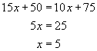.
REF: 089935a

5 ANS:
Plan A: , Plan B: . 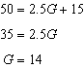 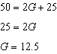 With Plan B, Dylan can rent 14 games, but with Plan A, Dylan can rent only 12. Bobby can choose either plan, as he could rent 20 games for $65 with both plans.
REF: 081728ai

6 ANS:
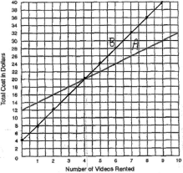. It is less expensive to rent 5 or more videos from Club A, as indicated from the graph above.
REF: spring9831a

7 ANS:
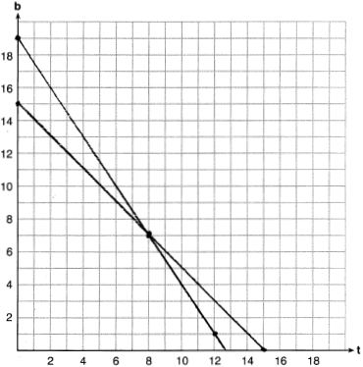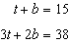 No, because according to the graph, 8 tricycles were ordered.
REF: 011937ai

8 ANS:
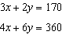 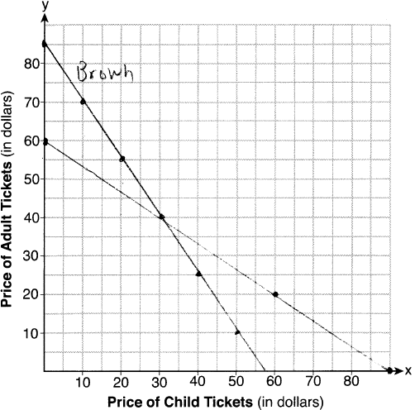 The price of a child’s ticket is $30 and the price of an adult’s ticket is $40.
REF: 012037ai

9 ANS:
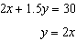 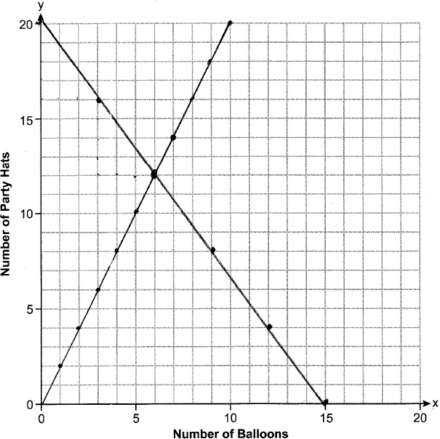 (6,12) is the intersection, meaning Anna bought 6 baloons and 12 hats.
REF: 012535ai

10 ANS:
a) Ron: , Josie: ; b) 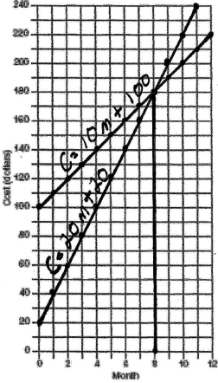 c) 8
REF: 060232a

11 ANS:
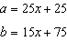; 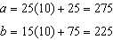 b will cost less; 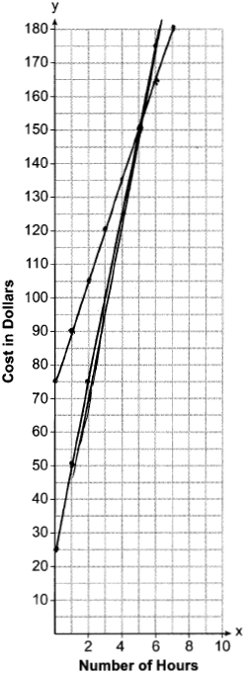; 5 hours
REF: 082337ai

12 ANS:
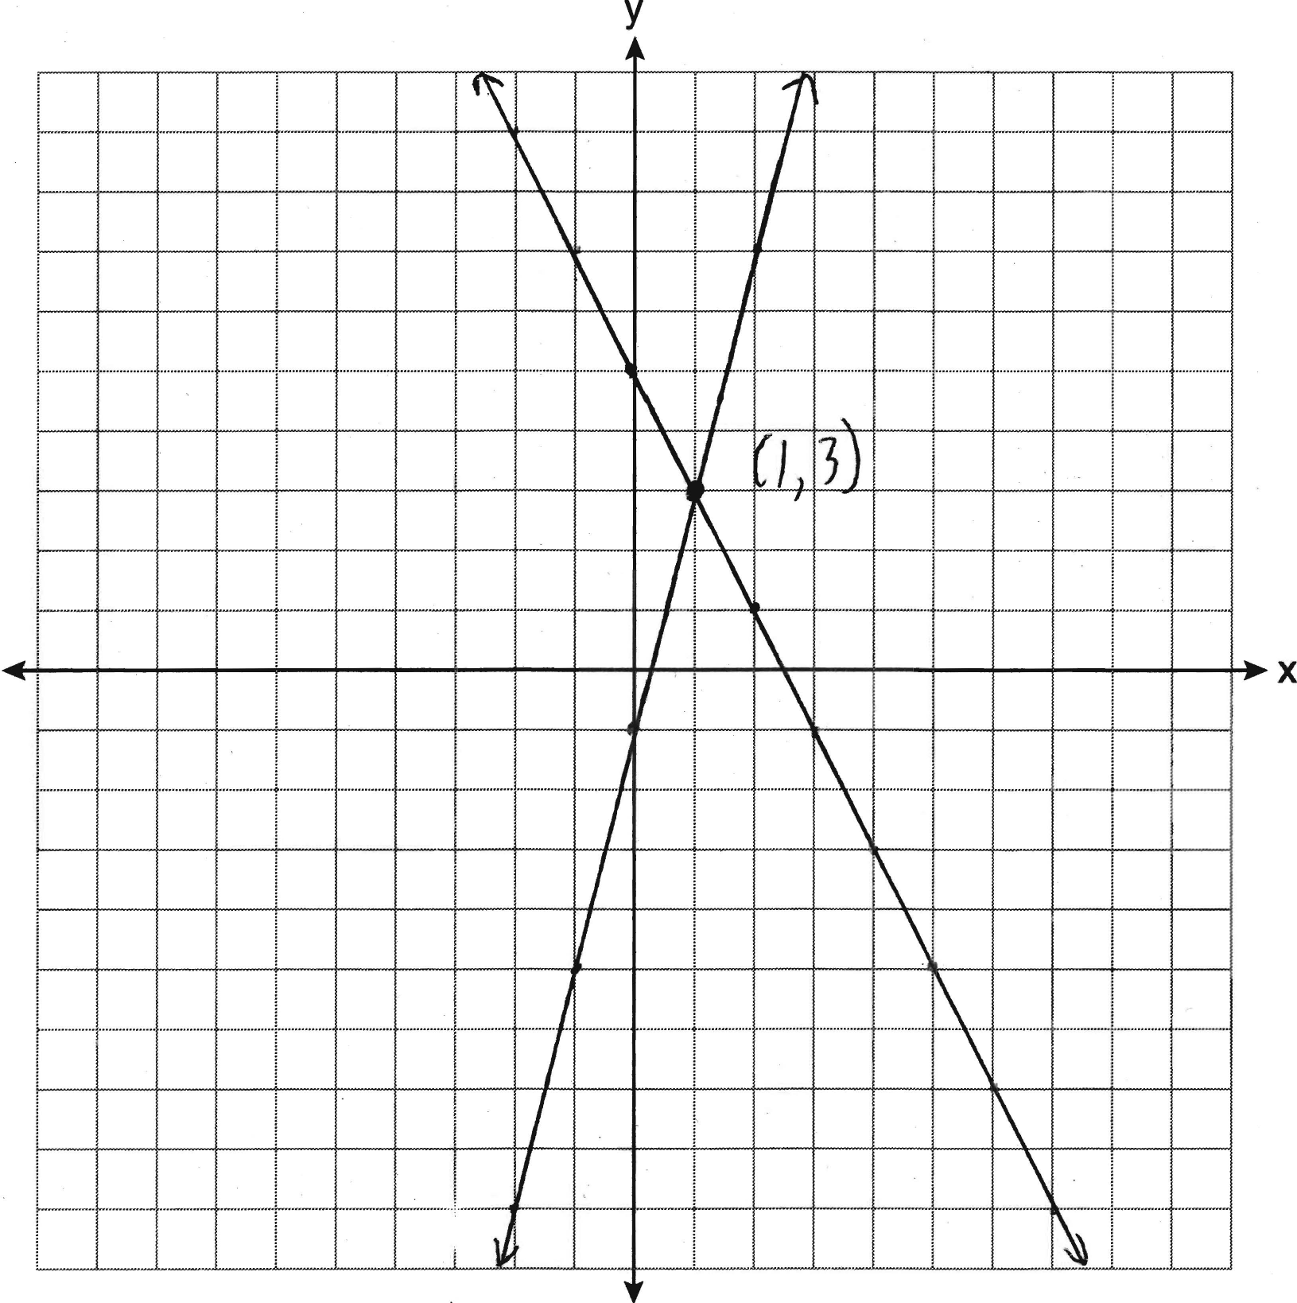
REF: 011235ia

13 ANS:
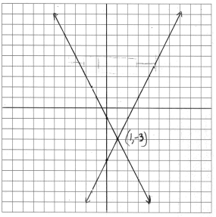
REF: 080938ia

14 ANS:
a) 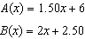 b) 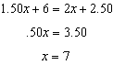 c) 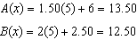 Carnival B has a lower cost.
REF: spr1308ai

15 ANS:
and 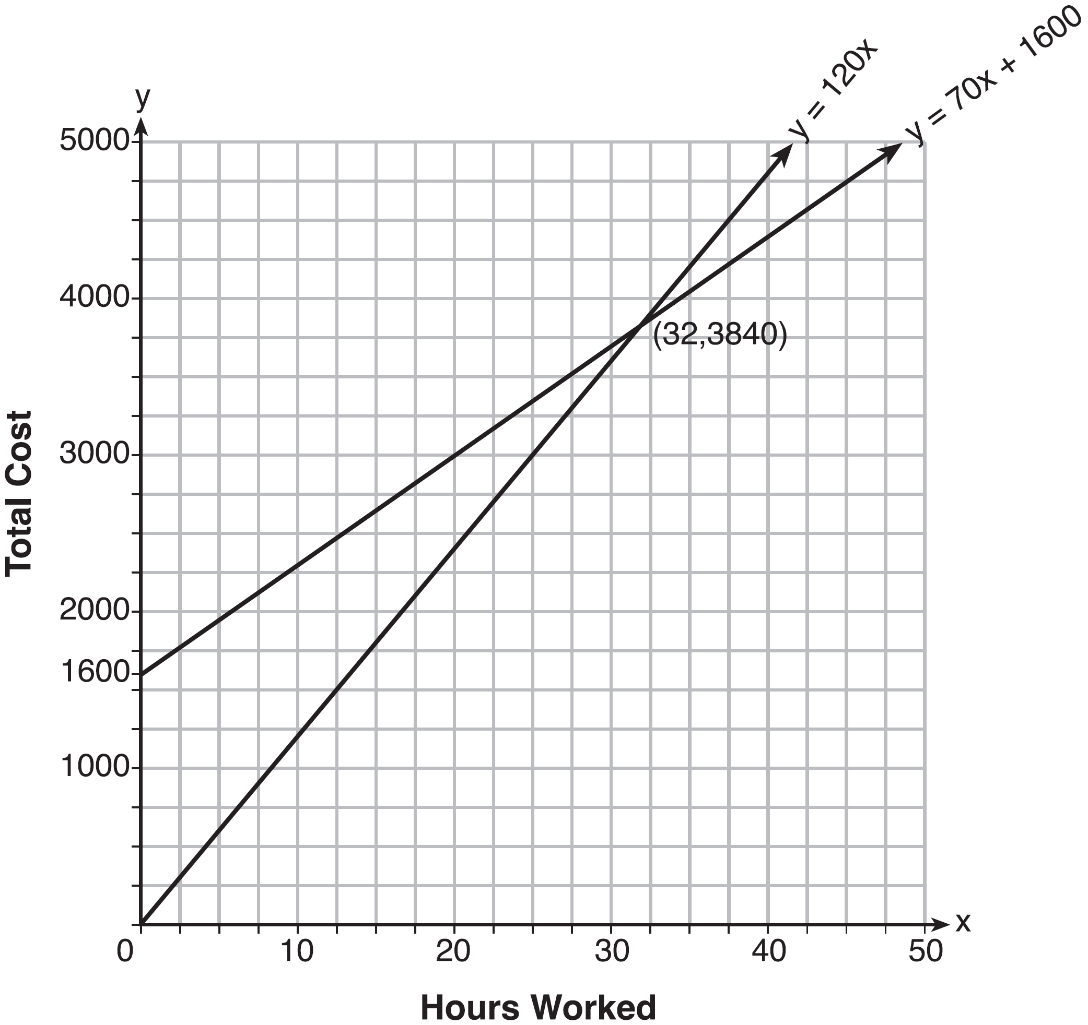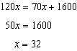 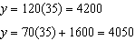 Green Thumb is less expensive.
REF: fall1315ai

16 ANS:
5. 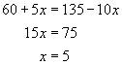. 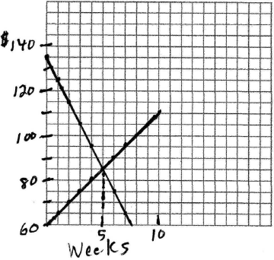
REF: 010329a

17 ANS:
. 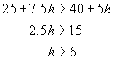. 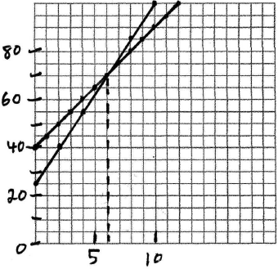
REF: 060226b

18 ANS:
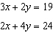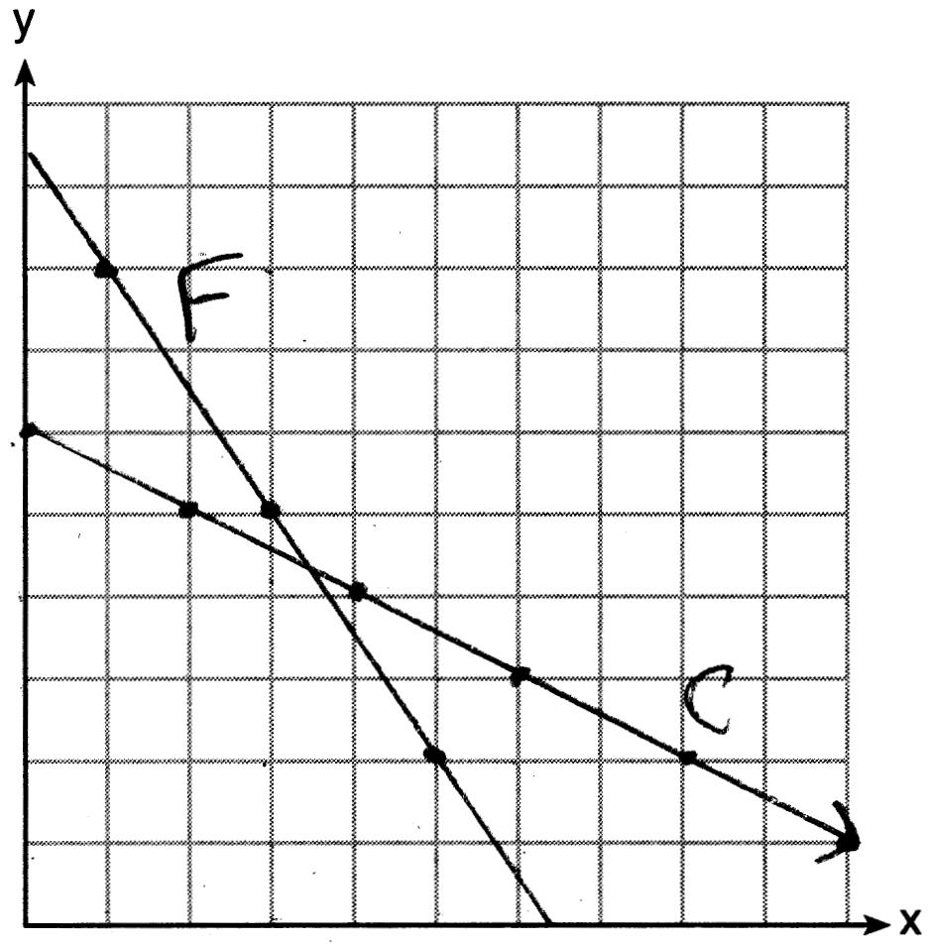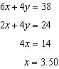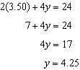
REF: 061637ai

19 ANS:
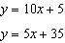 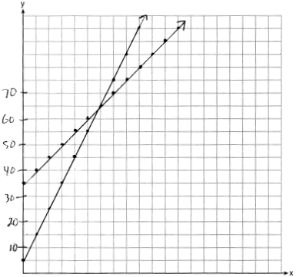 In 2016, the swim team and chorus will each have 65 members.
REF: 061737ai

