1 For the system shown below, what is the value of z?
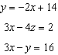
1) | 5
2) | 2
3) | 6
4) | 4

2 What is the value of y for the system shown below?
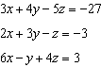
1)
2) | 6
3) | 3
4)

3 What is the value of x in the solution of the system of equations below?
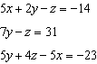
1) | -17
2) | 2
3)
4)

4 Consider the system below.
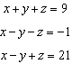
Which value is not in the solution, , of the system?
1)
2)
3) | 11
4) | 4

5 Consider the system of equations below:
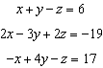
Which number is not the value of any variable in the solution of the system?
1)
2) | 2
3) | 3
4)

6 Which value is not contained in the solution of the system shown below?
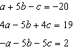
1)
2) | 2
3) | 3
4)

7 What is the solution for the system of equations below?
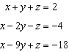
1)
2)
3)
4)

8 Consider the system of equations below?
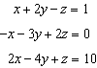
What is the solution to the given system of equations?
1)
2)
3)
4)

9 Solve the following system of equations algebraically for all values of x, y, and z:
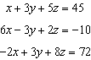

10 Solve the following system of equations algebraically for all values of a, b, and c.
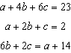

11 Solve the following system of equations algebraically for all values of x, y, and z:
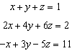

12 Solve the following system of equations algebraically for all values of x, y, and z:
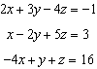

13 Solve the following system of equations algebraically for x, y, and z:
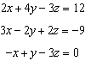

14 Solve the following system of equations algebraically for all values of x, y, and z:
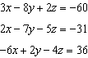

15 Seth has one less than twice the number of compact discs (CDs) that Jason has. Raoul has 53 more CDs than Jason has. If Seth gives Jason 25 CDs, Seth and Jason will have the same number of CDs. How many CDs did each of the three boys have to begin with?
1 ANS: 4
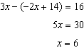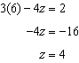

REF: 011803aii

2 ANS: 3
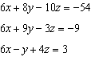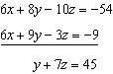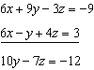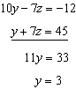

REF: 082421aii

3 ANS: 4
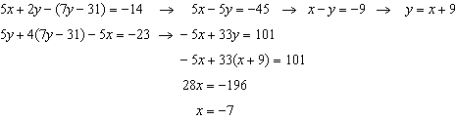

REF: 012515aii

4 ANS: 1
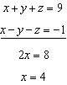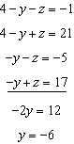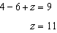

REF: 012018aii

5 ANS: 2
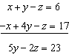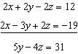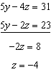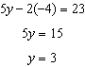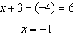

REF: 061923aii

6 ANS: 2
Combining (1) and (3): 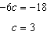 Combining (1) and (2): 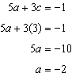 Using (3): 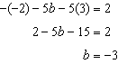

REF: 081623aii

7 ANS: 3
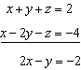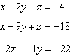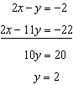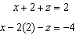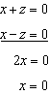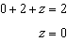

REF: 062311aii

8 ANS: 2
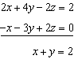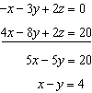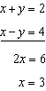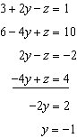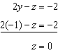

REF: 062208aii

9 ANS:
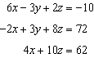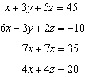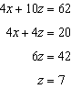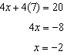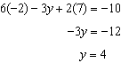

REF: spr1510aii

10 ANS:
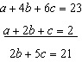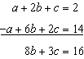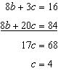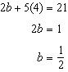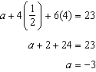

REF: 011933aii

11 ANS:
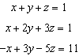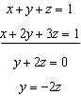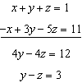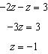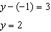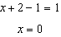

REF: 061733aii

12 ANS:
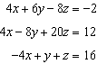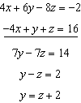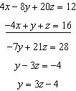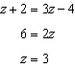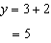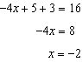

REF: 081833aii

13 ANS:
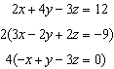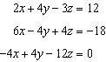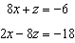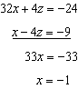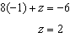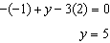

REF: 082335aii

14 ANS:
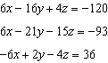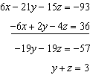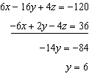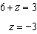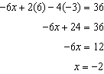

REF: 062433aii

15 ANS:
Seth=101, Jason=51, Raoul=104. 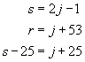. 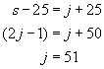. 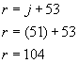. 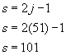

REF: 060326a

