1 A quadratic function and a linear function are graphed on the same set of axes. Which situation is not possible?
1) | The graphs do not intersect. | 3) | The graphs intersect in two points.
2) | The graphs intersect in one point. | 4) | The graphs intersect in three points.

2 Solve the systems of equations algebraically for all values of x and y:
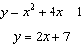

3 Solve the following system of equations algebraically for all values of x and y:
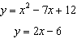

4 Solve the following systems of equations algebraically for all values of x and y:
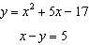

5 Graph the following system of equations on the set of axes below.
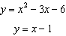

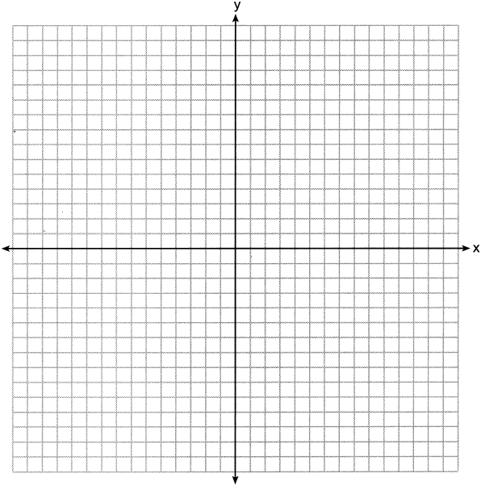

State the coordinates of all solutions.
1 ANS: 4
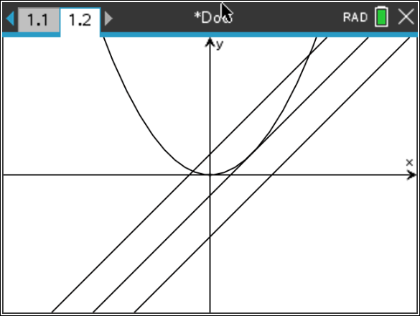

REF: 062216ai

2 ANS:
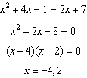 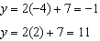 (-4,-1), (2,11)

REF: 082434ai

3 ANS:
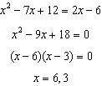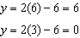

REF: 012534ai

4 ANS:
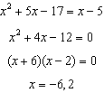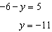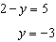
REF: fall2305ai

5 ANS:
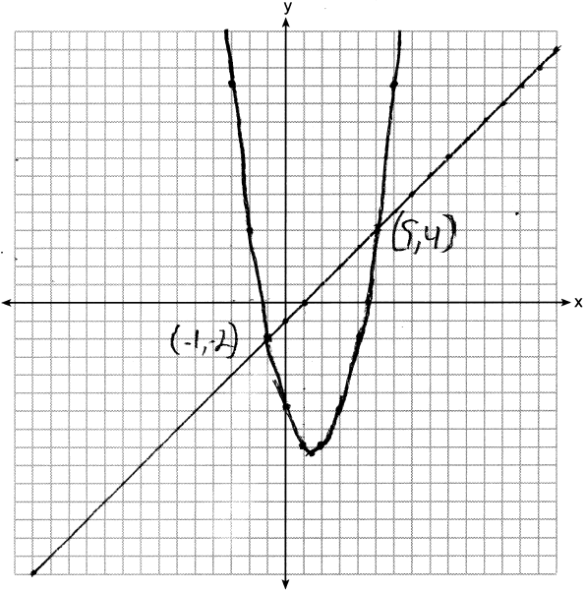
REF: 062431ai

