1 Selected values for the functions f and g are shown in the tables below.

x | f(x) |  | x | g(x)
0 |  |  | 0 | 0.58
1.23 |  |  | 8.52 | 2.53
8.52 | 2.53 |  | 13.11 | 3.01
9.01 | 3.01 |  | 16.52 | 3.29

A solution to the equation is
1) | 0 | 3) | 3.01
2) | 2.53 | 4) | 8.52

2 The path of a rocket is represented by the equation . The path of a missile designed to intersect the path of the rocket is represented by the equation 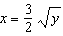. The value of x at the point of intersection is 3. What is the corresponding value of y?
1) |  | 3)
2) | 2 | 4) | 4

3 Which value, to the nearest tenth, is not a solution of if and ?
1) |  | 3) | 2.1
2) |  | 4) | 4.7

4 If and , an approximate solution for the equation is
1) | 1.96 | 3)
2) | 11.29 | 4)

5 If and , then how many real solutions are there to the equation ?
1) | 1 | 3) | 6
2) | 2 | 4) | 4

6 A landscape architect's designs for a town park call for two parabolic-shaped walkways. When the park is mapped on a Cartesian coordinate plane, the pathways intersect at two points. If the equations of the curves of the walkways are and , determine the coordinates of the two points of intersection. [Only an algebraic solution can receive full credit.]

7 Given: 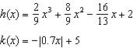
State the solutions to the equation , rounded to the nearest hundredth.

8 On the set of axes below, graph and for the given functions.
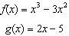

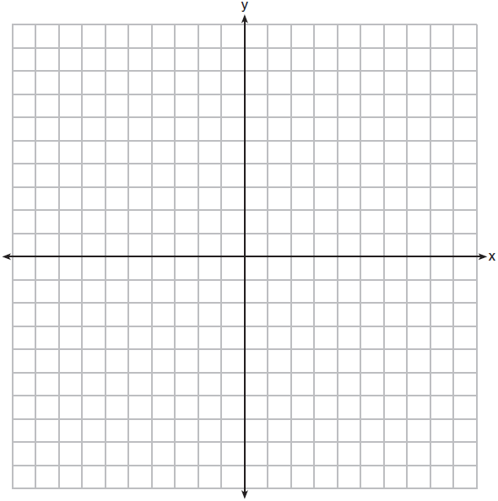

State the number of solutions to the equation .
1 ANS: 4 REF: 061914aii

2 ANS: 4
. 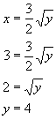

REF: 060205b

3 ANS: 4
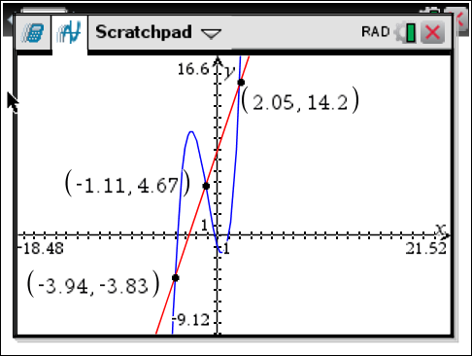

REF: 061622aii

4 ANS: 2
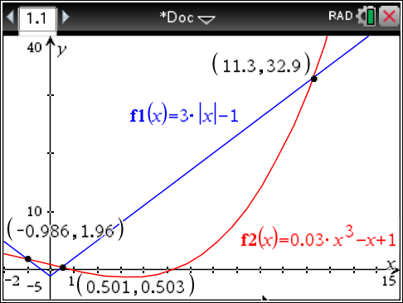

REF: 061705aii

5 ANS: 2
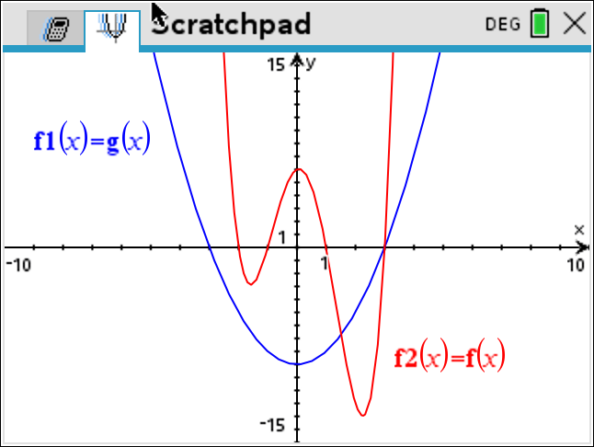

REF: 082319aii

6 ANS:
. 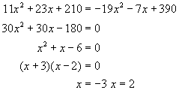 . . 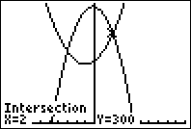

REF: 080831b

7 ANS:
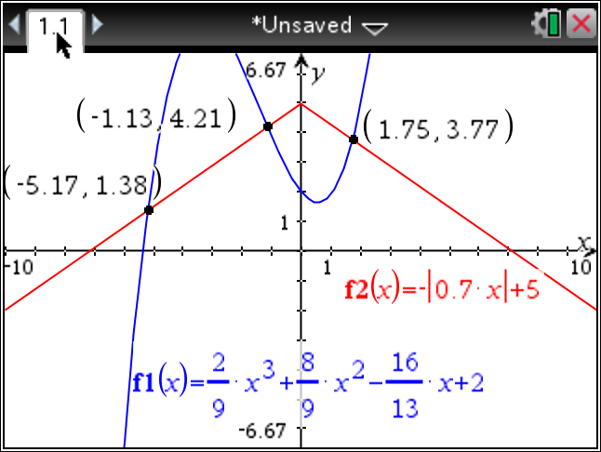

REF: fall1510aii

8 ANS:
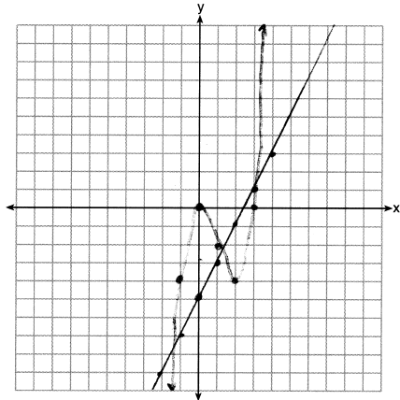 3

REF: 062233aii

