1 The graphs of the equations and intersect in Quadrant I for which values of a?
1) |  | 3)
2) |  | 4)

2 To the nearest tenth, the value of x that satisfies is
1) | 2.5 | 3) | 5.8
2) | 2.6 | 4) | 5.9

3 The equations and approximately model the growth of two separate populations where . What is the best approximation of the time, t, at which the populations are the same?
1) |  | 3) | 5.1
2) | 0.3 | 4) | 21.3

4 The flight paths of two Thunderbird jets are plotted on a Cartesian coordinate plane, and the equations of the jets' flight paths are represented by and . The best approximation of the intersection of the flight paths is
1) |  | 3)
2) |  | 4)

5 Pedro and Bobby each own an ant farm. Pedro starts with 100 ants and says his farm is growing exponentially at a rate of 15% per month. Bobby starts with 350 ants and says his farm is steadily decreasing by 5 ants per month. Assuming both boys are accurate in describing the population of their ant farms, after how many months will they both have approximately the same number of ants?
1) | 7 | 3) | 13
2) | 8 | 4) | 36

6 The populations of two small towns at the beginning of 2018 and their annual population growth rate are shown in the table below.

Town | Population | Annual Population  Growth Rate
Jonesville | 1240 | 6% increase
Williamstown | 890 | 11% increase

Assuming the trend continues, approximately how many years after the beginning of 2018 will it take for the populations to be equal?
1) | 7 | 3) | 68
2) | 20 | 4) | 125

7 During the summer, Adam saved $4000 and Betty saved $3500. Adam deposited his money in Bank A at an annual rate of 2.4% compounded monthly. Betty deposited her money in Bank B at an annual rate of 4% compounded quarterly. Write two functions that represent the value of each account after t years if no other deposits or withdrawals are made, where Adam's account value is represented by , and Betty's by . Using technology, determine, to the nearest tenth of a year, how long it will take for the two accounts to have the same amount of money in them. Justify your answer.

8 Researchers in a local area found that the population of rabbits with an initial population of 20 grew continuously at the rate of 5% per month. The fox population had an initial value of 30 and grew continuously at the rate of 3% per month. Find, to the nearest tenth of a month, how long it takes for these populations to be equal.

9 On a certain tropical island, there are currently 500 palm trees and 200 flamingos. Suppose the palm tree population is decreasing at an annual rate of 3% per year and the flamingo population is growing at a continuous rate of 2% per year. Write two functions, and , that represent the number of palm trees and flamingos on this island, respectively, x years from now. State the solution to the equation , rounded to the nearest year. Interpret the meaning of this value within the given context.

10 Objects cool at different rates based on the formula below.
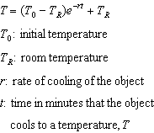
Mark makes T-shirts using a hot press to transfer designs to the shirts. He removes a shirt from a press that heats the shirt to 400°F. The rate of cooling for the shirt is 0.0735 and the room temperature is 75°F. Using this information, write an equation for the temperature of the shirt, T, after t minutes. Use the equation to find the temperature of the shirt, to the nearest degree, after five minutes. At the same time, Mark's friend Jeanine removes a hoodie from a press that heats the hoodie to 450°F. After eight minutes, the hoodie measured 270°F. The room temperature is still 75°F. Determine the rate of cooling of the hoodie, to the nearest ten thousandth. The T-shirt and hoodie were removed at the same time. Determine when the temperature will be the same, to the nearest minute.

11 On the accompanying grid, sketch the graphs of and over the interval . Identify and state the coordinates of all points of intersection.



12 On the accompanying grid, solve the following system of equations graphically:
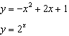



13 The populations of honeybees in two different colonies are studied for four months. During this time, the colony population can be approximated by , where is the colony population of bees at t months, is the initial population, and r is the growth rate. Colony A has an initial population of 10,000 bees and a continuous growth rate of 0.25. Colony B has an initial population of 6000 bees and a continuous growth rate of 0.45. Write functions for both and that model the honeybee populations of the colonies after t months. Graph and for .

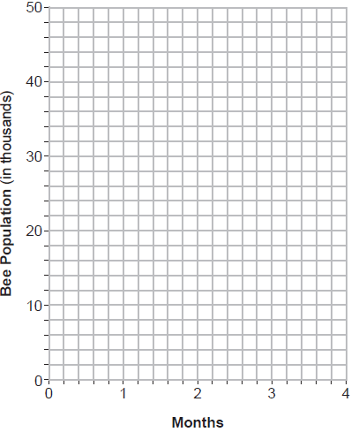

State, to the nearest tenth of a month, when the colonies will have the same population. Determine algebraically how long it will take, to the nearest tenth of a month, for the population in Colony A to triple.

14 A technology company is comparing two plans for speeding up its technical support time. Plan A can be modeled by the function and plan B can be modeled by the function where x is the number of customer service representatives employed by the company and and represent the average wait time, in minutes, of each customer. Graph and in the interval on the set of axes below.

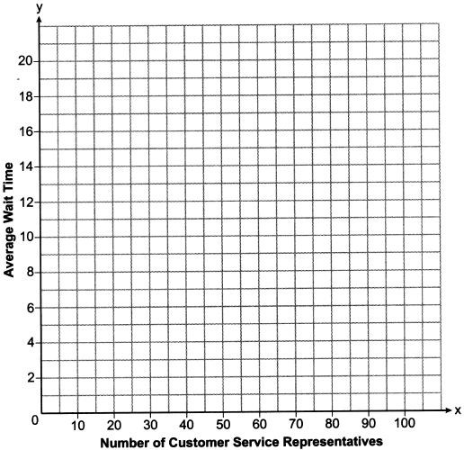

To the nearest integer, solve the equation . Determine, to the nearest minute, . Explain what this value represents in the given context.

15 The value of a certain small passenger car based on its use in years is modeled by , where is the value in dollars and t is the time in years. Zach had to take out a loan to purchase the small passenger car. The function , where is measured in dollars, and t is the time in years, models the unpaid amount of Zach's loan over time. Graph and over the interval , on the set of axes below.

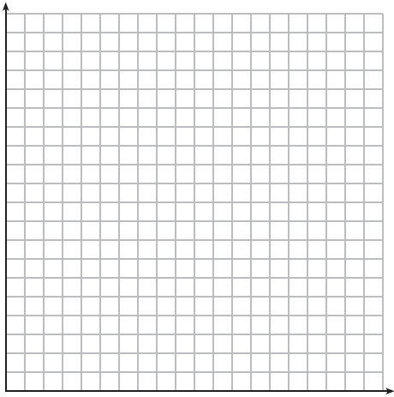

State when , to the nearest hundredth, and interpret its meaning in the context of the problem. Zach takes out an insurance policy that requires him to pay a $3000 deductible in case of a collision. Zach will cancel the collision policy when the value of his car equals his deductible. To the nearest year, how long will it take Zach to cancel this policy? Justify your answer.

16 Drugs break down in the human body at different rates and therefore must be prescribed by doctors carefully to prevent complications, such as overdosing. The breakdown of a drug is represented by the function , where is the amount left in the body, is the initial dosage, r is the decay rate, and t is time in hours. Patient A, , is given 800 milligrams of a drug with a decay rate of 0.347. Patient B, , is given 400 milligrams of another drug with a decay rate of 0.231. Write two functions, and , to represent the breakdown of the respective drug given to each patient. Graph each function on the set of axes below.



To the nearest hour, t, when does the amount of the given drug remaining in patient B begin to exceed the amount of the given drug remaining in patient A? The doctor will allow patient A to take another 800 milligram dose of the drug once only 15% of the original dose is left in the body. Determine, to the nearest tenth of an hour, how long patient A will have to wait to take another 800 milligram dose of the drug.
1 ANS: 4
The function passes through Quadrant I only if The function intersects the y-axis at and continues through Quadrant I with a positive slope. If the graphs of the equations intersect at (0,1), which is not in Quadrant I. Therefore,

REF: 060519b

2 ANS: 2
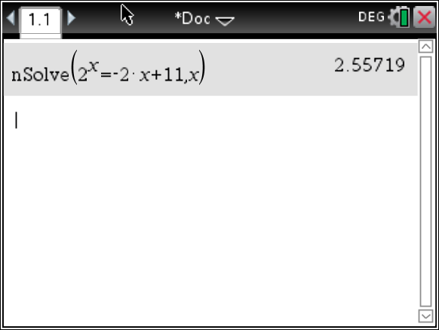

REF: 081603aii

3 ANS: 3
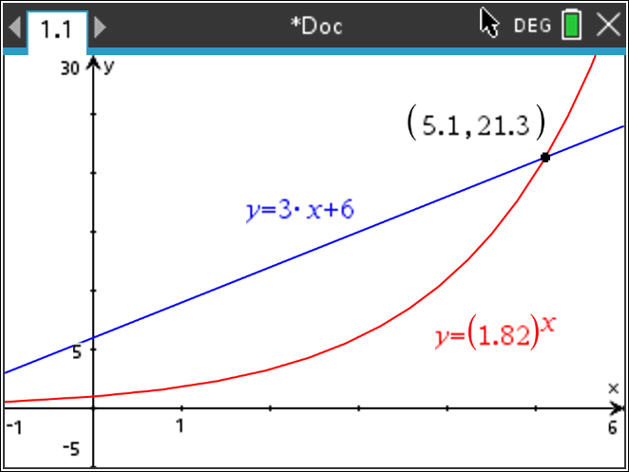

REF: 012406aii

4 ANS: 1
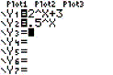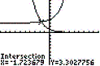

REF: 080705b

5 ANS: 2
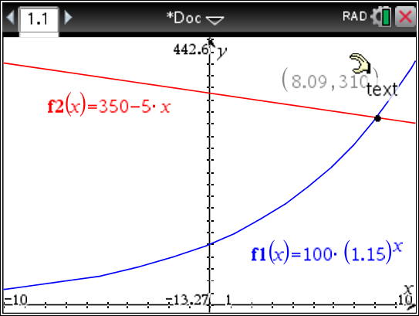

REF: 011716aii

6 ANS: 1
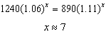

REF: 061814aii

7 ANS:
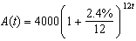 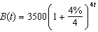 8.4, the value of t for which

REF: 012435aii

8 ANS:
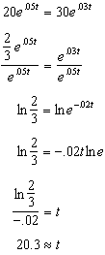

REF: 011829aii

9 ANS:
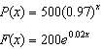; 18; The number of palm trees and flamingos will be equal in 18 years.

REF: 062336aii

10 ANS:
, , 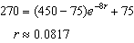, 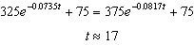

REF: 012337aii

11 ANS:
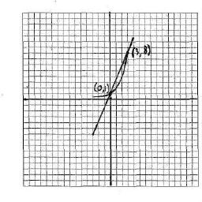

REF: 010628b

12 ANS:
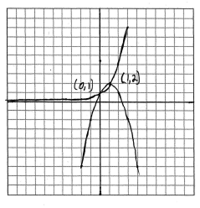

REF: 010527b

13 ANS:
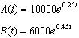 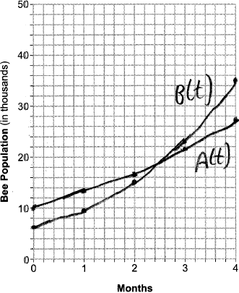 2.6 months for same. 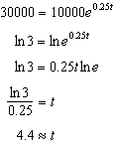

REF: 012537aii

14 ANS:
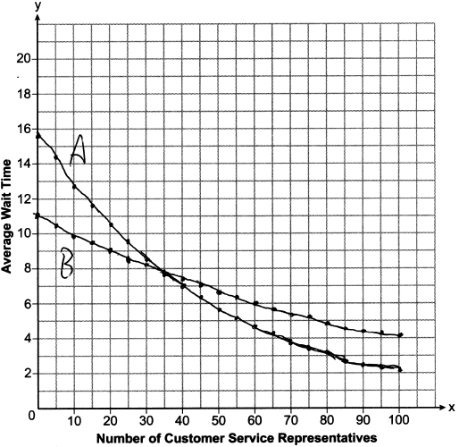35; , which represents the difference of the average wait time when there are 100 CSRs between the plans.

REF: 082237aii

15 ANS:
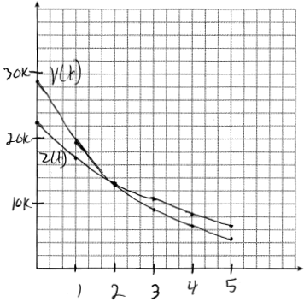 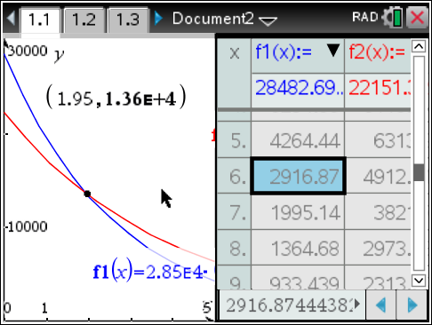 At 1.95 years, the value of the car equals the loan balance. Zach can cancel the policy after 6 years.

REF: 081737aii

16 ANS:
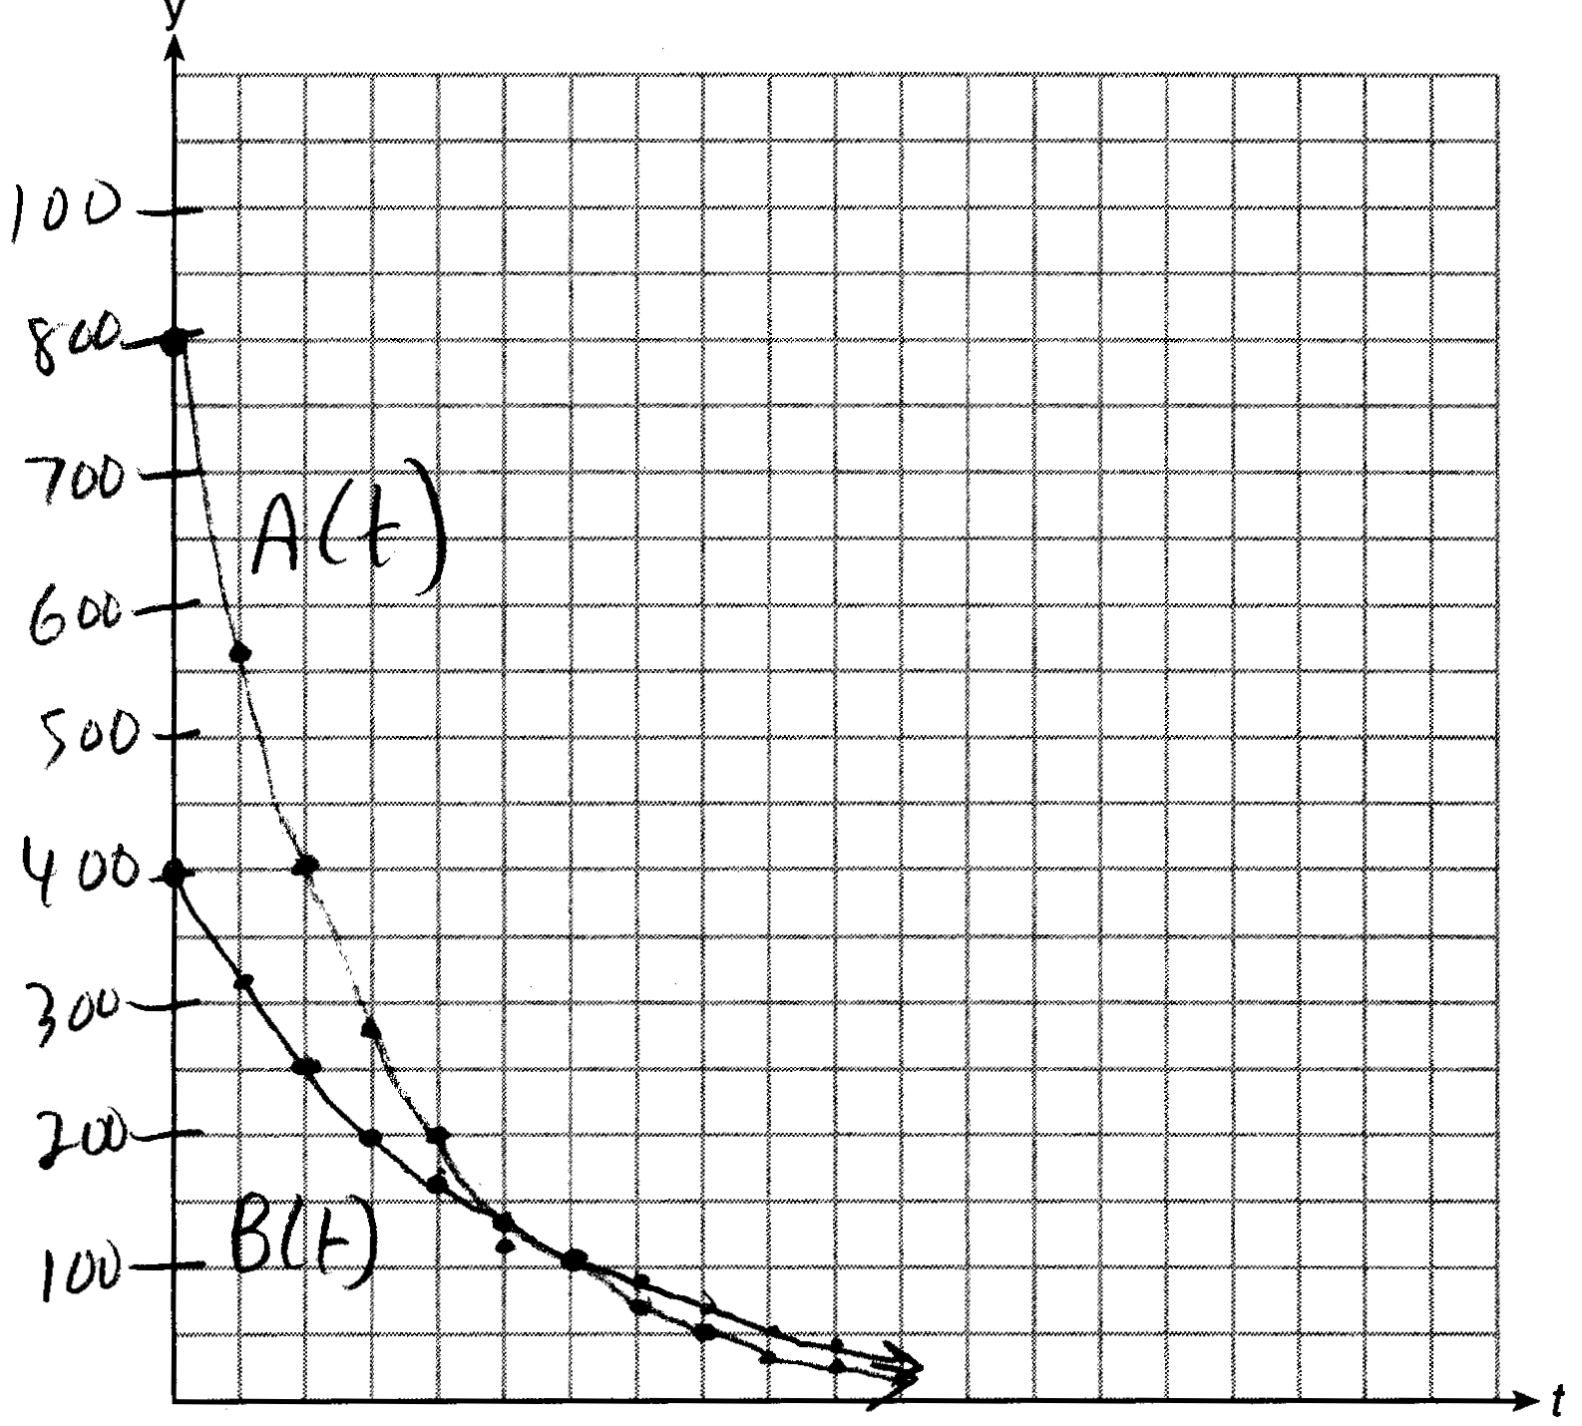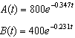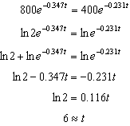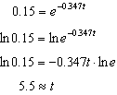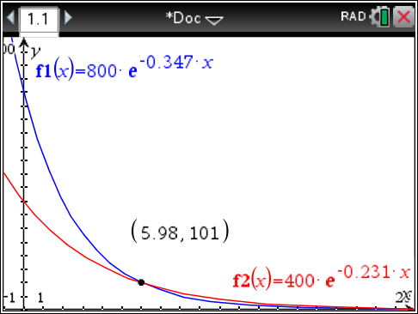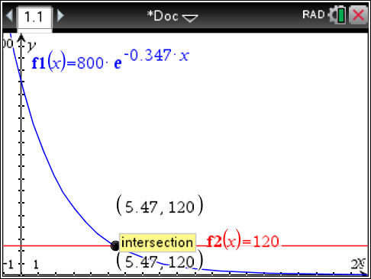

REF: 061637aii

