1 What is the total number of points of intersection of the graphs of the equations and ?
1) | 1 | 3) | 3
2) | 2 | 4) | 4

2 What is the total number of points of intersection of the graphs of the equations and ?
1) | 1 | 3) | 3
2) | 2 | 4) | 0

3 How many solutions exist for 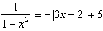?
1) | 1 | 3) | 3
2) | 2 | 4) | 4

4 Given the functions 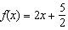 and 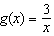, what are the solutions to ?
1) | or | 3) | or
2) | or | 4)

5 Which value, to the nearest tenth, is an approximate solution for the equation , if 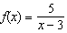 and ?
1) | 3.2 | 3) | 4.0
2) | 3.9 | 4) | 5.6

6 When 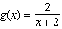 and are graphed on the same set of axes, which coordinates best approximate their point of intersection?
1) |  | 3)
2) |  | 4)

7 Determine algebraically the x-coordinate of all points where the graphs of and intersect.

8 Solve the system of equations algebraically for x and y: 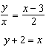

9 Sketch the graphs of 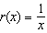 and on the set of axes below. Determine, to the nearest tenth, the positive solution of .

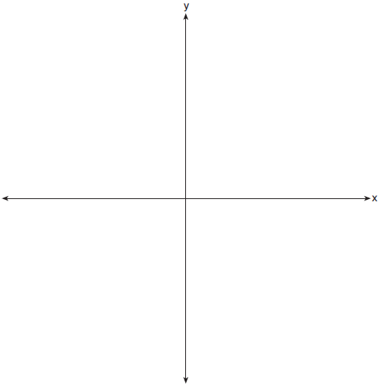

10 Sarah is fighting a sinus infection. Her doctor prescribed a nasal spray and an antibiotic to fight the infection. The active ingredients, in milligrams, remaining in the bloodstream from the nasal spray, , and the antibiotic, , are modeled in the functions below, where t is the time in hours since the medications were taken.
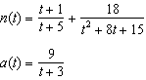
Determine which drug is made with a greater initial amount of active ingredient. Justify your answer. Sarah's doctor told her to take both drugs at the same time. Determine algebraically the number of hours after taking the medications when both medications will have the same amount of active ingredient remaining in her bloodstream.
1 ANS: 1
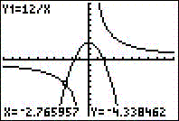

REF: 010704b

2 ANS: 1
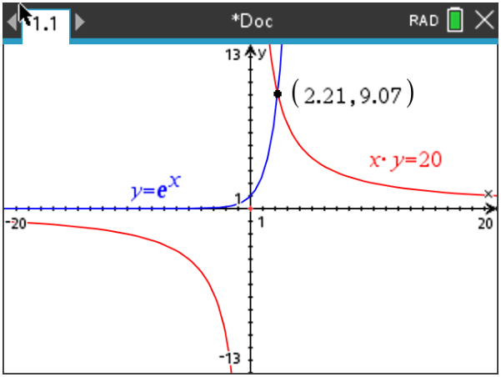

REF: 082210aii

3 ANS: 4
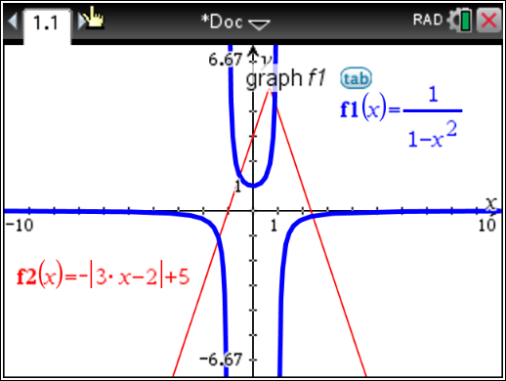

REF: 011924aii

4 ANS: 2
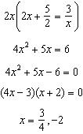

REF: 012504aii

5 ANS: 2
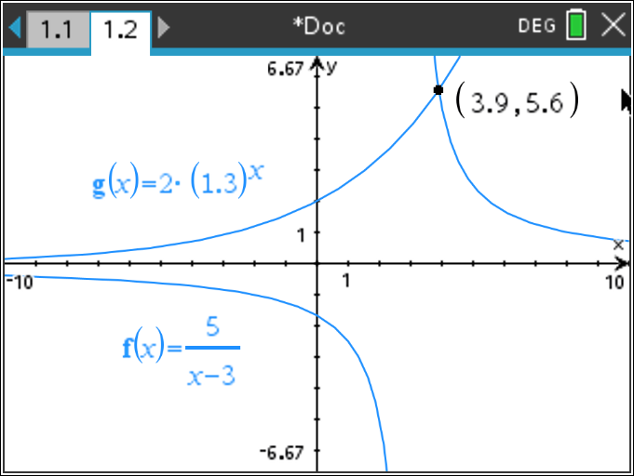

REF: 062402aii

6 ANS: 2
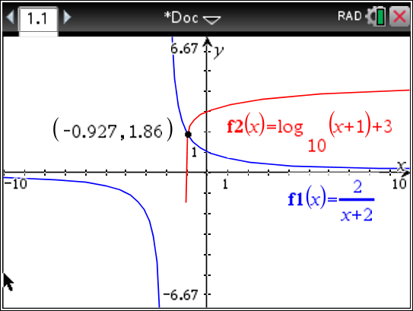

REF: 011712aii

7 ANS:
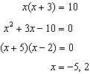

REF: 011431a2

8 ANS:
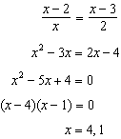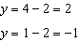

REF: 011737a2

9 ANS:
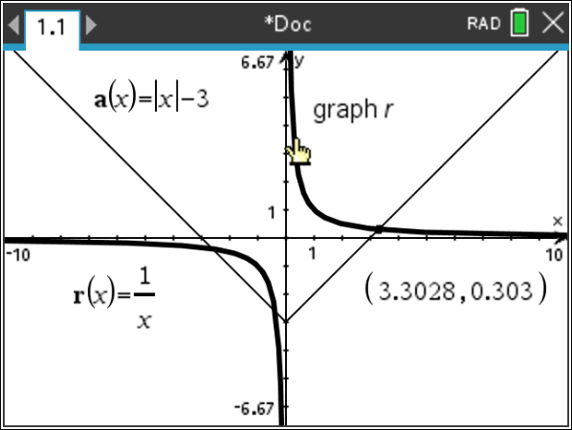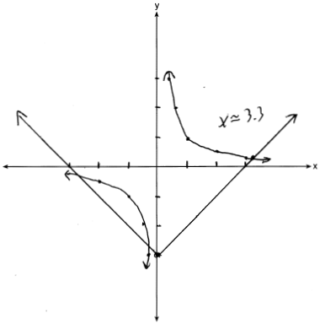

REF: 081932aii

10 ANS:
antibiotic 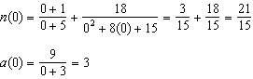 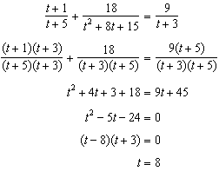

REF: 012037aii

