1 For all real values of x, if and , what is ?
1) |  | 3)
2) | 0 | 4)

2 Functions f and g are given below.
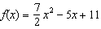
When is subtracted from , the result is
1) |  | 3)
2) |  | 4)

3 If and , which operation would not result in a polynomial expression?
1) |  | 3)
2) |  | 4)

4 If and , then which statement is not true?
1) |  | 3)
2) |  | 4) | 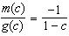

5 If and , then equals
1) |  | 3)
2) |  | 4)

6 Given and , what is for all defined values?
1) |  | 3)
2) |  | 4)

7 The volume of a cardboard box can be modeled by , which is the product of the length, width, and height, x. If the length can be represented by and the width can be represented by , then which function represents ?
1) |  | 3)
2) |  | 4)

8 Chet has $1200 invested in a bank account modeled by the function , where is the value of his account, in dollars, after n months. Chet's debt is modeled by the function , where is the value of debt, in dollars, after n months. After n months, which function represents Chet's net worth, ?
1) |  | 3)
2) |  | 4)

9 The revenue, , from selling x units of a product is represented by the equation , while the total cost, , of making x units of the product is represented by the equation . The total profit, , is represented by the equation . For the values of and given above, what is ?
1) |  | 3)
2) |  | 4)

10 A company produces x units of a product per month, where represents the total cost and represents the total revenue for the month. The functions are modeled by and . The profit is the difference between revenue and cost where . What is the total profit, , for the month?
1) |  | 3)
2) |  | 4)

11 Stone Manufacturing has developed a cost model, , where x is the number of sprockets sold, in thousands. The sales price can be modeled by and the company’s revenue by . The company's profits, , could be modeled by
1) |  | 3)
2) |  | 4)

12 A manufacturing company has developed a cost model, , where x is the number of items sold, in thousands. The sales price can be modeled by . Therefore, revenue is modeled by . The company's profit, , could be modeled by
1) |  | 3)
2) |  | 4)

13 The profit function, , for a company is the cost function, , subtracted from the revenue function, . The profit function for the Acme Corporation is and the revenue function is . The cost function for the Acme Corporation is
1) |  | 3)
2) |  | 4)

14 The profit function, , is found by subtracting the cost function, , from the revenue function, . Which function below represents the cost function given and ?
1) |  | 3)
2) |  | 4)

15 Given that , find if .

16 Given: and
Express as a polynomial in standard form.

17 Write the expression as a polynomial in standard form.
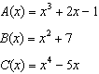

18 A company calculates its profit by finding the difference between revenue and cost. The cost function of producing x hammers is . If each hammer is sold for $10, the revenue function for selling x hammers is . How many hammers must be sold to make a profit? How many hammers must be sold to make a profit of $100?
1 ANS: 3

REF: 062210aii

2 ANS: 2

REF: 012513aii

3 ANS: 4 REF: 081803aii

4 ANS: 4
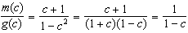

REF: 061608aii

5 ANS: 3 REF: 011710aii

6 ANS: 1
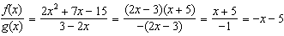

REF: 012412aii

7 ANS: 2

REF: 082418aii

8 ANS: 3 REF: 012002aii

9 ANS: 3
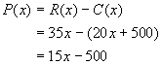

REF: 010220b

10 ANS: 2

REF: 081406ai

11 ANS: 3

REF: 082322aii

12 ANS: 2

REF: 061709aii

13 ANS: 1
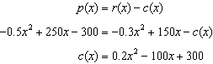

REF: 061813aii

14 ANS: 3
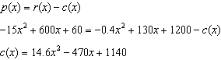

REF: 062421aii

15 ANS:

REF: 061625ai

16 ANS:
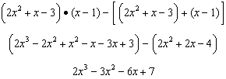

REF: 011833aii

17 ANS:
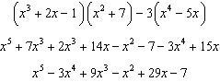

REF: 012330aii

18 ANS:
29, 45. 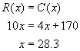. If you round down to 28 hammers, the company does not make a profit. Round up to 29. To make a profit of $100, 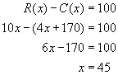.

REF: 080332b

