1 Given the function defined by the following:
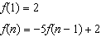
Which set could represent the range of the function?
1) |  | 3)
2) |  | 4)

2 If and , then
1) |  | 3) | 21
2) | 11 | 4) | 43

3 If a sequence is defined recursively by and for , then is equal to
1) | 1 | 3) | 5
2) |  | 4) | 17

4 Which function defines the sequence , where ?
1) |  | 3)
2) |  | 4)

5 Given , which function can be used to generate the sequence ?
1) |  | 3)
2) |  | 4)

6 Which recursively defined function has a first term equal to 10 and a common difference of 4?
1) | 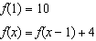 | 3) | 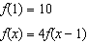
2) | 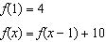 | 4) | 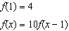

7 If the pattern below continues, which equation(s) is a recursive formula that represents the number of squares in this sequence?

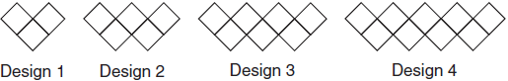
1) |  | 3) | 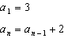
2) |  | 4) | 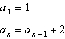

8 Given the pattern below, which recursive formula represents the number of triangles in this sequence?

1) |  | 3) | 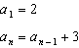
2) |  | 4)

9 Which recursively defined function represents the sequence ?
1) |  | 3)
2) |  | 4)

10 A sunflower is 3 inches tall at week 0 and grows 2 inches each week. Which function(s) shown below can be used to determine the height, , of the sunflower in n weeks?
I.
II.
III.
1) | I and II | 3) | III, only
2) | II, only | 4) | I and III

1 ANS: 2
; ; ;

REF: 061718ai

2 ANS: 4

REF: 081424ai

3 ANS: 3
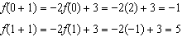

REF: 011520ai

4 ANS: 1 REF: 081610ai

5 ANS: 3 REF: 061720aii

6 ANS: 1 REF: 081514ai

7 ANS: 3 REF: 011818ai

8 ANS: 4 REF: 062121ai

9 ANS: 3 REF: 011618ai

10 ANS: 4 REF: 061421ai

