1 What is the inverse of the function ?
1) | 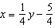
2) | 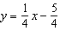
3)
4) | 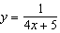

2 If , then the inverse function is
1) | 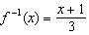
2) | 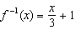
3) | 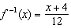
4) | 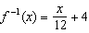

3 If 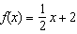, then the inverse function is
1) | 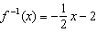
2) | 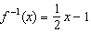
3)
4)

4 Given 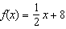, which equation represents the inverse, ?
1)
2)
3) | 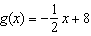
4) | 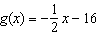

5 What is the inverse of ?
1) | 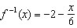
2) | 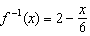
3) | 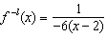
4)

6 The inverse of 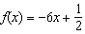 is
1) | 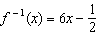
2) | 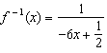
3) | 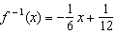
4) | 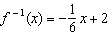

7 Given 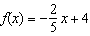, which statement is true of the inverse function ?
1) | is a line with slope .
2) | is a line with slope .
3) | passes through the point .
4) | has a y-intercept at .

8 Given 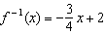, which equation represents ?
1) | 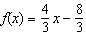
2) | 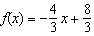
3) | 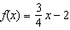
4) | 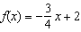

9 Given the inverse function 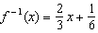, which function represents ?
1) | 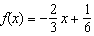
2) | 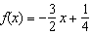
3) | 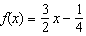
4) | 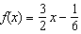

1 ANS: 2
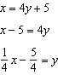

REF: 061909aii

2 ANS: 3
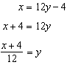

REF: 082304aii

3 ANS: 3
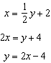

REF: 012315aii

4 ANS: 2
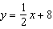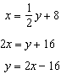

REF: 081806aii

5 ANS: 2
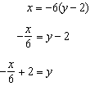

REF: 011821aii

6 ANS: 3
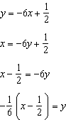

REF: 062217aii

7 ANS: 3
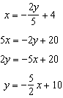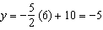

REF: 082223aii

8 ANS: 2
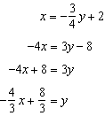

REF: 061616aii

9 ANS: 3
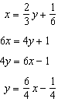

REF: 062321aii

