1 The graph of is shown below.

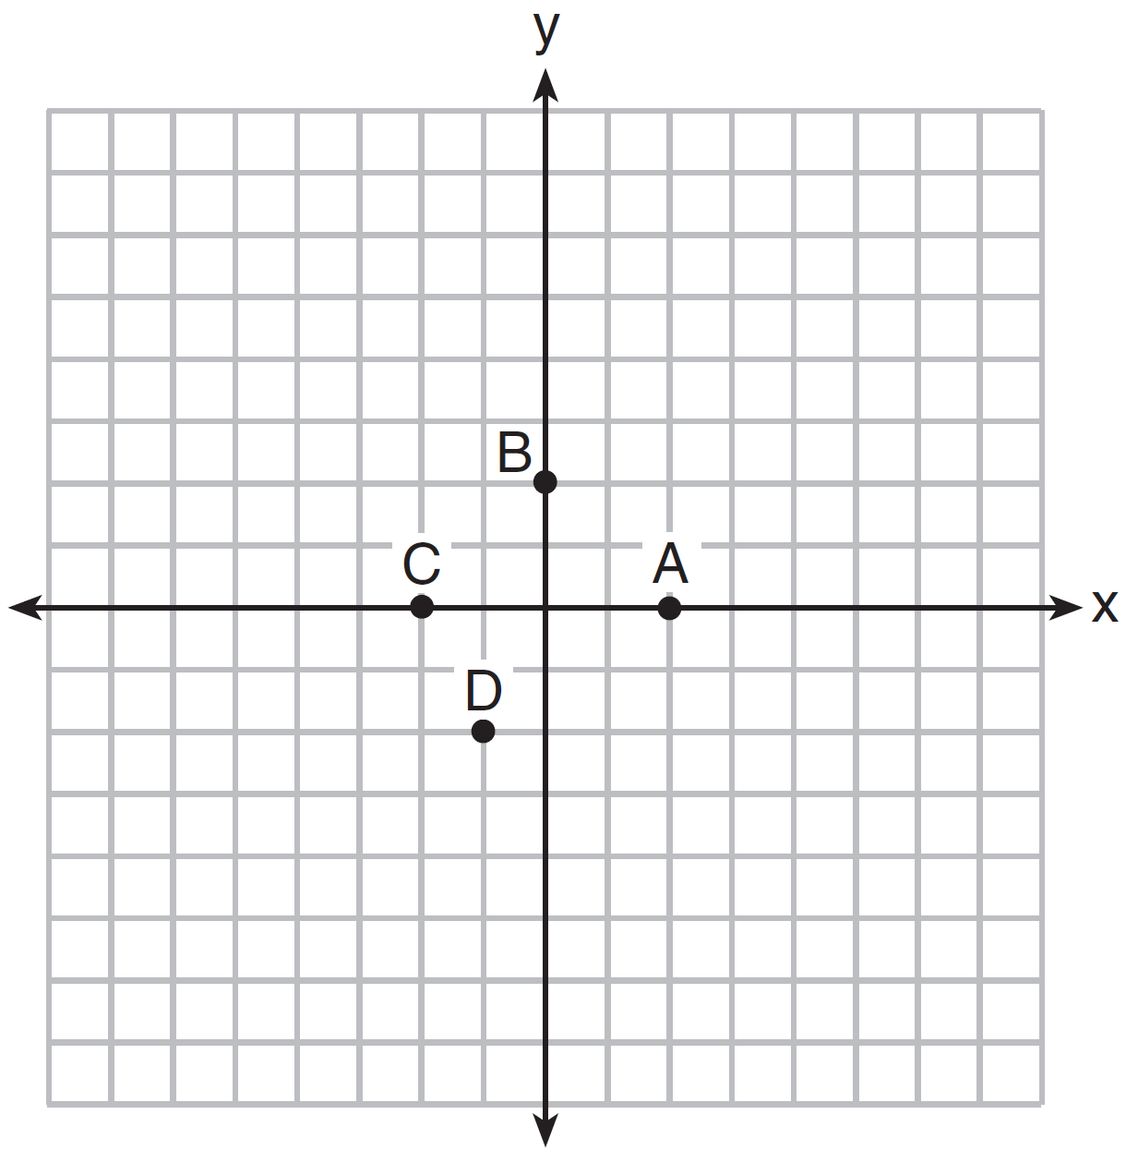

Which point could be used to find ?
1) | A
2) | B
3) | C
4) | D

2 The graph of is shown below.

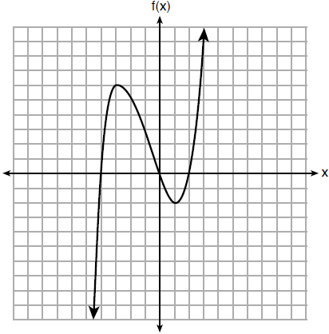

What is the value of ?
1) | 6
2) | 2
3)
4)

3 If , what is the value of ?
1)
2)
3) | 17
4) | 4

4 If 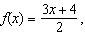 then is
1) | 21
2) | 16
3) | 14
4) | 4

5 Given , what is the value of ?
1)
2)
3) | 22
4) | 46

6 The function is defined as . The value of is
1)
2)
3) | 27
4) | 45

7 If then is equal to
1)
2)
3) | 17
4) | 25

8 A function is defined as . The value of is
1)
2)
3)
4)

9 If 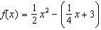, what is the value of ?
1) | 11
2) | 17
3) | 27
4) | 33

10 If , then is
1) | 315
2) | 307
3) | 159
4) | 153

11 If , what is the value of ?
1) | 13
2) | 19
3) | 37
4) | 54

12 If 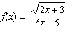, then 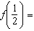
1) | 1
2)
3)
4)

13 If and , then what is the value of ?
1) | 10
2) | 8
3)
4)

14 Given , which statement is true?
1)
2)
3)
4)

15 If , which statement is true?
1)
2)
3)
4)

16 If , then which statement is true?
1)
2)
3)
4)

17 Lynn, Jude, and Anne were given the function , and they were asked to find . Lynn's answer was 14, Jude's answer was 4, and Anne's answer was ±4. Who is correct?
1) | Lynn, only
2) | Jude, only
3) | Anne, only
4) | Both Lynn and Jude

18 The value in dollars, , of a certain car after x years is represented by the equation . To the nearest dollar, how much more is the car worth after 2 years than after 3 years?
1) | 2589
2) | 6510
3) | 15,901
4) | 18,490

19 If 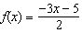, algebraically determine the value of x when .

20 If , determine .

21 Given , evaluate .

22 If 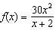, determine the value of 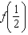.

23 The piecewise function is given below.

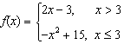

State the value of . Justify your answer.

24 The equation to determine the weekly earnings of an employee at The Hamburger Shack is given by , where x is the number of hours worked.
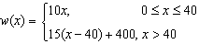
Determine the difference in salary, in dollars, for an employee who works 52 hours versus one who works 38 hours. Determine the number of hours an employee must work in order to earn $445. Explain how you arrived at this answer.
1 ANS: 1 REF: 061420ai

2 ANS: 1 REF: 081805ai

3 ANS: 2

REF: 061902ai

4 ANS: 3
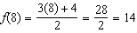

REF: 082201ai

5 ANS: 2

REF: 012304ai

6 ANS: 1

REF: 011902ai

7 ANS: 2

REF: 062311ai

8 ANS: 2

REF: 062103ai

9 ANS: 3
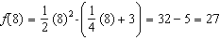

REF: 081704ai

10 ANS: 4

REF: 061802ai

11 ANS: 2

REF: 012001ai

12 ANS: 3
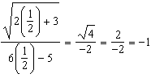

REF: 081512ai

13 ANS: 3
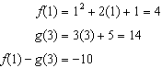

REF: 012410ai

14 ANS: 2

REF: 062202ai

15 ANS: 2

REF: 081605ai

16 ANS: 4

REF: 082318ai

17 ANS: 1

REF: 061705ai

18 ANS: 1

REF: 011508ai

19 ANS:
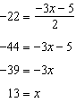

REF: 012529ai

20 ANS:

REF: 081925ai

21 ANS:

REF: 062426ai

22 ANS:
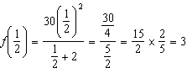

REF: 082426ai

23 ANS:

REF: 012430ai

24 ANS:
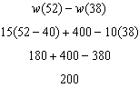 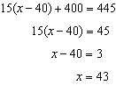 Since , . I substituted 445 for and solved for x.

REF: 061534ai

