1 What are the zeros of the polynomial function graphed below?
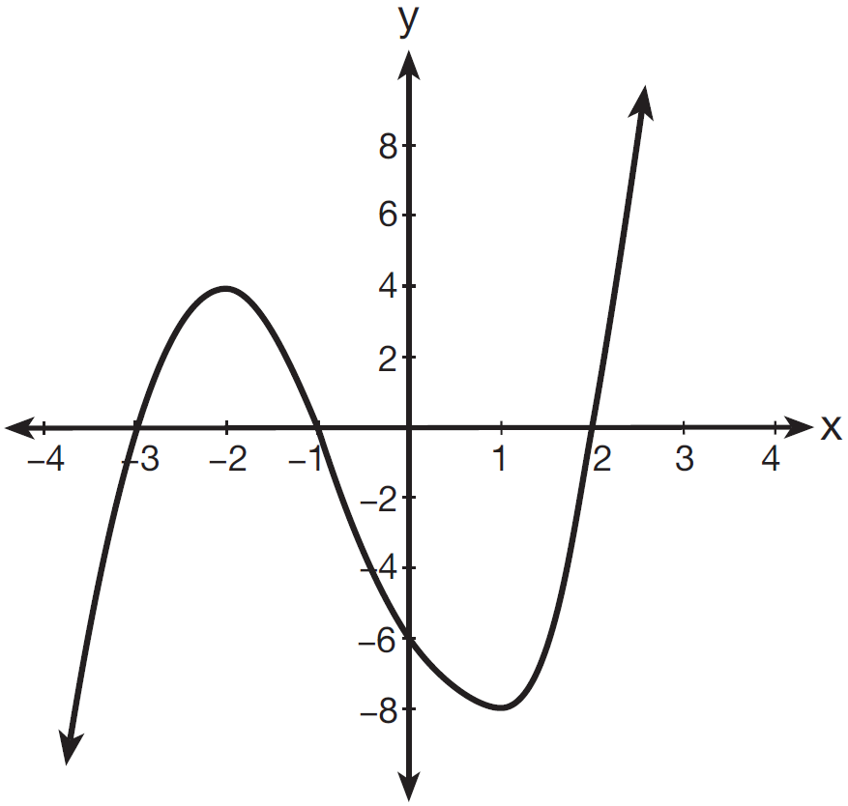
1)
2)
3)
4)

2 The function is graphed on the set of axes below.

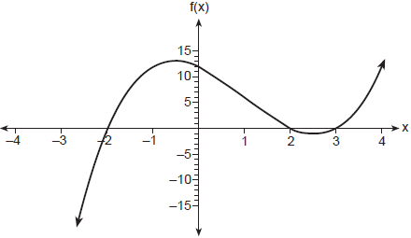

State the zeros of . Explain your reasoning.

3 Which graph has the following characteristics?
• three real zeros
•
•
1) | 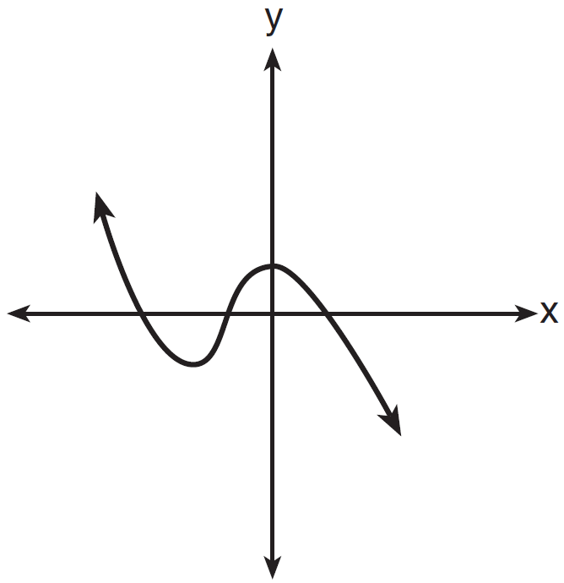
2) | 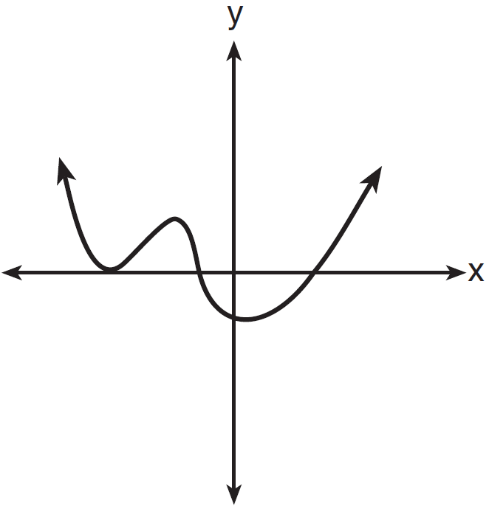
3) | 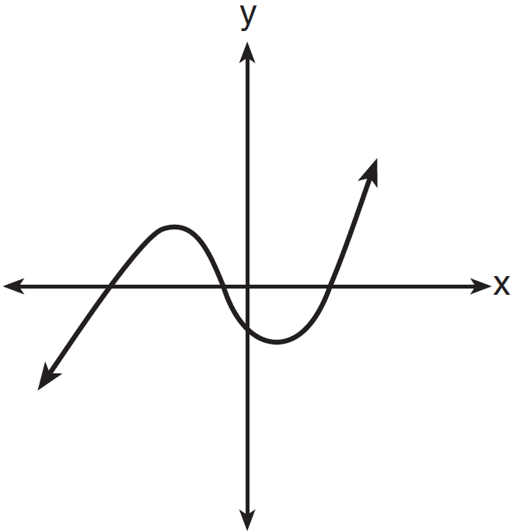
4) | 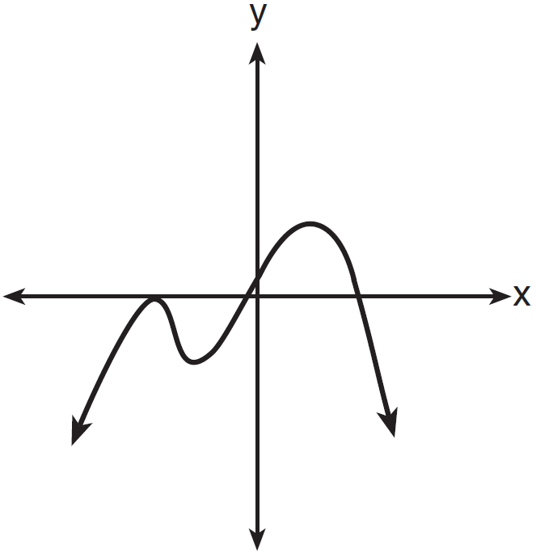

4 A 4th degree polynomial has zeros , 3, , and . Which graph could represent the function defined by this polynomial?
1) | 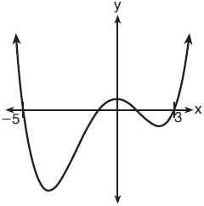
2) | 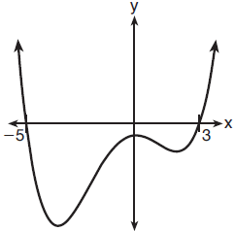
3) | 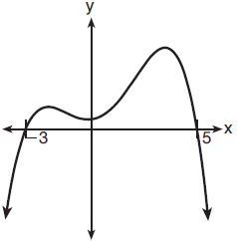
4) | 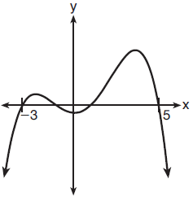

5 Which graph could represent a 4th degree polynomial function with a positive leading coefficient, 2 real zeros, and 2 imaginary zeros?
1) | 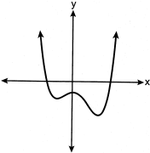
2) | 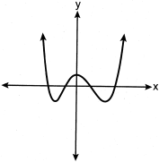
3) | 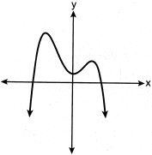
4) | 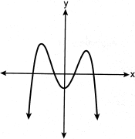

6 The graph of the function is shown below.

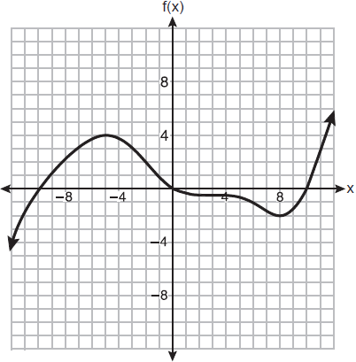

In which interval is always positive?
1)
2)
3)
4)

7 Consider the end behavior description below.
• as
• as
Which function satisfies the given conditions?
1)
2) | 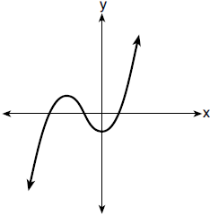
3)
4) | 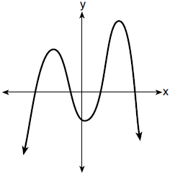

8 There was a study done on oxygen consumption of snails as a function of pH, and the result was a degree 4 polynomial function whose graph is shown below.

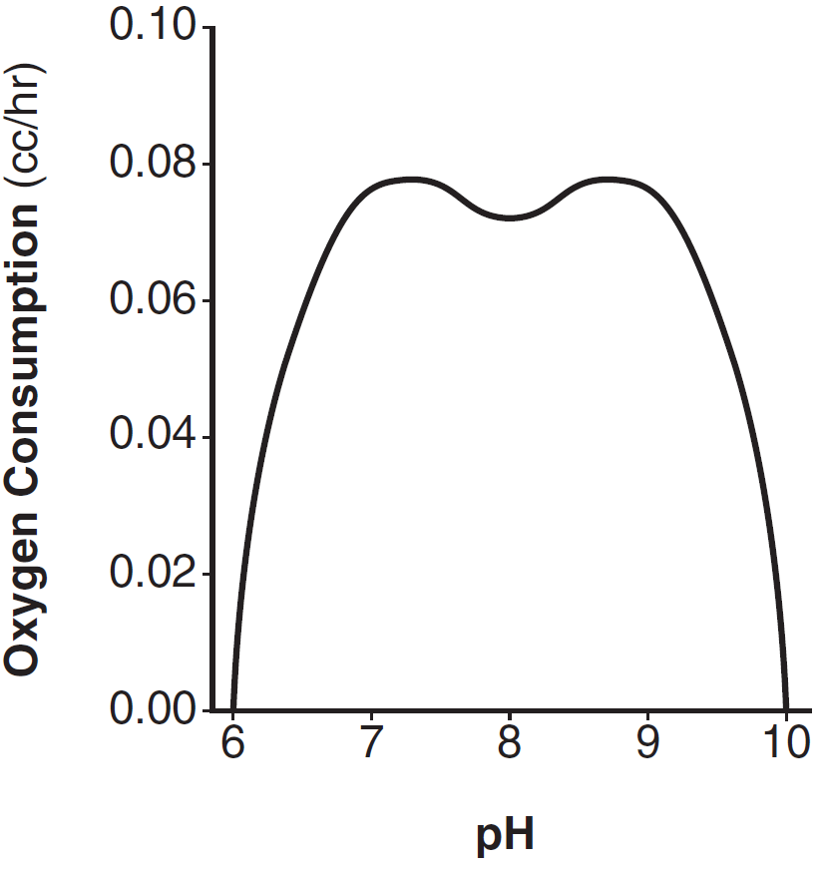

Which statement about this function is incorrect?
1) | The degree of the polynomial is even.
2) | There is a positive leading coefficient.
3) | At two pH values, there is a relative maximum value.
4) | There are two intervals where the function is decreasing.

9 The average cost of a gallon of milk in the United States between the years of 1995 and 2018 can be modeled by the equation , where represents the cost, in dollars, and t is time in years since January 1995. During this time period, in what year did reach its maximum?
1) | 1995
2) | 2013
3) | 2014
4) | 2018

10 Consider a cubic polynomial with the characteristics below.
• exactly one real root
• as
Given and , which equation represents a cubic polynomial with these characteristics?
1)
2)
3)
4)

11 Which description could represent the graph of , if a is an integer?
1) | As , as , and the graph has 3 x-intercepts.
2) | As , as , and the graph has 3 x-intercepts.
3) | As , as , and the graph has 4 x-intercepts.
4) | As , as , and the graph has 4 x-intercepts.

12 Given , for what values of x will ?
1) | , only
2) | or
3) | or
4) | , only

13 An estimate of the number of milligrams of a medication in the bloodstream t hours after 400 mg has been taken can be modeled by the function below.
, where
Over what time interval does the amount of medication in the bloodstream strictly increase?
1) | 0 to 2 hours
2) | 0 to 3 hours
3) | 2 to 6 hours
4) | 3 to 6 hours

14 The function below models the average price of gas in a small town since January 1st.
, where .
If is the average price of gas in dollars and t represents the number of months since January 1st, the absolute maximum reaches over the given domain is about
1) | $1.60
2) | $3.92
3) | $4.01
4) | $7.73

15 A polynomial equation of degree three, , is used to model the volume of a rectangular box. The graph of has x intercepts at , 10, and 14. Which statements regarding could be true?
A. The equation of .
B. The equation of .
C. The maximum volume occurs when .
D. The maximum volume of the box is approximately 56.
1) | A and C
2) | A and D
3) | B and C
4) | B and D

16 Factor completely over the set of integers: . Sara graphed the polynomial and stated “All the roots of are real.” Is Sara correct? Explain your reasoning.
1 ANS: 1 REF: 081501a2

2 ANS:
are the x-intercepts of f.

REF: 062326ai

3 ANS: 3
The graph shows three real zeros, and has end behavior matching the given end behavior.

REF: 061604aii

4 ANS: 2 REF: 061816aii

5 ANS: 1 REF: 082414aii

6 ANS: 4 REF: 082318aii

7 ANS: 3 REF: 012005aii

8 ANS: 2 REF: 061620aii

9 ANS: 2
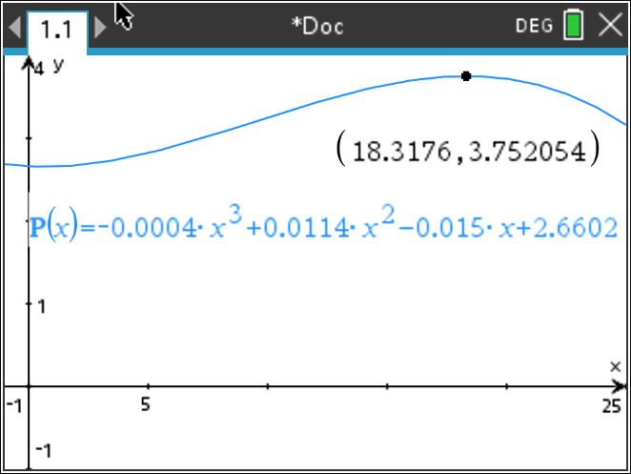

REF: 012414aii

10 ANS: 2
1) ; 3) quartic polynomial; 4) three real roots

REF: 012318aii

11 ANS: 2 REF: 081908aii

12 ANS: 2
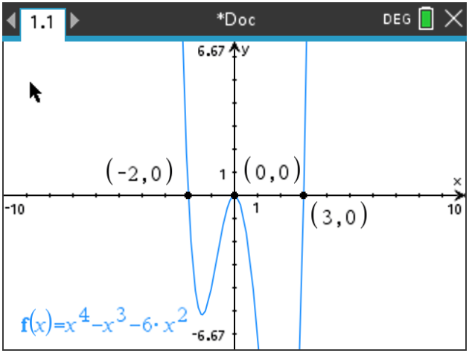

REF: 012316aii

13 ANS: 1
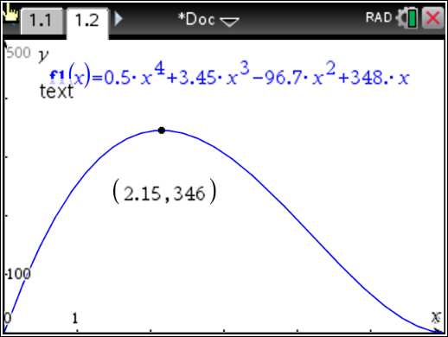

REF: 011908aii

14 ANS: 3
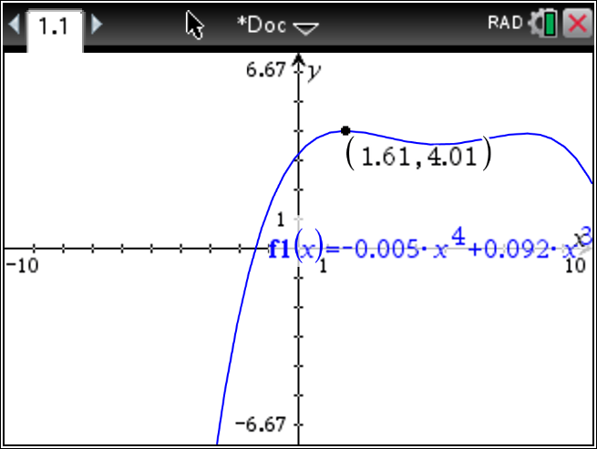

REF: 011817aii

15 ANS: 4
The maximum volume of is about 56, at

REF: 081712aii

16 ANS:
. No, because are roots.

REF: 061933aii

