1 The function is graphed below.

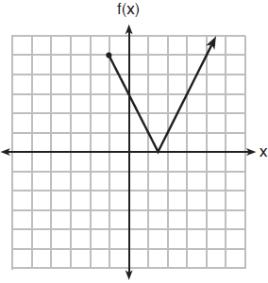

The domain of this function is
1) | all positive real numbers
2) | all positive integers
3)
4)

2 The diagram below shows the graph of , which models the height, in feet, of a rocket t seconds after it was shot into the air.

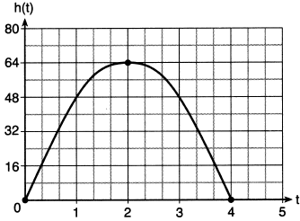

The domain of is
1)
2)
3)
4)

3 The effect of pH on the action of a certain enzyme is shown on the accompanying graph.

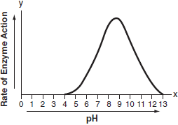

What is the domain of this function?
1)
2)
3)
4)

4 The graph of the function is shown below.

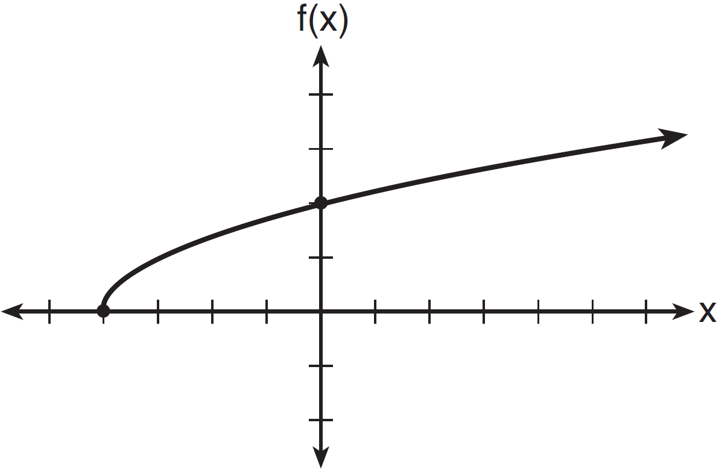

The domain of the function is
1)
2)
3)
4)

5 What is the domain of the function shown below?

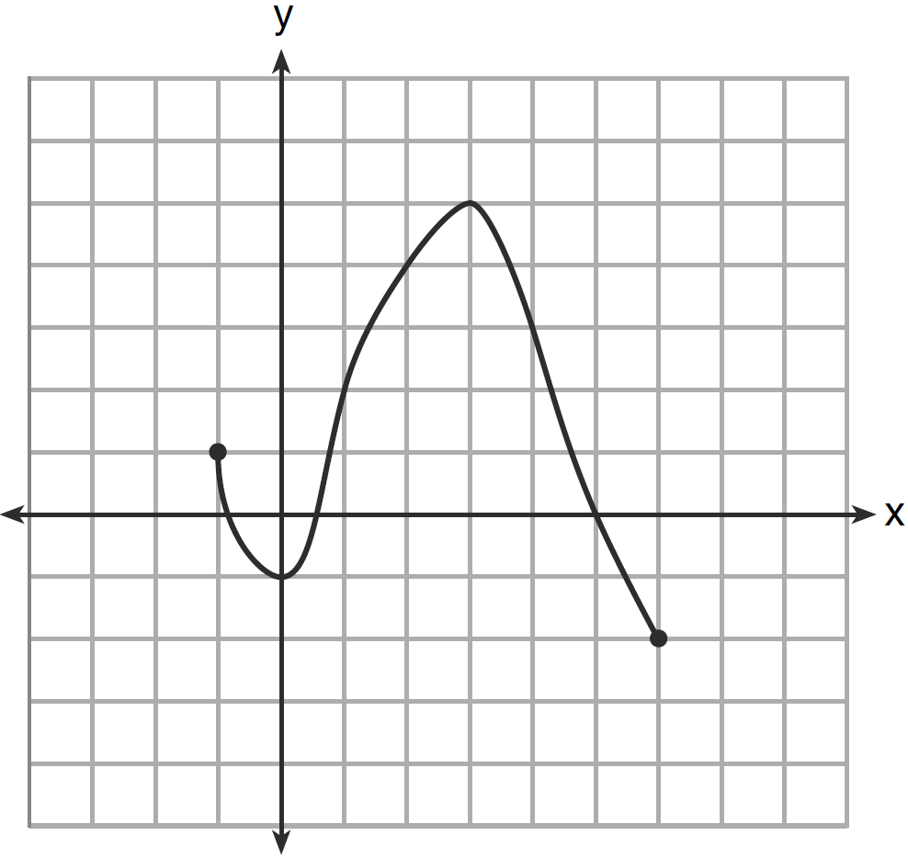
1)
2)
3)
4)

6 A function is graphed on the set of axes below.

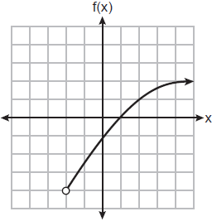

The domain of this function is
1)
2)
3)
4)

7 The graph of a relation is shown below.

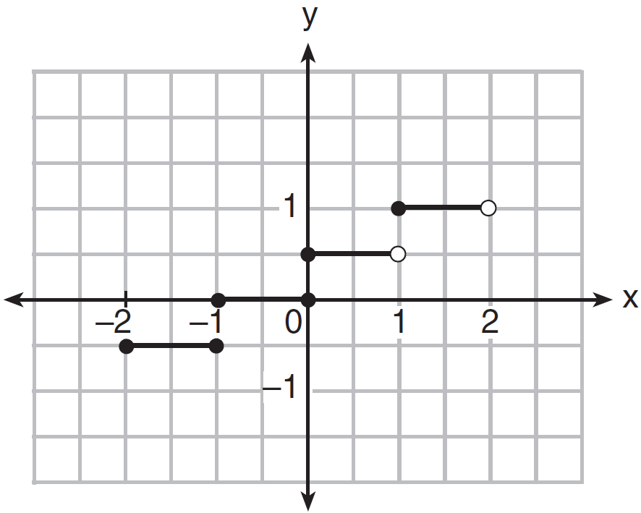

What is the domain of this relation?
1)
2) | 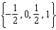
3)
4)

8 The accompanying graph shows the elevation of a certain region in New York State as a hiker travels along a trail.

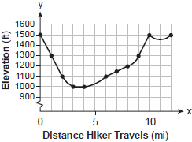

What is the domain of this function?
1)
2)
3)
4)

9 Which graph illustrates a quadratic relation whose domain is all real numbers?
1) | 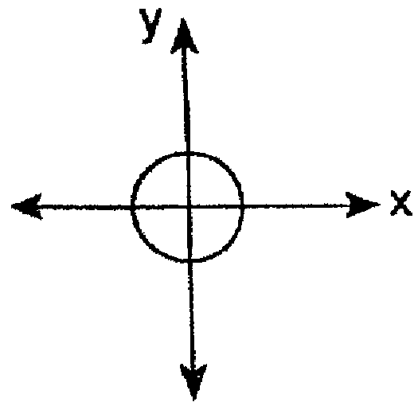
2) | 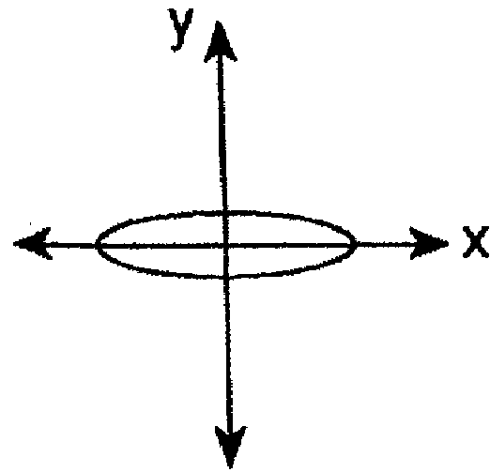
3) | 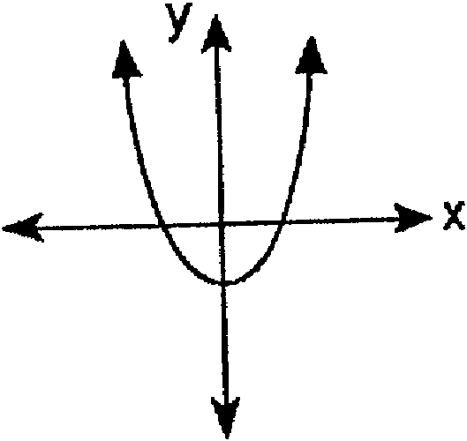
4) | 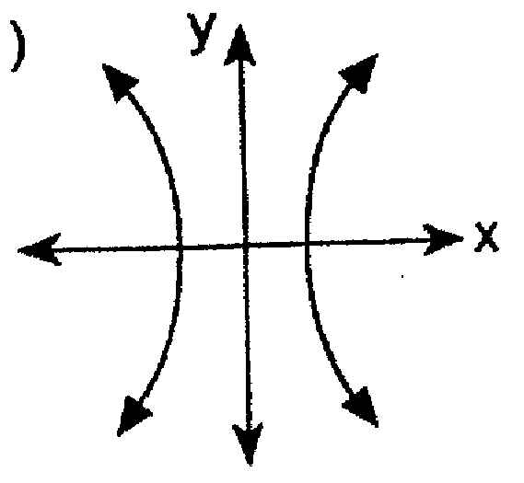

10 What is the range of the function shown below?

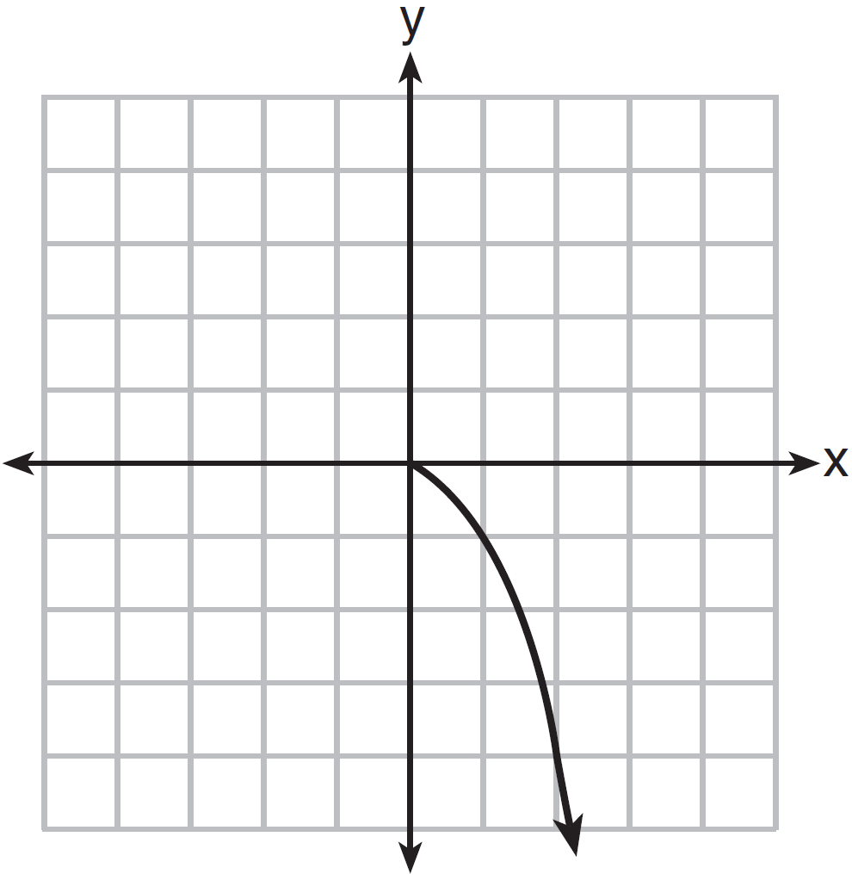
1)
2)
3)
4)

11 The air temperature in Dallas, Texas, over a 5-hour period is shown in the accompanying graph.

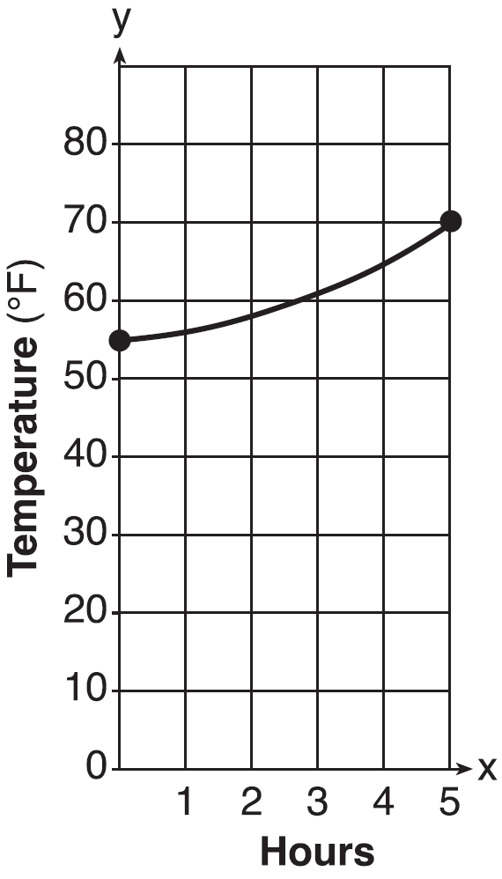
What is the range of this set of data?
1)
2)
3)
4)

12 Data collected during an experiment are shown in the accompanying graph.

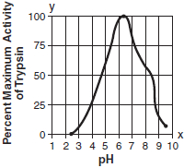
What is the range of this set of data?
1)
2)
3)
4)

13 The accompanying graph illustrates the presence of a certain strain of bacteria at various pH levels.

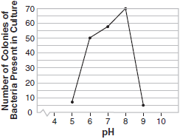

What is the range of this set of data?
1)
2)
3)
4)

14 A meteorologist drew the accompanying graph to show the changes in relative humidity during a 24-hour period in New York City.

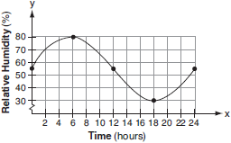

What is the range of this set of data?
1)
2)
3)
4)

15 The accompanying graph shows the heart rate, in beats per minute, of a jogger during a 4-minute interval.

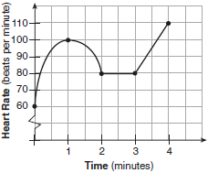

What is the range of the jogger's heart rate during this interval?
1)
2)
3)
4)

16 The graph below shows the average price of gasoline, in dollars, for the years 1997 to 2007.

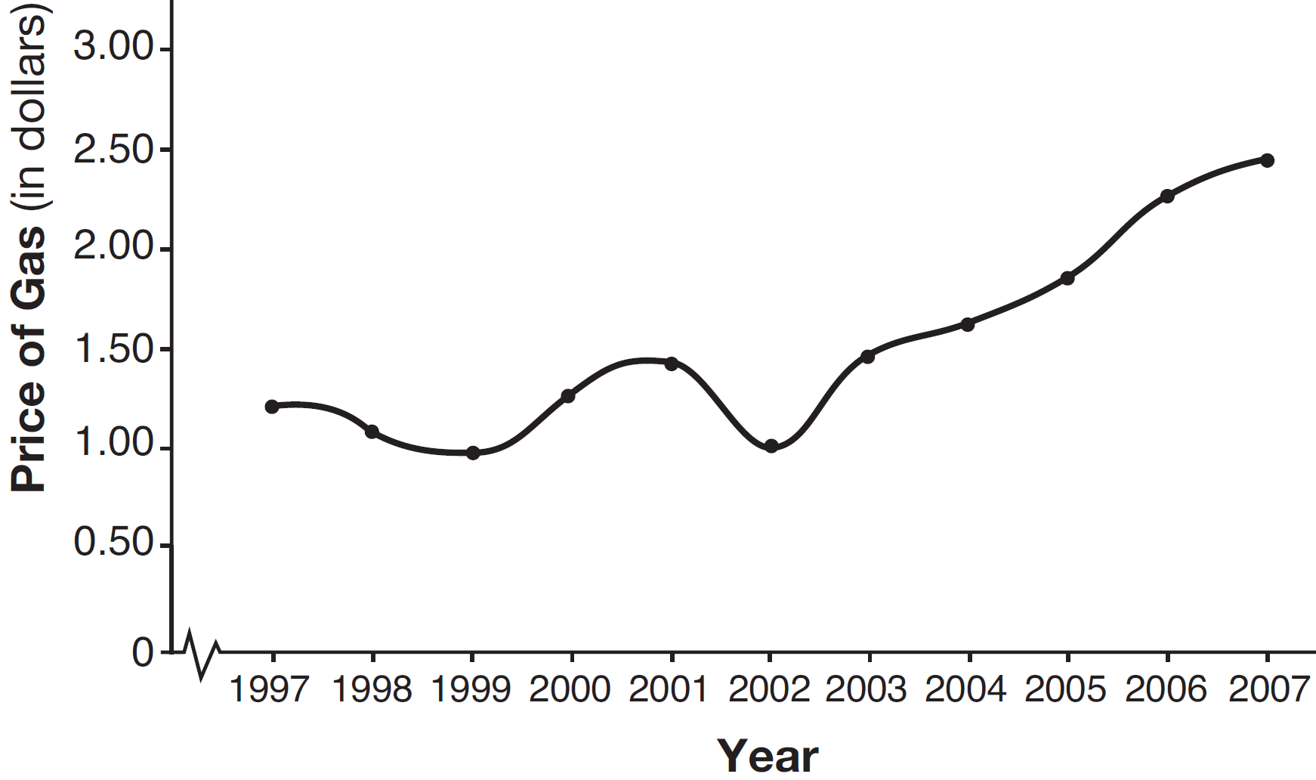

What is the approximate range of this graph?
1)
2)
3)
4)

17 What are the domain and the range of the function shown in the graph below?

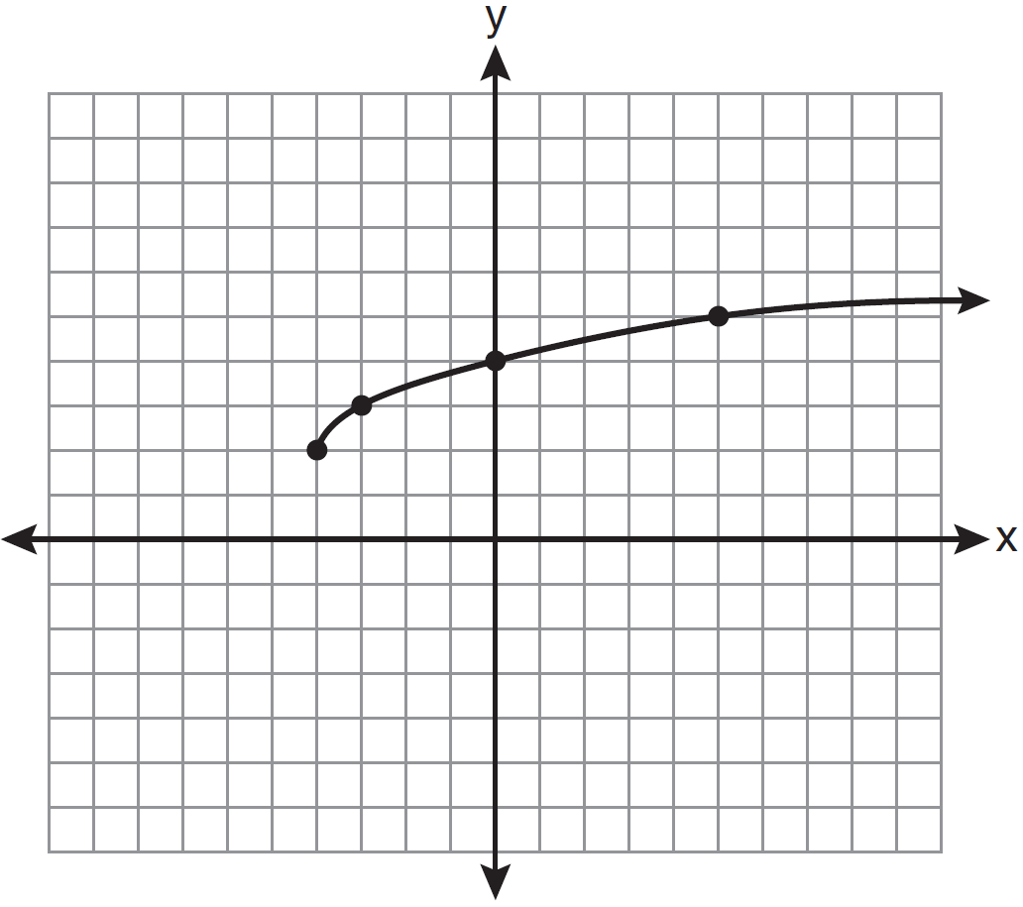
1)
2)
3)
4)

18 Which value is in the domain of the function graphed below, but is not in its range?

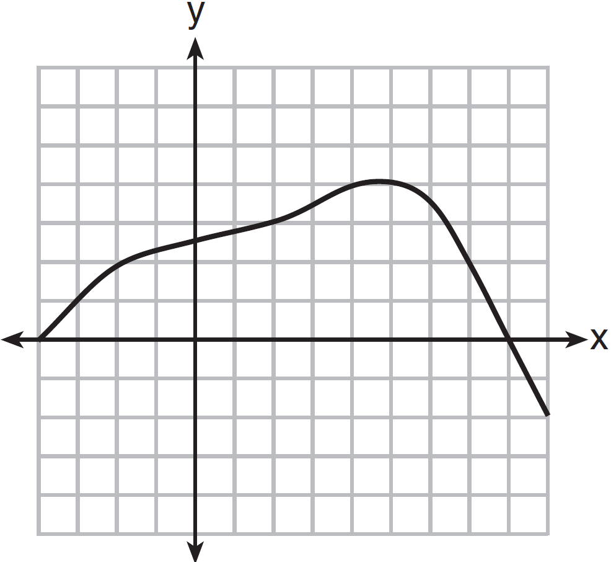
1) | 0
2) | 2
3) | 3
4) | 7

19 Bryan said that the piecewise function graphed below has a domain of all real numbers.

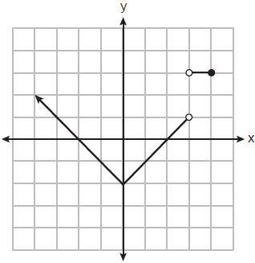

State two reasons why Bryan is incorrect.

20 A function is graphed on the set of axes below.

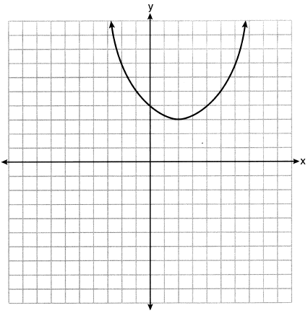

State the domain of this function. State the range of this function.

21 The graph below represents the function .

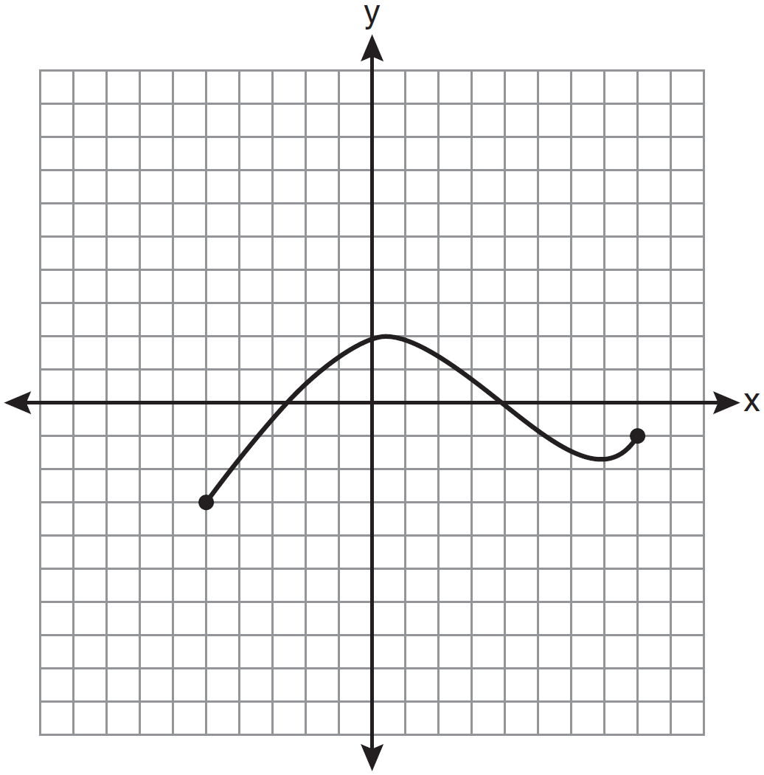

State the domain and range of this function.

1 ANS: 4 REF: 011917ai

2 ANS: 2 REF: 082222ai

3 ANS: 1 REF: 010602b

4 ANS: 4 REF: 061509ai

5 ANS: 1 REF: 061202a2

6 ANS: 1 REF: 012517ai

7 ANS: 3 REF: 061606a2

8 ANS: 3 REF: 060804b

9 ANS: 3 REF: 019518siii

10 ANS: 3 REF: 061308a2

11 ANS: 4 REF: 061013b

12 ANS: 3 REF: 010712b

13 ANS: 4 REF: 010918b

14 ANS: 3 REF: 080708b

15 ANS: 4 REF: 060501b

16 ANS: 3 REF: 061418a2

17 ANS: 2 REF: 081003a2

18 ANS: 4 REF: 061518a2

19 ANS:
The function is not defined at or .

REF: 082327ai

20 ANS:
Domain is reals. Range is .

REF: 062229ai

21 ANS:
D: . R:

REF: 011132a2

