1 The population of Austin, Texas from 1850 to 2010 is summarized in the table below.

Year | 1850 | 1870 | 1890 | 1910 | 1930 | 1950 | 1970 | 1990 | 2010
Population | 629 | 4428 | 14,575 | 29,860 | 53,120 | 132,459 | 251,808 | 494,290 | 790,390

Over which period of time was the average rate of change in population the greatest?
1) | 1850 to 1910 | 3) | 1950 to 1970
2) | 1990 to 2010 | 4) | 1890 to 1970

2 A cardboard box manufacturing company is building boxes with length represented by , width by , and height by . The volume of the box is modeled by the function below.
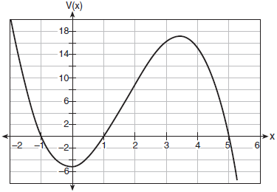
Over which interval is the volume of the box changing at the fastest average rate?
1) |  | 3) | [1,5]
2) | [1,3.5] | 4)

3 Irma initially ran one mile in over ten minutes. She then began a training program to reduce her one-mile time. She recorded her one-mile time once a week for twelve consecutive weeks, as modeled in the graph below.
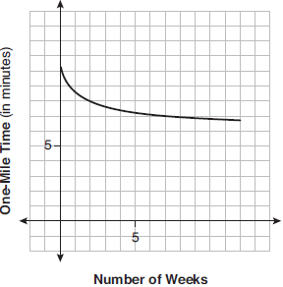
Which statement regarding Irma’s one-mile training program is correct?
1) | Her one-mile speed increased as the number of weeks increased. | 3) | If the trend continues, she will run under a six-minute mile by week thirteen.
2) | Her one-mile speed decreased as the number of weeks increased. | 4) | She reduced her one-mile time the most between weeks ten and twelve.

4 Consider the graph of g and the table representing t below.

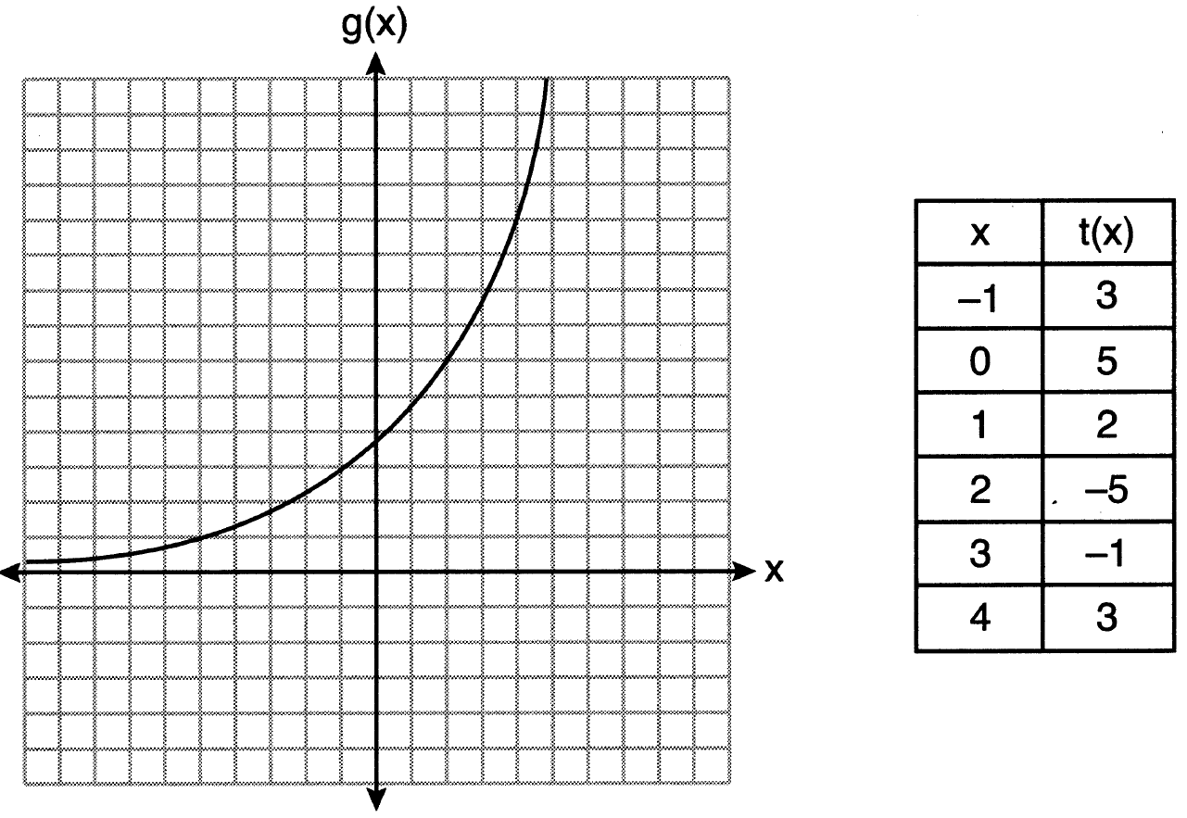

Over the interval , which statement regarding the average rate of change for g and t is true?
1) | g has a greater average rate of change. | 3) | The average rate of change for g is twice the average rate of change for t.
2) | The average rates of change are equal. | 4) | The average rate of change for g is half the average rate of change for t.

5 The distance needed to stop a car after applying the brakes varies directly with the square of the car’s speed. The table below shows stopping distances for various speeds.

Speed (mph) | 10 | 20 | 30 | 40 | 50 | 60 | 70
Distance (ft) | 6.25 | 25 | 56.25 | 100 | 156.25 | 225 | 306.25

Determine the average rate of change in braking distance, in ft/mph, between one car traveling at 50 mph and one traveling at 70 mph. Explain what this rate of change means as it relates to braking distance.

6 Determine the average rate of change, in mph, from 2 to 4 hours on the graph shown below.

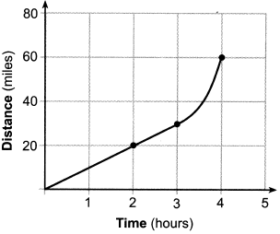
1 ANS:
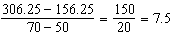 Between 50-70 mph, each additional mph in speed requires 7.5 more feet to stop.

REF: 081631aii

2 ANS: 4
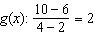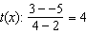

REF: 062212aii

3 ANS: 2
1) 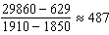; 2) 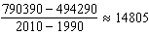; 3) 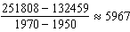; 4) 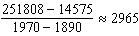

REF: 062301aii

4 ANS: 1
(1) 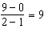 (2) 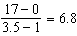 (3) 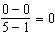 (4) 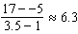

REF: 011724aii

5 ANS: 1 REF: 061904aii

6 ANS:
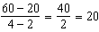

REF: 082225aii

