1 Joelle has a credit card that has a 19.2% annual interest rate compounded monthly. She owes a total balance of B dollars after m months. Assuming she makes no payments on her account, the table below illustrates the balance she owes after m months.

m | B
0 | 100.00
10 | 1172.00
19 | 1352.00
36 | 1770.80
60 | 2591.90
69 | 2990.00
72 | 3135.80
73 | 3186.00

Over which interval of time is her average rate of change for the balance on her credit card account the greatest?
1) | month 10 to month 60 | 3) | month 36 to month 72
2) | month 19 to month 69 | 4) | month 60 to month 73

2 The function can be used to predict the temperature of a cup of hot chocolate in degrees Fahrenheit after x minutes. What is the approximate average rate of change of the temperature of the hot chocolate, in degrees per minute, over the interval ?
1) |  | 3) | 0.11
2) |  | 4) | 8.93

3 The function models the number of grams in a sample of cesium-137 that remain after t years. On which interval is the sample's average rate of decay the fastest?
1) |  | 3) | [15,25]
2) |  | 4)

4 The equation 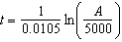 relates time, t, in years, to the amount of money, A, earned by a $5000 investment. Which statement accurately describes the relationship between the average rates of change of t on the intervals [6000, 8000] and [9000, 12,000]?
1) | A comparison cannot be made because the intervals are different sizes. | 3) | The average rate of change is larger for the interval [6000, 8000].
2) | The average rate of change is equal for both intervals. | 4) | The average rate of change is larger for the interval [9000, 12,000].

5 The value of a new car depreciates over time. Greg purchased a new car in June 2011. The value, V, of his car after t years can be modeled by the equation 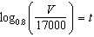. What is the average decreasing rate of change per year of the value of the car from June 2012 to June 2014, to the nearest ten dollars per year?
1) | 1960 | 3) | 2450
2) | 2180 | 4) | 2770

6 A fruit fly population can be modeled by the equation , where P represents the number of fruit flies after t days. What is the average rate of change of the population, rounded to the nearest hundredth, over the interval ? Include appropriate units in your answer.

7 An initial investment of $1000 reaches a value, , according to the model , where t is the time in years. Determine the average rate of change, to the nearest dollar per year, of this investment from year 2 to year 7.

8 In the town of Skaneateles, New York, house prices since 2008 have changed based on the function , where t is the number of years since 2008 and is the median house price. Determine the average rate of change for the median house price in Skaneateles, from 2010 to 2018 to the nearest dollar per year. Explain what this rate of change means as it relates to median house prices.

9 The world population was 2560 million people in 1950 and 3040 million in 1960 and can be modeled by the function , where t is time in years after 1950 and is the population in millions. Determine the average rate of change of in millions of people per year, from . Round your answer to the nearest hundredth.

10 Which function has a greater average rate of change on the interval ? Justify your answer.

x | m(x)
 | 1
0 | 1
1 | 3
2 | 13
3 | 37
4 | 81
5 | 151

11 Which function shown below has a greater average rate of change on the interval ? Justify your answer.

x | f(x)
 | 0.3125
 | 0.625
 | 1.25
 | 2.5
0 | 5
1 | 10
2 | 20
3 | 40
4 | 80
5 | 160
6 | 320

12 The population of China, in millions, can be modeled by the function , where x is the number of years since 1900. The population of India since 1900 is summarized in the table below:

Years since 1900 | Population (millions)
0 | 243
10 | 254
20 | 268
30 | 285
40 | 324
50 | 376.3
60 | 450.6
70 | 555.1
80 | 699
60 | 873.3
100 | 1056.6
110 | 1234.3
120 | 1380

Which country's population had a greater average rate of change between 1950 and 2020? Justify your answer.
1 ANS: 4
(1) 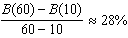 (2) 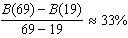 (3) 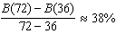 (4) 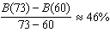

REF: 011721aii

2 ANS: 1
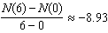

REF: 012012aii

3 ANS: 1
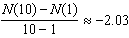, 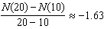, 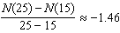, 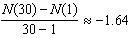

REF: 061807aii

4 ANS: 3
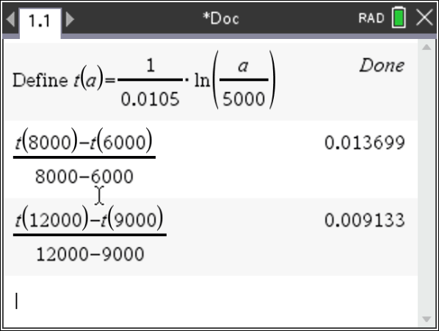

REF: 081922aii

5 ANS: 3
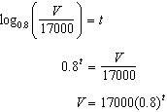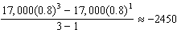

REF: 081709aii

6 ANS:
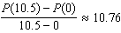 fruit flies per day

REF: 082332aii

7 ANS:
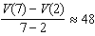

REF: 012427aii

8 ANS:
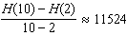 From 2014-2018, the median house price increased $11524 per year on average.

REF: 062434aii

9 ANS:
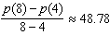

REF: 081827aii

10 ANS:
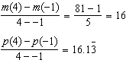 has a greater rate of change

REF: 012534aii

11 ANS:
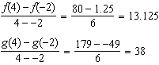 has a greater rate of change

REF: 061636aii

12 ANS:
China: 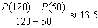 India: 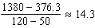 India

REF: 082433aii

