1 The graph below represents .

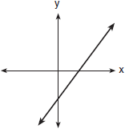

Which graph best represents ?
1) | 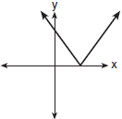 | 3) | 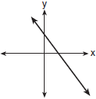
2) | 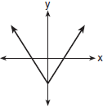 | 4) | 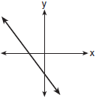

2 Which is the graph of ?
1) | 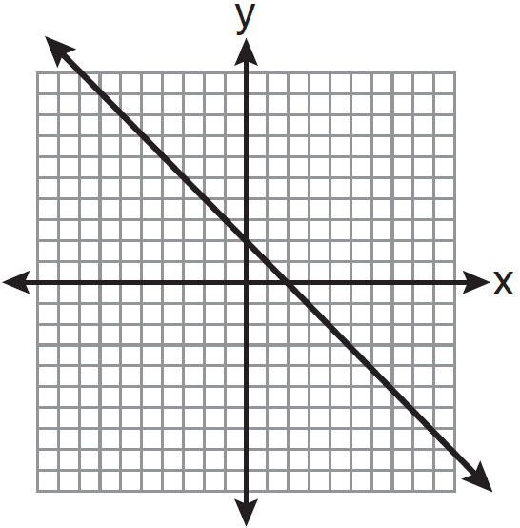
2) | 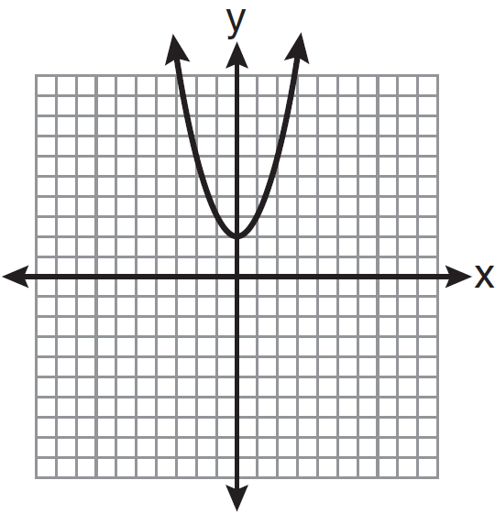
3) | 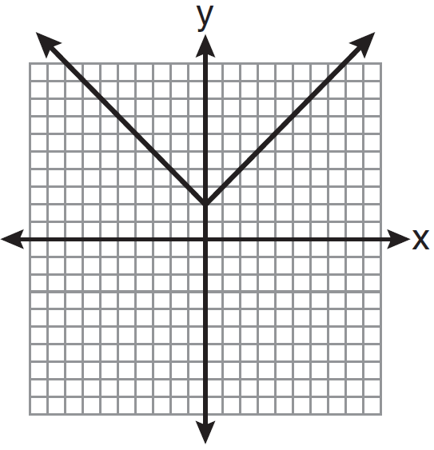
4) | 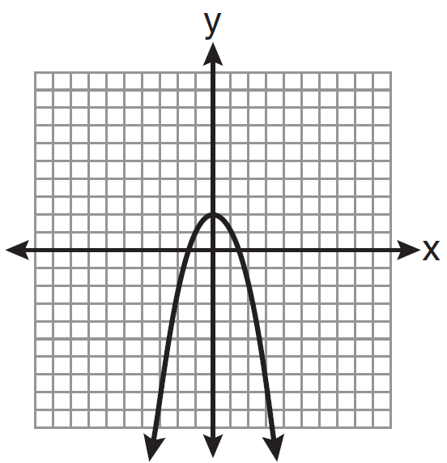

3 Which graph represents the equation ?
1) | 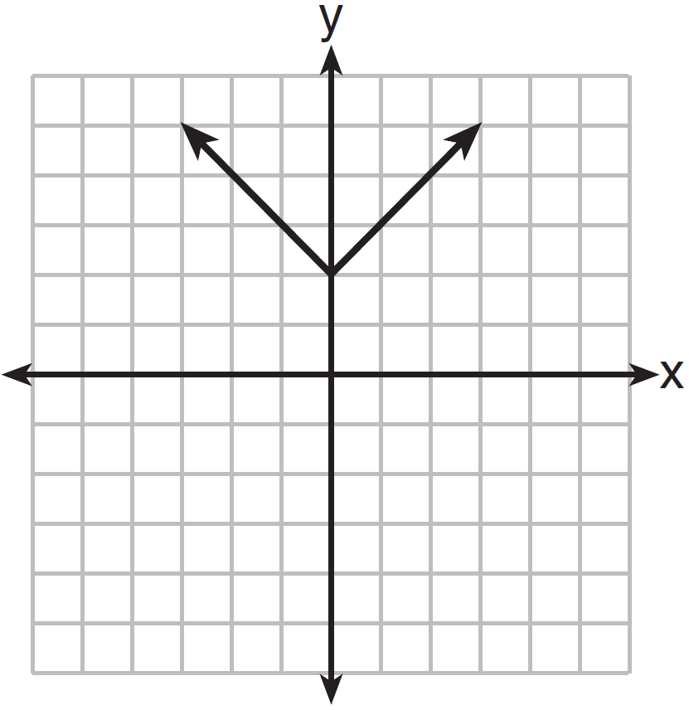
2) | 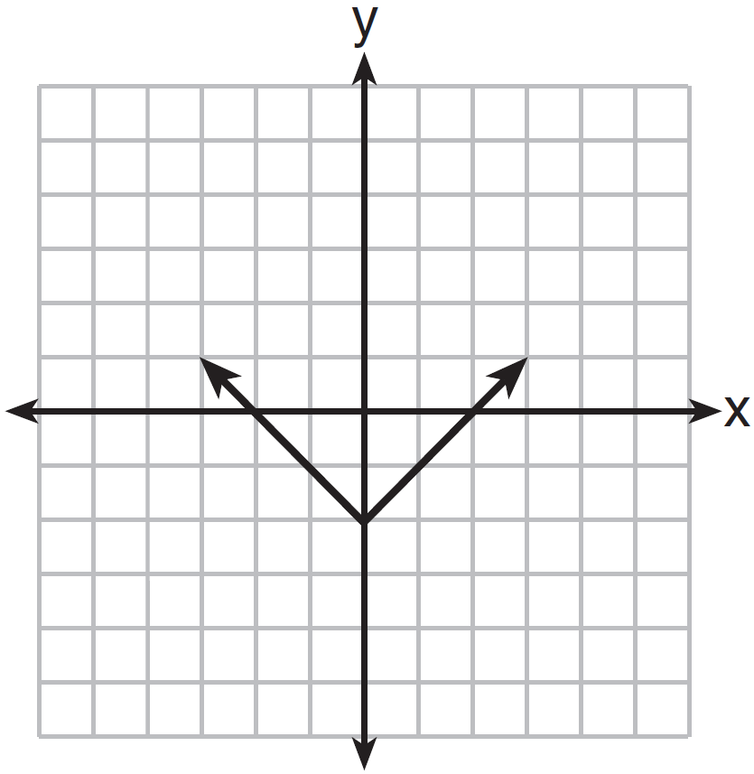
3) | 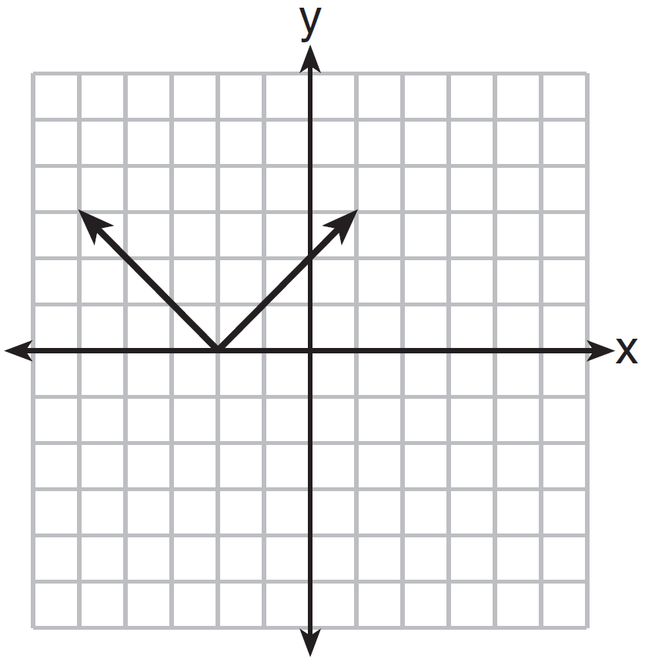
4) | 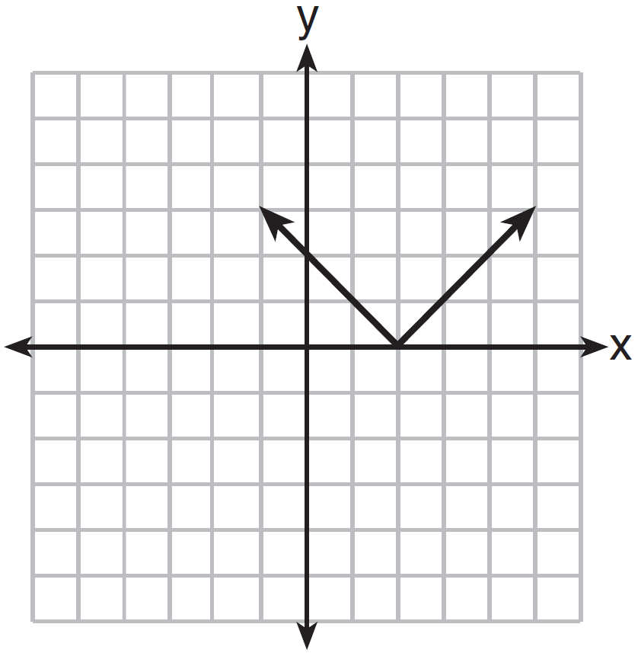

4 What is the minimum value of the function ?
1) |  | 3) | 3
2) | 2 | 4)

5 Which equation represents the function shown in the accompanying graph?

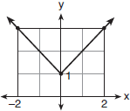
1) |  | 3)
2) |  | 4)

6 The table of values below can be modeled by which equation?

x | y
-2 | 5
-1 | 4
0 | 3
1 | 4
2 | 5

1) |  | 3)
2) |  | 4)

7 On the set of axes below, graph .

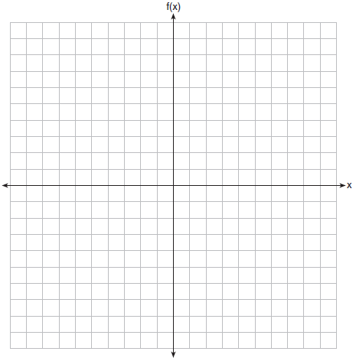

8 On the set of axes below, graph . Include the interval .

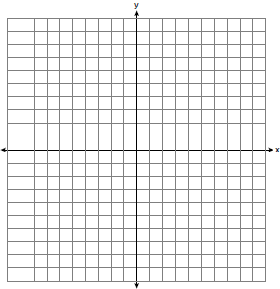

9 Graph the function 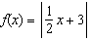 over the interval .

10 On the set of axes below, graph the function .

State the range of the function. State the domain over which the function is increasing.
1 ANS: 1 REF: 010414b

2 ANS: 3 REF: 011117ia

3 ANS: 4 REF: 081425ia

4 ANS: 1 REF: 011712ai

5 ANS: 1 REF: 080707b

6 ANS: 2 REF: 011502a2

7 ANS:
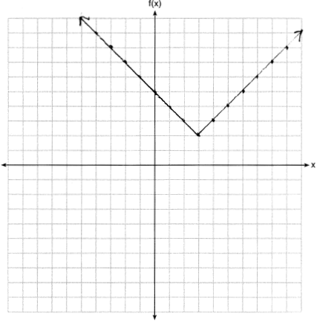

REF: 011825ai

8 ANS:
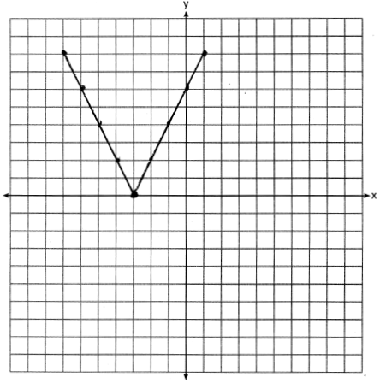

REF: 011333ia

9 ANS:
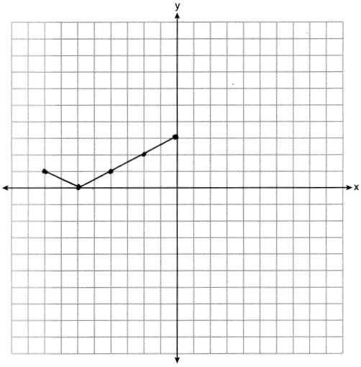

REF: 062126ai

10 ANS:
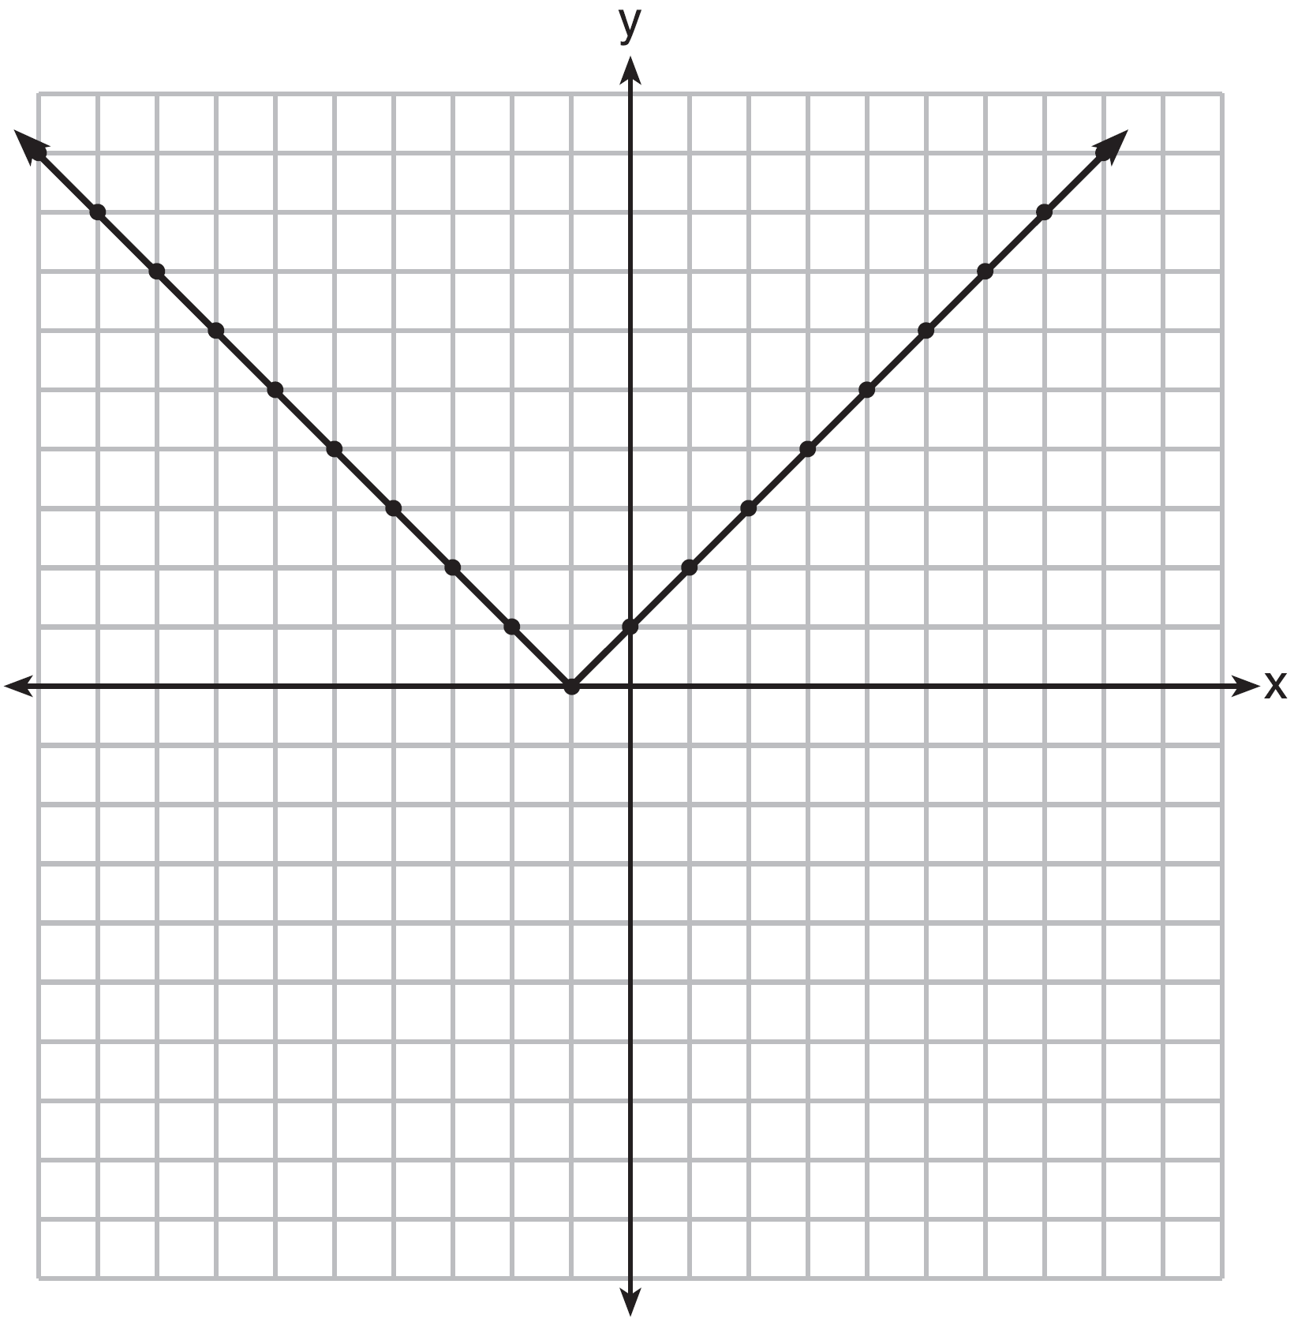Range: . The function is increasing for .

REF: fall1310ai

