1 The asymptote of the graph of is
1) |  | 3)
2) |  | 4)

2 Which statement about the graph of is false?
1) | The asymptote has equation . | 3) | The domain is the set of positive reals.
2) | The graph has no y-intercept. | 4) | The range is the set of all real numbers.

3 Which statement below about the graph of is true?
1) | has a y-intercept at . | 3) | As
2) | has a y-intercept at . | 4)

4 If and is the image of after a translation five units to the left, which equation represents ?
1) |  | 3)
2) |  | 4)

5 The graph of is translated to the right 1 unit and down 1 unit. The coordinates of the x-intercept of the translated graph are
1) |  | 3)
2) |  | 4)

6 Which equation best represents the graph below?

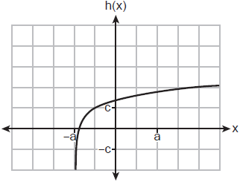
1) |  | 3)
2) |  | 4)

7 Which sketch could represent the function ?
1) | 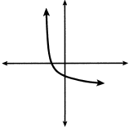 | 3) | 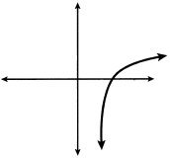
2) | 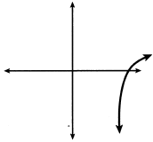 | 4) | 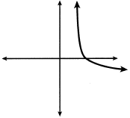

8 Describe the translations that map to .

9 Graph on the set of axes below.

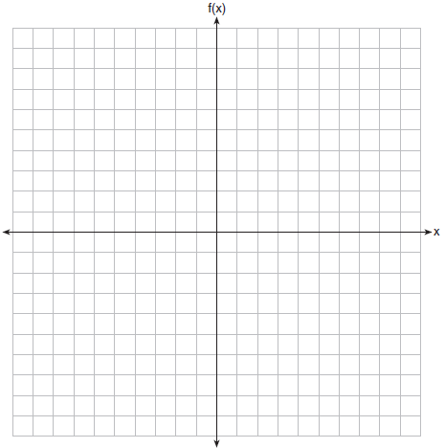

10 On the grid below, graph the function

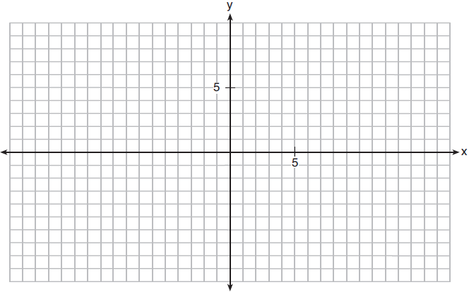

11 Sketch on the axes below.

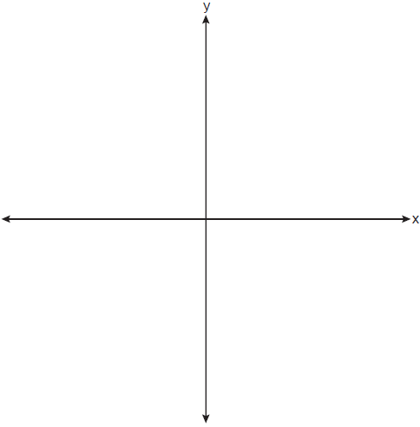

Describe the end behavior of as . Describe the end behavior of as

12 Graph on the set of axes below. Use an appropriate scale to include both intercepts.
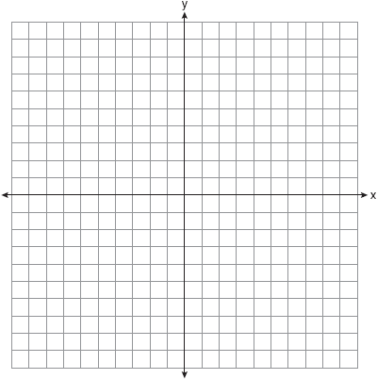

Describe the behavior of the given function as x approaches and as x approaches positive infinity.

13 Graph , where on the set of axes below.

State the equation of the asymptote of . When is reflected over the line , a new function is formed: . State the equation of the asymptote of .

14 Graph the following function on the axes below.

State the domain of f. State the equation of the asymptote.

1 ANS: 2 REF: 082409aii

2 ANS: 1
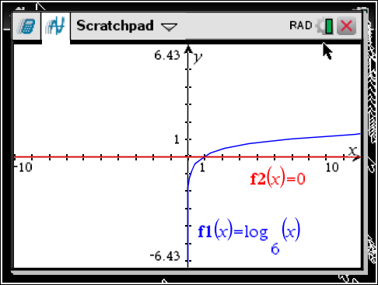

REF: 061618aii

3 ANS: 4 REF: 062215aii

4 ANS: 1 REF: 011902aii

5 ANS: 4
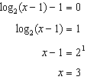

REF: 061819aii

6 ANS: 1 REF: 062308aii

7 ANS: 4
Translate the parent log function 2 to the right and reflect over the x-axis.

REF: 082207aii

8 ANS:
left 3, down 5

REF: 012525aii

9 ANS:
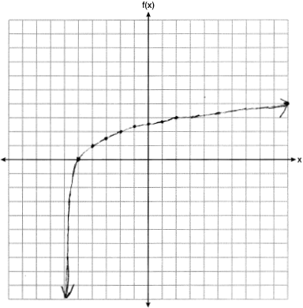

REF: 061927aii

10 ANS:
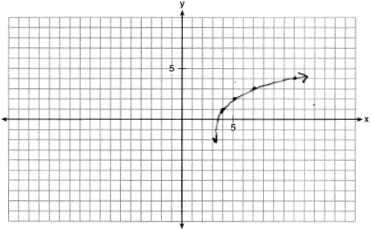

REF: 011932aii

11 ANS:
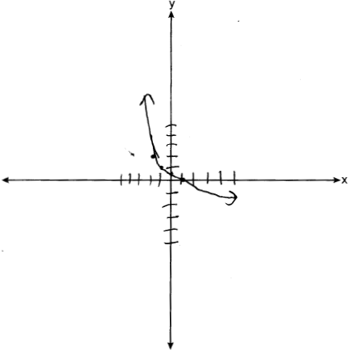 As . As .

REF: 082333aii

12 ANS:
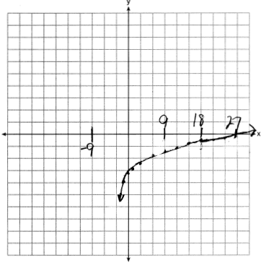 As . As .

REF: 061735aii

13 ANS:
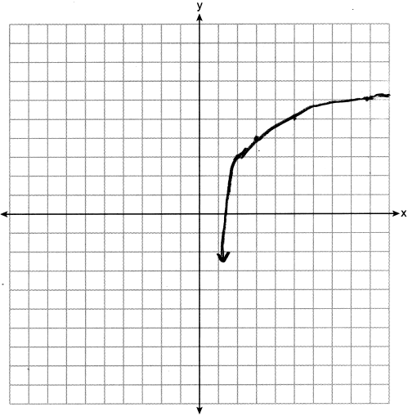

REF: 062436aii

14 ANS:
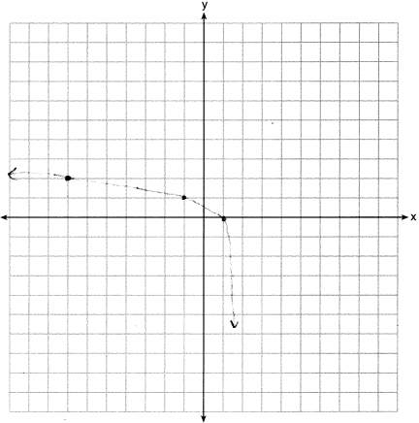Domain: , Asymptote

REF: 012034aii

