1 Which graph represents 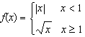?
1) | 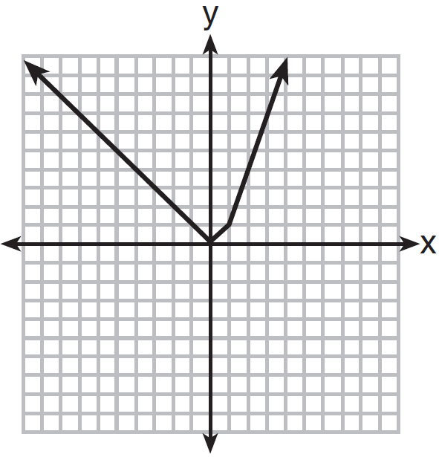
2) | 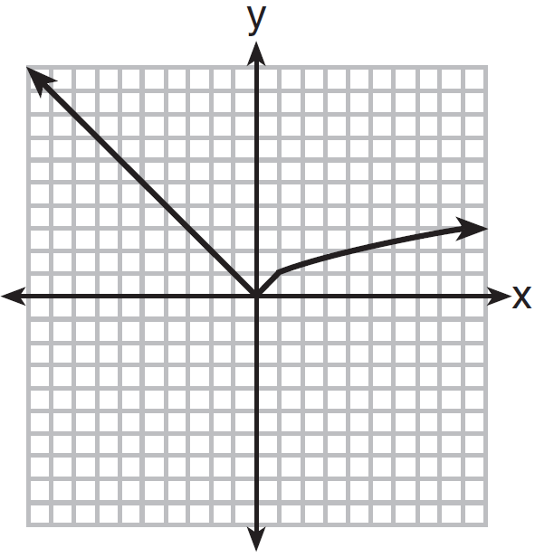
3) | 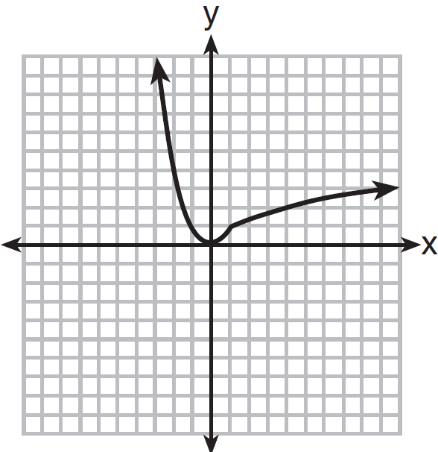
4) | 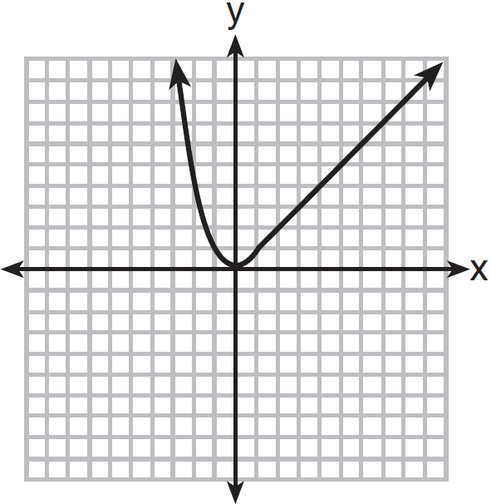

2 A function is graphed on the set of axes below.

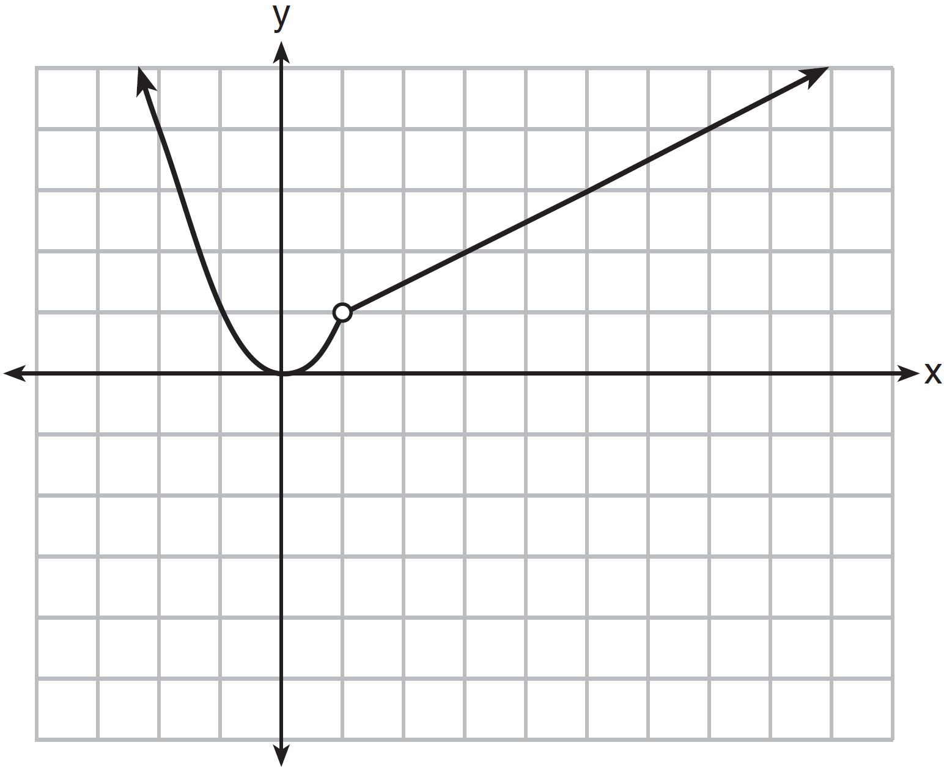

Which function is related to the graph?
1) | 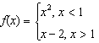
2) | 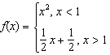
3) | 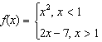
4) | 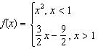

3 When the function 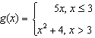 is graphed correctly, how should the points be drawn on the graph for an x-value of 3?
1) | open circles at and
2) | closed circles at and
3) | an open circle at and a closed circle at
4) | a closed circle at and an open circle at

4 Which graph below represents a function that is always decreasing over the entire interval ?
1) | 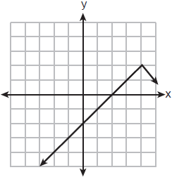
2) | 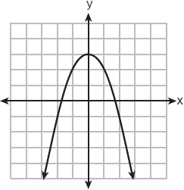
3) | 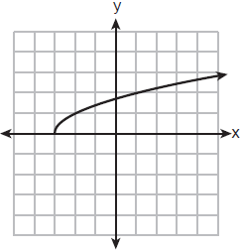
4) | 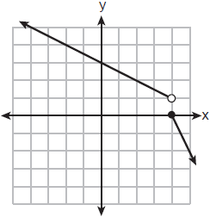

5 On the set of axes below, graph the piecewise function:
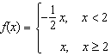

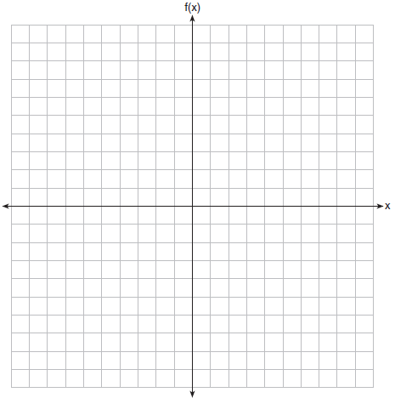

6 Graph the following function on the set of axes below.
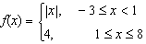

7 Graph the following piecewise function on the set of axes below.
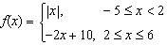

8 Graph the function: 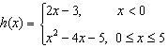

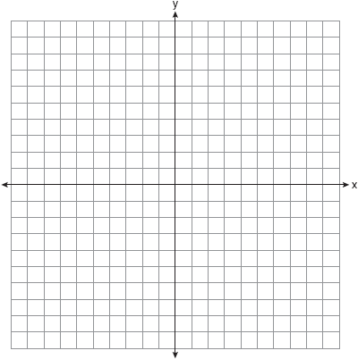

9 The function g is defined as
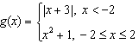
On the set of axes below, graph .

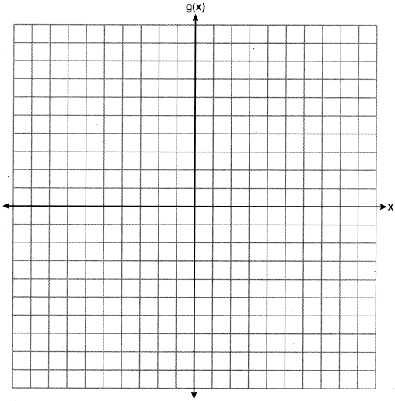

10 At an office supply store, if a customer purchases fewer than 10 pencils, the cost of each pencil is $1.75. If a customer purchases 10 or more pencils, the cost of each pencil is $1.25. Let c be a function for which is the cost of purchasing x pencils, where x is a whole number.
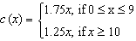
Create a graph of c on the axes below.

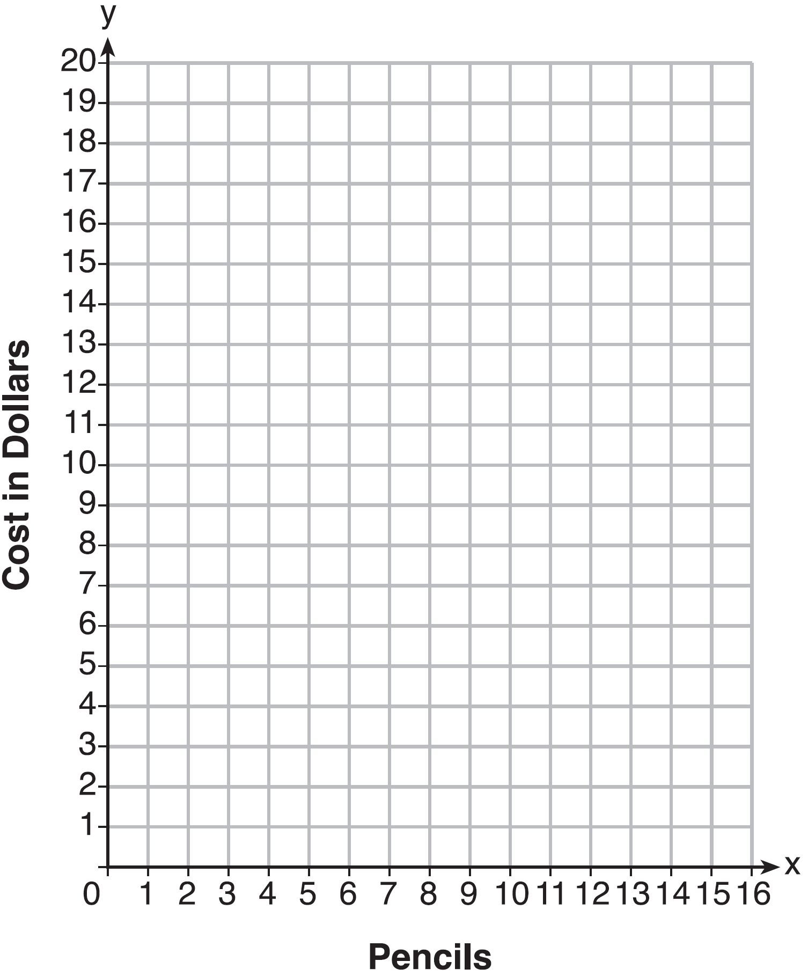

A customer brings 8 pencils to the cashier. The cashier suggests that the total cost to purchase 10 pencils would be less expensive. State whether the cashier is correct or incorrect. Justify your answer.
1 ANS: 2 REF: 081516ai

2 ANS: 2 REF: 081422ai

3 ANS: 4 REF: 081815ai

4 ANS: 4 REF: 012524ai

5 ANS:
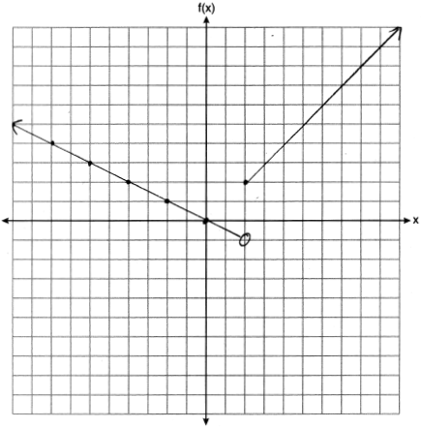

REF: 061832ai

6 ANS:
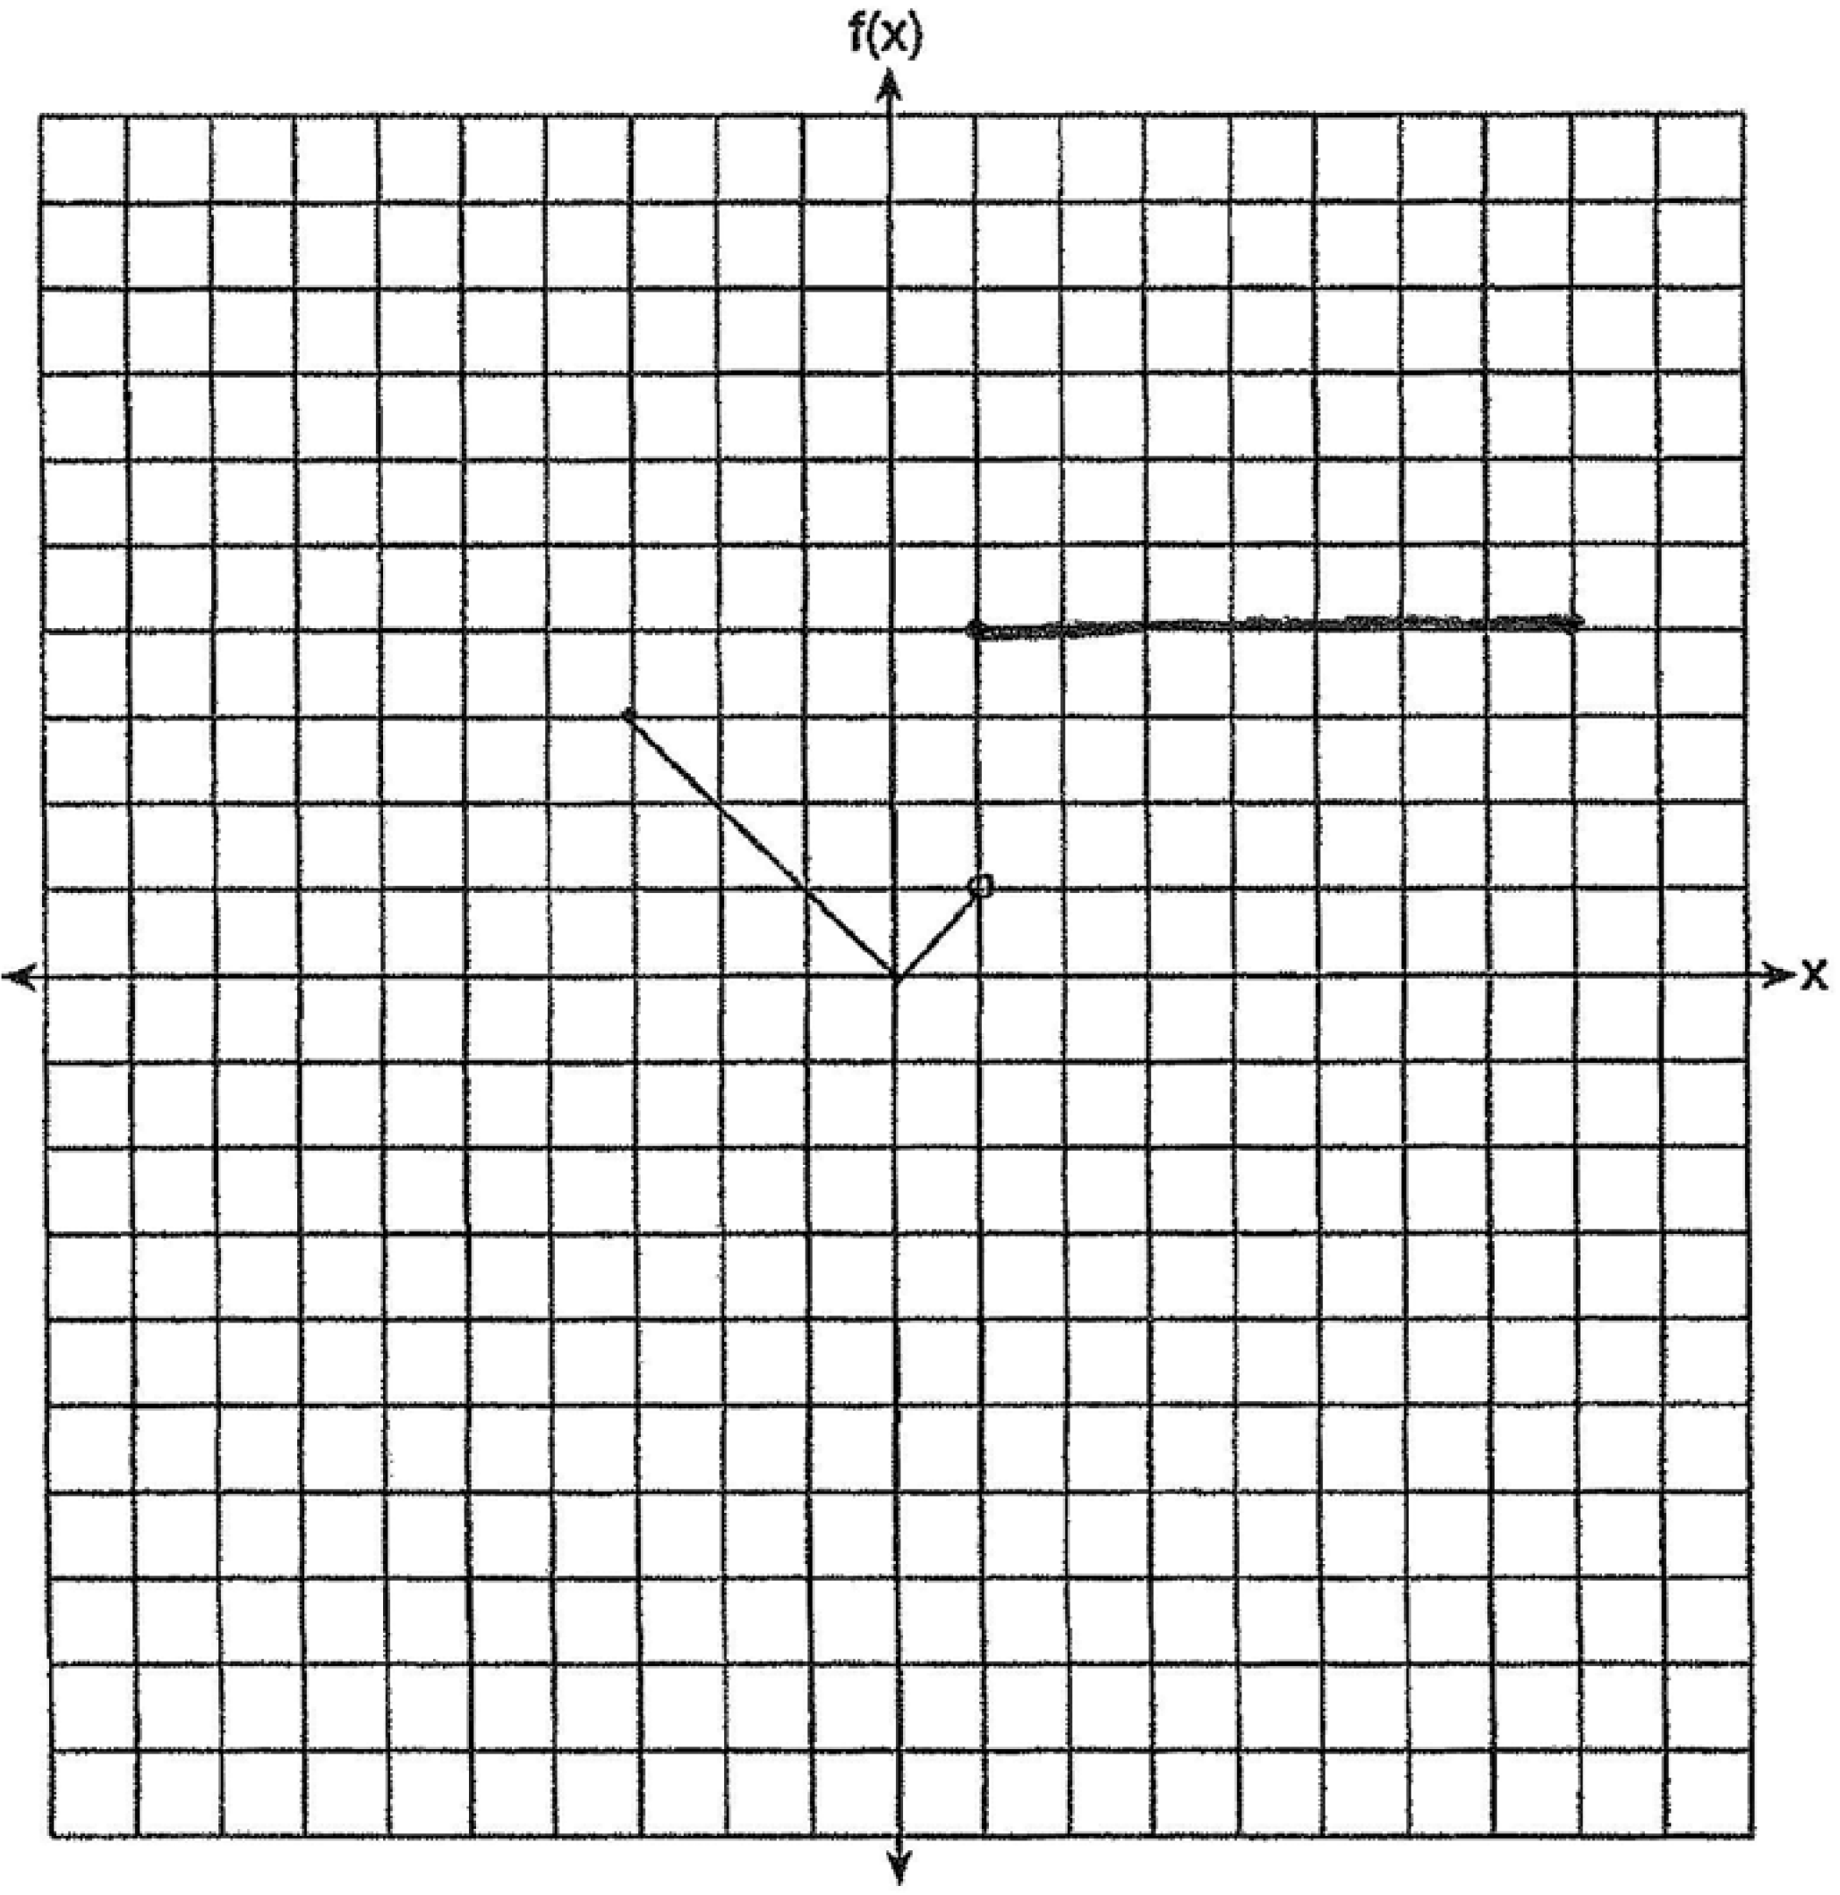

REF: 011530ai

7 ANS:
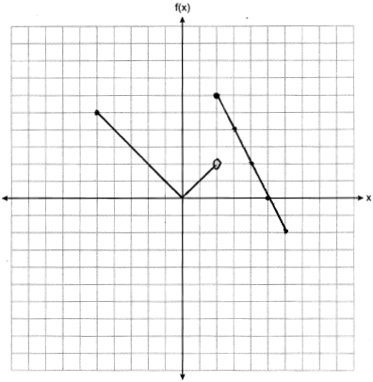

REF: 061927ai

8 ANS:
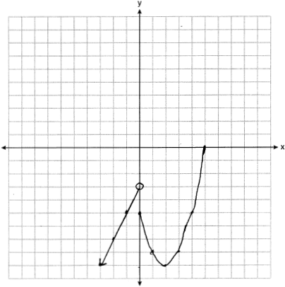

REF: 081932ai

9 ANS:
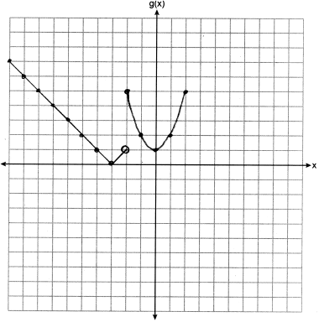

REF: 012332ai

10 ANS:
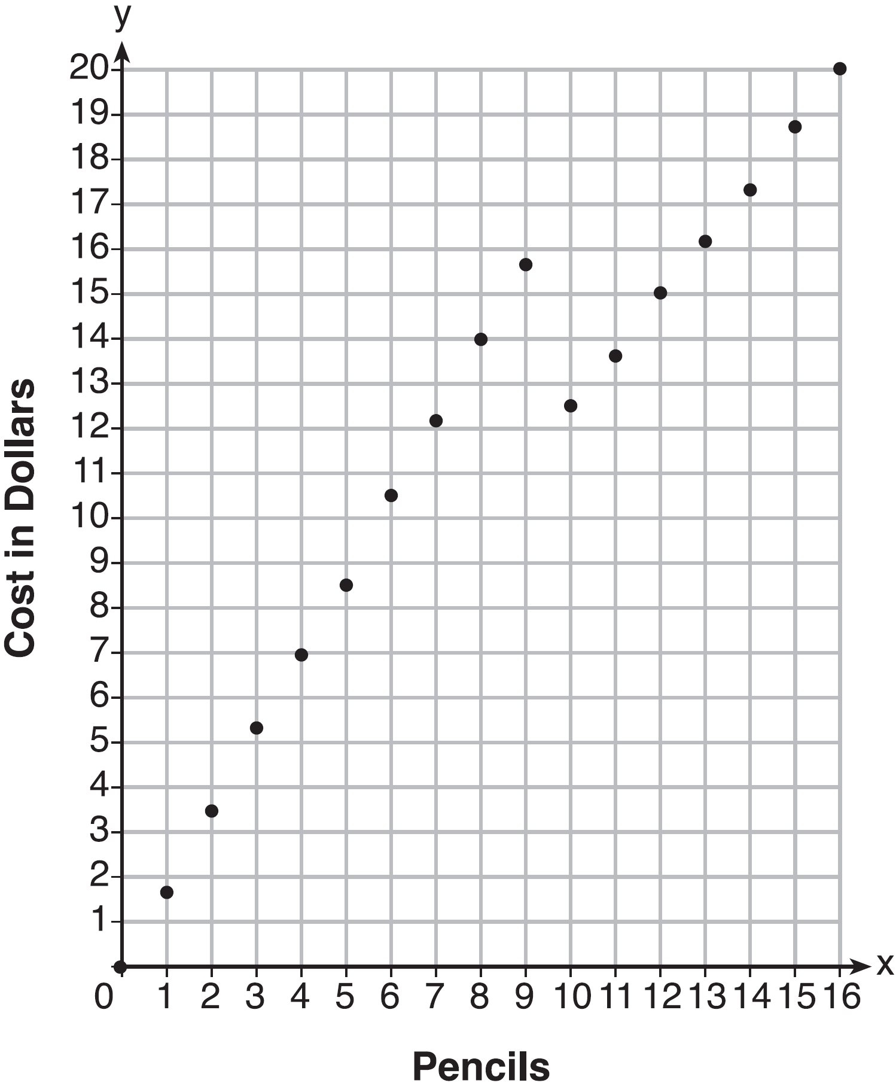Since according to the graph, 8 pencils cost $14 and 10 pencils cost $12.50, the cashier is correct.

REF: fall1312ai

