1 The function is graphed on the set of axes below.

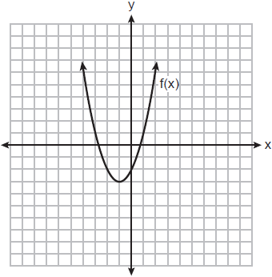

What is the equation of the axis of symmetry for ?
1)
2)
3)
4)

2 The function f is graphed on the set of axes below.

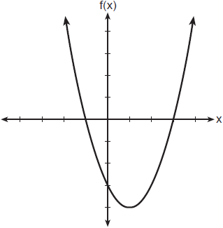

What is a possible factorization of this function?
1)
2)
3)
4)

3 The graph of the function is given below.

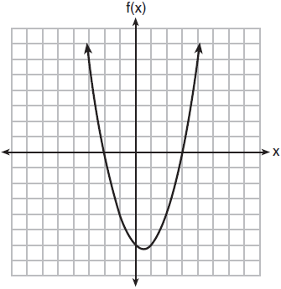

Could the factors of be and ? Based on the graph, explain why or why not.

4 If the zeros of a quadratic function, F, are and 5, what is the equation of the axis of symmetry of F? Justify your answer.

5 Graph the function on the set of axes below.

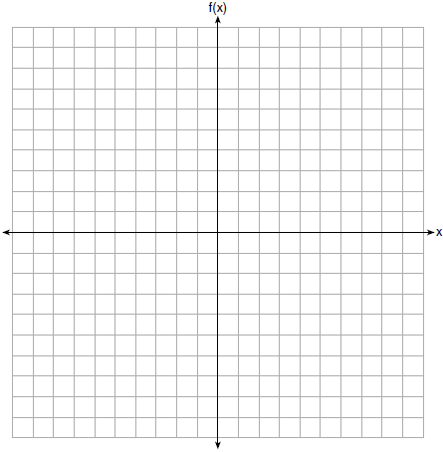

State the coordinates of the vertex of the graph.

6 Graph the function .

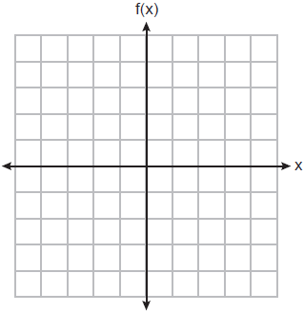

State the equation of the axis of symmetry of .

7 On the set of axes below, draw the graph of .

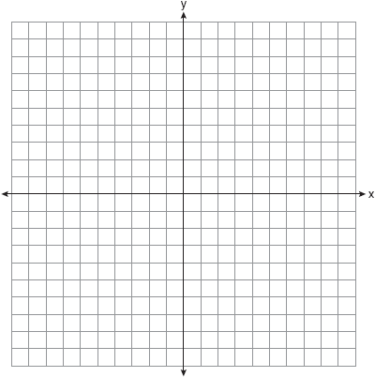

State the equation of the axis of symmetry.

8 On the set of axes below, graph .

State the coordinates of the minimum.
1 ANS: 1 REF: 012413ai

2 ANS: 2 REF: 082315ai

3 ANS:
Yes, because from the graph the zeroes of are and 3.

REF: 011832ai

4 ANS:
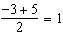

REF: 011829ai

5 ANS:
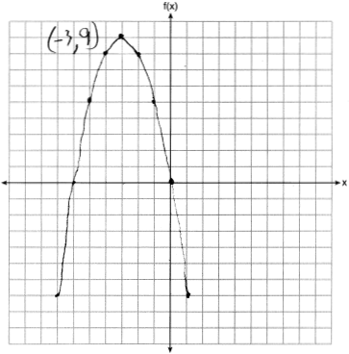

REF: 061726ai

6 ANS:
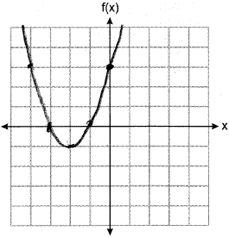

REF: 012526ai

7 ANS:
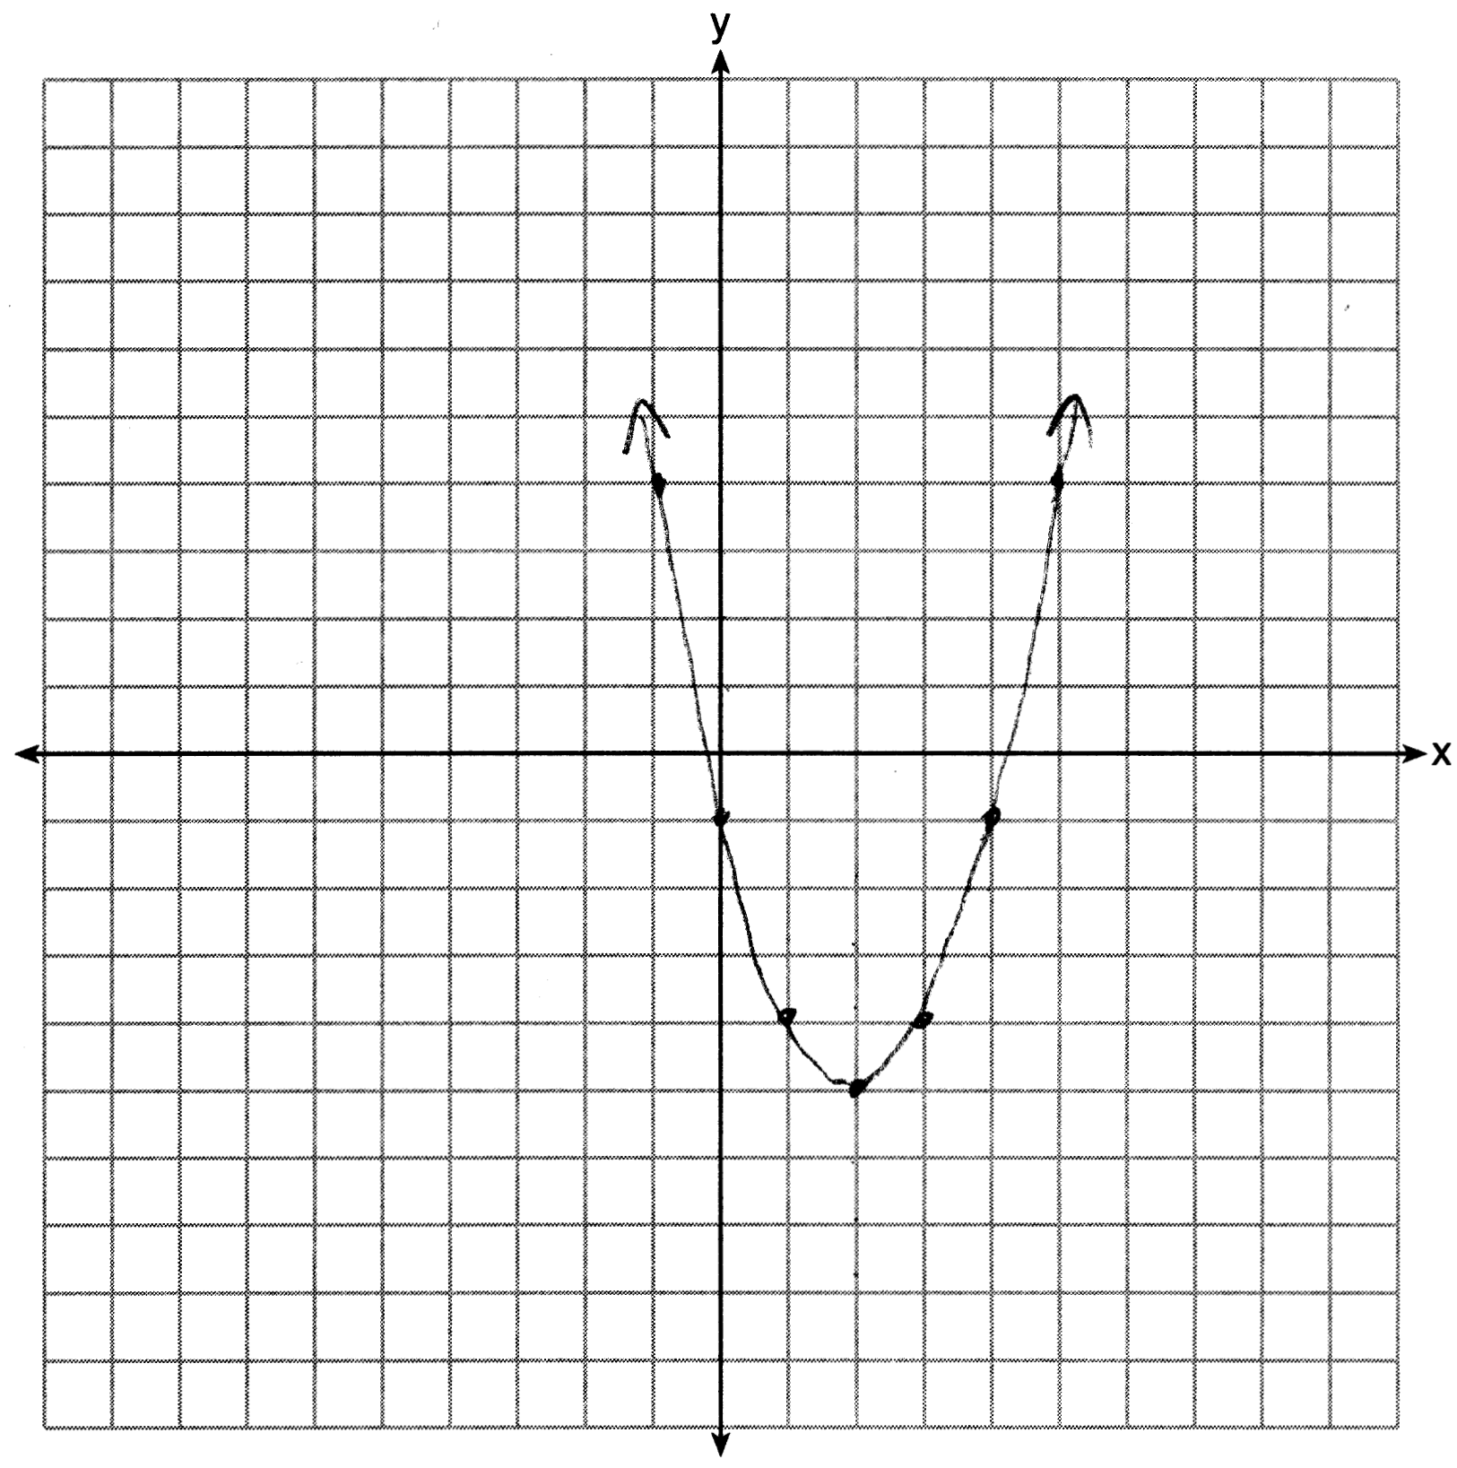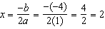

REF: 061627ai

8 ANS:
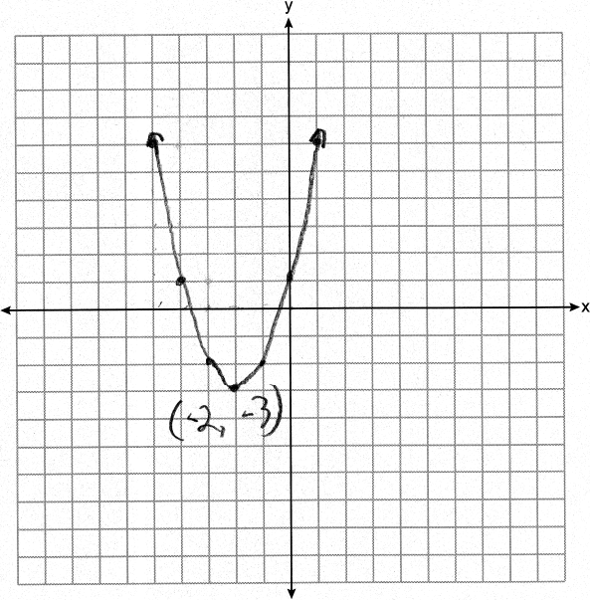

REF: 082425ai

