1 The graph of the equation is best described as
1) | a circle
2) | two lines
3) | an ellipse
4) | a hyperbola

2 Camisha is paying a band $330 to play at her graduation party. The amount each member earns, d, varies inversely as the number of members who play, n. The graph of the equation that represents the relationship between d and n is an example of
1) | a hyperbola
2) | a line
3) | a parabola
4) | an ellipse

3 Which equation represents a hyperbola?
1)
2)
3)
4) | 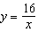

4 Which function is symmetrical with respect to the origin?
1)
2)
3) | 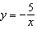
4)

5 The graph of which function is symmetric with respect to the graph of the line ?
1) | 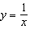
2)
3)
4)

6 Which graph represents an inverse variation between stream velocity and the distance from the center of the stream?
1) | 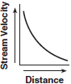
2) | 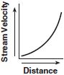
3) | 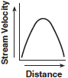
4) | 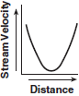

7 Which graph shows that soil permeability varies inversely to runoff?
1) | 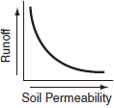
2) | 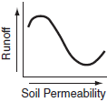
3) | 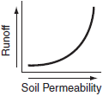
4) | 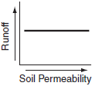

8 Jack is driving from New York to Florida. The number of hours that he drives and the speed at which he drives are inversely proportional. Which graph could be used to describe this situation if one axis represents speed and the other represents hours?
1) | 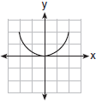
2) | 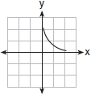
3) | 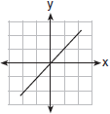
4) | 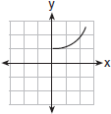

9 The price of a certain stock has decreased over 5 years, as shown in the graph below. Which of the following equations best represents this graph?

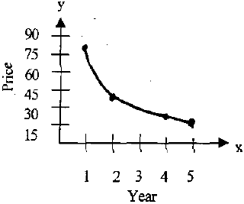
1)
2) | 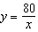
3)
4)

10 The accompanying graph shows the relationship between a person’s weight and the distance that the person must sit from the center of a seesaw to make it balanced.

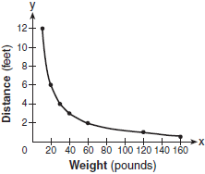

Which equation best represents this graph?
1)
2)
3)
4) | 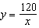

11 Which statement about the function 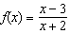 is true?
1) | Its domain does not include 2.
2) | Its domain does not include 3.
3) | Its range does not include 1.
4) | Its range does not include .

12 What is the domain of the function 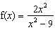?
1) | all real numbers except 0
2) | all real numbers except 3
3) | all real numbers except 3 and –3
4) | all real numbers

13 What is the domain of the function 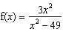?
1)
2)
3)
4)

14 Which negative real number is not in the domain of 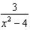?

15 The domain of the equation 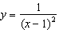 is all real numbers
1) | greater than 1
2) | except 1
3) | less than 1
4) | except 1 and

16 For 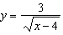, what are the domain and range?
1) | and
2) | and
3) | and
4) | and

17 In the set of real numbers, what is the domain of 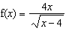?
1)
2)
3)
4)

18 What is the domain of the function 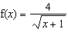 over the set of real numbers?
1)
2)
3)
4)

19 What is the domain of the function 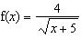 over the set of real numbers?
1)
2)
3)
4)

20 If 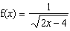, the domain of is
1)
2)
3)
4)

21 What is the domain of the function 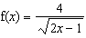 over the set of real numbers?
1) | 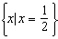
2) | 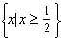
3) | 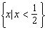
4) | 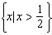

22 The domain of 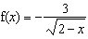 is the set of all real numbers
1) | greater than 2
2) | less than 2
3) | except 2
4) | between and 2

23 What is the domain of 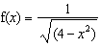?
1)
2)
3)
4) | all real numbers

1 ANS: 4 REF: 011009b

2 ANS: 1 REF: 060104b

3 ANS: 4 REF: 060616b

4 ANS: 3 REF: 060414b

5 ANS: 1 REF: 080714b

6 ANS: 1 REF: 060408b

7 ANS: 1 REF: 010603b

8 ANS: 2 REF: 080913b

9 ANS: 2 REF: fall9913b

10 ANS: 4 REF: 080312b

11 ANS: 3
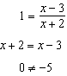
REF: 081623a2

12 ANS: 3
If x = 3 or -3, the denominator of the function is zero, which is undefined. 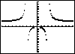
REF: 060407b

13 ANS: 2
If x = 7 or -7, the denominator of the function is zero, which is undefined. 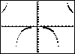
REF: 010504b

14 ANS:
REF: 010005siii

15 ANS: 2 REF: 069725siii

16 ANS: 1 REF: 011416a2

17 ANS: 4 REF: 010424siii

18 ANS: 4 REF: 068728siii

19 ANS: 1 REF: 010228siii

20 ANS: 4
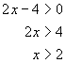. 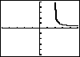
REF: 010314b

21 ANS: 4 REF: 080227siii

22 ANS: 2 REF: 011521a2

23 ANS: 3 REF: 069829siii

