1 In the interval , in how many points will the graphs of the equations and 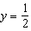 intersect?
1) | 1
2) | 2
3) | 3
4) | 4

2 On the coordinate plane below, sketch at least one cycle of a cosine function with a midline at , an amplitude of 3, and a period of .

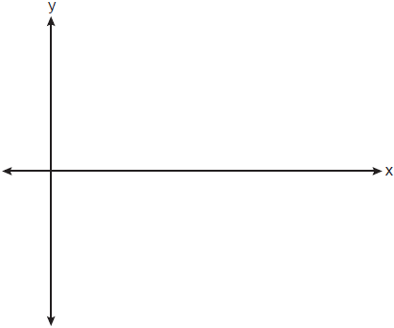

3 On the axes below, graph one cycle of a cosine function with amplitude 3, period , midline , and passing through the point .

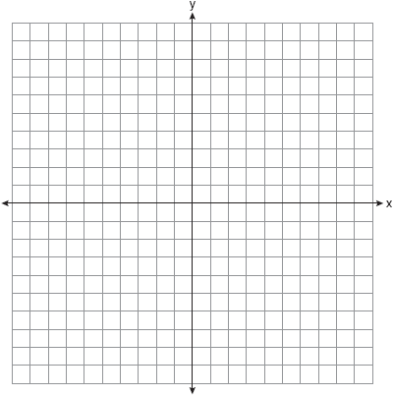

4 A radio wave has an amplitude of 3 and a wavelength (period) of meters. On the accompanying grid, using the interval 0 to , draw a possible sine curve for this wave that passes through the origin.



5 Write an equation for a sine function with an amplitude of 2 and a period of . On the grid below, sketch the graph of the equation in the interval 0 to .

6 On the graph below, draw at least one complete cycle of a sine graph passing through point that has an amplitude of 3, a period of , and a midline at .

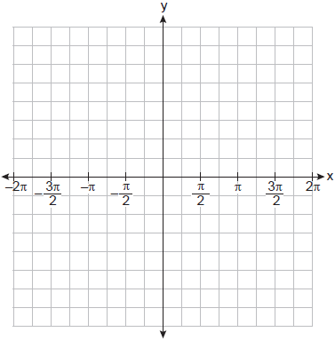

Based on your graph, state an interval in which the graph is increasing.

7 a) On the axes below, sketch at least one cycle of a sine curve with an amplitude of 2, a midline at 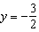, and a period of .
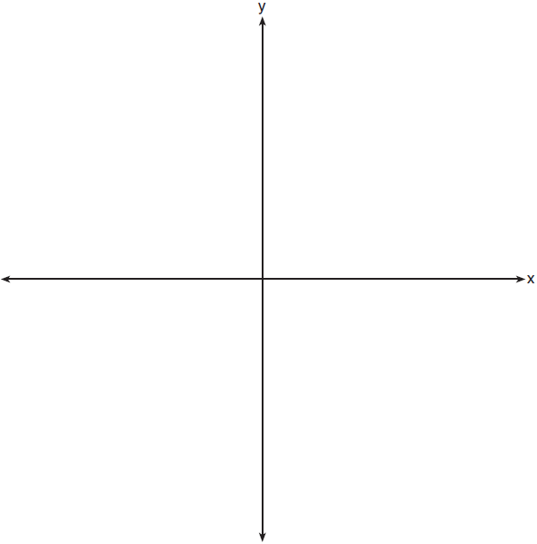

b) Explain any differences between a sketch of 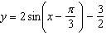 and the sketch from part a.

8 Sketch the graph of in the interval .

9 Sketch and label the function 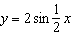 in the interval .

10 Graph over the domain on the set of axes below.

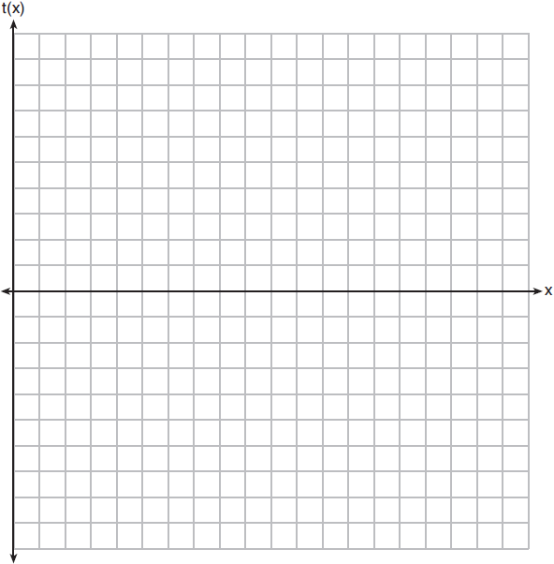

11 Graph at least one cycle of on the set of axes below.

12 Graph 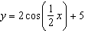 on the interval , using the axes below.

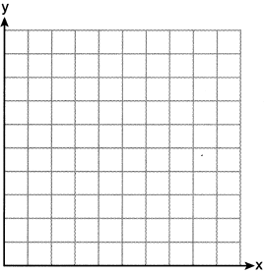

13 On the accompanying set of axes, graph the equations and in the domain . Express, in terms of , the interval for which .

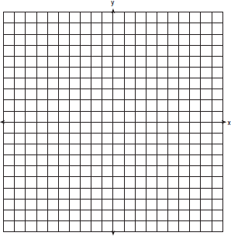

14 a On the accompanying set of axes, sketch the graph of the equations in the interval .
b On the same set of axes, reflect the graph drawn in part a in the x-axis and label it b.
c Write an equation of the graph drawn in part b.
d Using the equation from part c, find the value of y when 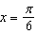.

15 On the same set of axes, sketch and label the graphs of 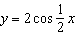 and for the values of x in the interval . State the number of values of x in the interval that satisfy the equation 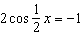.

16 A building’s temperature, T, varies with time of day, t, during the course of 1 day, as follows:
The air-conditioning operates when . Graph this function for and determine, to the nearest tenth of an hour, the amount of time in 1 day that the air-conditioning is on in the building.

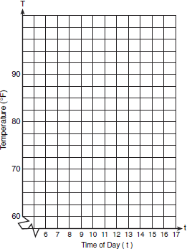

17 The tide at a boat dock can be modeled by the equation 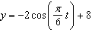, where t is the number of hours past noon and y is the height of the tide, in feet. For how many hours between and is the tide at least 7 feet? [The use of the grid is optional.]

18 Griffin is riding his bike down the street in Churchville, N.Y. at a constant speed, when a nail gets caught in one of his tires. The height of the nail above the ground, in inches, can be represented by the trigonometric function , where t represents the time (in seconds) since the nail first became caught in the tire. Determine the period of . Interpret what the period represents in this context. On the grid below, graph at least one cycle of that includes the y-intercept of the function.

Does the height of the nail ever reach 30 inches above the ground? Justify your answer.

19 The average annual snowfall in a certain region is modeled by the function 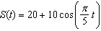, where S represents the annual snowfall, in inches, and t represents the number of years since 1970. What is the minimum annual snowfall, in inches, for this region? In which years between 1970 and 2000 did the minimum amount of snow fall? [The use of the grid is optional.]

20 A helicopter, starting at point A on Sunrise Highway, circles a 2-mile section of the highway in a counterclockwise direction. If the helicopter is traveling at a constant speed and it takes approximately 6.28 minutes to make one complete revolution to return to point A, sketch a possible graph of distance (dependent variable) from the helicopter to the highway, versus time (independent variable). If the helicopter is north of the highway, distance (d) is positive; if the helicopter is south of the highway, distance (d) is negative. (Disregard the height of the helicopter.) State the equation of this graph.

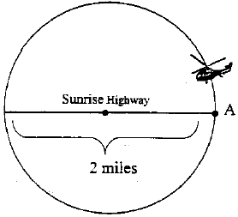

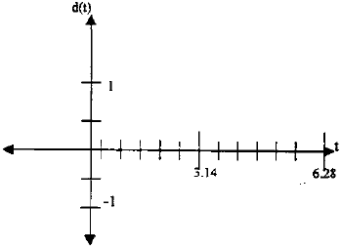

21 The ocean tides near Carter Beach follow a repeating pattern over time, with the amount of time between each low and high tide remaining relatively constant. On a certain day, low tide occurred at 8:30 a.m. and high tide occurred at 3:00 p.m. At high tide, the water level was 12 inches above the average local sea level; at low tide it was 12 inches below the average local sea level. Assume that high tide and low tide are the maximum and minimum water levels each day, respectively. Write a cosine function of the form , where A and B are real numbers, that models the water level, , in inches above or below the average Carter Beach sea level, as a function of the time measured in t hours since 8:30 a.m. On the grid below, graph one cycle of this function.



People who fish in Carter Beach know that a certain species of fish is most plentiful when the water level is increasing. Explain whether you would recommend fishing for this species at 7:30 p.m. or 10:30 p.m. using evidence from the given context.

22 The resting blood pressure of an adult patient can be modeled by the function P below, where is the pressure in millimeters of mercury after time t in seconds.
On the set of axes below, graph over the domain .

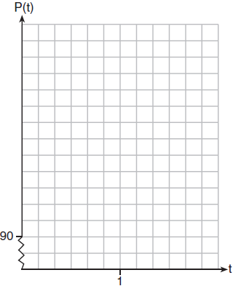

Determine the period of P. Explain what this value represents in the given context. Normal resting blood pressure for an adult is 120 over 80. This means that the blood pressure oscillates between a maximum of 120 and a minimum of 80. Adults with high blood pressure (above 140 over 90) and adults with low blood pressure (below 90 over 60) may be at risk for health disorders. Classify the given patient's blood pressure as low, normal, or high and explain your reasoning.
1 ANS: 2 REF: 069522siii

2 ANS:
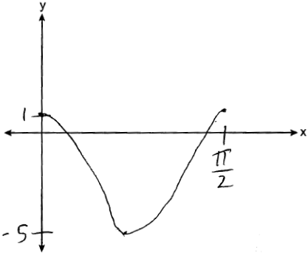

REF: 082328aii

3 ANS:
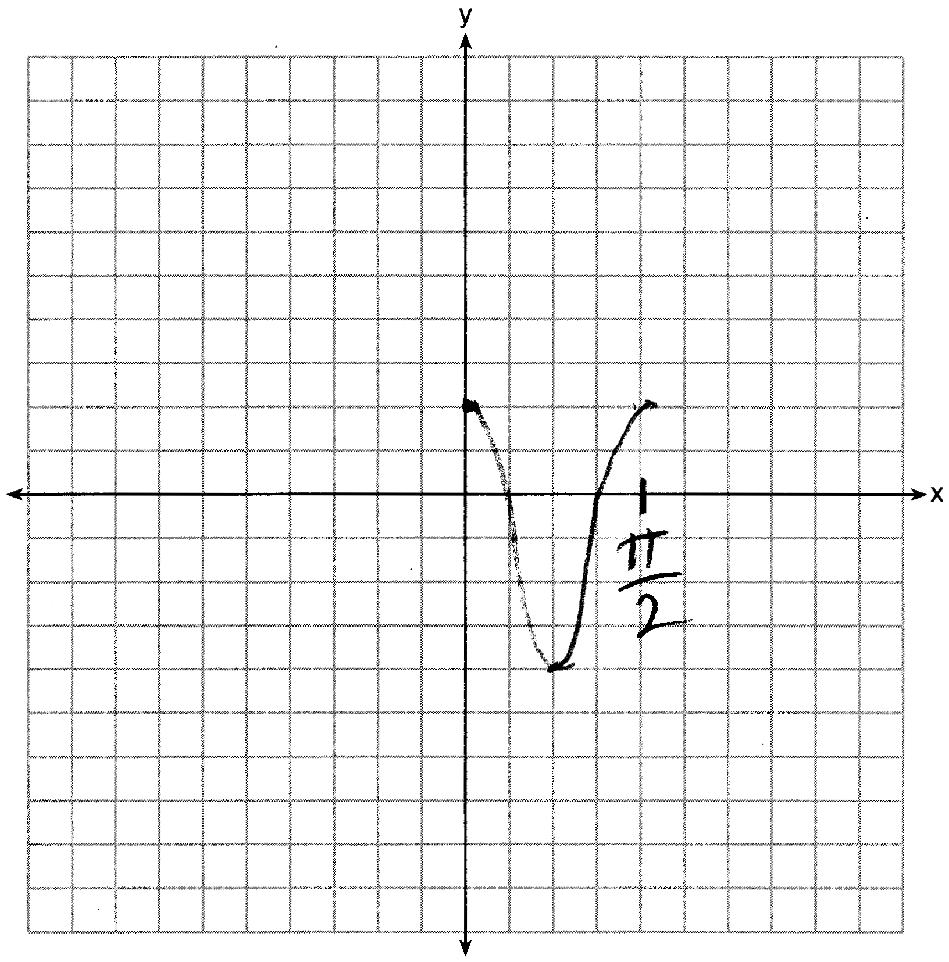

REF: 061628aii

4 ANS:
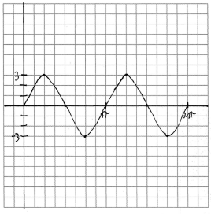

REF: 060832b

5 ANS:
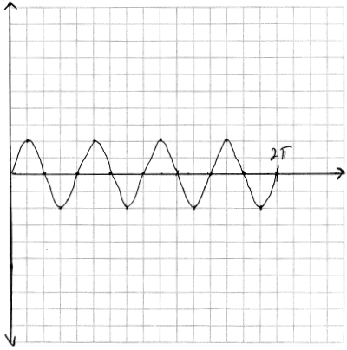

REF: 081934aii

6 ANS:
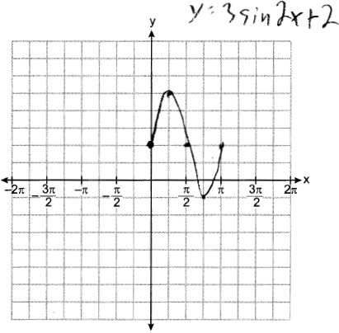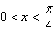

REF: 012436aii

7 ANS:
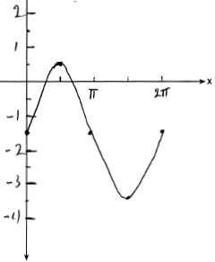Part a sketch is shifted units right.

REF: 081735aii

8 ANS:
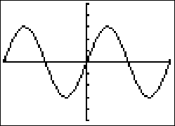

REF: 069040siii

9 ANS:
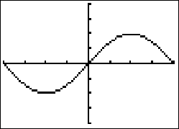

REF: 019536siii

10 ANS:
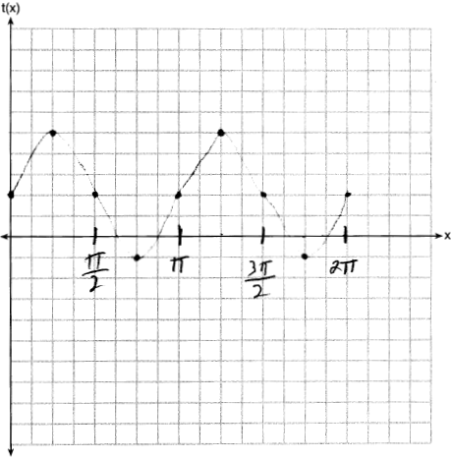

REF: 081830aii

11 ANS:
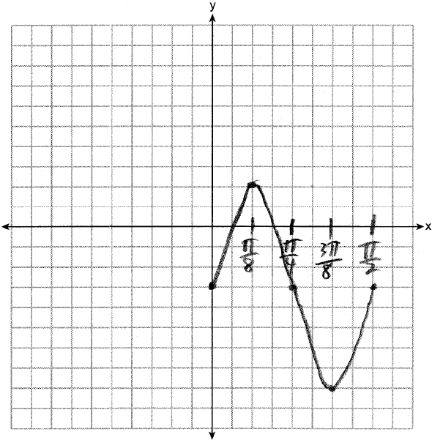

REF: 012529aii

12 ANS:
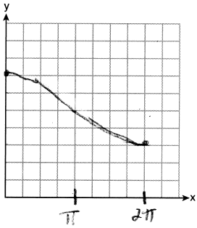

REF: 062231aii

13 ANS:
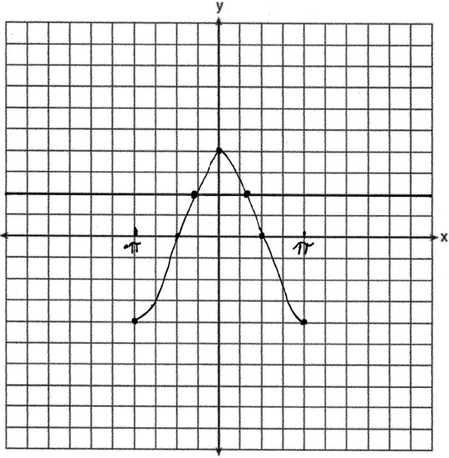 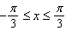. 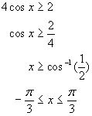

REF: 080532b

14 ANS:
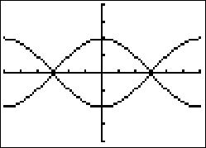 ,

REF: 069637siii

15 ANS:
1

REF: 018436siii

16 ANS:
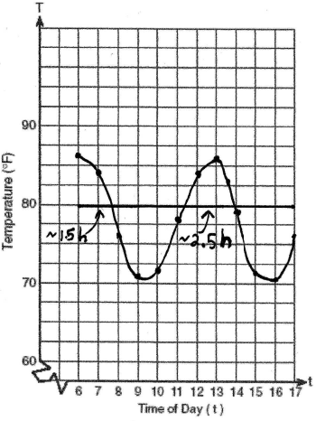 4.2. 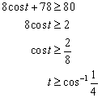. 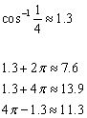. 7.6-6 = 1.6 hours. 13.9-11.3 = 2.6 hours. 1.6+2.6 = 4.2 hours. 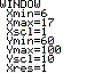 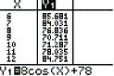 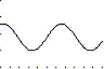

REF: 010329b

17 ANS:
8. 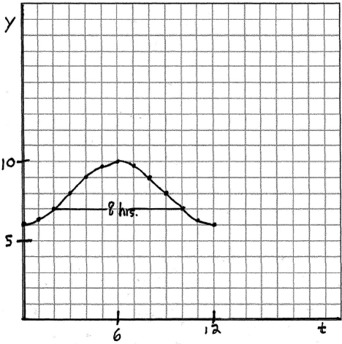. 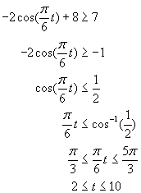

REF: 080433b

18 ANS:
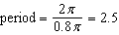. The wheel rotates once every 2.5 seconds. 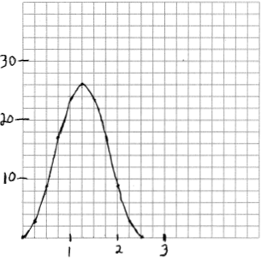 No, because the maximum of .

REF: 061937aii

19 ANS:
10, 1975, 1985, 1995. The minimum of the cosine function is . . 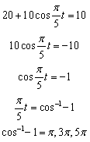. 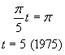. 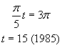. 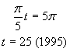. 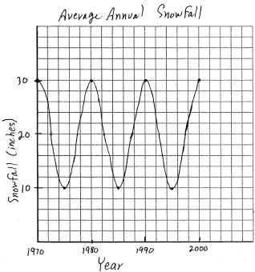

REF: 060731b

20 ANS:
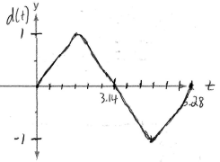

REF: fall9931b

21 ANS:
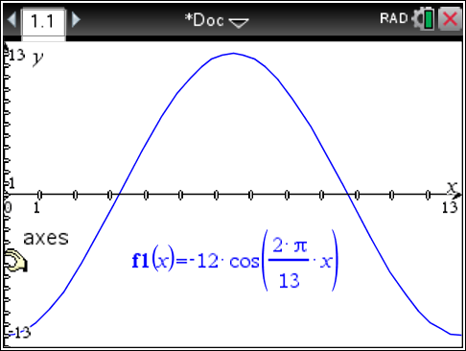The amplitude, 12, can be interpreted from the situation, since the water level has a minimum of and a maximum of 12. The value of A is since at 8:30 it is low tide. The period of the function is 13 hours, and is expressed in the function through the parameter B. By experimentation with technology or using the relation 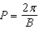 (where P is the period), it is determined that 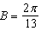. 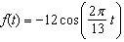 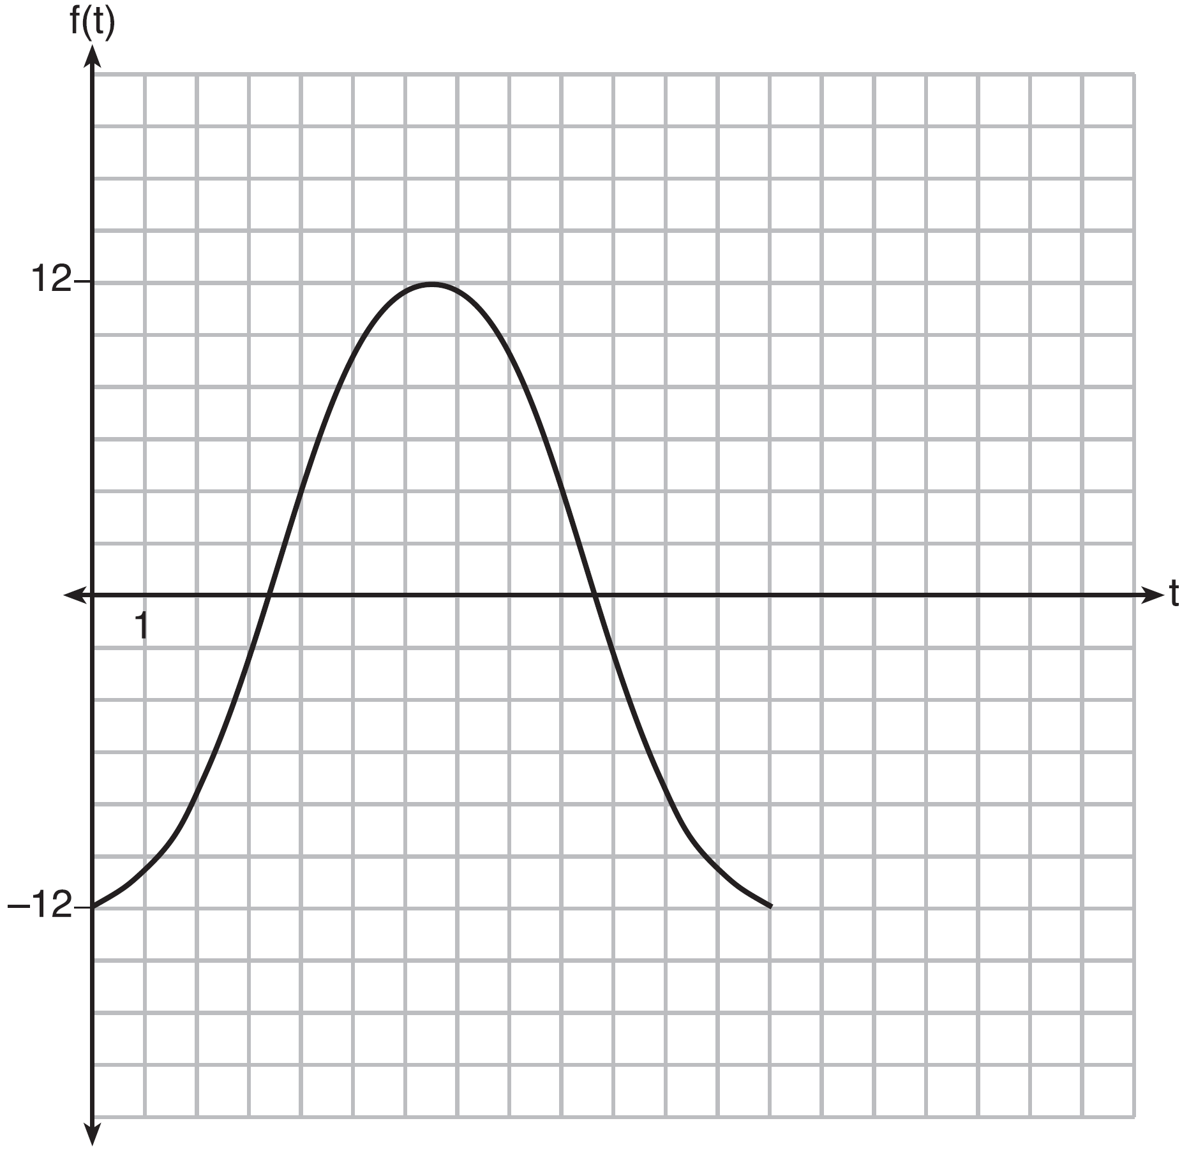
In order to answer the question about when to fish, the student must interpret the function and determine which choice, 7:30 pm or 10:30 pm, is on an increasing interval. Since the function is increasing from to (which corresponds to 9:30 pm to 4:00 am), 10:30 is the appropriate choice.

REF: spr1514aii

22 ANS:
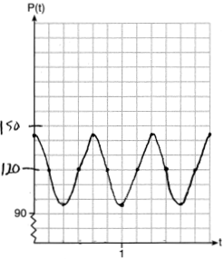 The period of P is , which means the patient’s blood pressure reaches a high every second and a low every second. The patient’s blood pressure is high because 144 over 96 is greater than 120 over 80.

REF: 011837aii

