1 One characteristic of all linear functions is that they change by
1) | equal factors over equal intervals | 3) | equal differences over equal intervals
2) | unequal factors over equal intervals | 4) | unequal differences over equal intervals

2 Which situation can be modeled by a linear function?
1) | The population of bacteria triples every day. | 3) | An amusement park allows 50 people to enter every 30 minutes.
2) | The value of a cell phone depreciates at a rate of 3.5% each year. | 4) | A baseball tournament eliminates half of the teams after each round.

3 Which situation could be modeled by using a linear function?
1) | a bank account balance that grows at a rate of 5% per year, compounded annually | 3) | the cost of cell phone service that charges a base amount plus 20 cents per minute
2) | a population of bacteria that doubles every 4.5 hours | 4) | the concentration of medicine in a person’s body that decays by a factor of one-third every hour

4 Which situation could be modeled as a linear equation?
1) | The value of a car decreases by 10% every year. | 3) | Two liters of water evaporate from a pool every day.
2) | The number of fish in a lake doubles every 5 years. | 4) | The amount of caffeine in a person's body decreases by every 2 hours.

5 Which situation could be modeled by a linear function?
1) | The value of a car depreciates by 7% annually. | 3) | The number of bacteria in a lab doubles weekly.
2) | A gym charges a $50 initial fee and then $30 monthly. | 4) | The amount of money in a bank account increases by 0.1 % monthly.

6 Which situation can be modeled by a linear function?
1) | A printer can print one page every three seconds. | 3) | The number of cells in an organism doubles every four days.
2) | A bank account earns 0.5% interest each year, compounded annually. | 4) | The attendance at a professional sports team's games decreases by 1.5% each year.

7 Which situation is not a linear function?
1) | A gym charges a membership fee of $10.00 down and $10.00 per month. | 3) | A restaurant employee earns $12.50 per hour.
2) | A cab company charges $2.50 initially and $3.00 per mile. | 4) | A $12,000 car depreciates 15% per year.

8 One Saturday afternoon, three friends decided to keep track of the number of text messages they received each hour from 8 a.m. to noon. The results are shown below.
Emily said that the number of messages she received increased by 8 each hour.
Jessica said that the number of messages she received doubled every hour.
Chris said that he received 3 messages the first hour, 10 the second hour, none the third hour, and 15 the last hour.
Which of the friends' responses best classifies the number of messages they received each hour as a linear function?
1) | Emily, only | 3) | Emily and Chris
2) | Jessica, only | 4) | Jessica and Chris

9 Grisham is considering the three situations below.
I. For the first 28 days, a sunflower grows at a rate of 3.5 cm per day.
II. The value of a car depreciates at a rate of 15% per year after it is purchased.
III. The amount of bacteria in a culture triples every two days during an experiment.
Which of the statements describes a situation with an equal difference over an equal interval?
1) | I, only | 3) | I and III
2) | II, only | 4) | II and III

10 Which scenario represents exponential growth?
1) | A water tank is filled at a rate of 2 gallons/minute. | 3) | A species of fly doubles its population every month during the summer.
2) | A vine grows 6 inches every week. | 4) | A car increases its distance from a garage as it travels at a constant speed of 25 miles per hour.

11 Which situation represents exponential growth?
1) | Aidan adds $10 to a jar each week. | 3) | Ella earns $20 per hour babysitting.
2) | A pine tree grows 1.5 feet per year. | 4) | The number of people majoring in computer science doubles every 5 years.

12 Which of the three situations given below is best modeled by an exponential function?
I. A bacteria culture doubles in size every day.
II. A plant grows by 1 inch every 4 days.
III. The population of a town declines by 5% every 3 years.
1) | I, only | 3) | I and II
2) | II, only | 4) | I and III

13 On an island, a rare breed of rabbit doubled its population each month for two years. Which type of function best models the increase in population at the end of two years?
1) | linear growth | 3) | exponential growth
2) | linear decay | 4) | exponential decay

14 Ian is saving up to buy a new baseball glove. Every month he puts $10 into a jar. Which type of function best models the total amount of money in the jar after a given number of months?
1) | linear | 3) | quadratic
2) | exponential | 4) | square root

15 The highest possible grade for a book report is 100. The teacher deducts 10 points for each day the report is late. Which kind of function describes this situation?
1) | linear | 3) | exponential growth
2) | quadratic | 4) | exponential decay

16 Sara was asked to solve this word problem: "The product of two consecutive integers is 156. What are the integers?" What type of equation should she create to solve this problem?
1) | linear | 3) | exponential
2) | quadratic | 4) | absolute value

17 Eric deposits $500 in a bank account that pays 3.5% interest, compounded yearly. Which type of function should he use to determine how much money he will have in the account at the end of 10 years?
1) | linear | 3) | absolute value
2) | quadratic | 4) | exponential

18 Which type of function is shown in the graph below?

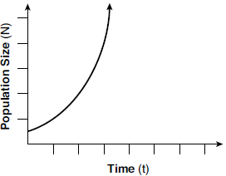
1) | linear | 3) | square root
2) | exponential | 4) | absolute value

19 A population that initially has 20 birds approximately doubles every 10 years. Which graph represents this population growth?
1) | 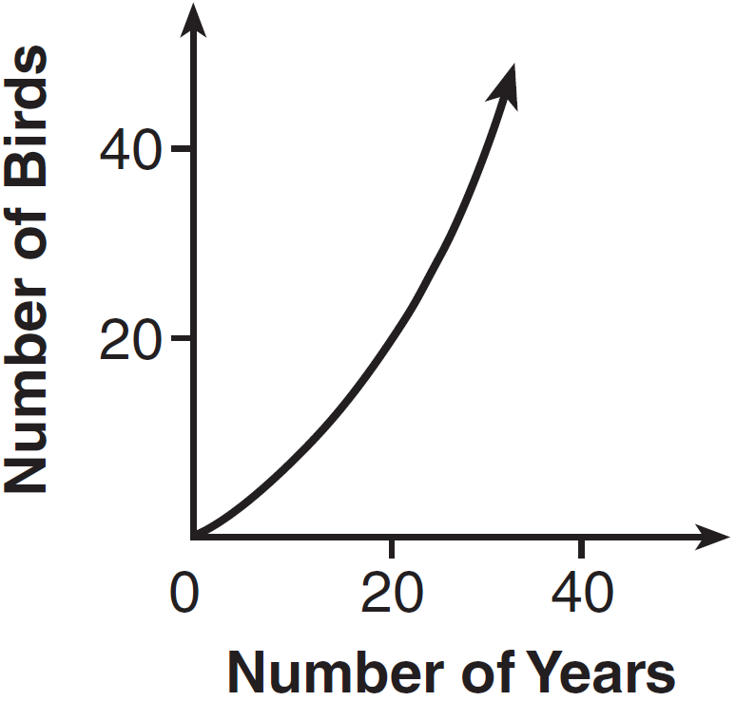 | 3) | 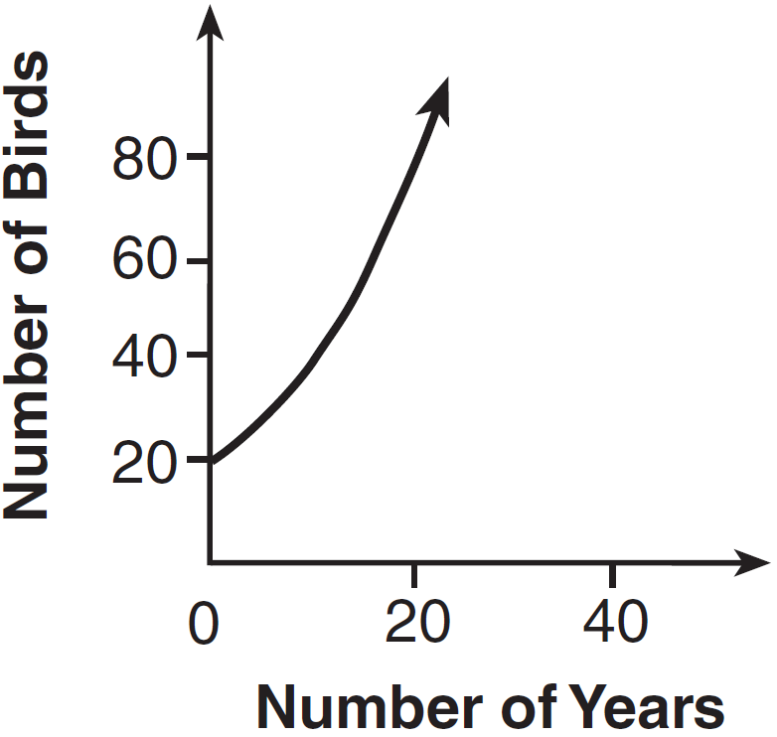
2) | 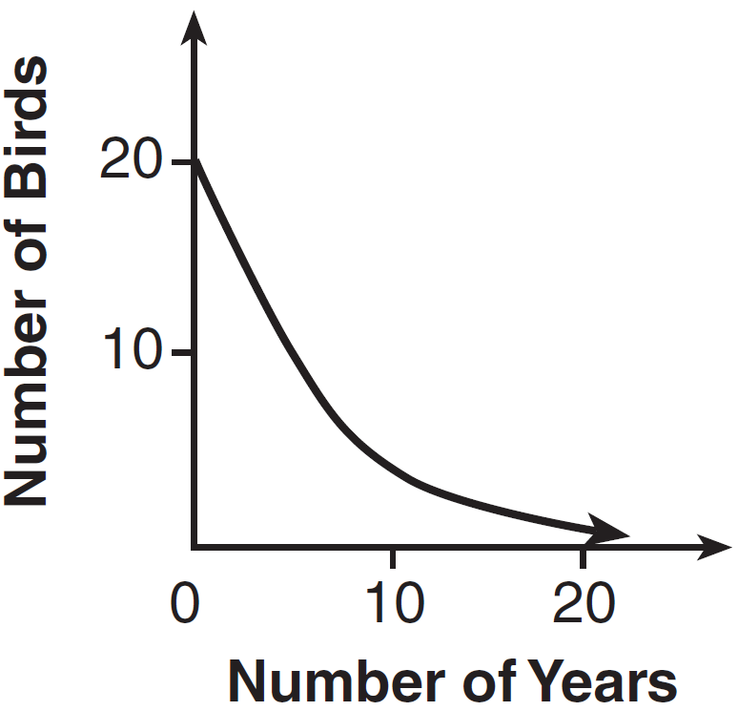 | 4) | 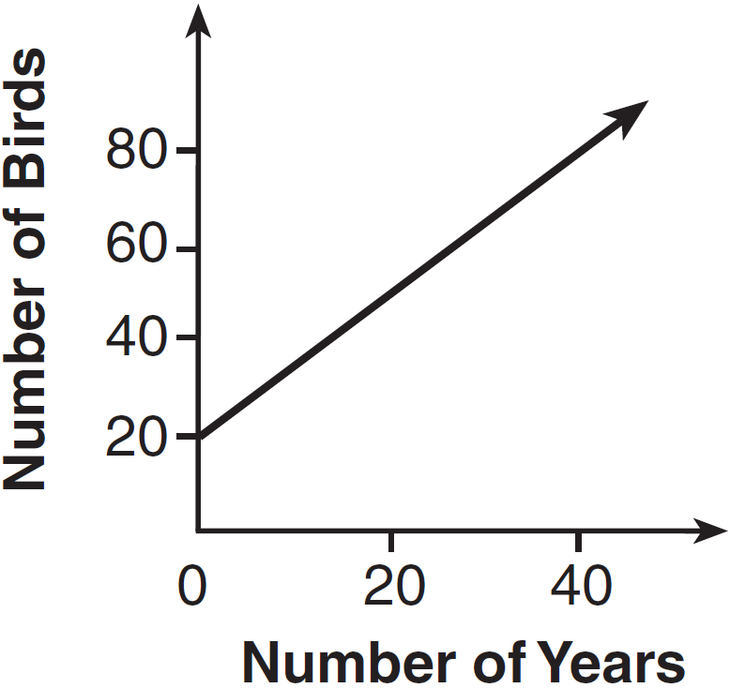

20 The tables below show the values of four different functions for given values of x.

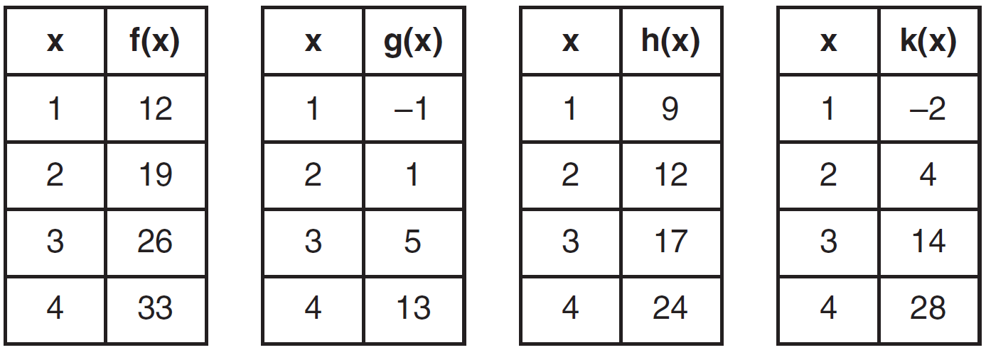

Which table represents a linear function?·
1) |  | 3)
2) |  | 4)

21 Which table of values represents a linear relationship?
1) | 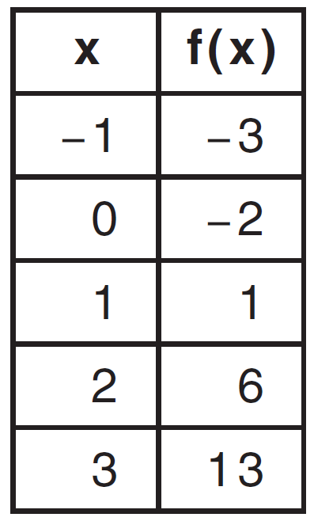 | 3) | 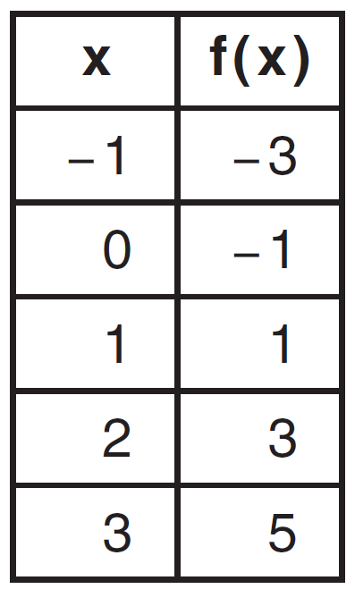
2) | 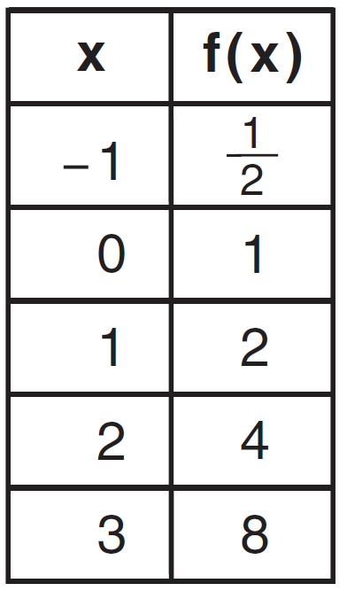 | 4) | 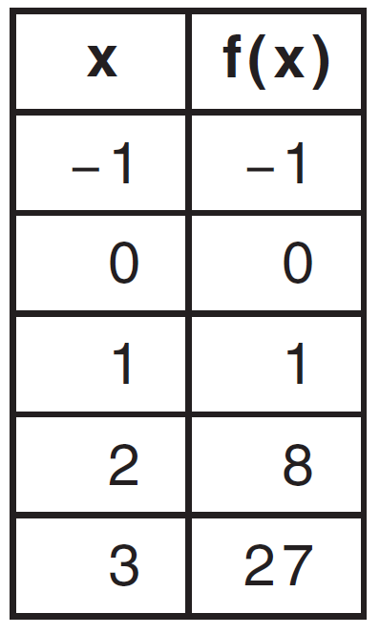

22 During physical education class, Andrew recorded the exercise times in minutes and heart rates in beats per minute (bpm) of four of his classmates. Which table best represents a linear model of exercise time and heart rate?
1) | 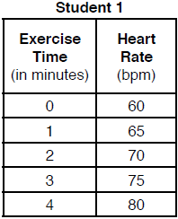 | 3) | 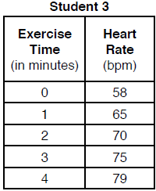
2) | 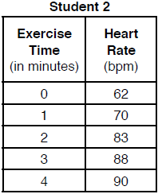 | 4) | 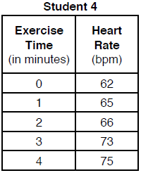

23 Tables of values for four functions are shown below.

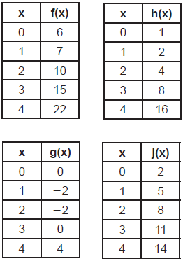

Which table best represents an exponential function?
1) |  | 3)
2) |  | 4)

24 Which table of values represents an exponential relationship?
1) | 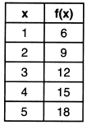 | 3) | 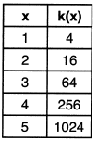
2) | 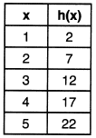 | 4) | 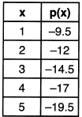

25 Thirty-two teams are participating in a basketball tournament. Only the winning teams in each round advance to the next round, as shown in the table below.
Number of Rounds Completed, x | 0 | 1 | 2 | 3 | 4 | 5
Number of Teams Remaining, f(x) | 32 | 16 | 8 | 4 | 2 | 1
Which function type best models the relationship between the number of rounds completed and the number of teams remaining?
1) | absolute value | 3) | linear
2) | exponential | 4) | quadratic

26 The function f is shown in the table below.

x | f(x)
0 | 1
1 | 3
2 | 9
3 | 27

Which type of function best models the given data?
1) | exponential growth function | 3) | linear function with positive rate of change
2) | exponential decay function | 4) | linear function with negative rate of change

27 The inputs and outputs of a function are shown in the table below.

x | f(x)
0 | 0.0625
1 | 0.125
2 | 0.25
3 | 0.5
4 | 1
5 | 2
This function can best be described as
1) | linear | 3) | exponential
2) | quadratic | 4) | absolute value

28 The table below shows the average yearly balance in a savings account where interest is compounded annually. No money is deposited or withdrawn after the initial amount is deposited.

Year | Balance, in Dollars
0 | 380.00
10 | 562.49
20 | 832.63
30 | 1232.49
40 | 1824.39
50 | 2700.54

Which type of function best models the given data?
1) | linear function with a negative rate of change | 3) | exponential decay function
2) | linear function with a positive rate of change | 4) | exponential growth function

1 ANS: 3 REF: 061721ai

2 ANS: 3 REF: 061911ai

3 ANS: 3 REF: 081412ai

4 ANS: 3 REF: 012017ai

5 ANS: 2 REF: 082213ai

6 ANS: 1 REF: 082402ai

7 ANS: 4 REF: 061814ai

8 ANS: 1 REF: 012308ai

9 ANS: 1 REF: 011623ai

10 ANS: 3 REF: 011711ai

11 ANS: 4 REF: 012405ai

12 ANS: 4
II is linear.

REF: 081823ai

13 ANS: 3 REF: 062407ai

14 ANS: 1 REF: 011805ai

15 ANS: 1 REF: 081717ai

16 ANS: 2 REF: 061624ai

17 ANS: 4 REF: 062117ai

18 ANS: 2 REF: 081907ai

19 ANS: 3 REF: 081410ai

20 ANS: 1 REF: 061606ai

21 ANS: 3 REF: 011505ai

22 ANS: 1 REF: 081802ai

23 ANS: 3

REF: 082317ai

24 ANS: 3

REF: 062208ai

25 ANS: 2 REF: 012316ai

26 ANS: 1 REF: 061906ai

27 ANS: 3 REF: 012513ai

28 ANS: 4 REF: 061406ai

