1 If 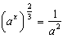, what is the value of x?
1) 1 2) 2 3) 4)

2 If , which expression is equivalent to x?
1) 2) 3) 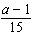 4) 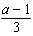

3 The solution set of is
1) 2) 3) 4)

4 The solution set of is
1) 2) 3) 4)

5 If , what does x equal?
1) 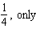 2) 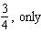 3) 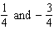 4) 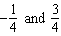

6 Determine the value of x and y if and .
1) 2) 3) 4)

7 Solve algebraically for x:

8 Solve algebraically for x:

9 Solve for x: 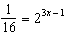

10 Solve for m:
1 ANS: 3
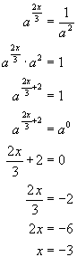

REF: 060516b

2 ANS: 2
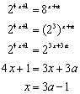

REF: 060814b

3 ANS: 2
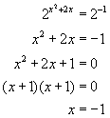. 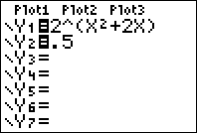. 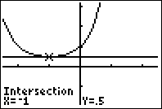

REF: 060612b

4 ANS: 3
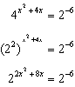. 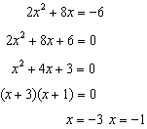

REF: 061015a2

5 ANS: 4
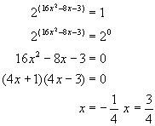. 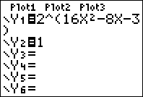. 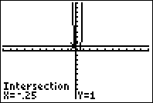

REF: 080819b

6 ANS: 3
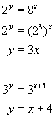. 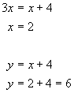

REF: 080118b

7 ANS:
. 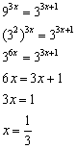

REF: 060923b

8 ANS:
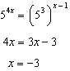

REF: 061528a2

9 ANS:
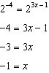

REF: 081529a2

10 ANS:
2. 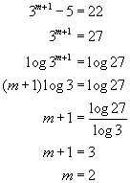. 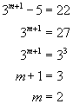. 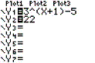. 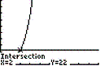

REF: 060522b

